Exploring Quadrilateral Properties with the Cabri Jr. Application

Allison Golem
Mayfield Middle School
Mayfield, OH
agolem@mayfieldschools.org

Cabri Jr. Menus

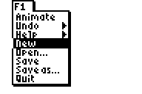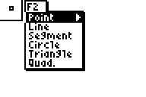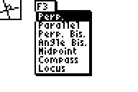

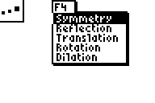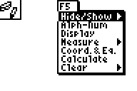

Cabri Basics

Draw a line segment.

- Choose Segment from the F2 menu by pressing enter.
- A pencil will appear. You are now in draw mode.
- Choose the starting location of your line segment. Using the arrows, the pencil is moved around the screen. When you have chosen a location, press enter. You get a blinking cursor.
- Use the arrows to choose the ending location of your line segment. Press enter to choose the location.

Draw a triangle.

- To open a new screen, choose New from the F1 menu.
- From the F2 menu, choose Triangle.
- The pencil will appear to indicate you are in draw mode. Choose the location of your first vertex by using the arrows and pressing enter.
- Choose the location of the second vertex by using the arrows and pressing enter.
- Choose the location of the third vertex by using the arrows and pressing enter.

Change the original triangle.

- Press Clear to leave the draw mode. An arrow will appear. You can move this arrow around using the arrow keys.
- Move the arrow to one of the vertices. You will know it is chosen because the vertex will blink and the arrow is transparent. Press Alpha. A hand will appear.
- Use the arrows to move the hand around. The size and shape of the triangle can be changed.

Measure the sides of the triangle.

- Press clear to remove the hand from the screen. You should now see the arrow cursor.
- Move the cursor to one of the vertices. From the F5 menu, move the cursor to measure. Use the right arrow key to open the other options. Choose the first option, D. and Length (Distance and Length).
- The cursor has changed to a pencil. The cursor should still be on one of the vertices. Press enter. The vertex should blink and temporarily get larger.
- Move the pencil to another vertex and press enter. This vertex should do the same, blink and temporarily get larger. The length of the segment will appear with a hand next to it.
- You can move this number anywhere on the screen. The distance is measured in pixels.

Exploring Quadrilateral Properties with the Cabri Jr. Application
Allison Golem
agolem@mayfieldschools.org

NCTM Standards
- Precisely describe, classify, and understand relationships among types of two-dimensional objects using their defining properties.
- Create and critique inductive and deductive arguments concerning geometric ideas and relationships.
- Make and investigation mathematical conjectures.
- Develop and evaluate mathematical arguments and proofs.
- Select and use various types of reasoning and methods of proof.

Ohio Academic Content Standards 5-7 Benchmarks
- Identify, describe and classify types of two-dimensional figures using their properties.

Adapted from:
- NCTM Illuminations
- Shape Makers by Michael T. Battista
- Elementary and Middle School Mathematics by John A. Van de Walle

Rationale

Geometric thinking develops at different times for different students. Students traverse through the van Hiele levels of geometric thought with most high school geometry students entering at level 1, which is analysis. However, level 2 or level 3 thinking is needed to understand and perform traditional proofs. The only way for students to pass through the levels is to be exposed to a broad range of geometric experiences that confront misconceptions and force them to construct an understanding of the concepts. These activities help students to understand properties of quadrilaterals as well as the relationships between the quadrilaterals by having students analyze each quadrilateral’s characteristics.

Materials:
- TI-83 Plus Family/TI-84 Plus Family Graphing Calculators
- Cabri Jr. Application
- Pre constructed Quadrilateral Makers
- USB Silverlink Cable
- TI-Connect software

Activities

- Give students several cut outs of quadrilaterals to sort into groups. After groups of students have sorted the quadrilaterals, have them justify the groups they have put them into by discussing the attributes in each group and If possible have students name each group.
- Use information gained from the initial sorting activity to choose two quadrilaterals for students to compare. For example, rectangles and parallelograms. Complete the Rectangles and Parallelograms activity.
- Ask students the following questions once they have completed the activity:
  - When you rotate or stretch the shapes, which attributes stay the same?
  - What is alike about all of the rectangle figures?
  - What is alike about all of the parallelogram figures?
  - What attributes do parallelograms and rectangles share?
  - What attributes differ between parallelograms and rectangles?
  - Did everyone create the figures in the same way?
- Once students begin to understand the defining attributes (angle measures, side lengths, parallelism, congruency), begin the discussion of properties of all quadrilaterals. The discussion should focus on which attributes remain the same and which change so students understand the subrelationships between quadrilaterals.
- Use the activities below to help students construct the subrelationships between quadrilaterals.
- Parallelograms and Rectangles
- Making Quadrilaterals
- Measuring Angles and Side Lengths of Quadrilaterals
- Predict and Check
- Which Quadrilateral Makers Can You Use?
- How Are They The Same?
- Quadrilateral Maker: Who Am I?

PARALELLOGRAMS AND RECTANGLES

- Go to Apps.
- Choose Cabri Jr.
- Press Enter.
- Press Y=, which is the F1 menu.
- Open the REC file.
- Move the cursor by using the arrow keys until it is over one of the vertices. The arrow will be “clear” and the vertex will flash. Press Alpha. The cursor will change to a hand. You now will be able to drag the vertex by using the arrow keys. Some vertices cannot be moved or do not move in all directions.
- Before moving the vertices, predict whether or not the REC file will make the shapes below.
- Check your predictions using the REC file from the Quad Makers.
- Repeat the process with the PARA file.

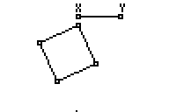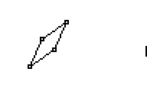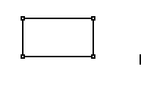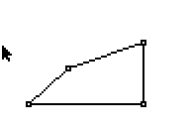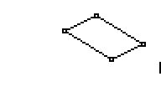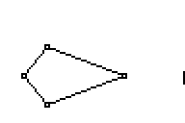

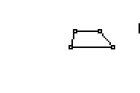
RECTANGLES

- Predict whether or not it is possible to create figure A with the REC file. Yes No
Here is the process that I used to try to recreate shape A:

- Predict whether or not it is possible to create figure B with the REC file. Yes No
Here is the process that I used to try to recreate shape B:

- Predict whether or not it is possible to create figure C with the REC file. Yes No
Here is the process that I used to try to recreate shape C:

- Predict whether or not it is possible to create figure D with the REC file. Yes No
Here is the process that I used to try to recreate shape D:

- Predict whether or not it is possible to create figure E with the REC file. Yes No
Here is the process that I used to try to recreate shape E:

PARALELLOGRAMS

A) Predict whether or not it is possible to create figure A with the PARA file. Yes No
Here is the process that I used to try to recreate shape A:

B) Predict whether or not it is possible to create figure B with the PARA file. Yes No
Here is the process that I used to try to recreate shape B:

C) Predict whether or not it is possible to create figure C with the PARA file. Yes No
Here is the process that I used to try to recreate shape C:

D) Predict whether or not it is possible to create figure D with the PARA file. Yes No
Here is the process that I used to try to recreate shape D:

E) Predict whether or not it is possible to create figure E with the PARA file. Yes No
Here is the process that I used to try to recreate shape E:

MAKING QUADRILATERALS

Use the Quadrilateral Makers to create each of the shapes below. Try to make each shape using EACH of the Quadrilateral Makers.

#1 #2
#3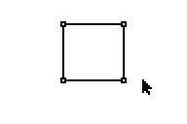#4 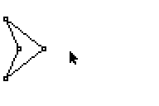 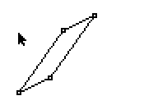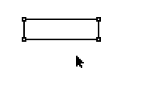

- Go to A.
- Choose Cabri Jr.
- Press e.
- Press !, which is the F1 menu.
- Open one of the Quadrilateral Maker files (KITE, RHOMBUS, QUAD, REC, SQUARE, PARA, TRAP).
- Move the cursor by using the arrow keys until it is over one of the vertices. The arrow will be “clear” and the vertex will flash. Press a. The cursor will change to a hand. Drag the vertex using the arrows to change the figure. Some vertices cannot be moved or do not move in all directions.
- Try to make the figures above with each Quadrilateral Maker. Pay particular attention to which Quadrilateral Makers can and cannot make each shape and why. Record your results in the table.
- Once you make the shape, perform a screen capture and save it.
MAKING QUADRILATERALS

Use all seven Quadrilateral Makers to make the pictures above. Tell which shape you Quadrilateral Maker you use to make each shape and why you used it. If you can make the shape with the Quadrilateral Maker, perform a screen capture to save your shape. If you cannot, explain why.

Shape | Quad Maker | Why?
#1

#2

#3

#4

**Adapted from Shape Makers by Battista

MEASURING ANGLES AND SIDE LENGTHS OF QUADRILATERALS

Use the Quadrilateral Makers: QUADM, KITEM, PARAM, SQUAREM, RHOMBUSM, RECM, and TRAPM for this activity.

Drag the vertices of each figure. Compare the angle measures, side lengths and parallel sides. Collect data about each as you move the vertices. Record your data and write a conjecture about each quadrilateral.

Quad Maker | Angle Measures | Side Lengths | Parallel Sides | Conjecture
QUADM
(Quadrilateral)

KITEM

PARAM
(Parallelogram)

Quad Maker | Angle Measures | Side Lengths | Parallel Sides | Conjecture
SQUAREM

TRAPM
(Trapezoid)

RHOMBUSM

RECM
(Rectangle)

PREDICT AND CHECK

“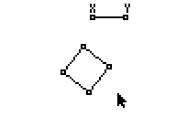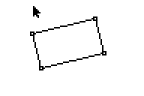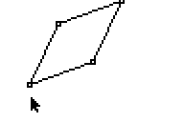
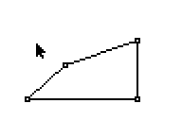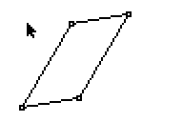

For each measured Quadrilateral Maker, predict which of the above shapes the Quadrilateral Maker can make. Check your prediction with the Cabri Jr. Quadrilateral Makers. If you can make it, perform a screen capture and save. If you cannot, explain why.

Quad Maker | Shape | I predict: I found: | I found that this Quad Maker will NOT make this shape because:
SQUAREM | 1  2  3  4  5 | Y N Y N  Y N Y N  Y N Y N  Y N Y N  Y N Y N
RECM | 1  2  3  4  5 | Y N Y N  Y N Y N  Y N Y N  Y N Y N  Y N Y N
PARAM | 1  2  3  4  5 | Y N Y N  Y N Y N  Y N Y N  Y N Y N  Y N Y N
RHOMBUSM | 1  2  3  4  5 | Y N Y N  Y N Y N  Y N Y N  Y N Y N  Y N Y N  Y N Y N

**Adapted from Shape Makers by Battista

Quad Maker | Shape | I predict: I found: | I found that this Quad Maker will NOT make this shape because:
QUADM | 1  2  3  4  5 | Y N Y N  Y N Y N  Y N Y N  Y N Y N  Y N Y N
KITEM | 1  2  3  4  5 | Y N Y N  Y N Y N  Y N Y N  Y N Y N  Y N Y N
TRAPM | 1  2  3  4  5 | Y N Y N  Y N Y N  Y N Y N  Y N Y N  Y N Y N

**Adapted from Shape Makers by Battista
WHICH QUADRILATERAL MAKERS CAN YOU USE?

For each measured Quadrilateral Maker, predict whether or not it can make each quadrilateral described in 1-6. Check your predictions using the Quadrilateral Makers. Screen capture and save all shapes that can be made.

Circle your answers. If a quadrilateral cannot make one of the described quadrilaterals, explain why not.

- A quadrilateral with side lengths 2, 3, 4, 5.
- A quadrilateral with side lengths 3, 3, 5, 5.
- A quadrilateral with all angles different.
- A quadrilateral with angles .
- A quadrilateral with two pairs of sides parallel.
- A quadrilateral with at least one line of symmetry.

**Adapted from Shape Makers by Battista

Quad Maker | Shape | I predict: I found: | I cannot make this shape because:
SQUAREM | 1  2  3  4  5  6 | Y N Y N  Y N Y N  Y N Y N  Y N Y N  Y N Y N  Y N Y N
RECM | 1  2  3  4  5  6 | Y N Y N  Y N Y N  Y N Y N  Y N Y N  Y N Y N  Y N Y N
PARAM | 1  2  3  4  5  6 | Y N Y N  Y N Y N  Y N Y N  Y N Y N  Y N Y N  Y N Y N
RHOMBUSM | 1  2  3  4  5  6 | Y N Y N  Y N Y N  Y N Y N  Y N Y N  Y N Y N  Y N Y N
QUADM | 1  2  3  4  5  6 | Y N Y N  Y N Y N  Y N Y N  Y N Y N  Y N Y N
KITEM | 1  2  3  4  5  6 | Y N Y N  Y N Y N  Y N Y N  Y N Y N  Y N Y N
TRAPM | 1  2  3  4  5  6 | Y N Y N  Y N Y N  Y N Y N  Y N Y N  Y N Y N  Y N Y N
**Adapted from Shape Makers by Battista

HOW ARE THEY THE SAME?

To check your answers, use the measured Quad Makers.

- Describe everything that is the same about all shapes made with the square.

- Describe everything that is the same about all shapes made with the rectangle.

- Describe everything that is the same about all shapes made with the rhombus.

- Describe everything that is the same about all shapes made with the parallelogram.

- Describe everything that is the same about all shapes made with the trapezoid.

- Describe everything that is the same about all shapes made with the kite.

**From Shape Makers by Battista

QUADRILATERAL MAKER: WHO AM I?

Predict which ONE Quadrilateral Maker is described by the riddle and explain your reasoning. Check your prediction using the Quadrilateral Maker.

- No matter how I change, I always have two pairs of sides with the same length and at least one line of symmetry. Sometimes I have only one line of symmetry. Which Quadrilateral Maker am I?

PREDICTION:

EXPLANATION:

CHECK:

EXPLANATION:

- No matter how I change, I always have at least one pair of parallel sides. Which Quadrilateral Maker am I?

PREDICTION:

EXPLANATION:

CHECK:

EXPLANATION:

- Whenever I have a right angle, I am a rectangle. Sometimes not all of my sides have the same length and I have no right angles. Which Quadrilateral Maker am I?

PREDICTION:

EXPLANATION:

CHECK:

EXPLANATION:

- I am always a parallelogram. I am always a kite. Sometimes I am not always right. Which Quadrilateral Maker am I?

PREDICTION:

EXPLANATION:

CHECK:

EXPLANATION:

- I always have at least two lines of symmetry. Sometimes not all of my sides have the same length. Which Quadrilateral Maker am I?

PREDICTION:

EXPLANATION:

CHECK:

EXPLANATION:

- I can have two right angles or four, but never just one. Which Quadrilateral Maker am I?

PREDICTION:

EXPLANATION:

CHECK:

EXPLANATION:

- I always have the measures of any two adjacent angles sum to 180°. Sometimes not all of my sides have the same length. I do not always have right angles. Which Quadrilateral Maker am I?

PREDICTION:

EXPLANATION:

CHECK:

EXPLANATION:

- Sometimes I have four different side lengths. Sometimes no pair of my angles has measures that sum to 180°. Which Quadrilateral Maker am I?

PREDICTION:

EXPLANATION:

CHECK:

EXPLANATION:

**Adapted from Shape Makers by Battista

