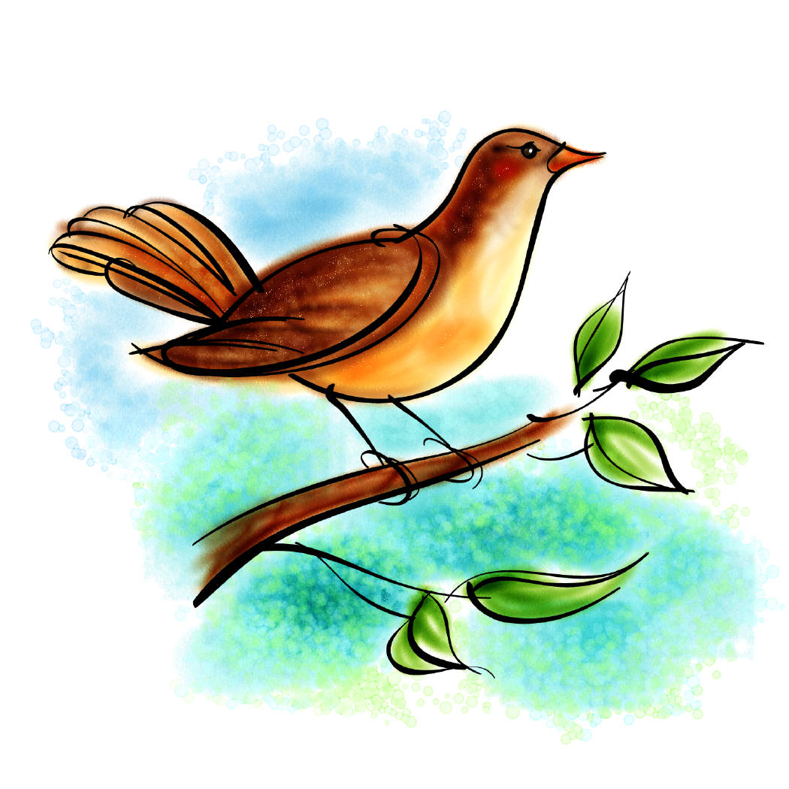
This is for the Birds!!

TYPE OF BIRD | Weight in Grams (g) | Wingspan in Centimeters (cm)
Barn Owl | 460 | 93
Pigeon | 370 | 70
Jay | 190 | 58
Woodpecker | 21 | 26
Turtle Dove | 180 | 55
Magpie | 250 | 60
Robin | 22 | 22
Mallard | 1500 | 98
Quail | 135 | 35
Buzzard | 1300 | 128
Raven | 1500 | 150
Hummingbird | 6 | 10

- Which bird weighs the most? _____________________________________________

- Which bird has the smallest wingspan? __________________________________

- Which bird has the largest weight to wingspan ratio? ________________________

- If an ostrich weighs 60,000 times more than a hummingbird, how much does it weigh? _______________________

- If the wingspan of an ostrich is 30 times more than a hummingbird, what is the wingspan of the ostrich? ___________________________

- Did you notice any patterns? If so, what were they?

- Did any of the following figures surprise you? If so, what were they?

- What is the range of the weight of the birds listed above? ___________________

- What is the mean of the wingspan of the birds listed above? ________________

- What is the median of the weight and wingspan for the birds listed above?
Weight = ______________ Wingspan = ____________________

