Problem 1 – Exponential Growth
When Connor was born, his parents put $1000 into an account to give him as a present on his 21st birthday. However, his parents forgot the yearly interest rate on the account.  The data (years and investment worth) is stored in L1 and L2 of your graphing calculator. | 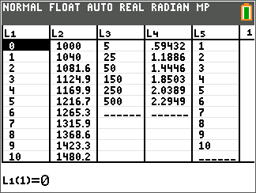
Create a scatter plot of the data by pressing y o [stat plot] Í matching the screen to the right.  To view the scatter plot, press q and select 9:ZoomStat.  It may be necessary to modify your viewing window if you wish to use the GridLine feature. Press p and change the value of Yscl: to 100. | 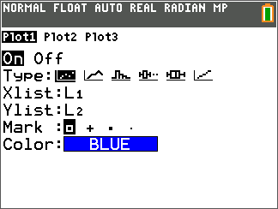
Using your knowledge of compound interest, study the data and the graph to determine a function for the growth of Connor’s money.
Enter your equation in Y1 and press s to check your result.

Note: The regressions can be found by pressing … and scrolling over to the CALC menu.

1. The equation for the data is: __________________________

2. What variable should be on the horizontal axis? Vertical axis?

3. How can you determine the interest rate for this growth?

Problem 2 – Logarithmic Growth
Scientists are testing the amount of greenhouse gases present at a research site near the north pole to determine the effect on polar ice melting. The results for a given area around the research site are stored in L3 and L4 of your graphing calculator. | 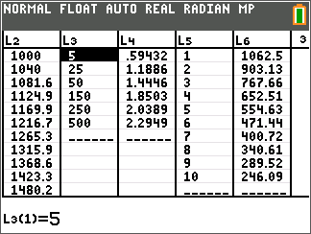
Create a scatter plot of the data by pressing y o [stat plot], selecting Plot 1 and pressing Í. Match the screen to the right.  To change the Xlist: and Ylist:, press y Â [L3] and y ¶[L4] respectively.  To view the scatter plot, press q and select 9:ZoomStat.  It may be necessary to modify your viewing window if you wish to use the GridLine feature. Press p and change the value of Xscl: to 50 and Yscl: to 0.25. | 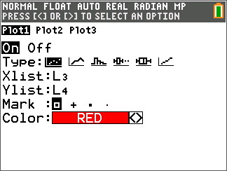
Determine a natural log equation to model the data by pressing …, scrolling over to CALC, and selecting 9:LnReg. | 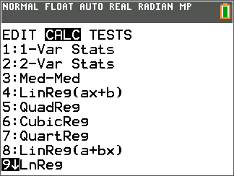
To finish the regression, enter L3, L4, and Y1 as shown on the screen to the right.  To enter Y1 on the Store RegEQ: line, press ½, arrow to the right to Y-VARS, choose 1: FUNCTION, and choose 1: Y1.  Select CALCULATE and press Í.  4. The equation for the data is: __________________________  Press s to view the scatter plot and regression equation both plotted. | 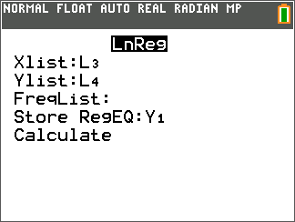
5. What variable should be on the horizontal axis? Vertical axis?

Problem 3 – Exponential Decay
Due to an environmental chemical spill, a farmer is losing the amount of land on which he can plant crops. The data in L5 and L6 of your graphing calculator show the year and amount of useable land for each year. Determine an equation that models the amount of land the farmer can use each year.
After creating a scatter plot of the data, use your graphing calculator to perform an exponential regression that models the data and plot the function by pressing s. Select appropriate Xscl and Yscl values.

6. The equation for the data is: __________________________

7. What is the number of acres the farmer started with in year zero?

8. By what percent does the amount of acres available decrease every year?

