Overview:
Students explore the circulatory subsystem within the heart by building a model of the human four-chambered heart. In addition to the biology concepts, students have an opportunity to build electrical circuits and use coding to write a simple program that blinks four LEDs in the order of the filling of each chamber. This project explores:  - the anatomy of the heart chambers.  - blood flow through the circulatory system.  - the calculation or pulse rate in beats per minute.  - writing a program to control the model.  - LED electrical circuits.  - material conductivity. |  | 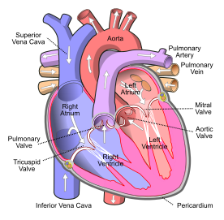 |  |  | 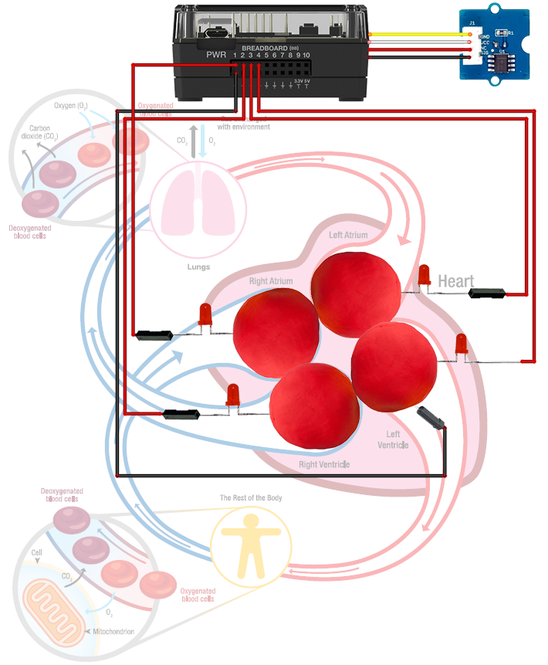
Possible NGSS topics to explore with the student
Disciplinary Core Ideas:  - MS-LS1-3 – Body is a system of interacting subsystems.  - MS-LS1-3 – Chemical reactions release energy as matter moves through the organism |  |  | Science & Engineering Practices:  - Developing and using models  - Constructing explanations & designing solutions  - Asking questions & defining problems |  |  |  | Crosscutting Concepts:  - Systems & System Models  - Cause & Effect  - Energy & Matter
Background:
The earliest and simplest forms of single-celled life developed metabolisms to conduct the molecular business of growth, repair, reproduction and energy harvesting. As single-celled organisms evolved into multicellular organisms, their body’s required a system to move metabolites among the many cells that were not in direct contact with their environment. A circulatory system, that is, a kind of plumbing, evolved to move metabolites into and out of the body and among all of the cells of the body.

The circulatory systems of multi-cellular organisms become increasingly sophisticated moving up the phylogenetic tree of evolution. Sponges (Porifera) rely on simple diffusion while jellyfish (Cnidaria) rely on body pumping for circulation. At some level of size and complexity, diffusion and body pumping are not sufficient to circulate the required metabolites through the organism. A dedicated circulatory system is required to move the body’s metabolites efficiently. A circulatory system needs a pump to push the fluid suspension of metabolites throughout the body. This pump is called a heart. The simplest heart is found in fish (ichthys); this heart has two chambers, an atrium, and a ventricle. One deficiency of the two-chambered heart is the mixing of oxygenated blood with unoxygenated blood. A more efficient and developed, the three-chambered heart is found in reptiles (turtles) with two atria and a single ventricle. The additional atria help to prevent the mixing of oxygenated blood with unoxygenated blood. The human (mammalian) four-chambered heart, two atria, and two ventricles are very efficient due to a complete separation of oxygenated blood from oxygenated blood within the organ.

The heart is a strong muscular organ which pumps blood through the body’s circulatory system. The human heart is located between the two lungs within the chest. The heart pumps blood with a rhythm, called the pulse, which is informed by the autonomic nervous system. When the flight or fight response occurs in our brain, such as when we are suddenly scared, our heart rate will rapidly increase and we can feel our heart pound within our chest. Normal resting is between 60 and 100 beats per minute or BPM.

When a person exercises, such as running, the autonomic nervous system raises the heart rate without the person’s conscious thought. The maximum heart for a young person is about 200; this maximum diminishes as a person ages. One measure of an athlete’s fitness is their cardiac output, which is the amount of blood they can circulate from the lungs to their muscles. Cardiac output is the product of the heart’s pulse rate by the heart’s stroke volume. An average person’s stroke volume is about 70 ml. One response to aerobic training is an enlargement of the stroke volume and the ability to maintain a fast heart rate. World-class aerobic athletes have large stroke volumes and can maintain fast heart rates for long periods, thus transporting large volumes of oxygen to their working muscles.

The function of the heart and lungs is to transport oxygen from the environment to the mitochondria within each cell of the body to oxidize the ingested sugar (glucose) from the digestive system to provide the energy required for life. When oxygen is breathed into the lungs, the oxygen diffuses into the blood’s red blood cells flowing through the high surface area alveolar bed within the lung. The oxygenated blood moves through the circulatory system to the high surface area capillary bed where the oxygen diffuses into the mitochondria within the cells to participate in metabolism. The flow of blood through the four chambers of the heart occurs in the following steps:

- Deoxygenated blood is returned from the body to the right atria through the vena calva.
- From the right atrium, blood flows to the right ventricle via the tricuspid valve.
- From the right ventricle, blood is pushed into the lungs for oxygenation via the pulmonary artery.
- From the lungs, the oxygenated blood is returned to the heart’s left atrium via the pulmonary vein.
- From the left atrium, the blood flows to the left ventricle via the mitral valve.
- From the left ventricle, the blood is pushed out to the capillary bed via the aorta.
Command Background:
Command | Example | Behavior
CONNECT LED <number> TO <bread board pin> | Send “CONNECT LED 1 TO BB1” | Associates an LED plugged into BB 1 on the Hub with a software object named LED 1.
CONNECT TEMPERATURE <number> TO <port> | Send “CONNECT TEMPERATURE 1 TO IN 1” | Associates a Grove temperature module plugged into port IN 1 on the Hub with a software object named TEMPERATURE 1.
SET LED <number> TO <state> | Send “SET LED 1 TO ON” | Switches the LED associated with the corresponding “CONNECT LED 1 …” command to ON. The state may also be OFF.
READ TEMPERATURE <number> | Send “READ TEMPERATURE 1” | Reads the grove temperature module associated with the corresponding “CONNECT TEMPERATURE 1 …” command in centigrade degrees. A Get command must immediately follow the READ command.
Get <variable> | Get t | Gets the value returned from the Hub from the previous READ command and stores the value into the variable named “t”.
SET SOUND <frequency in Hz> TIME <duration in Sec> | Send “SET SOUND 440 TIME 3” | Sets the speaker on the Hub to make a 440 Hz tone for 3 seconds.
eval(<variable>) | Send “SET LED eval(c) OFF” | Evaluates the variable named c and substitutes the value into the command string.
Supplies and Equipment:
- TI Nspire CX family calculator  - TI-Innovator Hub  - 4 x M/F Jumper Wires  - 1 x M/M Jumper Wires  - 4 x LED |  |  |  | - 4 x Toothpicks with labels  - 3oz. A conductive compound such as Play-Doh. Modeling clay or plasticine will not work  - Print of the Model Heart Build Sheet  - Grove Temperature sensor
Setup Project Model:
The four separate chambers of the heart are formed using Play-Doh. The heart’s blood flow is modeled using the Innovator Hub and four LEDs controlled by a TI-BASIC program.

The model should include these events:
- Unoxygenated blood flows into the right atrium via the superior vena cava.
- From the right atrium, blood flows to the right ventricle via the tricuspid valve.
- From the right ventricle, blood is pushed into the lungs for oxygenation via the pulmonary artery.
- From the lungs, the oxygenated blood is returned to the heart’s left atrium via the pulmonary vein.
- From the left atrium, the blood flows to the left ventricle via the mitral valve.
- From the left ventricle, the blood is pushed out to the capillary bed via the aorta.
- An indication of a heartbeat and the calculation of heart rate
The Student Activity | The Teacher Activity
Sit in small groups of 2-3 students with calculators and supplies for this activity. | Introduce the overall engineering goal of the project and how the model should represent some of the electrical aspects of the human heart. The project will be built stepwise with three student challenges. Discuss possible prototypes. Have students draw a picture of their prototype and describe how it will work. Share ideas with the class.
Challenge 1: Connect an LED to BB1 and blink at a rate of 2 Hz (flashes per second) for 10 seconds. | Guidance during challenge 1:  - Review concepts from 10 Minutes of Code for the Innovator Hub including the For-EndFor loop.  - Review the Mood Ring project as a basic example of feedback and control.  - Ensure students can identify the polarity of an LED.  - Demonstrate to students how to insert an LED into the receptacle of an M/F jumper wire. The anode (+) wire pin should be inserted into the BB 1, and the cathode (-) wire pin should be inserted into the ground hole.  - Show students how to open a new file and insert a program named “blink.”  - Demonstrate the code necessary to blink at 2 Hz (per second) for 10 seconds.  - Challenge students to blink the LED blink at a rate of 5 Hz for 20 seconds. |  |  |  |  | 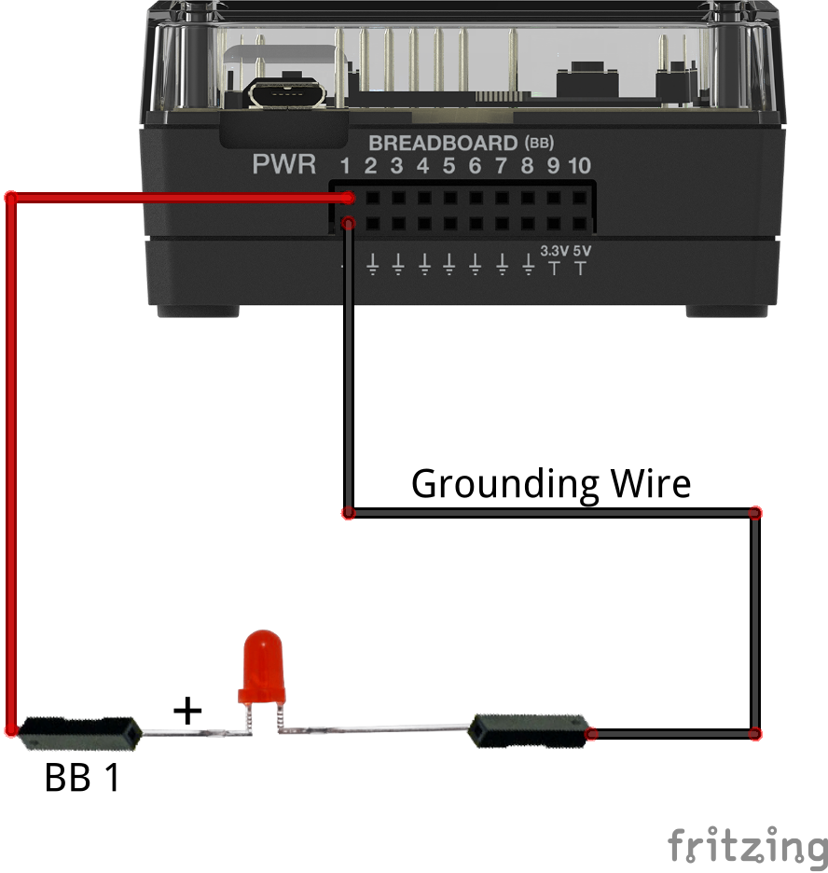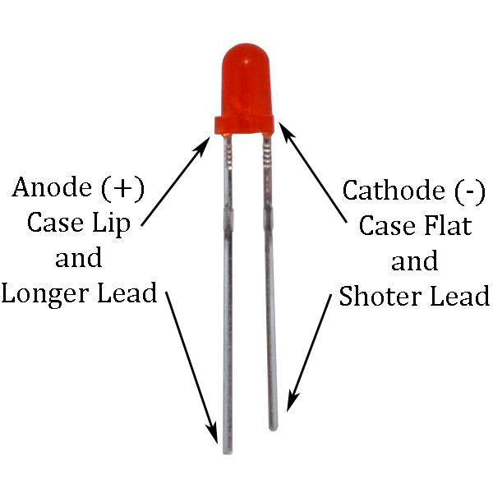  Send “CONNECT LED 1 TO BB 1”  For n,1,20  Send “SET LED 1 ON”  Wait .25  Send “SET LED 1 OFF”  Wait .25  EndFor
Challenge 2:  - Use four pieces of Play-Doh to model the four heart chambers.  - Place build sheet on the desk and place Play-Doh pieces on sheet.  - Label each piece of Play-Doh with the appropriate chamber name.  - Add three additional LEDs to the Hub connected to BB 2 thru BB 4.  - Insert the negative lead of each LED into each piece of Play-Doh.  - Add a single grounding wire from any of the pieces back into any ground on the BB connector of the Hub.  - Write a program to blink the four LEDs in sequence 1,2,3,4. Be sure to model the blinking order to match the blood flow order. The right atrium fills first while the left ventricle fills last.  - Add a beep to your program to sound like an EKG machine after each cycle of the heart. For example, the program should run for at least 30 seconds.  - What would you change in the program to speed up or slow  down the flashing? Calculate the “heart rate” for this program.  - What happens when you separate the chambers? Can you explain your observation? | Guidance during challenge 2:  - Be sure students insert the LEDs correctly with the polarity identified in the previous diagrams.  - Discuss the requirement that each LED object 1-4 has a CONNECT command to a unique BB pin.  - Discuss the concept of nested loops (loop within a loop).  - Be sure the two loops have different index variables.  - Notice the use of the eval() statement; this substitutes the value of the variable into the Hub command.  - The sound command should be short. Have students explore frequencies and durations to produce the desired effect.  - The “Heart Rate” of the model can be calculated from the code and expressed in Beats Per Minute (BPM):  - The inner “For” loop cycles four times for every heartbeat.  - There are two “Wait” of .075 seconds per cycle.  - The period for one heartbeat of the model is:  2 x 4 X .075 = 0.6 seconds/beat.  - Heart rate is the reciprocal of heartbeat period or 1/.6 = 1.67 beat per second.  - Convert heart rate from units of beats per second to units of beats per minute.  - Example calculation:  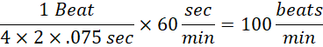 |  |  |  |  | 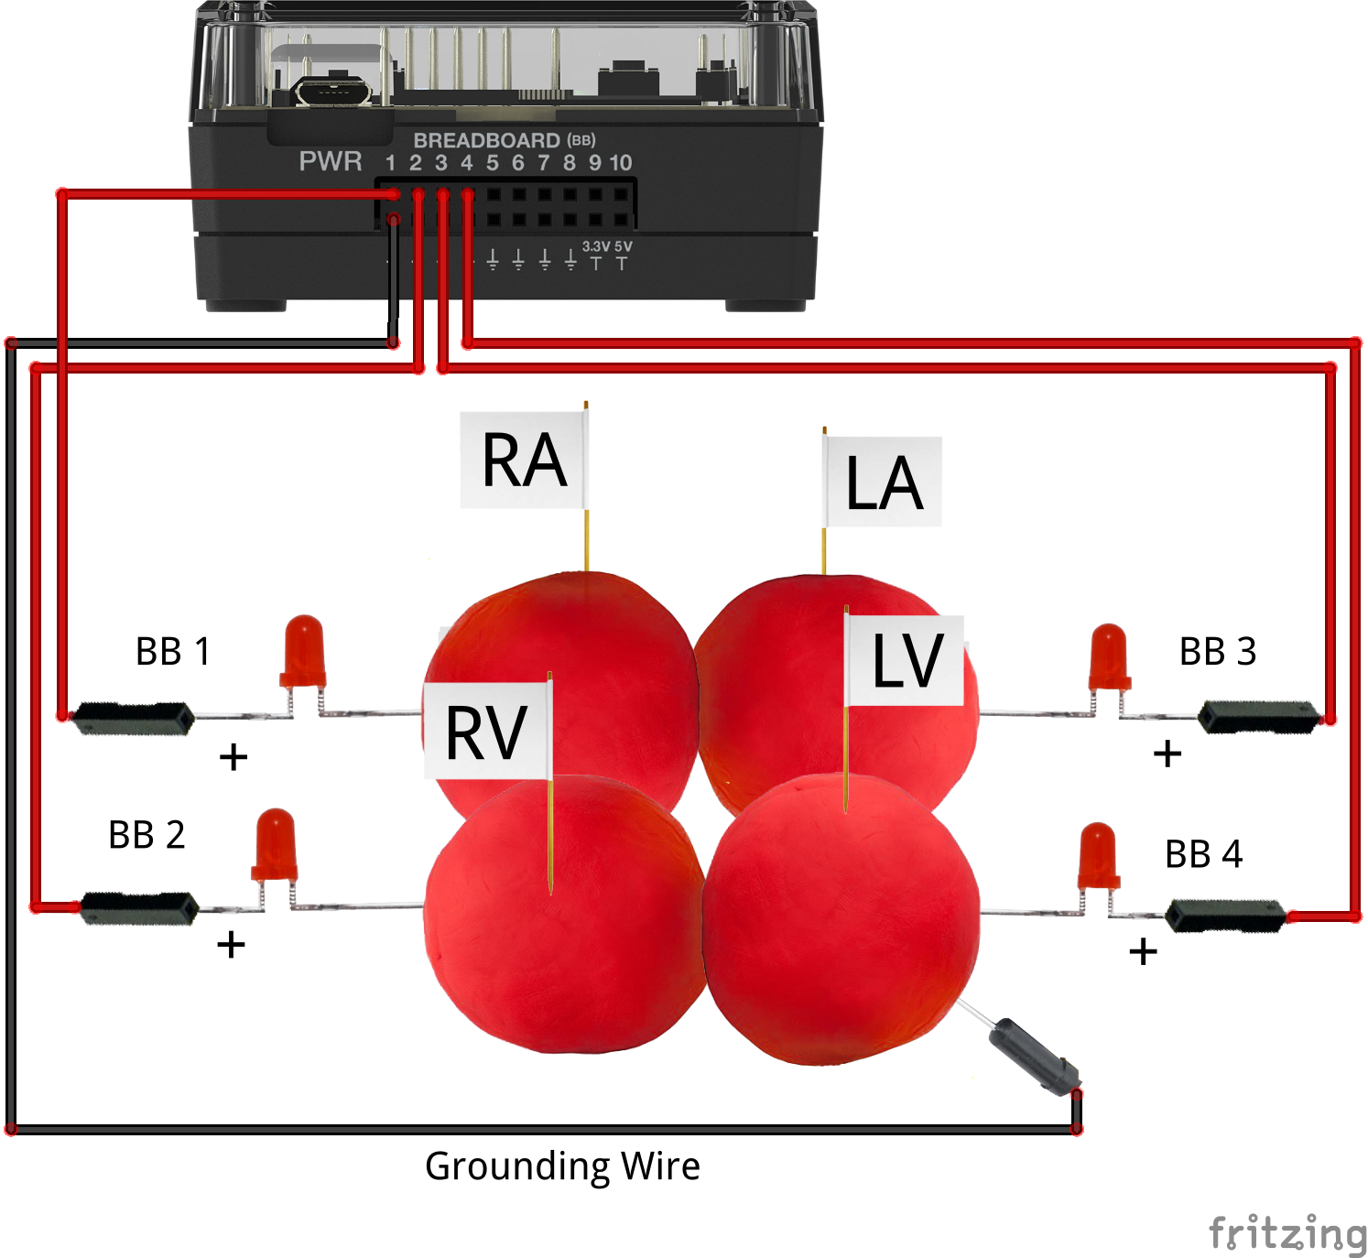  Send “CONNECT LED 1 TO BB 1”  Send “CONNECT LED 2 TO BB 2”  Send “CONNECT LED 3 TO BB 3”  Send “CONNECT LED 4 TO BB 4”  For n,1,30  For c,1,4  Send “SET LED eval(c)ON”  Wait .075  Send “SET LED eval(c)OFF”  Wait .075  EndFor  Send “SET SOUND 440 TIME .1”  EndFor
Challenge 3: The autonomic nervous system controls the human heart rate. When frightened, we do not need to think to make our heart beat faster. When our body becomes overheated, our heart rate elevates to try to cool us.  Use the Grove temperature sensor to modify the heart rate of the model. Change the program from Challenge 2 such that when body temperature goes up, heart rate goes up. | Guidance during challenge 3:  - Insert a Grove temperature module into IN 1 on the Hub  - CONNECT the TEMPERATURE 1 object to IN 1.  - Use a While-EndWhile loop to run the model indefinitely until the escape key is pressed to quit.  - Use the getKey() function to poll the calculator keyboard. Store the returned key press into a variable named key. Be sure to initialize the variable named key to enable the While loop to run initially.  - READ TEMPERATURE 1 each cycle of the While loop.  - Use a variable called “period” that programmatically changes the duration of the wait.  - Use an If-EndIf decision structure and the measured temperature to set the wait period.  - What are the symptoms of heat stroke? How does heart rate help the body to cool? |  |  |  |  | 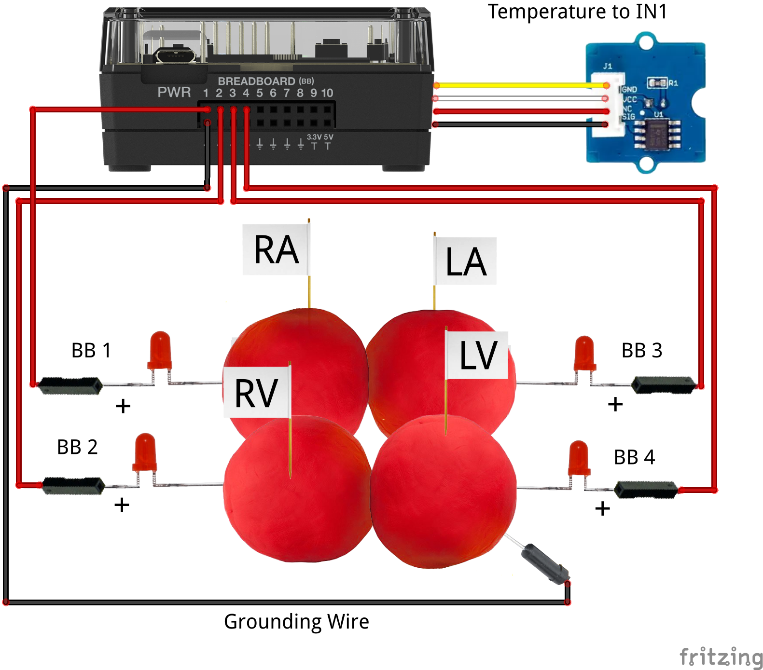  key:=""  Send "CONNECT LED 1 TO BB1"  Send "CONNECT LED 2 TO BB2"  Send "CONNECT LED 3 TO BB3"  Send "CONNECT LED 4 TO BB4"  Send "CONNECT TEMPERATURE 1 TO IN 1"  DispAt 8,"Press the [esc] key to quit"  While key≠"esc"  Send "READ TEMPERATURE 1"  Get t  If t≤27 Then  period:=0.15  Else  period:=0.05  EndIf  For c,1,4  Send "SET LED eval(c) ON"  Wait period  Send "SET LED eval(c) OFF"  Wait period  EndFor  bpm:=((1)/(2*4*period))*60  DispAt 3,"Temperature =",t  DispAt 4,"Heart Rate =",bpm,"BPM"  Send "SET SOUND 440 TIME .1"  key:=getKey()  EndWhile

