Overview: | AP Computer Sceience Principles Computational Thinking Practices:
Build a flippy do and slip it over your TI-RGB Array to explore base two numbers using the manipulatieve. Write a TI-BASIC program to abstract a representation of a decimal number in a binary format on the TI-RGB Array. | - LO 2.1.1 – Describe the variety of abastractions used to represent data.  - LO 2.1.2 – Explain how binary sequences are used to represent digital data.  - LO 2.2.1 – Develop an abstraction when writing a program or creating other computational artifacts.
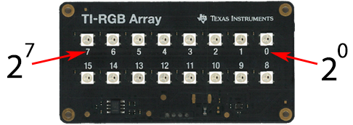  The TI-RGB Array can be used as a binary display. Notice the numbering of the pixels is in place value order. A pixel that is on represents the digit 1 while off represents the digit 0. | An example of the decimal number 13 displayed on the TI_RGB Array with the coresponding calculation.  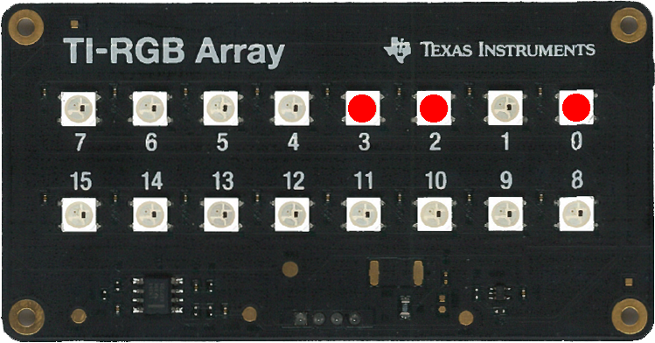  1x2³+1x2²+0x2¹+1x2⁰=13
Directions:
- Follow the instructions on the printout to Build you Flippy-Do.  - Slide the Flippy-Do on the TI-RGB Array.  - Fold the tabs up or down to match the binary number in the table.  - Fill in in the remainder of the table on the right. Do you see a pattern?
  Decimal | 4–bit binary number | Pixel 3 | Pixel 2 | Pixel 1 | Pixel 0
  0 | 0000 | off | off | off | off
  1 | 0001 | off | off | off | on red
  2 | 0010 | off | off | on red | off
  3 | 0011 | off | off | on red | on red
  4
  5
  6
  7
  8
  9
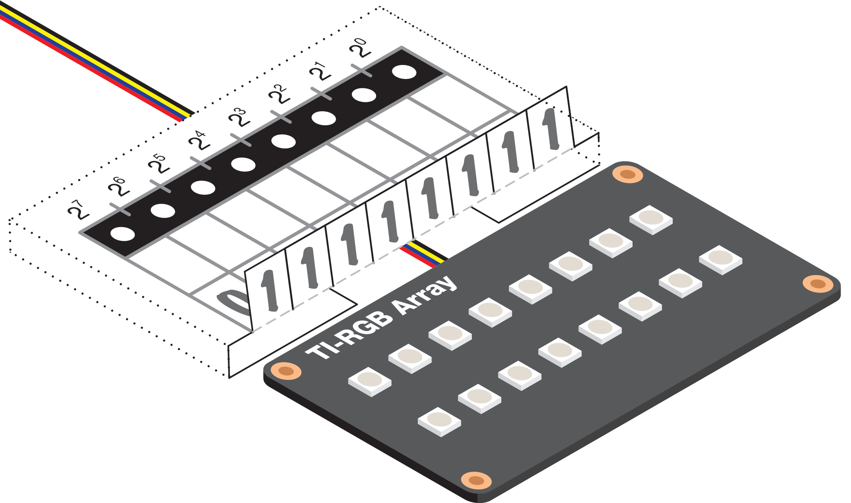
  Decimal | 4–bit binary number | Pixel 3 | Pixel 2 | Pixel 1 | Pixel 0
  10
  11
  12
  13
  14
  15
The table to the right contains every 8-bit number that has a single 1 in it. Do you notice a pattern?  - Fill out the remainder of the table writeing down the power of two and the decimal equivalent next to each binary number.
  Decimal | 8-bit binary number | Power of 2
  1 | 0000 0001 | 2⁰
  2 | 0000 0010 | 2¹
  4 | 0000 0100 | 2³
   | 0000 1000
   | 0001 0000
   | 0010 0000
   | 0100 0000
   | 1000 0000
Challenge 3:  - Write a program to turn on the TI_RGB Array for the number 13 and display the calculated decimal value as the sum of powers of 2³ through 2⁰.  - Set the tabs of the Flippy-Do up or down for the number 13. Run the program. Do the pixels on the TI_RGB Array match the number on the Flippy-Do?  - Modify your program to match a few more numbers from the table. Do you see how the TI_RGB Array can display binary numbers?  Challenge 3 Optional Extension: Try to represent the decimal 170 as an eight bit binary number. |  | Define c2()=  Prgm  Send "CONNECT RGB "  Send "SET RGB 0 255 0 0"  Send "SET RGB 1 0 0 0"  Send "SET RGB 2 255 0 0"  Send "SET RGB 3 255 0 0"  decimal:=1*2³ + 1*2² ⁺0*2¹ + 1*2⁰  Disp "Decimal = ",decimal  EndPrgm

