Making Music with Code
You will write a TI-BASIC program on your calculator to create sounds using the built-in speaker on the TI-Innovator Hub. You will also experiment with changing the length of time in which each sound plays. Once you have some experience, you will write a program to play a song. | 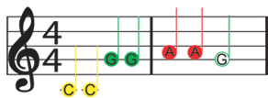  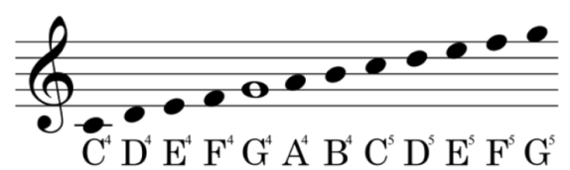  Treble clef scale with notes from C4 to G5  First notes of “Twinkle, Twinkle, Little Star”
Your Challenge:  Find the sheet music for a simple song and write a program to play the song on the TI-Innovator Hub. | Activity Materials:  - TI-84 Plus CE calculator  - TI-Innovator Hub  - Unit-to-unit cable
88 Key Piano Keyboard with Frequencies
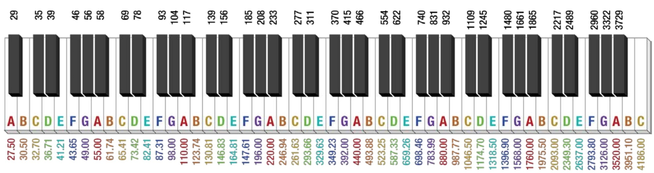
Frequencies (in Hertz...Hz) are listed below the white keys and above the black keys. For example, A0 is equal to 27.5 Hz while A4 is equal to 440 Hz. Notes start from A0 and go to C8 from left to right. Notice that as you move from left to right, each frequency for a note (B for example) roughly doubles. B0 is 30.50 Hz while B1 is 61.74 Hz and B2 is 123.74 Hz and so on.

Music Concepts | Explanation
Musical Scale | Music is arranged with symbols on a “scale”. We use a scale since the notes are divided by “octaves”. An octave represents eight steps between the equivalent note that is at either double or half the frequency. For example, A4 is 440 hertz (Hz), while A5 is 880 Hz (twice the value of A4), while A3 is 220 Hz (half of A4).
Beats per minute/Tempo | Have you ever noticed how some songs are slow while others are fast? Every song has its own “tempo” or speed. The speed is determined by the number of “beats per minute”. A slow song may have 50 beats per minute while a faster song may have 100 beats per minute.
Quarter, half, and whole notes  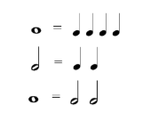 | - Notes can be shorter or longer depending on the song. One way for a musician to write a song with notes of different durations is to use whole notes, half notes, quarter notes, eighth notes, and sixteenth notes.  - One whole note equals four quarter notes or two half notes. One half note is equal to two quarter notes and so on.  - For a song that has 4-4 measures, it means that each measure of the song has 4 beats. A whole note would be equal to 4 beats (hence, one measure).  - How many half notes could fit into a 4-4 measure? If you said two, you are correct! Since each half note is equal to two beats and there are four total beats per measure, two half notes are equal to four beats.  So now you can see how a song with 100 beats per minute will have faster whole notes than a song with 50 beats per minute! Not all whole notes equal the same time duration!
Application of notes and beats per minute | Twinkle, Twinkle, Little Star is a song that has multiple notes and uses 4-4 time. Try to code this song with your calculator.

Projects Challenges
Challenge 1: Create a program called “C1”. Set the speaker on the Hub to play a tone of 440 Hz. Try several different tones. What is the lowest tone you can hear? What is the highest tone that you can hear?

Challenge 2: Create a program called “C2”. Make a door bell using any key press on the calculator to ring the chime.

Challenge 3: Write a program called “C3” that plays the Major C scale from C4 to C5. Each note should be played for a variable length of time using a variable named D (for duration).

Challenge 4: Create a program called “C4”. Make a metronome that: plays 10 beats with a tone of middle C4 with a duration of a ¼ note at 100 Beats per minute. To do this you will need to determine the how long a quarter note is (in seconds) based on the information above.
A rest of .1 seconds should be used between beats.
Try a double time tempo of 200 BPM.
Try using a 1/2 or whole note.

Create tables to convert notes to duration and frequency.
Challenge 5: Create a program called “C5”. Use the sheet music for Twinkle to play the first two bars of the song on your Hub.

Create tables to convert notes to duration and frequency.
Challenge 6: Create a program called “C6”. Use two lists with frequencies and durations and a loop to play the same Twinkle song.

Final Challenge: Find the sheet music for a simple song and play it on the Hub.

Example Programming Commands for the project
Example Code | Behavior
Send(“SET SOUND 440 TIME 4”) | Plays a 440 hertz tone on the speaker for 4 seconds
Output(3,1,”FREQUENCY(HZ)= ”)  Output(3,17,F) | When variable F has a value of 440, the following line is displayed on the calculator: FREQUENCY(HZ) = 440
For(N,1,10)  End | Runs the statements within the For/End loop 10 times
440→N  Send(“SET SOUND eval(N)”) | When eval is used within a Hub command, the variable value is inserted into the Hub command. In the example, the value 440 is stored to variable N. The next command is evaluated as Send(“SET SOUND 440” )and a tone is played on the Hub.
Wait 2 | Causes program execution to halt and wait for two seconds.
”NEXT COMMAND PLAYS C4“ | Quotes without a preceding command in a TI-84 Plus CE program can be used as a comment. A comment is meant to leave notes within the program for easier navigation later or to let the user know what the following line of code is used for. Comments are ignored when the program is run.

Calculator Notes:
- Press the [prgm] key to see a menu option for creating a new program.
- Press the [prgm] key to see a menu option for selecting programs to edit.
- While in the Program Editor, press [prgm] key to see menu items for programs.
- While in the Program Editor, press [alpha] [f5] to see editing options.
- While in Program Editor, use 2nd Left Arrow and 2nd Right Arrow to jump your cursor to the beginning and end of the line.
- Press [2nd] [quit] to leave the Program Editor and return to the home screen.
- While on the home screen, Press the [prgm] key and select the execution menu option for selecting a program names to paste to the home screen.
- While on the home screen, Press [enter] to run a program named on the home screen.
- The Home Screen “remembers” the last command entered. Press Enter after a program has run to run the program again.
- To stop (“break”) a running program press and hold the ON key until you receive a dialogue box.
- To stop (“break”) a program press and hold the ON key until you receive a dialogue box.

