Overview: |  |  | Objectives:
Teams are challenged to drive their Rover as close as they can to a toy dog without hitting the dog. Teams are free to investigate the motion of their Rover before the competition. During the competition, the organizer places the dog at a random distance in front of the team’s start line. The team is then free to measure the distance to the dog and use that value to calculate the drive time to program into their Rover. The closest team wins! |  |  | Students will:  - Investigate distance, time, and rate(speed).  - Utilize proportional thinking to solve a problem.  - Make measurements with appropriate units. |  | 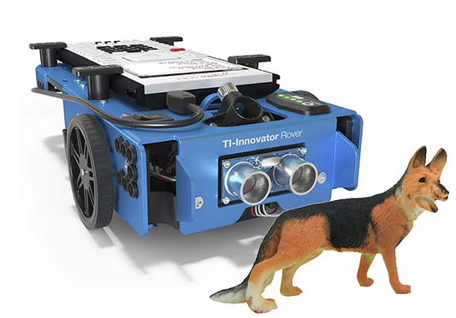
Background:
The TI-Rover is designed with built-in sensors to assist in driving with a constant speed in a straight line. The Rover has many drive commands that allow the user to enter many combinations of distance, direction, speed, and time. Also, the Rover can turn any angle and keep track of its location on an internal coordinate plane. If the Rover is on a surface that is not level or has inconsistent surface friction, the drive commands may produce unpredictable results. During this activity, only one drive command with variable time is allowed, and that time is predicted using previously measured time/distance data pairs.
Command Background:
Command | Example | Behavior
import <module> as <name space> | import ti_rover as rv | Imports the required ti_rover module into the Python program. Importing this module is required for all TI-Rover programs. The module provides the methods for controlling the Rover. Note: The name space “rv” is required and should not be changed.
rv.forward_time(<seconds>) | rv.forward_time(5) | Drives the Rover forward for five seconds at the default speed.

Supplies and Equipment per Team:
- TI-84 Plus CE Python  - Unit to Unit cable  - TI Innovator Hub  - TI Rover | - Metric tape measure or stick  - Masking tape  - Small plastic dog ~3” in height  - Optional small dry erase board and marker
Project Setup:
- Place participants into small groups of two, three, or four with a single Rover and calculator.
- The group is encouraged to ideate a clever team name. Team names are the tiebreaker during competition.
- Each team uses a piece of masking tape as a starting line for all measurements and the competition.
- Teams are encouraged to keep a detailed log of time vs. distance measurements of their Rover.
- Teams are free to use any method of analyzing the data and making their time prediction to avoid hitting the dog.
- Before announcing the winner, each team makes a brief presentation about how they predicted the time. A dry-erase board may be useful.
- The instructor is encouraged to acknowledge all successful methods of analysis with no particular “correct” method. Alternative thinking is encouraged.
- In the event of a tie, the team name should be used to break the tie.
The Student Activity: |  | The Teacher Activity:
Teams work in a flat, smooth area with about three meters of free space. Place a piece of tape at one end and write “START”. The Rover should be aligned with the “START” tape each time the Rover drives. |  | Work with the groups to find a clear, smooth space where the group will not be disturbed by the other groups. Help participants to lay out a course with a piece of tape labeled “start” and with a clear 2.5 meters in front of the Rover. If you use tables, be sure to remind participants to not drive off the edge.
Challenge 1 Program a time of your choosing (between .5 and 15 seconds) into the Rover. Run the program and measure the distance it travels from the “START” position. Record the time and distance in a data table — repeat measurement for at least five different times. |  | Guidance during challenge 1: Ensure participants understand the “START” position and alignment of the Rover with the tape. The Rover uses the axle as the zero for internal calculations. However, this is not required so long as participants are consistent in their technique. |  | import ti_rover as rv  rv.forward_time(5)
Challenge 2: When your team is confident of making a prediction, raise your hand, and the instructor will place the dog at a random position in front of your car. You may measure the distance to the dog. You have only one try to test your prediction to get as close as you can to the dog without touching it. |  | Guidance during challenge 2: It is important to manage the event schedule to provide time for each team to compete. Allow at least 5 minutes per team. You will need to estimate on-the-fly how much time to allow teams to prepare to allow sufficiently for the competition and the optional post-competition discussion. |  | Judging Tips: Consistency is the rule. If the rover tips the dog at all, this is considered a knock-down. Of course, the organizer is always free to make their own rules. Remember participants will find every way to game the rules!
Reflection: Your team will make a brief presentation on your solution. You should include your mathematical reasoning for determining the time and a concept from physical science that you considered or experienced. |  | What math concepts were used to make your prediction?  - Guess and check  - Proportional thinking  - Rate = distance/time  - Average of many trials  - Piecewise functions  - Regression analysis  - Points on a number line  - Scalar/vector values |  | What concepts from physical science were considered as you explored Rover’s motion?  - Friction  - Acceleration  - Weight on an inclined plane  - Initial and final positions and change in position  - Displacement vs. distance  - Velocity vs. speed  - Average vs. instantaneous velocity

