Mars Challenge: | Goals:
Navigate the shortest path around Olympus Mons. Be sure to avoid the obstacles placed on the mat. Place your rover at the “start” aligned with the 0◦ direction. You may use a ruler to measure segment lengths and a protractor to measure angles. These scaled values are used to write a program on a calculator connected to TI-Innovator™ Rover. Test your course and program on the drive mat that is setup on the floor of the classroom. | You will:  - plot a course on the student map using a ruler and protractor to navigate around Olympus Mons.  - use proportional reasoning to convert student map distances into scaled drive distances.  - use your scaled map measurements to write a TI-BASIC program on your calculator.  - test and refine your program by driving a TI-Innovator™ Rover on the Olympus Mons drive mat.
Background:
Orienteering is a navigation skill that uses several tools to identify the shortest path from one point to another, often while avoiding obstacles in the terrain. Some of these orienteering tools include a terrain map, protractor, and ruler. Most maps have a scale and compass rose printed in the corner. The scale is a proportion factor that converts a distance measured on the map to the distance in the actual terrain. Similarly, the compass rose is a diagram on the map that indicates the true north direction in the actual terrain. A skilled person with a scaled map and proper tools can lay a course on that map and use it to navigate the course on the terrain. In this activity, the drive mat represents the “actual terrain” while the student map is the “scaled map”.
Directions:
Find the scale of the student map.
- Measure the width of the Olympus Mons drive mat in the unit of meters and record the value in the table below.
- Measure the width of the Olympus Mons student map in the unit of centimeters and record the value in the table below.
- Calculate the scale of the student map using the formula below.
- Design a path around the volcano that avoids the marked obstacles. Use a ruler and pencil to draw that path of line segments onto the student map.
- Use a protractor to measure the exterior angles that are needed for Rover to turn from one line segment to the next along your path. You may find it helpful to extend the path line beyond the turning point to aid in measuring the exterior angle.

Example exterior angle measurement:

- Measure each path segment in cm and record in the table; use the map scale to calculate the distance the Rover must drive on the Olympus Mons drive mat.
58◦
Example calculation: a drive segment may be 6 centimeters and the student map scale may be .04m = 1 cm (this is an example only. You must find the actual scale using your own calculations and measurements), find the drive distance in meters:

$$6cm×\frac{.04m}{1cm}=.24m$$

- Write a TI-Innovator Rover program that drives each segment in the path.
Example: Send ("RV LEFT 58")
Send ("RV FORWARD .24 M)
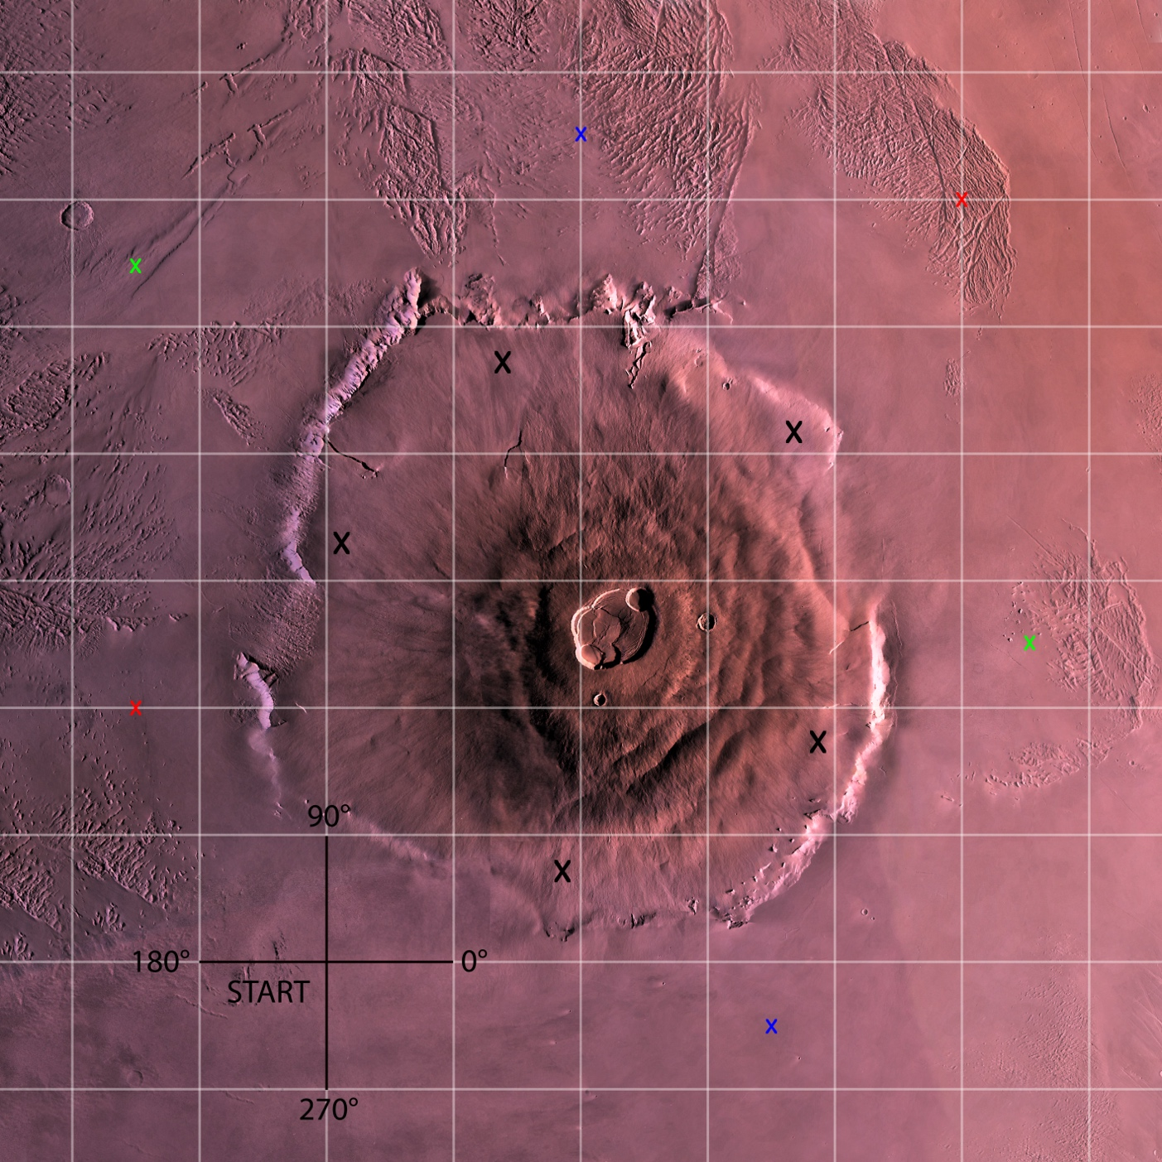
Note: Use Black X’s. Color X’s are for Unit 2 Mineral Challenge
Drive Mat width: ____________________ meters (m)
Student Map width: ____________________ centimeters (cm)
Scale (Drive Mat Width ÷ Student Map Width): __________ meters/centimeter
Segment | Angle (degrees) | Turn Direction  (L/R) | Student Map Length  (cm) | Scaled Drive Mat Length  (m)
1
2
3
4
5
6

