Directions: Use the Hub and other simulations to find the RGB values that make the colors of the Mood Ring. Fill the values into the chart and the code.

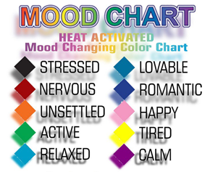 | Color RGB Value  Black 0 0 0  Red  Orange  Green  Turquoise  Cyan  Blue  Pink  Yellow  Purple | If t<24 Then  Send "SET COLOR 0 0 0"  DispAt 5,"You are STRESSED"  Elseif 24≤t<25 Then  Send "SET COLOR _ _ _"  DispAt 5,"You are NERVOUS"  Elseif 25≤t<26 Then  Send "SET COLOR _ _ _" DispAt 5,"You are UNSETTLED"  Elseif 26≤t<27 Then  Send "SET COLOR _ _ _"  DispAt 5,"You are ACTIVE"  Elseif 27≤t<28 Then  Send "SET COLOR _ _ _"  DispAt 5,"You are RELAXED"  Elseif 28≤t<29 Then  Send "SET COLOR _ _ _"  DispAt 5,"You are LOVEABLE"  Elseif 29≤t<30 Then  Send "SET COLOR _ _ _"  DispAt 5,"You are ROMANTIC"  Elseif 30≤t<31 Then  Send "SET COLOR _ _ _"  DispAt 5,"You are HAPPY"  Elseif 31≤t<32 Then  Send "SET COLOR _ _ _"  DispAt 5,"You are TIRED"  Elseif t≥32 Then  Send "SET COLOR _ _ _"  DispAt 5,"You are CALM"  Endif
Directions: Use colored pencils that match the mood color to draw in the inequalities used in the code above.

