Challenges:
  Challenge 1: Use the rv.color_rgb() function to explore using the color LED. Try to find RGB values for the primary and secondary colors.
  e.g. rv.color_rgb(255,155,0) will make yellow.
  Challenge 2: Use the text_at() function to display your name at several locations on the screen.
  Challenge 3: Have Rover drive 5 units forward. Use the rv.waypoint_x() function to read and display Rover’s horizontal position when Rover is finished driving.
  Challenge 4: Use a While loop to turn on the LED red, then green, then blue each for 1 second until the escape key is pressed.

Challenges:
  Challenge 5: Have Rover drive 5 units forward. Predict the amount of time for Rover to reach 4 units and read Rover’s position at that time. If the value returned is equal to 4 turn the LED green, if the value returned is less than 4 turn the LED red, and if the value is greater than 4, turn the LED blue.
  Challenge 6: Have Rover drive on the number line between 0 and 10. While Rover is driving, read its position and control the LED so that the LED displays colors corresponding to the number line diagram below.
  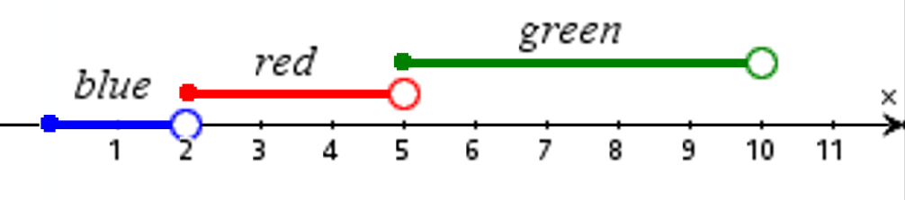
  Challenge 7: Have Rover drive on the number line between 0 and 10. While Rover is driving, read its position and control the LED so that the LED displays colors corresponding to the number line diagram below.
  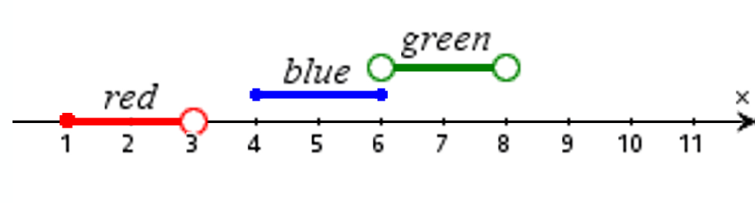
  Challenge 8: Have Rover drive on the number line between -10 and 10. While Rover is driving, read its position and control the LED so that the LED displays colors corresponding to the description below.
  - While Rover’s position is less than or equal to zero, the LED is magenta.
  - While Rover’s position is greater than 0 and less than 2, the LED is off.
  - While Rover’s position is greater than or equal to 2 and less than or equal to 4, the LED is red.
  - While Rover’s position is greater than 4 and less than 5, the LED is blue.
  - While Rover’s position is greater than or equal to 5 and less than 10, the LED is green.
  - While Rover’s position is greater than or equal to 10, the LED is yellow.

