Challenges:
  Challenge 1: Use rv.forward_time(T,S,”unit”) to have Rover drive the path described by the graph below.
  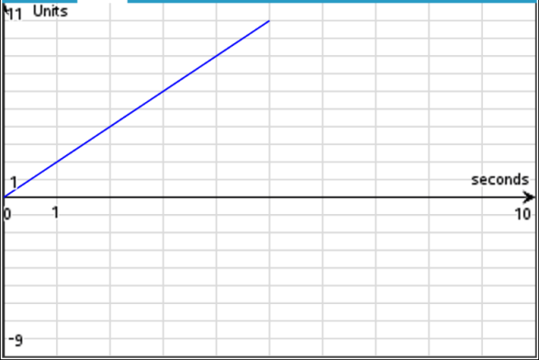
  Challenge 2: Use rv.forward_time() and rv.backward_time() or rv.forward() and rv.backward() with distance and speed options to have Rover drive the path described by the graph below.
  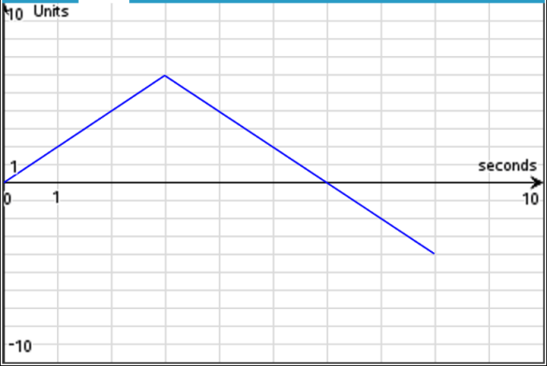
  Challenge 3: Use the rv.forward_time() , rv.backward_time(), rv.stay(), and rv.position() functions to have Rover drive the path described by the graph below.
  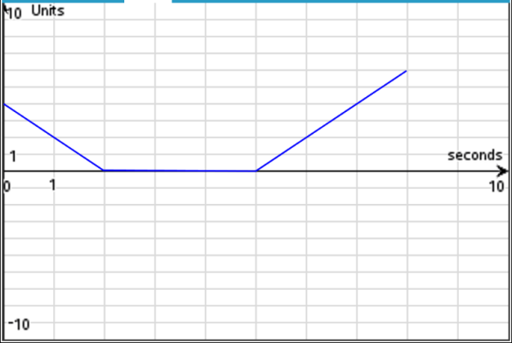
  Challenge 4: Use the rv.forward_time() , rv.backward_time(), rv.stay(), and rv.position() functions to have Rover drive the path described below.
  Rover starts at 3 units to the right of zero. Rover drives backward at 2 units per second for 3 seconds. Rover stops and stays for 2 seconds, then drives forward at 2 units per second for 1.5 seconds.
  Challenge 5: Have Rover drive the path described by the graph and table below. Use the rv.forward_time(), rv.backward_time() and rv.stay() functions.
  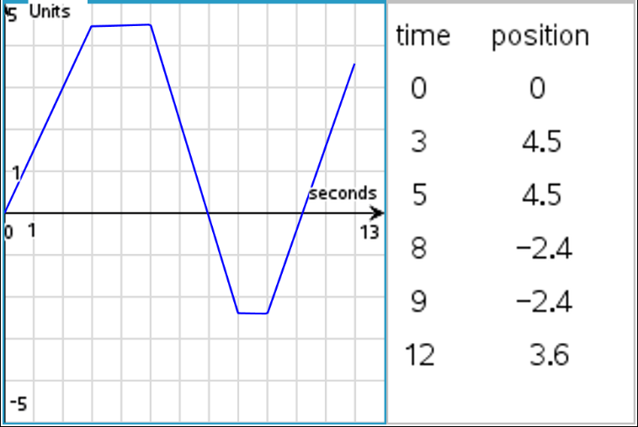
  Challenge 6: Have Rover drive the path described by the graph and table below and on page 6.2. Use the rv.forward_time() , rv.backward_time() and rv.stay() functions. Assume Rover starts at position zero.
  Note: The graph is of velocity vs. time.
  