Lesson Overview
In this lesson, students focus on how the mean can be described as the balance point for the distribution of a set of data. |  |  | Learning Goals
- Identify the mean as the balance point of a distribution;
- find and interpret deviations from the mean as a way to measure the spread of a distribution;
- describe why it is necessary to average the sum of the absolute deviations.
 | The mean is the balance point of a data distribution of data as well as a center of the distribution.
Prerequisite Knowledge |  |  | Vocabulary
Mean as a Balance Point is the fifth lesson in a series of lessons that investigates the statistical process. In this lesson, students calculate deviations from the mean, how far each value is above or below the mean. Students also focus on the balance point of a distribution, where the sum of the absolute deviations below the mean is equal to the sum of the absolute deviations above the mean. Prior to working on this lesson students should have completed these lessons: Median and Interquartile Range, Box Plots, and Mean as Fair Share. Students should:  - understand and be able to find the median, quartiles, and interquartile range of a set of data;  - understand and be able to interpret box plots;  - understand the concept of mean. |  |  | - mean: the sum of all the data values in a set of data divided by the number of data values.  - deviation: how far a value is above or below the mean.  - Mean Absolute Deviation (MAD): the mean of the absolute values of all deviations from the mean of a set of data.
Lesson Pacing
This lesson contains multiple parts and can likely be completed in 2 class periods.

Lesson Materials
- Compatible TI Technologies:
TI-Nspire CX Handhelds, TI-Nspire Apps for iPad®, TI-Nspire Software
- Mean as a Balance Point_Student.pdf
- Mean as a Balance Point_Student.doc
- Mean as a Balance Point.tns
- Mean as a Balance Point_Teacher Notes
- To download the TI-Nspire activity (TNS file) and Student Activity sheet, go to http://education.ti.com/go/buildingconcepts.
Class Instruction Key
The following question types are included throughout the lesson to assist you in guiding students in their exploration of the concept:
 Class Discussion: Use these questions to help students communicate their understanding of the lesson. Encourage students to refer to the TNS activity as they explain their reasoning. Have students listen to your instructions. Look for student answers to reflect an understanding of the concept. Listen for opportunities to address understanding or misconceptions in student answers.
 Student Activity: Have students break into small groups and work together to find answers to the student activity questions. Observe students as they work and guide them in addressing the learning goals of each lesson. Have students record their answers on their student activity sheet. Once students have finished, have groups discuss and/or present their findings. The student activity sheet can also be completed as a larger group activity, depending on the technology available in the classroom.
 Deeper Dive: These questions are provided to facilitate a deeper understanding and exploration of the content. Encourage students to explain what they are doing and to share their reasoning.

Mathematical Background
In the previous lesson , students investigated the concept of mean or average as a “fair share,” used a leveling-off strategy, and then developed the formal algorithm—finding the sum and dividing by the total number of values—to calculate what a “fair share” would be. As noted in Lesson 2, Median and Interquartile Range, measures of center and spread are both important in telling the story in the data. In this lesson, attention shifts to the spread around the mean, which is typically measured in terms of how far the data values deviate from the mean. Students calculate how far each value is above or below the mean and use these deviations from the mean as the first step in building a measure of variation based on the spread around the mean. The sum of the deviations is always zero, but the sum of the absolute values of the deviations (sometimes referred to as SAD) produces a positive sum of deviations. The average of the sum of the absolute mean deviations, which is called the mean absolute deviation or MAD, is one way to characterize the spread of a data distribution that is useful in comparing distributions. In analyzing distributions of data, students consider the interval defined by one MAD above and below the mean or mean +/- MAD. Exploring variation with the MAD sets the stage for introducing standard deviation in high school.
The second part of the lesson explores the notion of mean as the balance point of a distribution. The total distances (deviations) on each side of the mean “balance” each other; i.e., the sum of the absolute deviations below the mean is equal to the sum of the absolute deviations above the mean. This suggests the mean is the balance point of a data distribution of data as well as a center of the distribution.

Part 1, Page 1.3
Focus: Students will explore deviation by creating different distributions of numbers of goals.  On page 1.3, dots representing the goals scored in a tournament by nine soccer teams are plotted on a number line. Be sure students notice the total number of goals in the top left corner of the page. Students can grab and drag the dots to any integer position between and including 0 and 10 on the number line. | 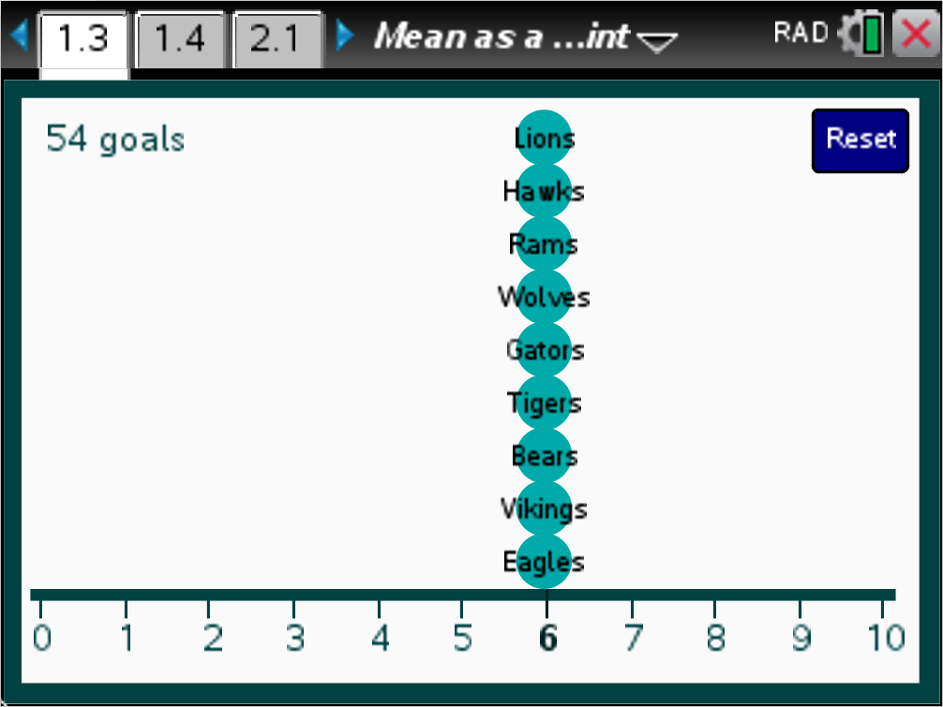
 |  |  | TI-Nspire Technology Tips
e selects dots to be moved by the arrow keys.
/. returns the graph to its original position.
Students should note how the total number of goals in the top left corner of the page changes to reflect the new positions of the teams on the number line.
Teacher Tip: The first two questions provide students with the background needed for the third question. Be careful that the discussion doesn’t get caught up in the nature of the tournament.
Class Discussion
In the following questions, two teams are considered evenly matched if they score the same number of goals for a given number of games. Each dot in the plot on page 1.3 represents a team in the tournament. The horizontal axis represents the number of goals each team scored in the tournament.
- How many teams were in the tournament?
Answer: 9 teams
- Explain what the graph tells you.
Answer: The plot displays what the number of goals scored by each team in a league might look like if the teams were evenly matched. Nine teams each scored six goals.
- Create a distribution of the number of goals scored in the tournament so the total number of goals is the same as the original goal count on page 1.3 and every team scored at least one goal.
Answers will vary. There must be nine scores that total to 54. One possible example would be: 2, 3, 4, 4, 6, 7, 8, 10, 10.

Class Discussion (continued)
- Were any of the teams evenly matched during the tournament? How do you know?
Answers will vary. Based on the example above, yes, those scoring the same number of goals would be evenly matched. Two teams had 4 goals, and two teams had 10 goals.
- Was the tournament “fair”? Explain your reasoning.
Answers will vary. Possible response using the example above: The tournament was not fair because the numbers of goals the teams scored were far apart—from 2 and 3 to 10, so the teams as a whole were not evenly matched. Other students might suggest that any tournament is fair—having teams evenly matched is not important.
Students should work in pairs or small groups. Select some subset or all of the tasks in the question and have a pair or group answer the question for the distribution of that data. Groups do not need to do more than one of the tasks. Students should show their solution on the TNS activity and, if possible, project all of the different solutions for the entire class to see. This can be done using screen capture with TI-Nspire Navigator or another screen-capture device. If none of these are available, give students post-it notes and a sheet of large poster paper with a number line like the one on page 1.3. Have them make a dot plot of their distribution on the poster paper and display it at the front of the room. Add the original distribution from page 1.3 to those being displayed.
Student Activity Questions—Activity 1
1. Create a distribution of the number of goals each team scored so that the total number of goals remains 54, and the following conditions hold: Each of the teams scored at least 1 goal, no team scored more than 10 goals during the tournament, and you know that:
Select one of the following conditions (or your teacher will assign):
- One team scored 6 goals, and another team scored 9 goals.
Possible answer: The number of goals per team could be: 3, 4, 4, 4, 6, 8, 8, 8, 9 (deviation 18).
- Two teams scored 10 goals.
Possible answer: The number of goals per team could be: 2, 2, 5, 5, 5, 7, 8, 10, 10 (deviation 22).
- No team scored 6 goals, and one team scored 3 goals.
Possible answer: The number of goals per team could be: 3, 4, 5, 5, 5, 7, 8, 8, 9 (deviation 16).
- Three teams scored 1 goal; at least two teams scored 9 goals.
Possible answer: The number of goals per team could be: 1, 1, 1, 8, 8, 8, 9, 9, 9 (deviation 30).
- No team scored 6 goals; three teams scored 1 goal.
Possible answer: The number of goals per team could be: 1, 1, 1, 2, 9, 10, 10, 10, 10 (deviation 38).

Student Activity Questions—Activity 1 (continued)
- Two teams scored 6 goals; two teams scored 8 goals.
Possible answer: The number of goals per team could be: 4, 4, 4, 6, 6, 7, 7, 8, 8 (deviation 12).
- Two teams scored only 1 goal; three teams scored 10 goals.
Possible answer: The number of goals per team could be: 1, 1, 2, 6, 6, 8, 10, 10, 10 (deviation 28).
Class Discussion (continued)
Have students inspect all of the plots, and then pose the question:
- Rank the distributions in the order of the most evenly matched to the least evenly matched.
Answer: Answers will vary. From the example answers in question one the order based on SAD is
f, c, a, b, g, d, e.
Teacher Tip: Allow students some time to do this, monitoring what the groups are discussing. Some may think that the distributions where the teams are most evenly matched are those with two or three teams that have the same number of goals; ask them about the other teams – remind them that the task is to look for distributions where most of the scores seem about the same. Others may suggest distributions that seem to bunch around the middle. Push students to figure out how they would rate the tournaments in some consistent way in order to rank the tournaments. Note that some may not recognize that 6 is the mean number of goals for each of the distributions. You might have students verify this.
Looking at how the teams bunch or cluster is a start, but one question is how to discriminate between distributions that have somewhat the same shape. Some students may try adding and get a total of 54 and then dividing by 9 to get a “center” total of 6; which will be true for all of the distributions. The task is to find a way to measure the spread of the number of goals in a distribution from a mean of 6. A helpful hint might be to ask how many steps (two steps to the right of 6 would be 8) a given number of goals is away from the mean. Eventually, some groups will suggest finding the steps away from 6 for each team, i.e., the difference between the number of goals each team scored and 6, the number each team would have if they were evenly matched.
After students have been working and determined some strategies for ranking, have them explain their approaches. You might want to have the groups thinking about the number of steps from 6 that share last place. Depending on your focus, you can introduce the concept of absolute value or you can just refer to distance as always being positive. If you choose to consider absolute value, discuss the differences, , where x_{i} is the number of goals scored. Note that the differences are positive when and negative when . Have students add these for their distributions and discover that all of the sums are 0. Someone may suggest or you might have to bring up the idea of absolute value as a way to manage the negative values and get an absolute sum of the distances. This value is called the sum of the absolute deviations (SAD).

Student Activity Questions—Activity 1 (continued)
2. a. Write a description of what you learned by doing and discussing the task in question 1:
Possible response: To find how evenly matched a set of teams are, you use the mean number of goals the teams scored and then figure out how far off the number of goals each team scored is from the mean. If you add all of these distances, using positive distances, you get a way to describe how the number of goals spread around the mean. Then you can rank the distributions according to these numbers, and the one with the smallest sum is the one that has a distribution of the most evenly matched teams.
b. If you used your method on a distribution that has all of the teams scoring six goals, what would be the sum of the distances from the mean? Explain why your answer makes sense.
Answer: The sum of the distances from the mean would be 0, which makes sense because all of the teams scored 6 goals.
Part 2, Page 1.4
Focus: Students explore the concept that the mean is the balance point of a distribution and develop the concept that the sum of the absolute deviations for values below the mean is equal to the sum of the absolute deviations for values above the mean.  The fulcrum can be moved by grabbing and dragging the fulcrum itself. | 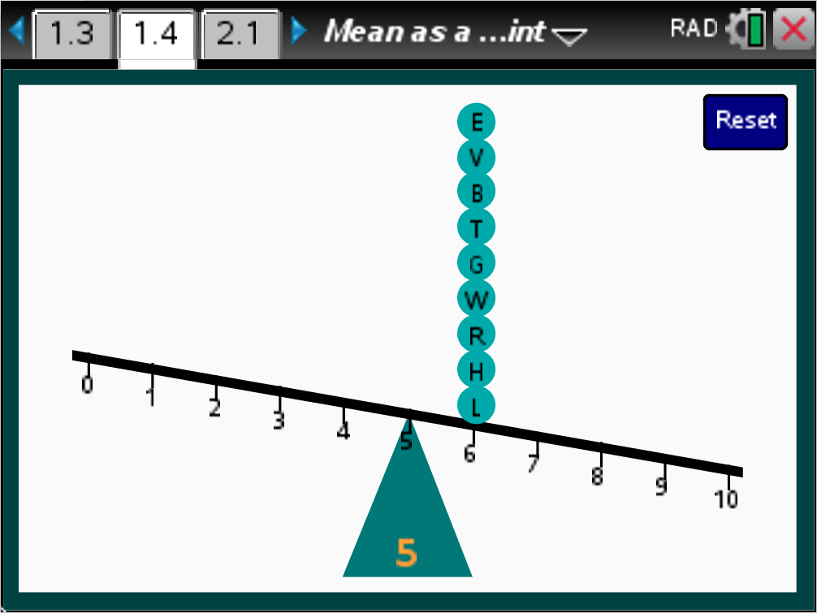
 |  |  |  | TI-Nspire Technology Tips
e toggles through the dots and fulcrum to be moved by the arrow keys.
/. returns the graph to its original position.
The dots can be moved to any integer location on the number line. When the dots are balanced, an arrow appears on the fulcrum.
Reset to return to the original screen.
Class Discussion
Have students… |  | Look for/Listen for…
On page 1.4, move the fulcrum to 6. Move one of the dots to 2 and one of the dots to 1.
- Describe what happened to the visual representation of the distribution. |  | Answer: The number line tipped with the side having the dots at 1 and 2 lower.
- Is the mean still 6? Why or why not? |  | No; Answers will vary. The mean is not 6 because if you did a “fair share,” you would have to take from the remaining sixes to make up for the 1 and 2. Another way to think is to find the total number of goals, which is 45 and divide by the 9 teams to get a mean of 5 goals per team.

Class Discussion (continued)
- Keep the two dots at 2 and 1. Find at least two ways to move some of the remaining dots to keep the mean number of goals at 6. (Leave at least 1 dot at 6.) Describe each of the distributions for the number of goals per team you found. | Answers will vary. Those that are correct should compensate for the 9 steps to the left of the mean created by the dots at 1, which is 5 to the left, and 2, which is 4 to the left, by totaling 9 steps to the right of the mean. For example, 3 dots at 7, 1 at 8, and 1 at 10 will make 9 steps to the right and give a distribution of 1, 2, 6, 6, 7, 7, 7, 8, 10.
- Move one more dot from 6 to 3. Use the TNS activity to figure out how you could adjust your distribution so the mean number of goals remains 6. | Answers will vary. You would have to move dots to total 3 more steps to the right. For the example above, you could move the remaining 6 to 9 and for 1, 2, 3, 7, 7, 7, 8, 9, 10.
On page 1.4,
- Move the dots to balance the number line when the fulcrum is at 5. | Possible answer: 1, 2, 3, 4, 6, 6, 6, 8, 9. Some students may suggest all of the dots at 5. Be sure to acknowledge this as one good answer and then ask for other distributions.
- Suppose the dots on the number line represented the number of pencils nine people in class have. Use the values in your distribution to find the “fair share” – the number of pencils each would have if they shared equally. Explain how you found your answer. | Possible answer: If you put all of the pencils together, you would have 45 pencils. There are 9 people so each would have or 5 pencils.
- Find the absolute sum of the deviations from 5 for your distribution. | Possible answer using the example above: 20.
Student Activity Questions—Activity 2
1. Without having any more than three of the dots at the same place, move the dots to balance the number line when the fulcrum is at 8.
a. Make a conjecture about what the fair share would be, and then check your work.
Possible answer: One distribution might be 5, 6, 6, 8, 9, 9, 9, 10, 10. The fair share would be 8. The sum of the values is 72, and dividing by 9, gives 8.
b. What is the sum of the absolute deviations from the balance point?
Possible answer based on the example above: 14.
2. Check your work for question 1 using page 1.4.

Part 3, Pages 2.2 and 2.4
Focus: Students use the mean absolute deviation to describe the typical deviation of data values from the mean of all the values.  Pages 2.2 and 2.4 work in the same way as page 1.4.  Add Data allows from one to five other values to be added to the distribution.  Reset returns the graph to its original position. | 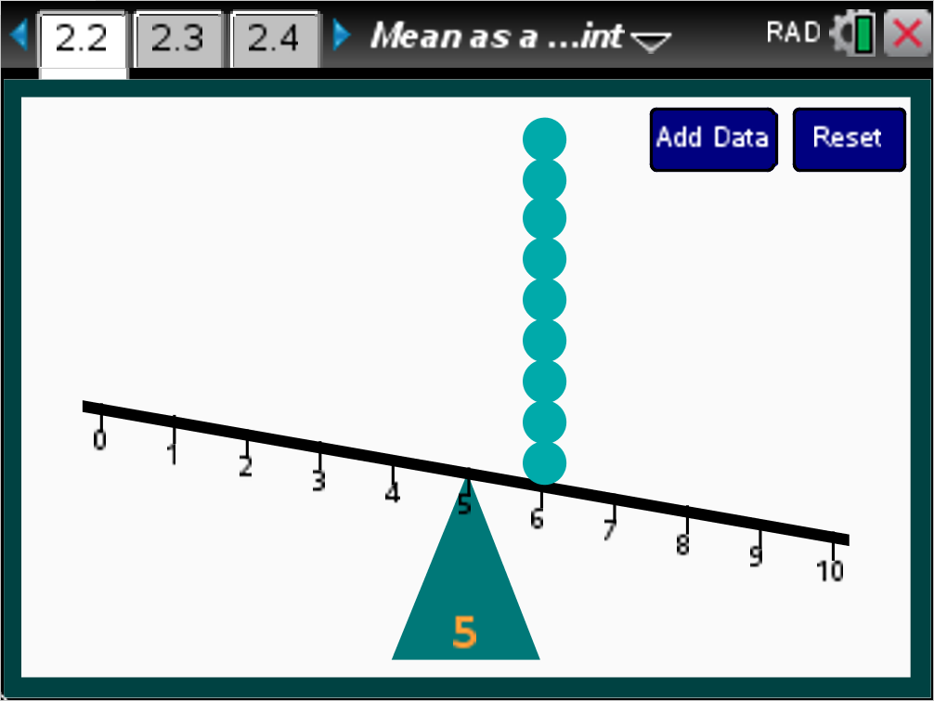
 |  |  |  |  | TI-Nspire Technology Tips
e toggles through the dots and fulcrum to be moved by the arrow keys.
· adds a value to the distribution.
b accesses page controls on page 2.4
/. returns the graph to its original position.
Page 2.4 displays two fulcrums, with the active fulcrum indicated by a grey line. | 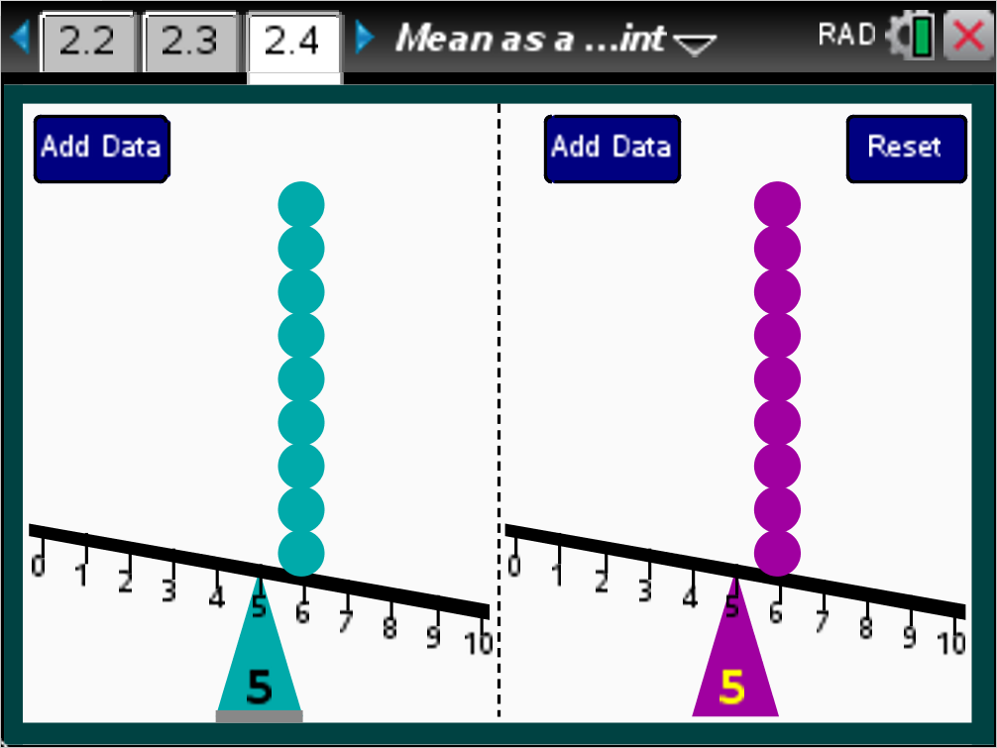
Class Discussion
Have students… |  | Look for/Listen for…
Think about the tournament again where the mean number of goals scored per team is 6.
- Use the TNS activity to create a distribution that keeps the mean at 6 and has two teams that scored 4 goals and 3 teams that scored 9 goals in the tournament. |  | Possible answer: 1, 4, 4, 5, 6, 7, 9, 9, 9.
- What is the sum of the absolute deviations for your distribution? |  | Possible answer based on the example above: 20.
- Suppose instead of 9 teams there were 11 teams in the tournament, but the mean number of goals scored per team remained 6. Use Add Data to add two more teams to the distribution. Create a distribution, with the mean at 6, with two teams that scored 4 goals and 3 teams that scored 9 goals in the tournament. Find the sum of the absolute deviations for your new distribution. |  | Possible answer: 2, 3, 4, 4, 5, 6, 7, 8, 9, 9, 9 with the sum of absolute deviations of 24.

Class Discussion (continued)
Teacher Tip: The following question is an important problem to discuss. Because the number of teams is different in the two cases, the SAD is not useful—the SAD increases if the team added has a number of goals that is different than the mean. This presents the need to find the mean of the absolute deviations in order to compare spreads, giving rise to the Mean Absolute Deviation (MAD).
- Which of the distributions of the number of goals, from the questions above, is closer to having evenly matched teams? Explain your reasoning. | Answer: You cannot just use the two sums, 20 and 24 to say that the distribution with the sum of 20 is closer to having evenly matched teams than the other distribution because the number of teams is different. You need to take the average of the deviations to be able to compare. So, is while is . Two copies of is less than 2 copies of (i.e., ); the average or mean absolute deviation is smaller for the distribution for 11 teams, so those teams are closer to being evenly matched than the nine teams in the first distribution.
Use page 2.4 in the TNS activity. The average of the sum of the absolute deviations is called the mean absolute deviation or MAD. The MAD is useful for measuring the spread of a distribution around the mean. Consider a tournament with 10 teams and another one with 12 teams, both having 6 as the mean number of goals scored.
- Create a distribution for each team and find the MAD for your two distributions. | Answers will vary.
- Which tournament has the most evenly matched teams? Explain your reasoning. | Answers will vary. The one with the smallest MAD will indicate the least amount of spread of the number of goals from 6 so that tournament would have the most evenly matched teams.
- Compare your distributions and MADs with your classmates. Rank the distributions in terms of the spread, from distributions with the least to the most spread as measured by the MAD. | Answers will vary.

Student Activity Questions—Activity 3
1. Use one of the pages from the activity to create a distribution where the MAD is:
a. 1
Answers will vary. One example is 10 values with a mean of 5, with five 4s and five 6s: 4, 4, 4, 4, 4, 6, 6, 6, 6, 6.
b. 5
Answers will vary. One example is to have 10 values, with five at 0 and five at 10.
c. 0
Answers will vary. One example is to have 10 values all at 10.
2. Which of the statements below are true? Explain your reasoning.
a. The larger the MAD, the smaller the spread of a distribution.
Answer: False, because a large MAD indicates that the typical or average distance of the data from the mean is large.
b. If the MAD is small, the values in the distribution are relatively clustered around the mean.
Answer: True, because it means the average distance of the data away from the mean is relatively small.
c. The mean is a point at which the values in a distribution below the mean “balance” the values in the distribution above the mean in terms of distance from the mean.
Answer: True, the sum of the absolute deviations from the mean of the data below the mean is equal to the sum of the absolute deviations from the mean of the data above the mean.
d. If the mean is 5, then a deviation from the mean of 2 would indicate the value is at 7.
Answer: False, the point 3 would also have an absolute deviation of 2 from the mean.
3. The MAD is often described as the typical distance of a data value from the mean. This is the interval between the mean minus the MAD and the mean plus the MAD, i.e., mean +/- MAD.
a. If the mean is 5 and the MAD is 2, describe the interval 1 MAD from the mean.
Answer: One MAD from the mean would be the interval from 3 to 7.
b. If one MAD from the mean is the interval from 5 to 11, what is the mean? The MAD? Explain how you found your answer.
Answer: The mean will be 8 and the MAD will be 3 because the interval is 6. The mean is exactly in the middle of the interval, so 3 up from 5 and 3 down from 11, which gives you 8.

Part 4, Pages 3.2–3.3
Focus: Students use meanMAD to compare spreads.  Mean displays the mean of each distribution.  MeanMAD displays the mean and mean absolute deviation of the distributions. | 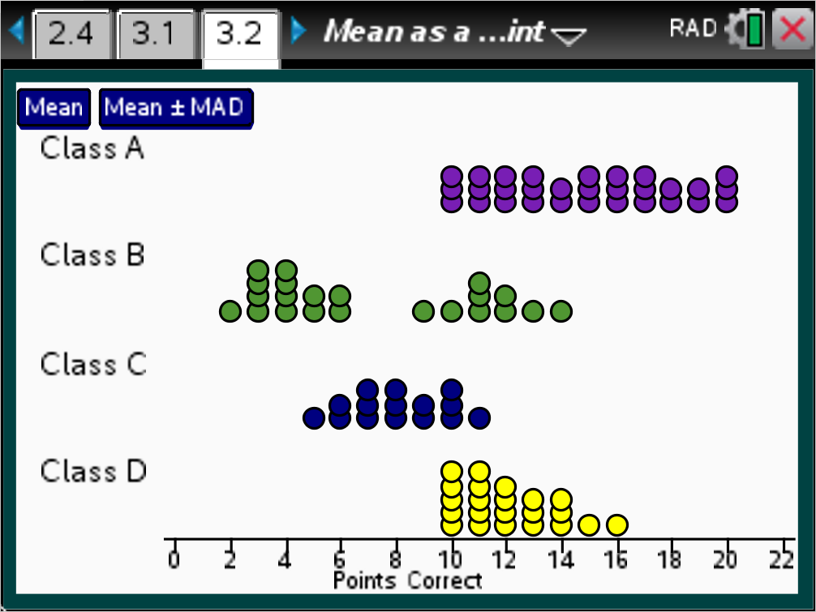
 |  |  | TI-Nspire Technology Tips
e selects mean and meanMAD.
· toggles on and off mean and meanMAD.
b accesses page controls.
/. Resets the page.
Menu> Data displays four sets of classes with different distributions of the number of correct points.  New Data displays sets of four classes with randomly generated distributions of the number of correct points on page 3.3. | 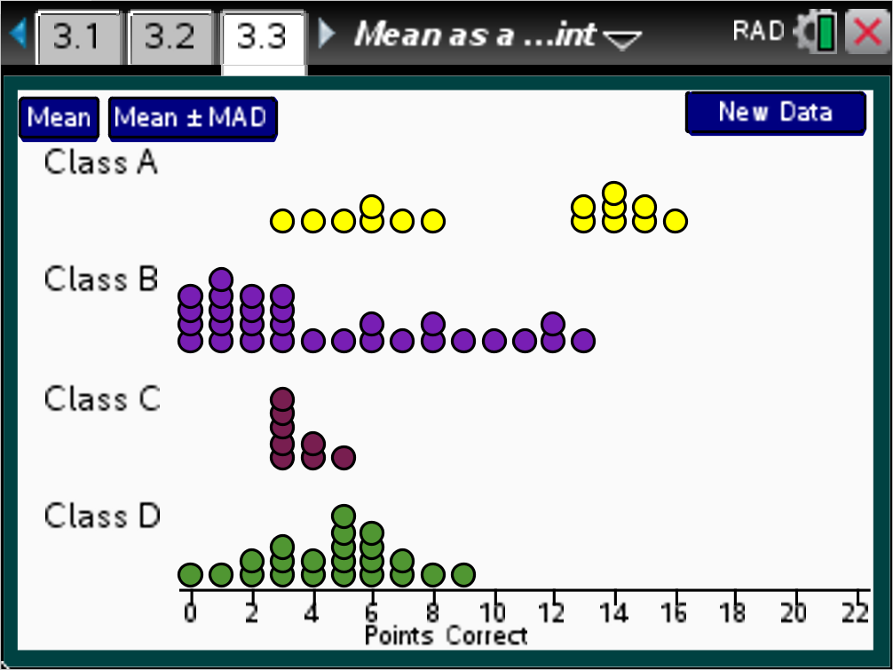
Class Discussion
Page 3.2 shows the number of points correct on a 20-point test for four different classes.
- Which of the classes do you think had the largest mean? The smallest? The largest spread around the mean as defined by the MAD? The smallest? Explain your reasoning.
Answers will vary. Students might make the conjecture that Class A had the largest mean because the distribution of the number of points correct is the farthest to the right; Class C the smallest mean because the distribution of the number of points seems farthest left. Class A or B, the largest MAD because they had the largest spread, and Class C the smallest because the spread was so small.
- Think of the mean as the balance point of the distribution of the number of correct points. Estimate the mean and the MAD for the number of correct points for each class.
Answers will vary.
- Check your answers using the TNS activity. What is the mean and MAD for Class D?
Answer: The mean is 12 points correct and the MAD is 1.4.
- Were any of your estimates far off? If so, explain what might have misled you.
Answers will vary. Students might have estimated the mean incorrectly for B because the distribution is bimodal but more of the points are to the left.
Reset the page and choose Data Set 2, which shows the distribution of the number of correct points on the test from four classes from another school. Answer the first three questions from this Class Discussion for the new data set.
Answers will vary. Students may not estimate the means correctly for Classes A, B and C because of the skewed distributions.
Student Activity Question—Activity 4
1. Reset and choose Data Set 3 for the number of correct points for students in four classes from a different school. Rank these classes in terms of the number of correct points. Give reasons for your ranking.
Answers will vary. Class A would seem to have the highest mean number of correct points, around 15. The ranking would seem to be A, B, D, C. Class D had the smallest spread with a MAD of 0.9, but overall the scores were lower than those in Class A or Class B. Over half of the students in Class C scored lower than nearly all of the students in Classes A or B.
Deeper Dive – Page 1.3

Return to page 1.3. Move the dots to display each of the distributions below. Then estimate to the nearest whole number, what you think the mean will be.
- 1, 3, 6, 6, 7, 7, 8, 8, 8
Possible answer: Mean is about 6.
- 5, 6, 6, 7, 7, 7, 8, 8, 9
Possible answer: Mean is about 7.
- 1, 2, 2, 2, 2, 2, 5, 5, 6
Possible answer: Mean is about 3.
- 1, 1, 2, 4, 4, 6, 8, 8, 8
Possible answer: Mean is about 5 (4.7).
Deeper Dive – Pages 2.2 and 2.3

Create the following distributions, and then estimate the mean and the MAD.
- 1, 1, 10, 10, 10, 10, 10, 10, 10
Answer: The mean is 8, and the MAD is about 3 ().
- 6, 6, 7, 7, 8, 8, 9, 9, 10, 10
Answer: The mean is 8, and the MAD is or 1.2.
- 6, 7, 7, 8, 8, 8, 9 ,9, 10
Answer: The mean is 8, and MAD is.

Deeper Dive – Page 3.3

- Generate random sets of classes until you have four classes where at least two distributions are relatively symmetric. Sketch the distributions and describe the relationship between the means and your estimate for the medians.
Answers will vary, but in general the means and medians should be relatively close. In the example below, Class A is symmetric and the mean is 8.8 and median is close at 8.5. Class B is relatively symmetric and the mean is 9.7 and the median is 10.
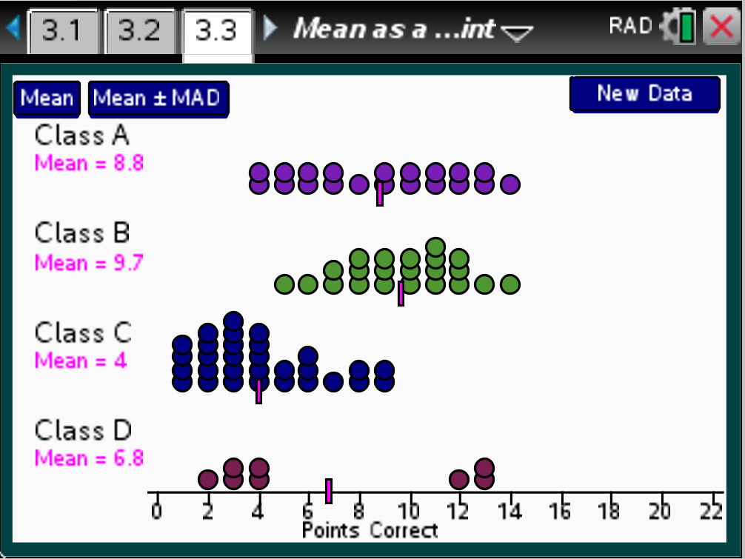
- Generate random sets of classes until you have four classes where the distributions of the number of points correct show at least two skewed distributions. Sketch the distributions and describe the relationship between the mean of each and your estimate of the median for each.
Answers will vary. One example is below, where the distribution of points for Classes B and D are skewed right. The mean of Class B is 3.3, which is larger than its median, 2. In Class D, the mean is 7.8 and the median is smaller at 7. In Class A, there are too few points to describe the overall shape since moving one or two points could change the description. Class C is fairly symetric somewhat skewed. The mean is 8.9 and the median is 9.
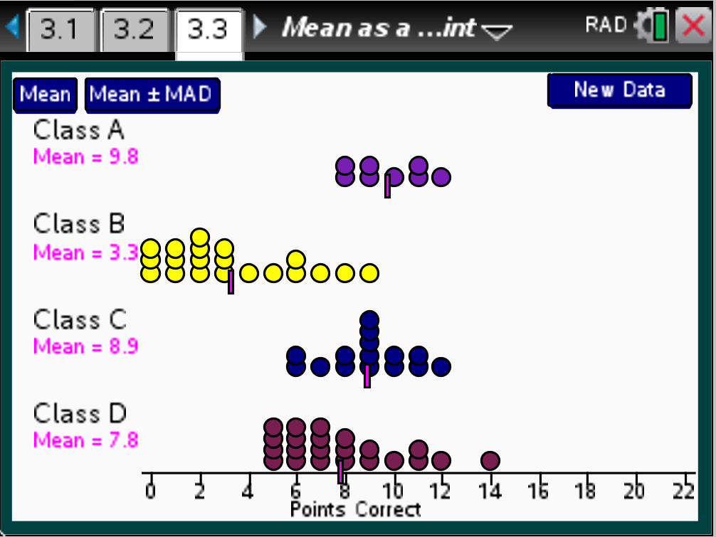

Deeper Dive – Page 3.3 (continued)

- Make a conjecture about the relationship between the tails of a skewed distribution and the relation between the mean and the median. Find another skewed distribution and check your conjecture.
Answers will vary. A conjecture might be that the mean is more in the direction of the tail than the median if the skewed distribution has a long tail. The median is smaller than the mean for Class C (4 vs a mean of 3.5), where there is a tail.
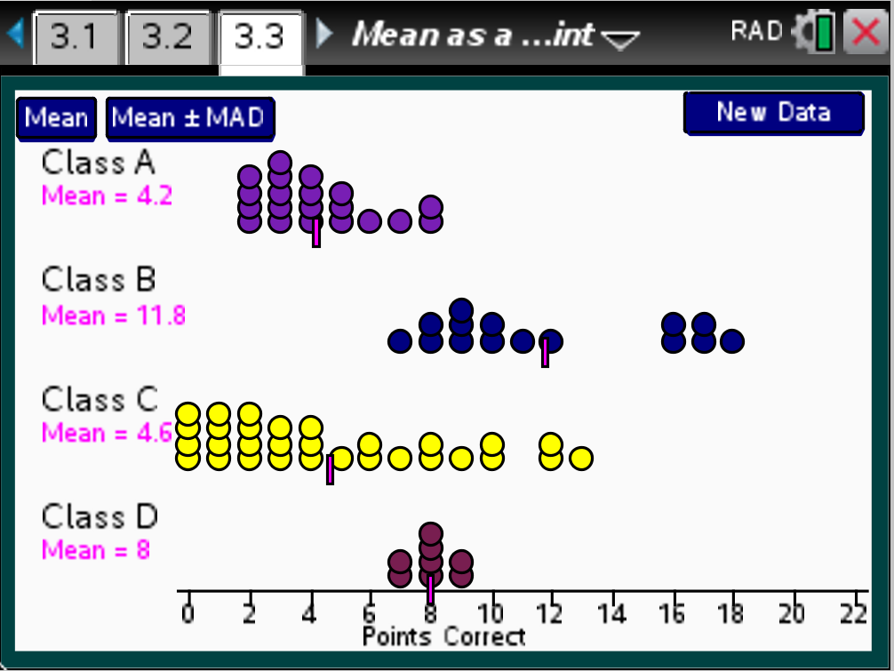

Sample Assessment Items
After completing the lesson, students should be able to answer the following types of questions. If students understand the concepts involved in the lesson, they should be able to answer the following questions without using the TNS activity.
1. The mean is considered a balance point of a distribution because
a. the mean will be in the middle of the distribution.
b. half of the scores are above the mean and half of the scores are below the mean.
c. the sum of the distances of the scores below the mean is the same as the sum of the distances of the scores above the mean.
d. the mean of the absolute deviations from the mean will lie in the center of the distribution.
Answer: c) the sum of the distances of the scores below the mean is the same as the sum of the distances of the scores above the mean.
2. Given the set {1, 5, 7, 7, 10}, if you add the value 6 to the data, the mean absolute deviation will
a. increase.
b. decrease.
c. remain unchanged.
d. There is not enough information to tell how the value will affect the mean absolute deviation.
Answer: b) decrease.
3. Find the mean and the MAD for the given distribution.
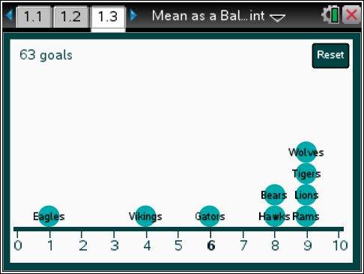
Answer: Mean is 7 and the MAD is .
4. The mean of each of the four distributions is 4. Rank the distributions in terms of the least to the most spread around the mean.
a. b.
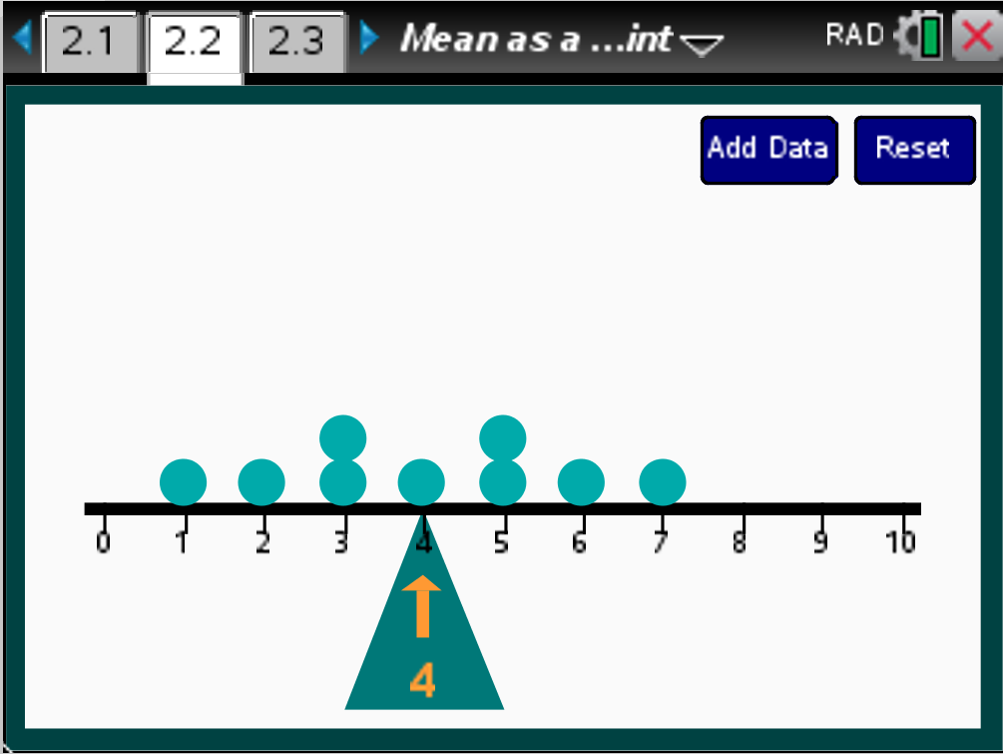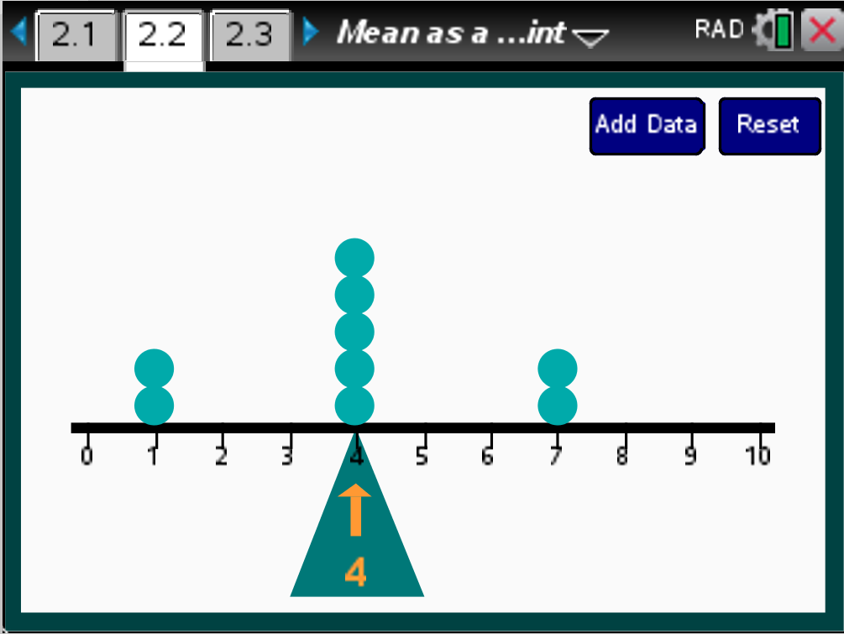
c. d.
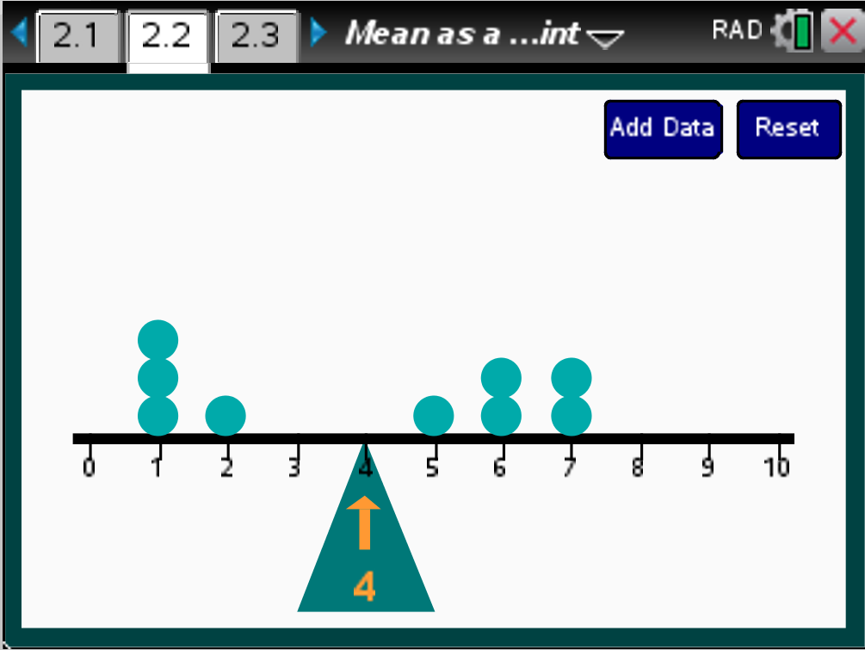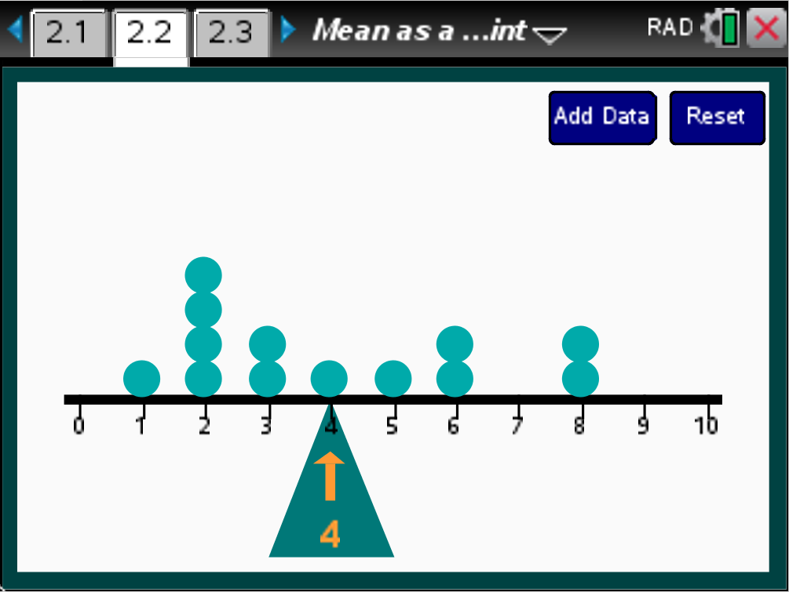
Answer: a) MAD =; b) MAD = ; c) MAD = ; d) MAD =2; least to most: b, a, d, c

Student Activity Solutions
In these activities you will work together to use the mean absolute deviation to describe the deviation from the mean. After completing each activity, discuss and/or present your findings to the rest of the class.
Activity 1 [Page 1.3]
1. Create a distribution of the number of goals each team scored so that the total number of goals remains 54, and the following conditions hold: Each of the teams scored at least 1 goal, no team scored more than 10 goals during the tournament, and you know that:
Select one of the following conditions (or your teacher will assign):
- One team scored 6 goals, and another team scored 9 goals.
Possible answer: The number of goals per team could be: 3, 4, 4, 4, 6, 8, 8, 8, 9 (deviation 18).
- Two teams scored 10 goals.
Possible answer: The number of goals per team could be: 2, 2, 5, 5, 5, 7, 8, 10, 10 (deviation 22).
- No team scored 6 goals, and one team scored 3 goals.
Possible answer: The number of goals per team could be: 3, 4, 5, 5, 5, 7, 8, 8, 9 (deviations sum to 16).
- Three teams scored 1 goal; at least two teams scored 9 goals.
Possible answer: The number of goals per team could be: 1, 1, 1, 8, 8, 8, 9, 9, 9 (Deviations sum to 30).
- No team scored 6 goals; three teams scored 1 goal.
Possible answer: The number of goals per team could be: 1, 1, 1, 2, 9, 10, 10, 10, 10 (Deviations sum to 38).
- Two teams scored 6 goals; two teams scored 8 goals.
Possible answer: The number of goals per team could be: 4, 4, 4, 6, 6, 7, 7, 8, 8 (Deviations sum to 12).
- Two teams scored only 1 goal; three teams scored 10 goals.
Possible answer: The number of goals per team could be: 1, 1, 2, 6, 6, 8, 10, 10, 10 (Deviations sum to 28).
2. a. Write a description of what you learned by doing and discussing the task in question 1.
Possible response: To find how evenly matched a set of teams are, you use the mean number of goals the teams scored and then figure out how far off the number of goals each team scored is from the mean. If you add all of these distances, using positive distances, you get a way to describe how the number of goals spread around the mean. Then you can rank the distributions according to these numbers, and the one with the smallest sum is the one that has a distribution of the most evenly matched teams.
b. If you used your method on a distribution that has all of the teams scoring six goals, what would be the sum of the distances from the mean? Explain why your answer makes sense.
Answer: The sum of the distances from the mean would be 0, which makes sense because all of the teams scored 6 goals.
Activity 2 [Page 1.4]
1. Without having any more than three of the dots at the same place, move the dots to balance the number line when the fulcrum is at 8.
a. Make a conjecture about what the fair share would be, and then check your work.
Possible answer: One distribution might be 5, 6, 6, 8, 9, 9, 9, 10, 10. The fair share would be 8. The sum of the values is 72, and dividing by 9, gives 8.
b. What is the sum of the absolute deviations from the balance point?
Possible answer based on the example above: 14.
2. Check your work for question 1 using page 1.4.
Activity 3 [Pages 2.2 and 2.4]
1. Use one of the pages from the activity to create a distribution where the MAD is:
a. 1
Answers will vary. One example is 10 values with a mean of 5, with five 4s and five 6s: 4, 4, 4, 4, 4, 6, 6, 6, 6, 6.
b. 5
Answers will vary. One example is to have 10 values, with five at 0 and five at 10.
c. 0
Answers will vary. One example is to have 10 values all at 10.
2. Which of the statements below are true? Explain your reasoning.
a. The larger the MAD, the smaller the spread of a distribution.
Answer: False, because a large MAD indicates that the typical or average distance of the data from the mean is large.
b. If the MAD is small, the values in the distribution are relatively clustered around the mean.
Answer: True, because it means the average distance of the data away from the mean is relatively small.
c. The mean is a point at which the values in a distribution below the mean “balance” the values in the distribution above the mean in terms of distance from the mean.
Answer: True, the sum of the absolute deviations from the mean of the data below the mean is equal to the sum of the absolute deviations from the mean of the data above the mean.
d. If the mean is 5, then a deviation from the mean of 2 would indicate the value is at 7.
Answer: False, the point 3 would also have an absolute deviation of 2 from the mean.
3. The MAD is often described as the typical distance of a data value from the mean. This is the interval between the mean minus the MAD and the mean plus the MAD, i.e., mean +/- MAD.
a. If the mean is 5 and the MAD is 2, describe the interval 1 MAD from the mean.
Answer: One MAD from the mean would be the interval from 3 to 7.
b. If one MAD from the mean is the interval from 5 to 11, what is the mean? The MAD? Explain how you found your answer.
Answer: The mean will be 8 and the MAD will be 3 because the interval is 6. The mean is exactly in the middle of the interval, so 3 up from 5 and 3 down from 11, which gives you 8.
Activity 4 [Page 3.2]
1. Reset and choose Data Set 3 for the number of correct points for students in four classes from a different school. Rank these classes in terms of the number of correct points. Give reasons for your ranking.
Answers will vary. Class A would seem to have the highest mean number of correct points, around 15. The ranking would seem to be A, B, D, C. Class D had the smallest spread with a MAD of 0.9, but overall the scores were lower than those in Class A or Class B. Over half of the students in Class C scored lower than nearly all of the students in Classes A or B.

