Directions: Use this document as a guide with the .tns file on your TI-Nspire CXII calculator.

Student Tasks:
Coding Challenge 6: Choose five mood messages from the list and write a program to display them, each on a different line, of the TI-Nspire CXII display.
Coding Challenge 7: Combine your favorite mood color with your favorite mood message.

Write a program that displays both.

Coding Challenge 8: Connect the temperature sensor to IN1 and write a program that creates a temperature object named my_temp.  Measure the my_temp object and store value in the variable named temp.  Display an appropriate prompt with the measurement value and units. | - Connect temperature sensor to port IN1  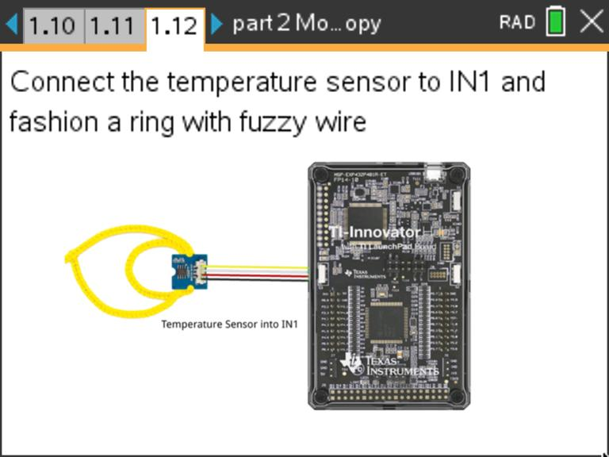
Science Activity 10: Use the previous program to explore the temperatures around you.  -What is the temperature of the room?  -What is the temperature of your skin?  -How low of a reading can you measure?  -What is the temperature of an ice cube?  * do not submerge sensor in liquid |  | Record values here:
Coding Challenge 9: Write a program using a for loop that will read and display ten temperature measurements.

Use sleep(2) to pause for two seconds in each cycle.
Coding Challenge 10: Use a while loop to continuously monitor temperature.

Include an if conditional statement using appropriate temperatures to display the following text and LED color:
- "cool" - blue
- "just right" - green
- "hot" - red

Final Coding Challenge 11: Use the skills from all of the previous challenges to design and code your mood ring. Your program should display mood messages and colors over a range of finger temperatures.

Helpful tips:
-As a starting point, modify a copy of the previous program. Switch to that program editor page, and select [ctrl]+B, then [menu]->Actions->Create Copy.

- Include at least five if case intervals that change the mood color and message based on finger temperatures.

- Temperature intervals of about two degrees will help your ring respond to typical temperature measurements.

