Math Objectives  - Students will visualize a solid generated by revolving a graph about the x-axis.  - Students will calculate the area of a cross section of a solid generated by rotating a function graph about the x-axis.  - Students will use the area of a cross section of a solid generated by rotating a function graph about the x-axis to estimate and find the exact volume of the solid.  - Students will look for and make use of structure. (CCSS Mathematical Practice)  - Students will model with mathematics. (CCSS Mathematical Practice)  Vocabulary  - revolve about the x-axis  - solid  - disk  About the Lesson  - This lesson involves giving students a visual representation of solids of revolution.  - As a result, students will:  - Observe that the solid generated by revolving the function graph about the x-axis can be generated by disks centered on the x-axis, the radius of which correspond to the value of the function at that point.  - Observe that the volume of a solid of revolution can be estimated using a sum of volumes of disk slices.  - Observe that exact volume can be found using integration.  NOTE: While this .tns document provides an aid in visualizing a solid of revolution, it is a good idea to have a physical example for students to consider, such as a vase or lamp or a table leg that has been shaped on a lathe (or a ceramic piece shaped on a pottery wheel).  TI-Nspire™ Navigator™ System  - Use Quick Poll to assess student understanding.  - Use Class Capture to demonstrate different methods of estimating area under a curve. | 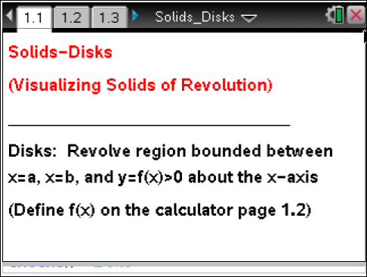  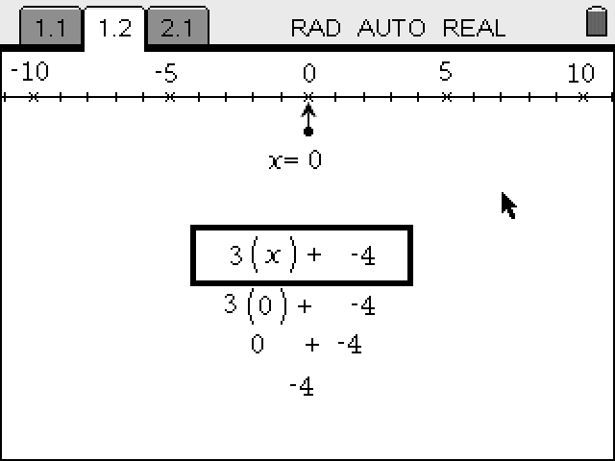  TI-Nspire™ Technology Skills:  - Download a TI-Nspire document  - Open a document  - Move between pages  - Grab and drag a point  Tech Tips:  - Make sure the font size on your TI-Nspire handheld is set to Medium.  - In Graphs, you can hide the function entry line by pressing / G.  Lesson Materials:  Student Activity  - Solids_Disks_Student.pdf  - Solids_Disks_Student.doc  TI-Nspire document  - Solids_Disks.tns  Visit www.mathnspired.com for lesson updates and tech tip videos.
Discussion Points and Possible Answers

Tech Tip: While it is also possible to drag the points to change the values of a, b, and xc along the x-axis, the slider arrows provide much better control for the students, especially on the handheld units.

Move to page 1.3.  1. The graph of the function between x = a and x = b has been rotated about the x-axis, generating the solid region pictured on this page. | 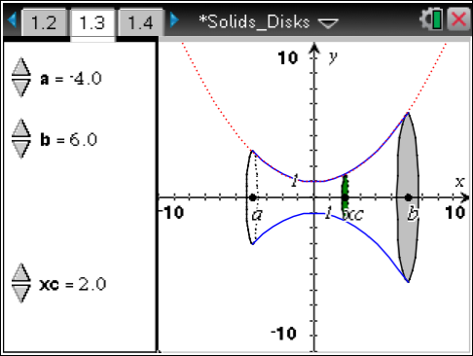
a. Imagine you sliced through the solid region, slicing parallel to the y-axis. What is the shape of the cross section? Explain.

Answer: The cross section will be circular. Student explanations may include descriptions of what revolving about the x-axis will generate.

b. Does the shape of the cross section depend on the location where you make your slice? Explain.

Answer: No, the shape of the cross section won’t change. All slices will be circular. The size of the slice will change.

c. Move point xc along the x-axis using the arrows at the left. Does this support or contradict your prediction from part 1b? Explain.

Answer: Yes, because anywhere along the x-axis, the cross section is still circular.

TI-Nspire Navigator Opportunity: Screen Capture
See Note 1 at the end of this lesson.

2. Use the xc arrows on the left to move to xc = 3. Suppose you slice through the solid at that point.
a. What is the shape of the cross section at that location? Explain.

Answer: It is circular because the distance from the x-axis to the edge of the cross section is the same at all points.

b. What is the area of the cross section when xc = 3? How did you determine this?

Answer: ; the radius of the circular cross section at xc = 3 is determined by the value of the function there, . Thus the area of that circular cross section is .
TI-Nspire Navigator Opportunity: Quick Poll
See Note 2 at the end of this lesson.
Move to page 1.4.  3. Use the xc arrows on the left to move to xc = 3. The cross section of the solid at that point is pictured on the left.  a. How is the area of the disk at xc, shown on the left, calculated? | 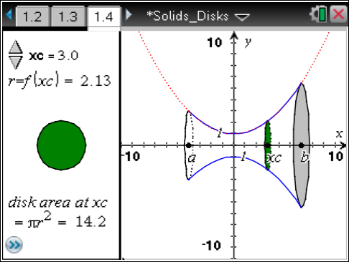
Answer: The radius is the value of the function at xc = 3. The area is found using .

b. How does this compare to the area you found in question 2b? Explain.

Answer: It is the same.

c. How could you express the area of a cross section taken at any point x between a and b? Explain.

Answer: At any x value, the cross section will still be circular, so the area of the cross section will be , where r is the radius of the circular cross section. But the radius is determined by the value of the function at that x value. Thus the area will be .
d. Do you think you will be able to find the area of a cross section in the same way for any function rotated about the x-axis? Explain.

Answer: Yes. For any solid generated by revolving the region bounded between x = a and x = b, the graph of a positive function which is continuous on [a, b], and the x-axis, the cross sections will be circular. The radii of cross sections will always be the value of the function at the location where the cross section is taken.

TI-Nspire Navigator Opportunity: Quick Poll
See Note 3 at the end of this lesson.
Move to page 1.2.  4. Click on the screen and type in Define f(x) = and a function of your choice.  a. What do you think the solid generated by rotating your function’s graph about the x-axis will look like? |  | 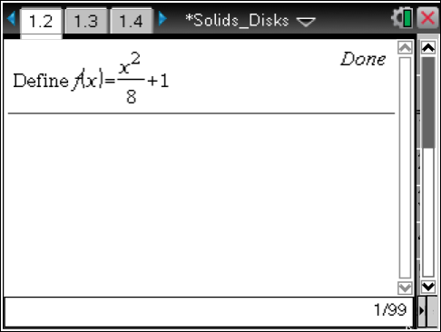
Answer: Student answers may vary. They should note that it will still have circular cross sections, but different functions will have different shapes.

Teacher Tip: You may want to give your students a set of functions to choose from in order to ensure that they have functions whose solids will be easy to see in a standard window. Alternatively, you may wish to allow students to select any function, creating opportunities to troubleshoot graphing windows, to address issues of discontinuity, etc.

b. What do you think a cross section of the solid generated by rotating your function’s graph about the x-axis will look like? Explain.

Answer: If the function is continuous everywhere in the interval over which it is bound, the cross sections will be circular.

c. What do you think the area of a cross section taken at xc = 1 will be? Explain.

Answer: The area will be , where f(1) is the value of the student’s function at x = 1.

TI-Nspire Navigator Opportunity: Screen Capture
See Note 4 at the end of this lesson.
Move to page 1.4.  You may have to adjust your window to get a good view of your function’s graph rotated about the x-axis.  5. a. Were your predictions from question 4 correct? Explain.  Answer: Answers may vary. |  | 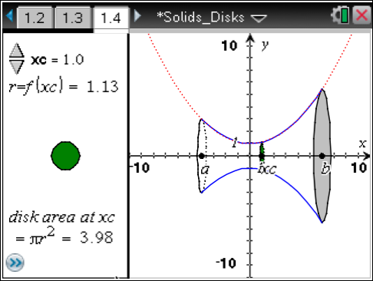
b. How could you express the area of a cross section taken at any x-value between a and b?

Answer: The area will be where f(x) is the value of the student’s function at x.

6. Set a = –3 and b = 6. Place xc anywhere between a and b. Suppose that you take a very thin slice of the solid at xc, in the shape of a thin disk of thickness ∆x.

a. What is the volume of the disk you have released from the solid? Explain.

Answer: The volume is . This is because the disk is a cylinder of
radius f(xc) and height ∆x.

b. Imagine that you slice the whole solid into several thin disks of thickness ∆x. How could you estimate the total volume of the solid using these disks? Explain. (Hint: Think back to Riemann sums.)

Answer: The answer should be equivalent to a sum of the form , where the xc’s are the locations in the interval where the solid has been sliced.

c. How could you find the exact volume of your solid? Explain. (Hint: Think back to how limits of Riemann sums were used to find areas.)

Answer: . Analogous to using Riemann sums to find areas, take the limit of the sum in part 6c, where ∆x is going to 0. This is the integral over the interval of possible values for xc: –3 to 6.

d. Will this work for any function? Explain a method for finding the exact volume of a solid of revolution.

Answer: Any function which is continuous over the interval. Cross sections will always be disks, and you can always build the solid out of these disks. Letting the thickness of the slices go to 0, you get the exact volume by calculating the integral .

Wrap Up
Upon completion of this discussion, the teacher should ensure that students understand:
- That cross sections of a solid of revolution of a continuous function on a bounded interval about the x-axis are circular.
- The volume of such solids can be estimated by summing cross sectional disks.
- The volume of such solids can be found by integrating the cross-sectional areas.

Assessment
Have students find the volumes of solids generated by other students’ functions. Ask students when this method won’t work. What if you revolved about a different axis? What about over an interval including 0? What if you took slices parallel to the x-axis?

TI-Nspire Navigator

Note 1
Question 1, Screen Capture: Use a Screen Capture here to show different students’ choices of cross sections of the solid. This will help drive home the point that all of the cross sections are circular but of different sizes depending on location along the axis of the solid.

Note 2
Question 2, Quick Poll: Use a Quick Poll to find students’ determinations of the area. Opportunities may arise to discuss why using the formula for area of a circle makes sense.

Note 3
Question 3, Quick Poll: Use a Quick Poll here to determine if students think cross sections will always be circular and the radii will always be the values of the function there. This could be used as an entry point for a whole group discussion.

Note 4
Question 4, Screen Capture: Use a Screen Capture to show the solids generated by revolving different functions about the x-axis. This could create opportunities to discuss what cross sections will look like and if they will ever be different.

