Math Objectives  - Students will learn that for a continuous non-negative function f, one interpretation of the definite integral is the area of the region bounded above by the graph of y = f(x), below by the x-axis, and by the lines x = a and x = b.  - Students will visualize and compute values for three different Riemann sums: left-hand endpoint, right-hand endpoint, and midpoint, and use these values to estimate the area of a region R.  - Students will learn about the nature of these estimates as the number of rectangles increases.  - Students will consider other functions and relate these Riemann sums to function characteristics.  Vocabulary  - Riemann sum • area of a plane region • continuous  - definite integral • underestimate, overestimate  - left-hand endpoint, right-hand endpoint, and midpoint sum  About the Lesson  - This lesson involves three Riemann sums used to estimate the area of a plane region.  - As a result, students will:  - Conjecture about each estimate as the number of rectangles increases.  - Conjecture about each estimate in relation to certain characteristics of the function.  - Consider the magnitude of the error in each approximation.  - Conjecture about other geometric figures that might produce better estimates.  TI-Nspire™ Navigator™  - Use Class Capture to demonstrate different Riemann sums for various values of n.  - Use Quick Poll to assess student understanding.  Activity Materials  - Compatible TI Technologies:  TI-Nspire™ CX Handhelds,   TI-Nspire™ Apps for iPad®,  TI-Nspire™ Software | 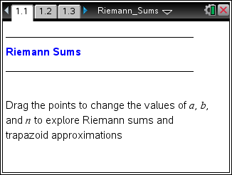  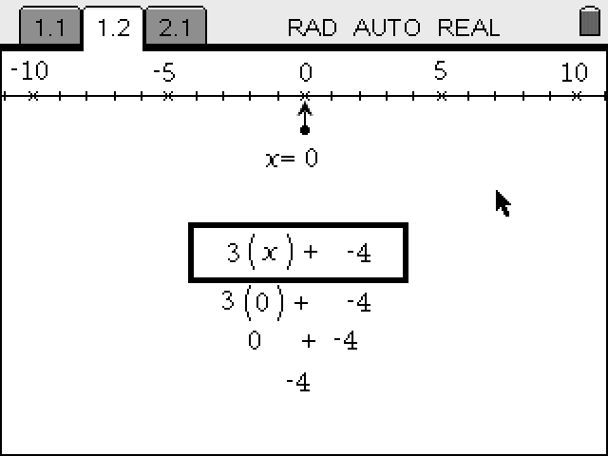  Tech Tips:  - This activity includes screen captures taken from the TI-Nspire CX handheld. It is also appropriate for use with the TI-Nspire family of products including TI-Nspire software and TI-Nspire App. Slight variations to these directions may be required if using other technologies besides the handheld.  - Watch for additional Tech Tips throughout the activity for the specific technology you are using.  - Access free tutorials at http://education.ti.com/calculators/pd/US/Online-Learning/Tutorials  Lesson Files:  Student Activity  - Riemann_Sums_Student.pdf  - Riemann_Sums_Student.doc  TI-Nspire document  - Riemann_Sums.tns

Discussion Points and Possible Answers
Tech Tip: Once the bottom of the screen is selected, students using handhelds can use the left and right arrows to change the value of n, the number of sub-intervals. On the keypad, e and g e will change the type of Riemann sum.
Read the exercise on page 1.4. Then, move to page 1.3.  Consider the definite integral (the area of the region R bounded by the graph of y = x² + 2, the x-axis, and the lines x = 1 and x = 6). | 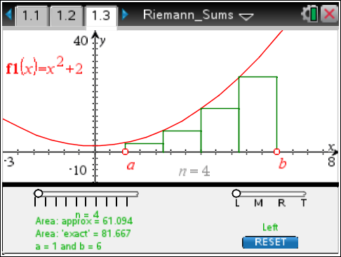
- In the bottom screen, select L, for left-hand endpoint Riemann sum. Move the slider for to set the number of rectangles used to estimate the area of the region. Give answers to 3 decimal places. Note that a decimal approximation of the exact area of the region is also given.
a. Complete the following table.

Answer:

n | 2 | 4 | 8 | 16 | 32
Left | 43.1235 | 61.094 | 71.055 | 76.279 | 78.953

b. How do your results change in relation to the ‘exact’ area as n increases? Explain your answer geometrically.

Answer: As n increases, the left-hand endpoint Riemann Sum gets closer and closer to the exact area. This seems reasonable since as n increases, the width of each rectangle decreases, the number of rectangles increases, and the rectangles tend to cover, or fill, more of the region. There is less area of the region missed by the rectangles.
Note: You might ask students what happens to the error as the number of rectangles doubles.
TI-Nspire Navigator Opportunity: Class Capture and Quick Poll
See Note 1 at the end of this lesson.
c. As n increases, the left-hand endpoint Riemann sum in this case always returns an underestimate of the exact area of the region. Explain this result. What characteristic of the function f can be used to justify your answer?

Answer: In this case, all of the approximating rectangles are completely contained in the region (inscribed rectangles). Therefore, the sum of the areas of the rectangles must be less than the exact area of the region. Because f is an increasing function on the interval [1, 6], this Riemann sum, left-hand endpoints, will always produce an underestimate of the exact area. This result is true for any increasing function on an interval [a, b]. The left Riemann sum will underestimate the area of the region.

2. Move the point to select R, for right-hand endpoint Riemann sum.  a. Complete the following table.  Answer: | 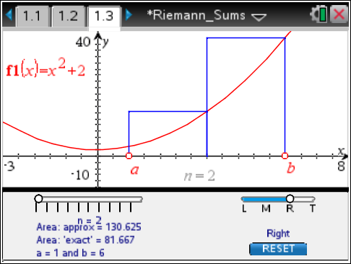
n | 2 | 4 | 8 | 16 | 32
Right | 130.625 | 104.844 | 92.930 | 87.217 | 84.421

b. When the rectangles are formed from a right-hand endpoint Riemann sum, how does this change in relation to the ‘exact’ area as n increases? Explain your answer geometrically.

Answer: As n increases, the right Riemann sum gets closer and closer to the exact area. This seems reasonable since as n increases, the width of each rectangle decreases, the number of rectangles increases, and the rectangles tend to cover more of the region. Once again, there is less area of the region missed by the rectangles.

c. As n increases, the right-hand endpoint Riemann sum in this case always returns an overestimate of the exact area of the region. Explain this result. What characteristic of the function f can be used to justify your answer?

Answer: In this case, all of the approximating rectangles cover more than the region (circumscribed rectangles). Therefore, the sum of the areas of the rectangles must be greater than the exact area of the region. Because f is an increasing function on the interval [1, 6], this right Riemann sum, will always produce an overestimate of the exact area. This result is true for any increasing function on an interval [a, b]. The right-hand endpoint Riemann sum will overestimate the area of the region R.
3. Select M, for midpoint Riemann sum.  a. Complete the following table.  Answer: | 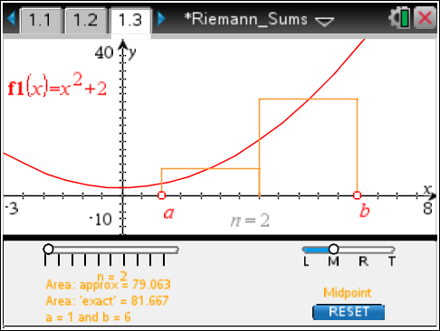
n | 2 | 4 | 8 | 16 | 32
 | 79.063 | 81.016 | 81.504 | 81.626 | 81.656

b. How does the Riemann sum formed from rectangles made from the midpoint of the subintervals change in relation to the exact area as n increases? Explain your answer geometrically.

Answer: As n increases, the midpoint Riemann sum gets closer and closer to the exact area. This seems reasonable since as n increases, the width of each rectangle decreases, the number of rectangles increases, and the rectangles tend to cover the region more precisely. As n increases, the rectangles tend to fill in more of the region, with less of each rectangle lying outside of the region.

c. As n increases, the midpoint Riemann sum in this case appears to return values that are close to the exact area of the region. Explain this result. Why do you think the midpoint Riemann sum in this case is a better estimate of the area of the region than the left-hand endpoint or right-hand endpoint Riemann sums? That is, why is the midpoint sum closer to the exact answer than the left or right sum for fixed values of n?

Answer: Part of each rectangle omits a portion of the region R, the actual area, and part captures an almost equivalent region outside of R. The areas of these regions (the small part inside R and the small portion outside of R) appear to be about the same. Therefore, the area of each rectangle is a very good approximation of a small portion of the total area of R. As n increases, the width of each rectangle decreases, the number of rectangles increases, and the rectangles cover the region R more precisely. The rectangles fill in more of the region R, and for each rectangle, the portion of R omitted and the portion captured outside of R become smaller. Therefore, the area of each small region decreases, and the area of the small region missed and the area of the small region added are very close.

4. Change the values of n, the type of Riemann sum (L, M, or R), and the definition of the function f1 as necessary to answer the following questions.
a. Consider the function . Compute F(6) – F(1). How does this value compare to the exact answer in questions 1, 2, and 3? What is the relationship between F and f?

Answer:

This is the exact value displayed in the top screen of this activity.

F is an antiderivative of f. That is, F′(x) = x² + 2 = f(x).

Teacher Tip: A fine discussion point is to ask students whether they believe this last result is true in all cases. That is, if F is an antiderivative of f, is it always true that ? In addition, if there is no closed-form antiderivative of f, there is a need for a method to approximate this definite integral. One method is a Riemann sum.

Tech Tip: To modify the function, double-tap the text and the keyboard will open.
b. Consider the function f1(x) = –x² + 36 on the interval [1, 6]. Compute left, right, and midpoint Riemann sums for various values of n. Explain what happens to these values as n increases. Why is left always an overestimate and why is right Riemann sums always an underestimate?
Answer: As n increases, each Riemann sum—Left, Right, and Midpoint—gets closer and closer to the exact value. Geometrically, in each case the rectangles cover the area of the region R more precisely. Because the function f1 is decreasing on the interval [1, 6], left Riemann sums are always an overestimate and right is always an underestimate. Again, for a fixed n, Midpoint Riemann sums appears to produce a better estimate than Left or Right, closer to the exact value.

TI-Nspire Navigator Opportunity: Class Capture and/or Live Presenter
See Note 2 at the end of this lesson.
c. Consider the function f1(x) = 3x² – 18x + 32 on the interval [1, 6]. Compute left, right, and midpoint Riemann sums for various values of n. Explain what happens to these values as n increases. Is it possible to predict whether left or right Riemann sums will always be an underestimate or overestimate? Why or why not?

Answer: As n increases, each Riemann sum—Left, Right, and Midpoint—gets closer and closer to the exact value. Geometrically, in each case the rectangles cover the area of the region R more precisely. The function f1 is not monotonic over the interval [1, 6]. It is decreasing on the interval [1, 3] and increasing on the interval [3, 6]. Therefore, it is not possible to predict whether Left or Right Riemann sums will always produce an underestimate or overestimate. However, it still appears that for a fixed n, Midpoint Riemann sums produces a better estimate than either Left or Right.

Teacher Tip: Challenge students to find a value for n such that Left (or right) is an underestimate and a different value for n such that Left (Right) is an overestimate.
Have students explore if the midpoint is an over- or underestimate for function that are increasing and decreasing, or if the concavity is an important factor to consider.
TI-Nspire Navigator Opportunity: Quick Poll
See Note 3 at the end of this lesson.

d. Can you suggest another, better sum to estimate the area of the region R based on different geometric figures (other than rectangles)? Explain why your method would produce a more accurate estimate of the area.

Answer: Students should logically suggest using trapezoids rather than rectangles. Because a trapezoid more closely covers a small portion of the region R, we expect an estimate for the area of R using trapezoids to be better than Left, Right, or Midpoint Riemann sums for a fixed n. Students might also suggest using a parabola in each subinterval (Simpson's rule). By definition, the trapezoidal rule and Simpson's rule are not Riemann sums, but both provide good estimates for the definite integral. You might challenge students to try and write a formula for an estimate of the area of R using trapezoids.

Wrap Up
Upon completion of this activity, the teacher should ensure that the students understand:
- The geometric interpretation of a left-hand endpoint, right-hand endpoint, and midpoint approximation to a definite integral.
- When Left and Right Riemann sums produce underestimates or overestimates related to whether the function is increasing or decreasing over the interval.
- Geometrically, why Midpoint Riemann sums produces a better estimate than Left or Right of the definite integral for a fixed n.
- As n increases—equivalently, as the number of rectangles increases—each of these Riemann sums produces a better approximation to the area of the region R.
- There are other methods to approximate the definite integral that might produce even better estimates for a fixed n.

TI-Nspire Navigator
Note 1
Question 1, part b, Class Capture
As students move through this activity, capture the screens of the class when there are different values of n and have the students discuss what they observe.
Quick Poll
The question on Page 1.4 can be used as a Quick Poll
For f1(x)=x² +2, evaluated from 1 to 6, compare the left, midpoint, and right Riemann sums.
Answer: Left < Midpoint < Right for increasing functions

Note 2
Question 4, part b, Class Capture and/or Live Presenter
Direct groups of students to use different values of n for this item and capture the screens of the handhelds. Have the class discuss what they observe in the Class Captures.

Note 3
Question 4, part c, Quick Poll
A Quick Poll can be given at the conclusion of the lesson. You can save the results and show a Class Analysis at the start of the next class to discuss possible misunderstandings students might have.

The following is a sample question you can use:

True or False: For a non-monotonic function, it possible to predict whether the Left or Right Riemann sums will produce an overestimate or underestimate.
Answer: False

