Math Objectives  - Students will determine the relationship between the width and length of a garden with a rectangular shape and a fixed amount of fencing. The garden is attached to a barn, and exactly three sides of the garden will be fenced.  - Students will determine a formula that can be used to compute the area of the garden when given the width.  - Students will find the dimensions of the garden that has the maximum possible area.  - Students will make sense of problems and persevere in solving them (CCSS Mathematical Practice).  Vocabulary  - perimeter  - area  - maximize  - conjecture  About the Lesson  - In this activity, students explore the area of a garden with a rectangular shape that is attached to a barn. Exactly three sides of the garden must be fenced. Students will sketch possible gardens and enter their data into a spreadsheet.  - As a result students will:  - Graph the data, find an equation for the area of the garden in terms of its width, find the maximum area of the garden, and solve related problems.  - Determine that, given a fixed amount of fencing, the area enclosed depends upon the dimensions chosen.  - The extension problem provides an opportunity for students to explore a different scenario—a rectangular garden that must be fenced on all four sides. Problem 2 in the TI-Nspire document may be used to explore this scenario.  Activity Materials  Compatible TI Technologies : TI-Nspire™ CX Handhelds,  TI-Nspire™ Apps for iPad®, TI-Nspire™ Software | 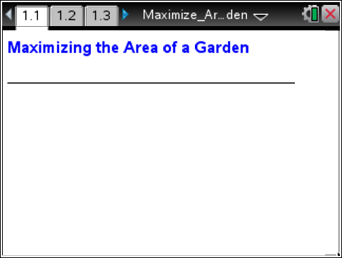  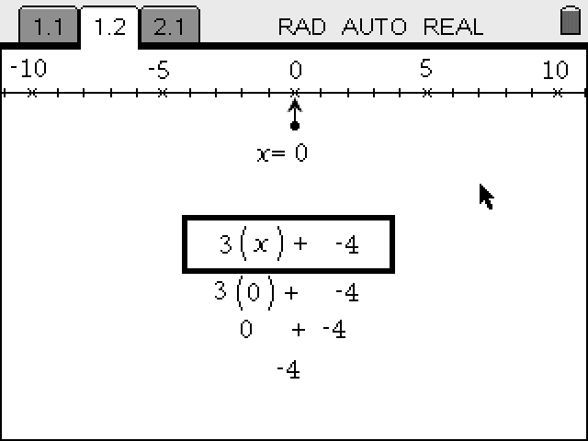  Tech Tips:  - This activity includes screen captures taken from the TI-Nspire CX handheld. It is also appropriate for use with the TI-Nspire family of products including TI-Nspire software and TI-Nspire Apps. Slight variations to these directions may be required if using other technologies besides the handheld.  - Watch for additional Tech Tips throughout the activity for the specific technology you are using.  - Access free tutorials at http://education.ti.com/calculators/pd/US/Online-Learning/Tutorials  Lesson Materials:  Student Activity  - Maximize_Area_Garden_  Student_pdf  - Maximize_Area_Garden_  Student_doc  TI-Nspire™ Document  - Maximize_Area_Garden_  Student_tns
Discussion Points and Possible Answers

Move to page 1.2.  1. As directed on page 1.2, draw a sketch of each of your five different gardens. Be sure to use a variety of width values. Remember that only three sides of the garden are to be fenced and that you will use 22 meters of fencing. | 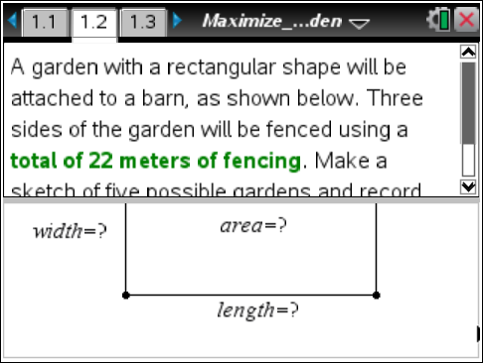
2. Record the width, length, and area of each garden in the table below. Be sure to include appropriate units of measurement.

Sample Answers: Answers will vary—one possible set of answers:

Sketch no. | Width | Length | Area
1 | 2 m | 18 m | 36 m²
2 | 4 m | 14 m | 56 m²
3 | 6 m | 10 m | 60 m²
4 | 7 m | 8 m | 56 m²
5 | 8 m | 6 m | 48 m²

3. Considering the data from your sketches, describe what happens to the area of the garden as the width of the garden increases.

Sample Answers: Answers will vary. Students might say that the area increases, decreases, or both increases and decreases.

Teacher Tip: Depending on the values that students choose for the width, they might conclude that the area values always increase or always decrease. Question 4 was included so that students could compare their data to that of other students.

4. Compare your answer to question 3 with the answers of other students in your class. Use the class data to describe what happens to the area of the garden as the width of the garden increases.

Sample Answers: Students should discover that for a large sample of different widths, as the width of the garden increases, the area of the garden first increases and then decreases.
5. If the goal is to maximize the area of the garden, which of your garden sketches would be the best option? Why? Give the width, length, and area of the garden.

Sample Answers: Answers will vary. Students should choose their garden sketch with the greatest area but might have other ideas about the “best” garden after comparing their sketches with those of other students.

Move to page 1.3.  6. On page 1.3, click in cell A1 of the spreadsheet in the lower-left work area of the screen. Enter the width and area data for each of your five garden sketches.  Sample Answers: Values for the width and area shown in the table in question 2 have been entered in the spreadsheet. | 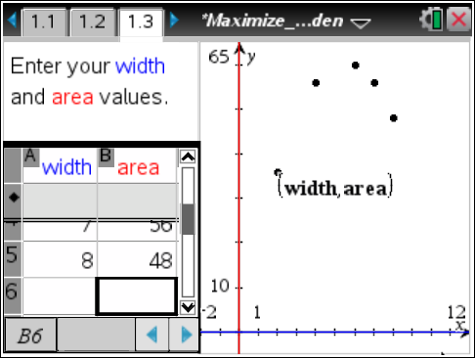
Tech Tip: Press / e to move from one work area on the screen to another, or move the cursor to that region of the screen with the Touchpad and press x. The active work area will have a bold outline.

Tech Tip: To move from one work area to another tap that region on the screen. To enter data in the spreadsheet double tap the cell and use the on-screen keyboard to enter the desired value.

Teacher Tip: Remind students to pay close attention to the list names in the spreadsheet and to enter their data into the appropriate lists.

Teacher Tip: Students might need verbal prompts to notice that the
x-values of the points graphed always increase from left to right while the y-values first increase and then decrease.
7. As you enter data in the spreadsheet, a scatter plot of the data will be graphed. Describe the shape of the plot.

Sample Answers: Answers may vary, depending on the data that students have entered in their spreadsheets. If they have a good variety of points (a mix of width values that includes both small and large values), students should notice that the data points “rise” and then “fall” as you follow the graph from left to right.
8. Write a formula for the amount of fencing used in terms of the width (w) and length (l) of the garden.

Answer: 2w + l = 22 or l + 2w = 22 or an equivalent formula

9. Rearrange the formula from question 8 to express the length (l) of the garden in terms of the width (w).

Answer: l = 22 – 2w or 22 – 2w = l or an equivalent formula

10. Write an equation that could be used to determine the area (A) of this garden if you know only the width (w) of the garden. Hint: Use your answer from question 9 that expresses the length of the garden in terms of the width.

Answer: A = w(22 – 2w) or A = 22w – 2w² or an equivalent formula

11. Let x represent the width of the garden and let f(x) represent the area of the garden in terms of its width. Write a function to express the area of the garden in terms of the width of the garden.

Answer: f(x) = x(22 – 2x) or f(x) = 22x – 2x² or an equivalent formula

12. What values can be used for the width of the garden in this problem? In other words, what is the domain of your function?

Answer: The width must be greater than 0 meters and less than 11 meters, or 0 < x < 11.

Move to page 1.4.

13. On page 1.4, graph your function with the scatter plot on a full page.  - Press / G or e to show the entry line.  - f1(x) = is displayed. Enter your function definition, and then press ·.  Note: The scatter plot label (width, area) has been moved. | 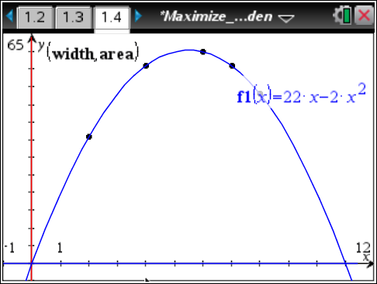
Tech Tip: Double tap the graphing window to make the function entry line appear.

14. If the graph of the function does not fit your data, recheck your data entries on page 1.3 and your answer for question 11.
15. What are the width and area of the garden with the maximum possible area?

Answer: width = 5.5 meters and area = 60.5 square meters

16. How did you determine the maximum area of the garden?

Sample Answers: Answers will vary as students have a variety of methods to find the maximum area. Some students may trace on their function while others may find the vertex.

Teacher Tip: If students use a table to determine the maximum area, it’s important to check that they understand that a table might not display the maximum area despite the fact that they can change the Table Step value for the width. Aside from traditional methods of finding the vertex, other methods for determining the maximum area are included in the Tech Tips at the end of this document.

17. Suppose that a rectangular garden of this type (with three sides fenced using 22 meters of fencing) is to have an area of 52.5 square meters.
a. What width and length could be used to form a garden with this area? (Add pages, as needed, to the TI-Nspire document to solve this problem.)

Sample Answers: width = 3.5 m and length = 15 m; or width = 7.5 m and length = 7 m

b. Describe the method you used to find the width and length.

Sample Answers: Methods for finding the width will vary. See the Teacher Tip below.

Teacher Tip: There are many ways to solve this problem. Methods include the following:
1. Graph the function f2(x) = 52.5 with the graph of the area function. Find the points of intersection of the graphs.
2. Add a point to the graph of the function. When the y-value of the point’s ordered pair is changed to 52.5, the value of x that results in this function value is computed.
3. Use Numerical Solve to find the width.
4. Add a Table and change the Table Step value until the values of x (width) that produce the desired area are found.
5. Set up the appropriate equation, and use the quadratic formula to solve for the width.
(Tech Tips for some of these methods can be found at the end of this document.)

- Jackie will use 44 meters of fencing to make a garden with a rectangular shape that will be attached to a barn. (Only three sides will be fenced.) How will the maximum area of her garden compare to the maximum area of the same type of garden that used 22 meters of fencing? Justify your answer. (Add pages, as needed, to the TI-Nspire document to solve this problem.)

Answer: The maximum area of Jackie’s garden will be four times the maximum area of the garden with 22 meters of fencing. Methods similar to those used for the solution of the earlier problem can be used to solve this problem.

Extension:

1. Suppose that a garden with a rectangular shape is not attached to a barn. You will still use 22 meters of fencing, but all four sides must be fenced. What width and length do you think the garden should have to produce the maximum area? Make a conjecture, and explain your reasoning.

Sample Answers: Answers will vary. Some students might correctly guess that the sides of the garden should have equal lengths.

2. Use Problem 2 in the TI-Nspire document to explore the dimensions of this type of garden. Add pages, as needed, to determine the width and length that will result in a garden with the maximum area.

Answer: width = 5.5 m, length = 5.5 m, and area = 30.25 m²

Tech Tip: The rectangle on page 2.2 displays various dimensions and area values as students drag the point. The spreadsheet is set up for Automatic Data Capture. To view the data in a scatter plot, students will need to add a Graphs or Data & Statistics application page and set up the plot.

Teacher Tip: The perimeter equation is 2w + 2l = 22, and the equation for the area in terms of the width is A = w(11 – w). The maximum value of the area function can be found using any of the strategies described for the first area maximization problem in this activity.

3. How does the maximum area of a garden with four fenced sides compare to the maximum area of the garden that was attached to a barn? Compare your answer to those of your classmates.

Answer: The maximum area of the rectangular garden with four fenced sides is one-half the maximum area of the rectangular shaped garden that was attached to a barn.

Teacher Tip: Students may observe that the maximum area of this garden is one-half the area determined in the first area maximization problem. Encourage them, if time permits, to see if this relationship holds for perimeters other than 22 meters. Ask students to form a conjecture about whether this relationship is always true.

Let some constant k represent the fixed perimeter. It can be determined that the maximum area of the rectangular figure with four fenced sides and perimeter k is k²/16.

When three sides are fenced, as described in the problem with one side of the garden attached to the barn, the maximum area of the rectangular shaped figure with perimeter k is k²/8.

Additional Tech Tips for this Activity

Tech Tip: To select Menu, you will need to press .

Tracing on a Function  Students can trace on their function to determine the maximum function value.  1. Select Menu > Trace > Graph Trace.  - To move to the graph of the function, press £ or ¤. Then, use the right ¢ or left ¡ arrow keys on the touchpad to trace on the graph.  - Note the ordered pair in the lower-right corner of the screen.  - When the maximum value of the function is approached, the tracing point moves to the maximum function value and the word maximum is displayed.  - The coordinates of this point are displayed in the lower-right corner of the screen. | 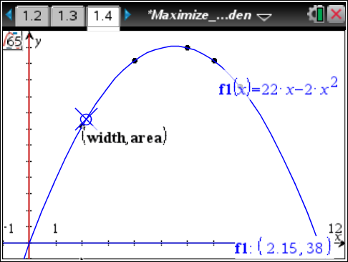
Tech Tip: To move the cursor, drag the trace point on the screen by dragging your finger.

2. To change the Trace Step, select Menu > Trace > Trace Step.  - The current Trace Step is Automatic.  - If desired, enter a Trace Step value. Press e to move to OK, and press x or ·.  3. To exit the tracing mode, press d. | 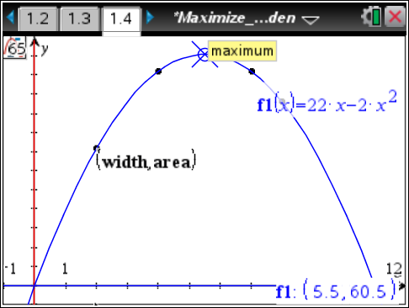
Adding a Function Table  1. To add a Table, select Menu > Table > Split-screen Table. (The shortcut is / T.)  - When the Table work area is selected (outlined in bold), the Table Start and the Table Step values may be edited.  2. Select Menu > Table > Edit Table Settings.  3. To remove the table, press / T. | 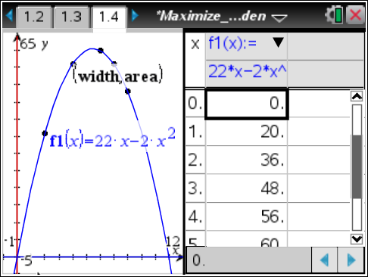
Computing a Regression Equation  1. To compute a regression equation, first add a page by pressing / ~. Select Add Calculator.  2. Select Menu > Statistics > Stat Calculations > Quadratic Regression.  3. Press x to display the list names, and choose width for the X List.  4. Press e to move to Y List.  5. Press x and choose area for the Y List.  6. Press e to move to OK, and press x or ·. | 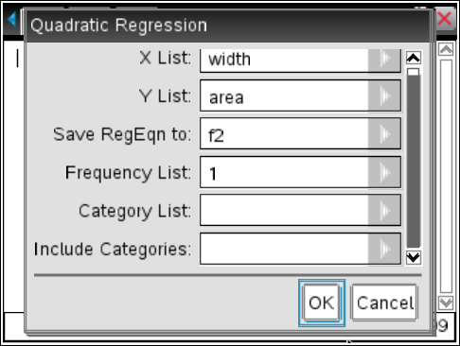  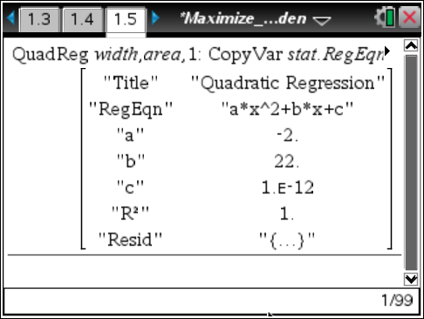
Tech Tip: To add a page to a document press , then select the desired type of page.

Tech Tip: A regression equation can also be computed in a Lists & Spreadsheet application. The advantage of that method is that if data are changed or additional data added, the regression equation is updated.

Graphing the Regression Equation  1. To graph the regression equation, return to a page that contains a graph of the data.  2. Press e to show the entry line. f3(x) = is displayed.  3. Press the up arrow £ to display f2(x), the regression equation.  4. Press · to graph the regression equation.  5. Move the function label, as needed. | 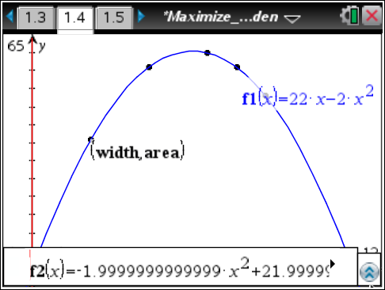  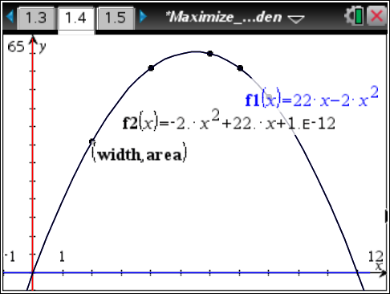
Using Numerical Function Maximum  This menu option will determine the value of the independent variable that produces the maximum function value.  1. To compute the value on a new Calculator page, press / ~ and choose Add Calculator. Select Menu > Calculus > Numerical Function Maximum.  2. Type f1(x), x in the parentheses and press ·. The function value at this value of x can also be computed as shown.  Note: f1(x), the function that students should have first entered on page 1.4, or the regression equation (f2(x)) can be used for this option. | 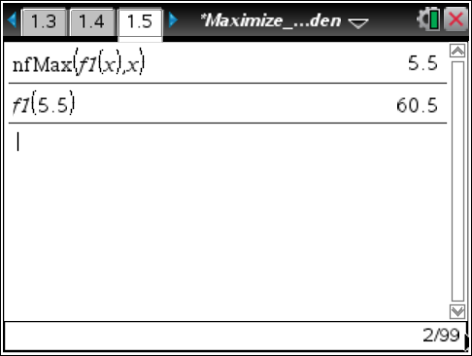
Method 1 in the Teacher Tip for Question 17  Note: These screenshots are shown in a new problem. This Problem 2 is not related to Problem 2 in the TI-Nspire document.  Graph the function f2(x) = 52.5 with the graph of the area function (f1(x)). Find the points of intersection of the graphs.  1. Select Menu > Geometry > Points & Lines > Intersection Point(s).  2. Move the cursor near one of the graphs and press x or ·.  3. Move the cursor near the second graph and press x or ·. Both points of intersection are displayed.  4. Press d to exit the Intersection Point(s) tool. | 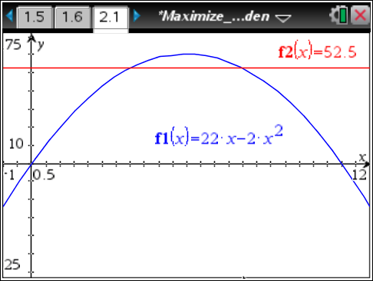
 | 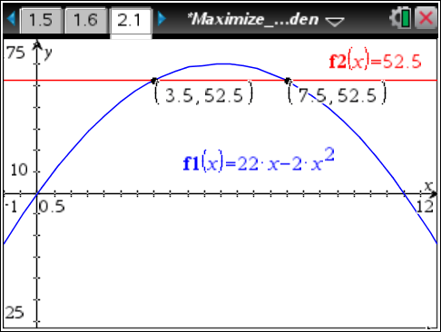
Method 2 in the Teacher Tip for Question 17  Add a point to the graph of the function. When the y-value of the point’s ordered pair is changed to 52.5, the value of x that results in this function value is computed.  1. To add a point to the graph of the function, select Menu > Geometry > Points & Lines > Point On.  2. Click twice on the graph of the function.  3. Press d.  4. Move the cursor over the y-value of the ordered pair, and press x or · twice to open a text box.  6. Replace the current value with 52.5, and press ·.  7. Place a point to the right of the vertex, and repeat the process to determine the second solution. | 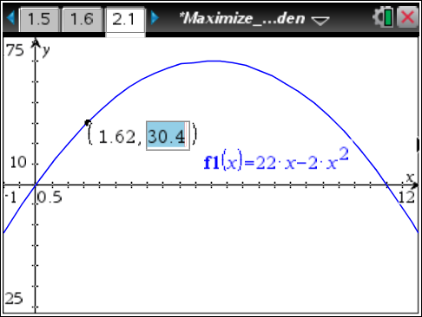  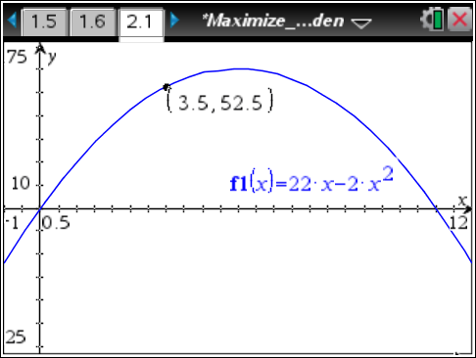
Method 3 in the Teacher Tip for Question 17  Use the Numerical Solve tool to find the width.  1. Add a new page by pressing / ~. Select Add Calculator.  2. Select Menu > Algebra > Numerical Solve.  3. Type 22x – 2x² = 52.5, x in the parentheses and then press ·. (Alternatively, enter nSolve(f1(x) = 52.5, x.)  4. To solve within a certain domain, include the left and right endpoints of the domain as shown. | 