Math Objectives  - Students will be able to interpret the slope of a line as the rate of change of the y-coordinate per unit increase in the x-coordinate as one moves from left to right along the line.  - Students will be able to determine value of the slope of a line from considering the change in y over the change in x between two points on a line.  - Students will be able to use the slope and knowledge of horizontal or vertical change between two points to determine the other.  Vocabulary  - ratio • vertical • rate  - slope • horizontal  About the Lesson  - This lesson involves helping students think of slope as a rate of change.  - As a result, students will:  - Be prepared to move to applications of linear functions where the change in one quantity is proportional to the change in another quantity.  TI-Nspire™ Navigator™ System  - Send out the Slope_as_Rate.tns file.  - Monitor student progress using Class Capture.  - Use Live Presenter to spotlight student answers.  Activity Materials  - Compatible TI Technologies: TI-Nspire™ CX Handhelds,  TI-Nspire™ Apps for iPad®, TI-Nspire™ Software | 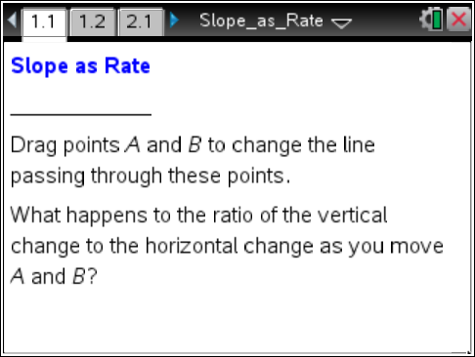  Tech Tips:  - This activity includes screen captures taken from the TI-Nspire CX handheld. It is also appropriate for use with the TI-Nspire family of products including TI-Nspire software and TI-Nspire App. Slight variations to these directions may be required if using other technologies besides the handheld.  - Watch for additional Tech Tips throughout the activity for the specific technology you are using.  - Access free tutorials at http://education.ti.com/  calculators/pd/US/Online-Learning/Tutorials  Lesson Files:  Student Activity  - Slope_as_Rate_Student.pdf  - Slope_as_Rate_Student.doc  TI-Nspire document  - Slope_as_Rate.tns

Discussion Points and Possible Answers

Tech Tip: If students experience difficulty dragging the point, check to make sure that they have moved the arrow until it becomes a hand (÷) getting ready to grab the point. Press /x to grab the point and close the hand ({). Press d to release the point or deselect other objects. Be patient on 1.2 and 3.1; it takes a moment for the values to update.
Tech Tip: If students experience difficulty grabbing and dragging a point, have them tap and hold the desired point for a few seconds and then drag the point to the desired location.

If a line is not vertical, then its slope tells us the rate of change in the y-coordinate to the change in x-coordinate as we move from one point on the line to another point.  - Move point A on page 1.2 to (–8, –5). Move point B to four different locations that make the slope of the line exactly equal to 0.6.  Answer: |  | 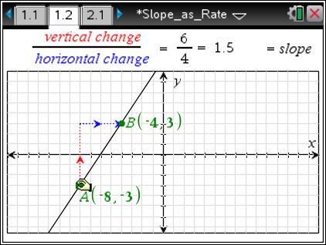
Coordinates of point B | Vertical Change  (from A to B) | Horizontal Change  (from A to B) | Change in y-coordinate  Change in x-coordinate
(2,1) | 1 – (–5) = 6 | 2 – (–8) = 10 | 0.6
(–3,–2) | –2 – (–5) = 3 | –3 – (–8) = 5 | 0.6
(7,4) | 4 – (–5) = 9 | 7 – (–8) = 15 | 0.6
(12,7) | 7 – (–5) = 12 | 12 – (–8) = 20 | 0.6

 | Tech Tip: The points on page 1.2 can be easily moved by clicking the point and then using the arrows. Use d to deselect.
 | Teacher Tip: You might want to revisit the amount of the vertical and horizontal changes. Students can determine this by simply counting the number of units. Some may know this ratio as “rise over run”. Some students might subtract the coordinates. If so, this would be a good opportunity to discuss the slope formula: .
TI-Nspire Navigator Opportunity: Quick Poll and/or Class Capture
See Note 1 at the end of this lesson.
2. Make a new line by moving both points A and B so that the slope is equal to –1.5 and the horizontal change in x-coordinates between A and B is 6.

- What is the vertical change in y-coordinates?

Answer: –9

b. Suppose two other points C and D are on the same line. The x-coordinate of C is 100 less than the x-coordinate of point A and the x-coordinate of D is 100 units greater than x-coordinate of point A. What is the difference in the y-coordinates of points C and D?

Answer: 300 units

Teacher Tip: A proportion could be used to solve this problem. The difference in the x-coordinates of points C and D is 200, therefore:

c. Which point has the larger y-coordinate? Explain your reasoning.

Answer: Point C has the larger y-coordinate because it is to the left of D, and the slope of the line is negative which means the line is falling from left to right.

Move to page 2.1.  If we are moving from left to right along a line, the slope of that line tells us how much the y-coordinate will change (and in what direction) for every 1-unit increase in x-coordinate.  3. Why does this make sense?  Answer: The slope is the vertical change divided by the horizontal change. A 1-unit increase in x-coordinate means the denominator (horizontal change) is 1, so the slope will be exactly the same as the numerator (vertical change), the change in the y-coordinate. | 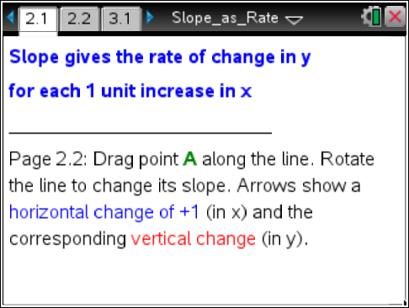
Move to page 2.2  4. Move point A along this line. Why is the vertical change shown always the value 0.6?  Answer: The slope is the vertical change divided by the horizontal change. Since the horizontal change is always a 1-unit increase and the slope is always 0.6, then the vertical change must always be 0.6. | 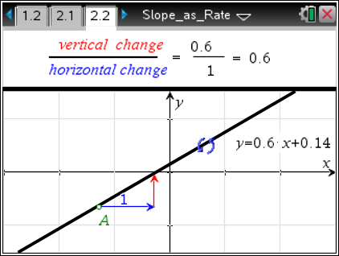
5. Now try rotating the line to different slope positions.
a. What will be true about the vertical change corresponding to a positive 1-unit horizontal change anywhere along a line of slope m?

Answer: The vertical change will be exactly the same as the slope.

- James has a line where the y-coordinate increases at a rate of 3 units for every 1 unit increase in x-coordinate. He believes the slope of the graph is 1/3, but is not confident. Explain why he is correct or where his thinking was incorrect.

Answer: James is incorrect. The correct slope is 3. He made the mistake of dividing the change in x by the change in y instead of the other way around. (This is a common error. Note that the sign of the slope is positive since the y-coordinate is increasing as the x-coordinate increases.)

- Miriam has a line where the y-coordinate decreases at a rate of 2 units for every 1-unit increase in x-coordinate. She is trying to decide whether the slope is 2 or –2. Sketch a graph to convince Miriam which slope is correct.

Answer: The sign of the slope is negative since the y-coordinate is decreasing as the x-coordinate increases. The sketch will have a negative slope.

d. Sal has a line where all the y-coordinates are the same. He says that the slope of the line is 0. Jay says the slope of the line is undefined. With whom do you agree, and why?

Answer: The slope is 0. (Note that the rate of change interpretation still makes sense – the
y-coordinates are not changing as the x-coordinate increases.)

Tech Tip: Students should use page 1.2 to explore and more easily get a slope of 0. Students will not be able to make the slope be exactly 0 on the freely rotating graph on page 2.2. A value such as 7.345E–4 is close, as this number is actually expressed in scientific notation, 7.345 x 10^{–4} = 0.0007345.

e. Ronah is looking at a graph of a line where the x-axis represents time in hours and the y-axis represents distance in miles. In what units would the slope of the line be measured? Draw a graph at which Ronah could be looking and explain the context of the situation.

Answer: The slope is the vertical change divided by the horizontal change, so the units of slope would be miles/hours (or miles per hour).
Students could draw a position-time graph and if the slope is positive, the object is moving away from the origin.

Teacher Tip: This is a very important connection to make for applying linear relationships in context. Mathematically proficient students can apply the mathematics they know to solve problems arising in everyday life. They can interpret mathematical results in the context of a situation and reflect if the results make sense.

f. The graph below shows Retha's distance traveled in miles for the first part of her trip. At what rate is she traveling?

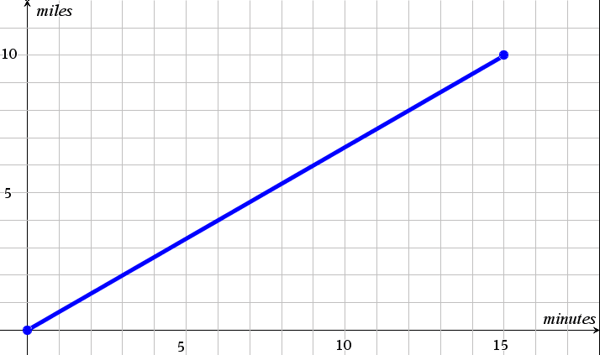

Answer: 10/15 miles/minute or 2/3 miles/minute or 40 mph.

TI-Nspire Navigator Opportunity: Quick Poll
See Note 2 at the end of this lesson.
Move to page 3.1.  Two slope triangles have been created on the given line.  6. Complete the table for the given coordinates of A, B, C, and D. | 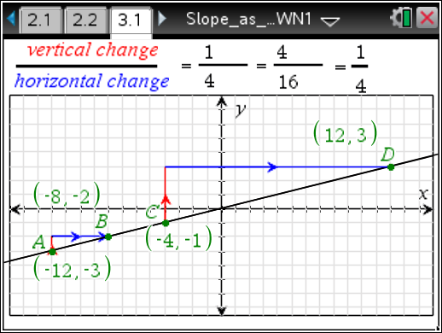
Change in y-coordinates
Change in x-coordinates
A (–12, –3) | B (–8, –2)
C (–4, –1) | D (12, 3)

7. a. What do you notice about the slope of the line that contains points A and B?

Answers The slope of the line is positive; the slope of the line is .

b. The line that contains points A and B also contains points C and D. What happens when you calculate the slope of the line using points C and D?

Answer: You get the same slope calculation as you do when using points A and B.

8. a. What do you expect will happen to the ratio of the vertical change to the horizontal change in the first slope triangle if you move A to a new location?

Answer: The ratio of the vertical change to the horizontal change will not change no matter where the points are on the line.

b. Move A to a new location. What is the ratio of the vertical change to the horizontal change?

Answer: The ratio of the vertical change to the horizontal change is still .

9. What relationship do the slope triangles have to each other?

Answer: The ratios of the vertical sides to the horizontal sides in the slope triangles are equal. Both slope triangles are right triangles. The slope triangles are similar.
10. A line has a slope of 4. One of the points on the line is (2, 5). Name another point that lies on the line and show how you determined the coordinates of the second point.

Sample Answers: Answer will vary. Any point (x, y) such that 4$=\frac{5-y}{2-x}$. For example (-3, 0).

TI-Nspire Navigator Opportunity: Quick Poll
See Note 3 at the end of this lesson.
11. What is the slope of the line that contains the points (–1, –3), (2, 3), and (3, 5)?

Answer: The slope of the line that contains the points is 2 no matter which two points you use to calculate the slope.

12. A line has a slope of 2. Name two points that lie on the line and show how you determined the coordinates of the points.

Answer: Answers will vary. For example, (2, 4) and (1, 2). The y changes by 2 for every one unit change in x. This can also be found by using the relationship $\frac{y_{2}-y_{1}}{x_{2}-x_{1}}=$2.

Wrap Up
Upon completion of the discussion, the teacher should ensure that students understand:
- The interpretation of slope as rate of change of y-coordinate per 1-unit increase in x-coordinate.
- How to use knowledge of slope and either the change in x or change in y to compute the other.
- The slope between any two points on the same line is the same.

TI-Nspire Navigator
Note 1
Question 1, Quick Poll and/or Class Capture: You might want to take a Class Captures of student work on Question 1. All student responses should line up on the same line through point A and with slope 0.6.

Note 2
Question 5, Quick Poll: These questions lend themselves well to a final quick poll to make sure students have gotten the key points of the lesson.

Note 3
Question 10, Quick Poll: Use an (x,y) Numerical Input Quick Poll to collect students’ points. All of the correct points that students submit will be collinear with the given point (2, 5). Right-click on the graph in the Review Workspace to Add Teacher Point (2, 5). Then right-click on the graph in the Review Workspace to Add Teacher Equation y = 4x – 3.

