Math Objectives  - Students will understand what it means for an ordered pair of numbers to be a solution to a single linear equation and to a system of linear equations.  - Students will use appropriate tools strategically (CCSS Mathematical Practice).  Vocabulary  - system of linear equations  - solve  About the Lesson  - This lesson involves solving systems of linear equations. The emphasis is on helping students understand that the solution to a system of equations is an ordered pair that makes both equations true (or “balances” both equations) at the same time.  - By using a visual approach to solving the system, students will discover the meaning of a numerical solution to a system of equations.  - Students will be able to explore systems of linear equations that have infinitely many or no solutions, non-linear systems, and systems with non-integer and negative solutions.  - A good warm-up activity to use is What Is a Variable. In it, students investigate how the value of an expression of the form mx + b for a given m and b changes relative to a change in x. The reasoning underlying this relationship can be helpful in figuring out how to work with the balance.  TI-Nspire™ Navigator™  - Use Quick Poll to check student understanding.  - Use Class Capture to examine patterns that emerge.  - Use Live Presenter to engage and focus students.  Activity Materials  - Compatible TI Technologies: TI-Nspire™ CX Handhelds,  TI-Nspire™ Apps for iPad®,  TI-Nspire™ Software | 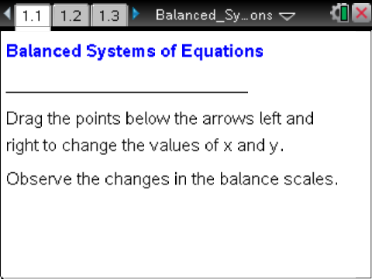  Tech Tips:  - This activity includes screen captures taken from the TI-Nspire CX handheld. It is also appropriate for use with the TI-Nspire family of products including TI-Nspire software and TI-Nspire App. Slight variations to these directions may be required if using other technologies besides the handheld.  - Watch for additional Tech Tips throughout the activity for the specific technology you are using.  - Access free tutorials at http://education.ti.com/calculators/pd/US/Online-Learning/Tutorials  Lesson Materials:  Student Activity  - Balanced_Systems_of_Equations_Student.pdf  - Balanced_Systems_of_Equations_Student.doc  TI-Nspire document  - Balanced_Systems_of_Equations.tns

Discussion Points and Possible Answers

Tech Tip: If students experience difficulty dragging a point, check to make sure that they have moved the cursor arrow until it becomes a hand (÷) getting ready to grab the point. Also, have students make sure that the label point x= or point y= appears. Instruct them to press / xto grab the point and close the hand ({). When they have finished moving the point, they should press d to release it.

Move to page 1.2.  - Move the arrows until x = 3 and y = 6. Describe what each scale looks like. Why are they in this position?  Answer: The left scale will be lower on the left side because when 3 and 6 are substituted for x and y, respectively, the left side of the equation is greater than the right side: 6 > 2(3) – 3, or 6 > 3. The right scale will be balanced because the two sides of the equation are equal: 3 + 6 = 9. | 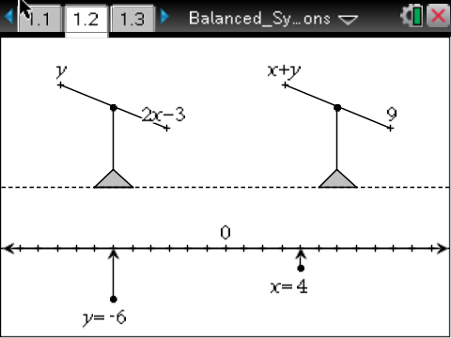
Teacher Tip: The lower side of the balance scale is the greater (“heavier”) side, while the higher side is the lesser (“lighter”) side. The values of x and y determine the ”weight” of each side of the scale, as can be seen when substitutions are made. For any (x, y) pair, the balances indicate the state of the two equations for the given values of x and y. Ultimately, the overall focus of the assignment is to find whether there are any (x, y) pairs that balance both scales. In this first question, students should be looking at how the values of x and y affect each of the balances.

TI-Nspire Navigator Opportunity: Live Presenter
See Note 1 at the end of this lesson.
- What does it mean if a scale is “balanced”? If x = –1, what value of y will balance the left scale? The right scale?

Answer: A balanced scale indicates that the values of the two sides are equal. If x = –1, the left scale is balanced when y = –5. If x = –1, the right scale is balanced when y = 10.

TI-Nspire Navigator Opportunity: Quick Poll (Open Response)
See Note 2 at the end of this lesson.
- Find three ordered pairs (x, y) that balance the left scale. Describe the strategy you used.

Sample answers: Answers will vary. Possible answers include (–1, –5), (0, –3), (1, –1),
(3, 3), and (4, 5). Students’ strategies might include choosing a value for x and evaluating the left side of the scale for the corresponding y-value or recognizing from earlier work that the value of the expression will change according to a pattern: as x increases by 1 unit, the value of y will increase by 2. The students can use this paradigm to create ordered pairs that will maintain the balance or equality. Other strategies are possible, including trial and error.

Teacher Tip: Students can solve numerically, algebraically, or simply by sliding the arrows on the number line in the .tns file. Reinforce that these ordered pairs are all solutions to the equation y = 2x– 3. Students might come up with ordered pairs such as (1.5, 0) without using the number line. This file was constructed to contain only integer values on the number line. You might want to discuss the fact that there are an infinite number of solutions to the equation. Students might also notice patterns in the ordered pairs leading to a discussion about slope, rate of change, and connections to the graph.

TI-Nspire Navigator Opportunity: Class Capture
See Note 3 at the end of this lesson.

- Find three ordered pairs (x, y) that balance the right scale. How was your strategy for this problem the same or different from the one you used in problem 3?

Sample answers: Answers will vary. Possible answers include (–1, 10), (0, 9), (1, 8), (4, 5), and (10, –1). Students might use a different strategy, since it is quite easy to generate ordered pairs whose sum is 9.

TI-Nspire Navigator Opportunity: Class Capture:
See Note 4 at the end of this lesson.

- Find values for x and y that satisfy the conditions in the table below.

Values |  | Is it Balanced?
x | y | Left Scale | Right Scale
2 | 1 | Yes | No
5 | 4 | No | Yes
5 | 1 | No | No
4 | 5 | Yes | Yes

TI-Nspire Navigator Opportunity: Class Capture
See Note 5 at the end of this lesson.
6. Compare your table from question 5 with a partner’s table. Were any of your answers the same? If so, which ones? Discuss why some of them might be the same and some might be different.

Sample answers: Most students will have different values for the first three rows of the table. Every student should have (4, 5) in the last row. For the third row, students should note that they need to find any ordered pair that does not work in either—and they can do that by deliberately choosing values that make both scales unbalanced. The key point is that only one ordered pair makes both of the scales balance at the same time and finding it might be difficult.

Teacher Tip: This is an important time to emphasize that there are infinitely many solutions for each of the individual equations, but only one solution that satisfies both equations at the same time. This is called the solution to the system of equations. Have students share how they found their solution for the fourth row, and ask the class whether they think the strategies would work for another set of equations and why.

7. What is the significance of the last row of the table in problem 5?

Answer: (4, 5) is the only solution to this system of equations.

Move to page 1.3.  8. How many solutions are there for this system of equations? How do you know?  Answer: There are infinitely many solutions. Every pair that balances one of the scales will also balance the other. Increasing x by 1 and y by 2 keeps both scales in balance. Since the pattern can be continued indefinitely, there are an infinite number of solutions. | 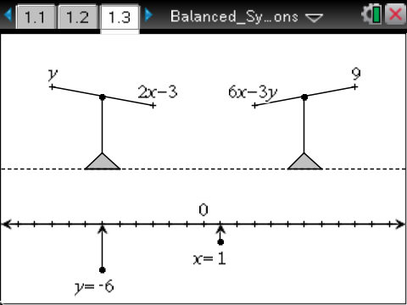
Teacher Tip: Since some students might stop after finding only one ordered pair that balances both equations, you may want to encourage students to find several different solutions. Because this system of equations has infinitely many solutions, you may also wish to discuss coinciding lines. Students might notice that the equations are equivalent. If the second equation is rewritten in slope-intercept form, it is identical to the first.

TI-Nspire Navigator Opportunity: Class Capture
See Note 6 at the end of this lesson.
Move to page 1.4.  9. How many solutions are there for this system of equations? How do you know?  Answer: The system has no solution. One reasoning method that can be used to arrive at this conclusion is to balance the left-hand scale and note that for every 1 unit increase of x, y increases by 2 | 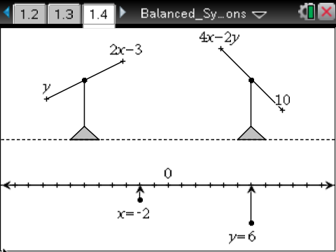
units. However this strategy always leaves the right-hand scale unbalanced. Thus, there is no way to balance both of the scales simultaneously.

Teacher Tip: Discuss with students the fact that these equations represent parallel lines. The slopes are the same, but the y-intercepts are different. This is easier to see if both equations are rewritten in slope-intercept form. You might also refer to the lesson titled How Many Are There? for additional support. Students might also notice that the second equation has coefficients that are twice those in the first (if the first equation was rewritten with the y term on the right side), but the constant term in one is not twice that in the other.
TI-Nspire Navigator Opportunity: Quick Poll (Open Response)
See Note 7 at the end of this lesson.

Wrap Up
Upon completion of the discussion, ensure that students are able to understand:
- A solution to an equation in two variables is an ordered pair of numbers that balances both sides of the equation, making the statement true.
- A linear equation in two variables has an infinite number of solutions.
- A solution to a system of equations in two variables is an ordered pair of numbers that balances the two equations at the same time, making both equations true at the same time.

Upon completion of the extensions, ensure that students understand that some systems of equations have one solution, some no solutions, and some indefinitely many solutions.

TI-Nspire Navigator
Note 1
Question 1, Live Presenter: Select a student to be the Live Presenter and show how to answer question 1. Discuss the mathematical sense of the movements of the balances as they relate to the changing values of x and y.

Note 2
Question 2, Quick Poll (Open Response): Use an Open Response Quick Poll to ask students to first submit their y-value for the left scale when x = – 1. Discuss how this was accomplished. Then ask students to submit their y-value for the right scale when x = –15. Discuss how this was accomplished.

Note 3
Question 3, Class Capture: Separate the class into two groups. Select one student to say one of the ordered pairs that he/she found. One group will show that it “balances” the equation (or not) using the balance, if possible. The other group will use the Scratchpad and show whether or not the ordered pair satisfies the equation by substituting on the screen. For example, using the ordered pair (4, 5), type into the calculator page: 5 = 2 ∙ 4 – 3 and press ·. When the equation is true, true will be displayed, otherwise false will be displayed. To return back to the document, students will press c > Current. Then, pick one or two students from each group and use the Class Capture feature to display only those students’ screens. Discuss their answers. If errors are made, use Class Capture or Live Presenter to show the correct answer. Repeat this for as many ordered pairs as you like.

Note 4
Question 4, Class Capture: Do the same procedure described in Note 3, but using the right-side equation.

Note 5
Question 5, Class Capture: Select four pairs of students. Assign each pair one of the four rows of the table to be completed. Use Class Capture to show each pair of students, one pair at a time, to show their answers. Discuss as needed. Ask for other ordered pairs that are not shown.

Note 6
Question 8, Class Capture: Once the students have established that there are an infinite number of solutions, take a Class Capture of all student screens to show as many different ordered pairs that satisfy the system as possible. (Note: if you teach more than one class that uses this activity, keep track of how many solutions were found in each class and encourage a friendly competition by saying something like, “Second period found 8 different ordered pairs.”)

Note 7
Question 9, Quick Poll (Open Response): Use an Open Response Quick Poll to have students submit their answers to question 9. Discuss how they decided upon their answer.

