Some Like it Tepid!
TI-Nspire CX II and TI-Innovator Hub with TI-SensorLink™

Project Overview: In this activity, students are challenged to design a system that informs the user if their coffee is too hot to drink. The system should notify the user of three states: Too hot to drink; too cold to drink; and just right to drink. Students may choose to notify the user with a particular color of the Innovator Hub’s onboard LED and/or a particular sound played on the built-in speaker. After designing and building the system, use the hot water and then ice water to test the system. Use the results of your tests to adjust the code to ensure the system works as expected.

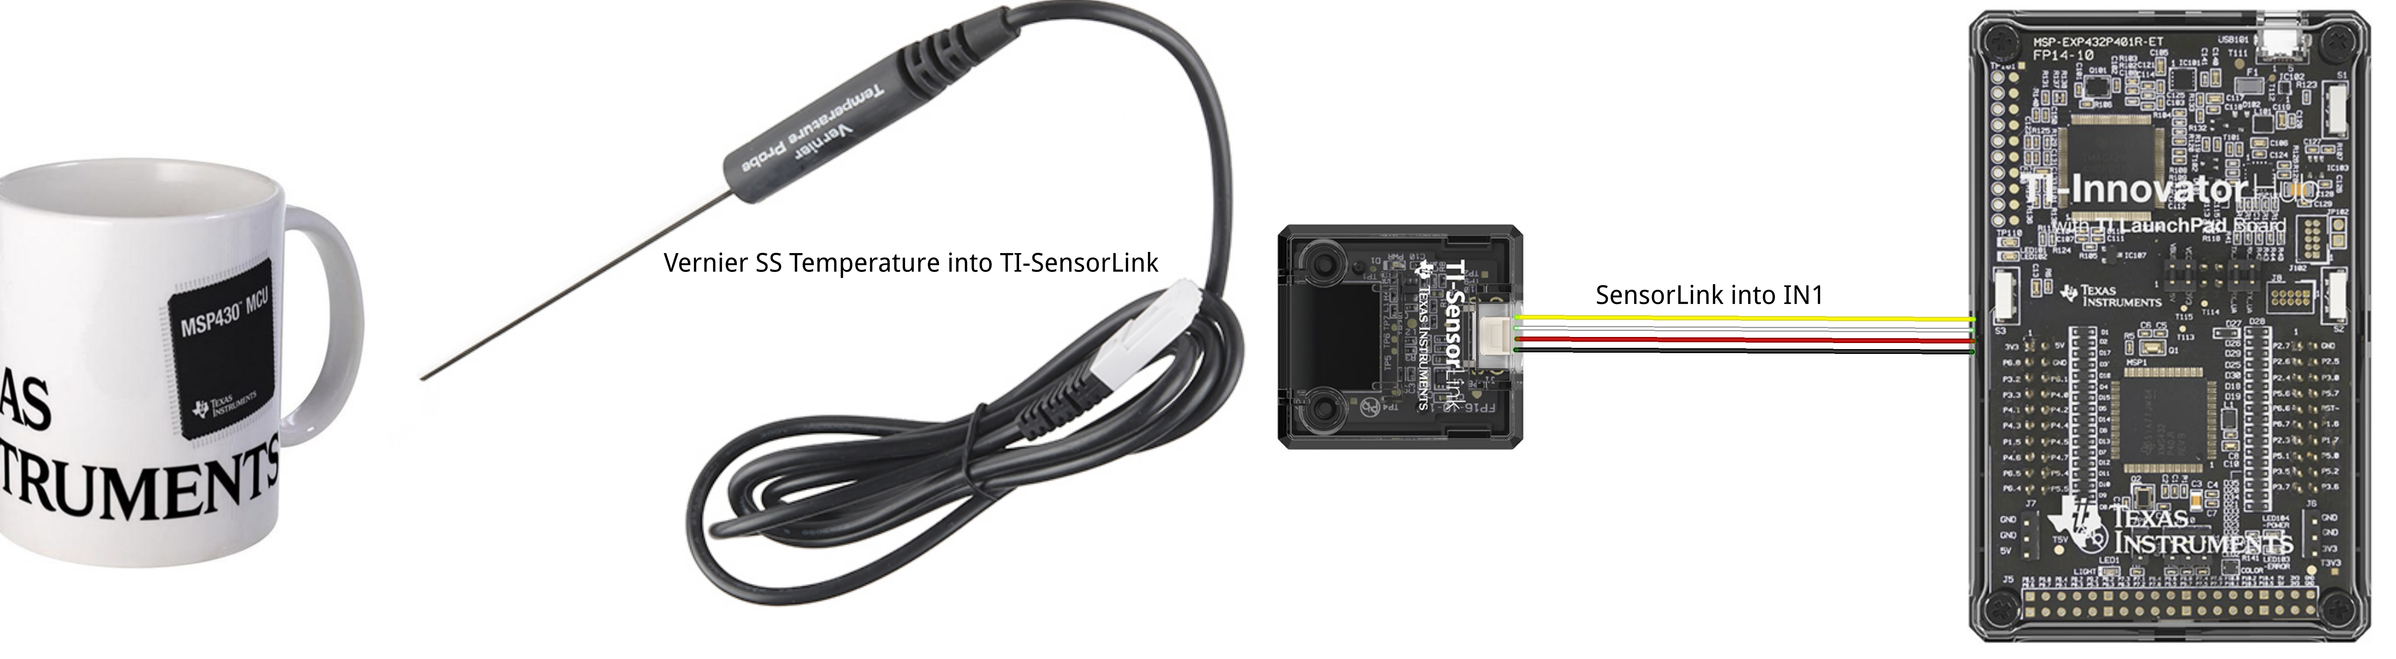
Parts List for project:
- TI-Innovator™ Hub  - TI Nspire CX II  - TI-SensorLink™ Adapter  - Vernier BTA SS Temperature Probe | - Coffee cup or styrofoam cup  - Hot water  - Ice in cubes  - Instant coffee (optional)

Example TI-BASIC Code for TI Nspire CX:
- Code snippet to set the RGB color LED to yellow on the Hub:  color.rgb(255,128,0)  - Code snippet to set speaker to 256 Hz on the Hub for 10 seconds:  sound.tone(256,10)  - Code snippet to display a message on the calculator:  text_at(8,”Just right”,”left”)  - Code snippet to connect and read the temperature sensor:  tempsensor=vernier(“IN 1”,”temperature”)  t = tempsensor.measurement()  text_at(5,“Temperature = “ + str(t)+ "°C")  - Code snippet to read and display the temperature sensor continuously every second until the [ecs] key is pressed.  while get_key() !=”esc”:  **t = tempsensor.measurement()  **text_at(5,”Temperature = “ + str(t)+ "°C",”left”)  - Complete Program:  from ti_hub import *  tempsensor=vernier("IN 1","temperature")  text_at(10,”press [esc] to quit”,”left”)  while get_key() != "esc":  t = tempsensor.measurement()  text_at(5,"Temperature = " + str(t)+"°C","left")  if t>65:  text_at(8,"It is cool","left")  color.rgb(255,0,0)  sound.tone(512,10)  if t>=50 and t<=65:  text_at(8,"Just right","left")  color.rgb(0,255,0)  sound.tone(256,10)  if t<50:  text_at(8,"too cool","left")  color.rgb(0,0,255)  sound.tone(1024,10)  sleep(1) | - Code snippet to a make decision tree using the if-then statement:  if t>65:  text_at(8,"It is cool","left")  color.rgb(255,0,0)  sound.tone(512,10)  if t>=50 and t<=65:  text_at(8,"Just right","left")  color.rgb(0,255,0)  sound.tone(256,10)  if t<50:  text_at(8,"too cool","left")  color.rgb(0,0,255)  sound.tone(1024,10)  sleep(1)

