Topic 3: Geometry and Trigonometry | Trigonometric Ratios, Unit Circle, Triangle Trig
- The following diagram shows $∆ABC$. Diagram not to scale.  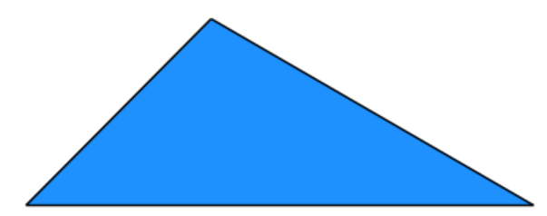  A  $16$  C $45°$ $30°$ B  $$A\hat{B}C=30° \\ B\hat{C}A=45° \\ AB=16$$  Find $AC$. |  | (6 marks)
Mark scheme:  Method 1  Valid approach to find the height of $∆ABC$.  E.g. $\sin{30}=\frac{x}{16}$ and $\cos{60}=\frac{x}{13}$  $\sin{30}=\frac{1}{2}$ or $\cos{60}=\frac{1}{2}$  Height = 8  Correct working  $$\sin{45}=\frac{8}{AC'}\sqrt{8^{2}+8^{2}}$$  Correct working  $$\sin{45}=\cos{45}=\frac{1}{\sqrt{2}}$$  Correct answer  $$PR=8\sqrt{2}$$  Method 2  Correct substitution in the Law of Sines  $$\frac{x}{\sin{30°}}=\frac{16}{\sin{45°}}$$  $\sin{30°}=\frac{1}{2}$ and $\sin{45°}=\frac{1}{\sqrt{2}}$  $$x\sin{45°}=16\sin{30°}$$  $$x=8\sqrt{2}$$ |  | (M1)  (A1)  (A1)  (A1)  (A1)  (A1)  (M1)(A1)  (A1)(A1)  (A1)  (A1)

