Topic 3: Geometry and Trigonometry | Trig Identities and Proofs
- Given that $\cos{x=\frac{4}{7}}$, where $x$ is an acute angle  - Find the value of $\sin{x}$  - Find the value of $\sin{2x}$ |  |  | (4 marks)  (3 marks)
Mark scheme:

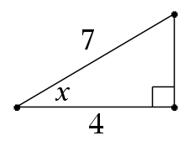
$$7^{2}=4^{2}+b^{2}$$  $$49=16+b^{2}$$  $$33=b^{2}$$  $$b=\sqrt{33}$$  $$\sin{x=\frac{\sqrt{33}}{7}}$$ |  | (M1)  (A1)  (M1)  (A1)
- $\sin{2x=2\sin{x\cos{x}}}$  $$\sin{2x=2}\left(\frac{\sqrt{33}}{7}\right)\left(\frac{4}{7}\right) \\ \sin{2x=\frac{8\sqrt{33}}{49}}$$ |  | (M1)  (M1)  (A1)

