Topic 2: Functions | Transformations of Functions
- 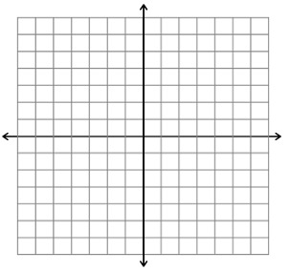  The graph of $y=f(x)$ for $-3≤x≤3$ is shown above.  - Sketch the graph of $y=f\left(x\right)-3$.  - Sketch the graph of $y=f(-x)$.  - Sketch the graph of $y=2f(x)$. |  | (2 marks)  (2 marks)  (2 marks)
Mark scheme: |  | (A2)  (A2)  (A2)

