Topic 5: Calculus | Graphical Relationships of Anti-Derivatives (AA HL and AI HL Only)
- The graph of the function $f$ is shown below.
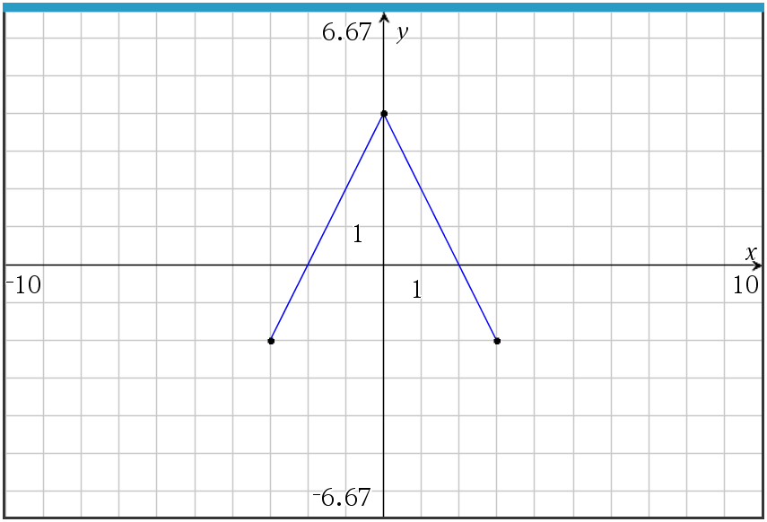
Let $g$ be the function given by $g\left(x\right)=\int_{0}^{x}{f(t)}dt$.
- Find $g(2)$, $g'(2)$, and $g''(2)$.  - Find the interval(s) within $(-3, 3)$ where $g$ is decreasing.  - Find the interval(s) within $(-3, 3)$ where the graph of $g$ is concave down. Explain your reasoning.  - On the axes below, sketch the graph of $g$ on the closed interval $\left[-3,3\right]$.  Mark scheme:  - $g\left(2\right)=\int_{0}^{1}{f\left(t\right)dt}=-\int_{-1}^{0}{f\left(t\right)dt}=-4$  - $g$ is decreasing on $-3<x<-2$ and $2<x<3$  $g^{'}\left(x\right)=f\left(x\right)<0$ on these intervals  - The graph is concave down on $0<x<3$. This is true because $g^{''}\left(x\right)=f^{'}\left(x\right)<0$ on this interval, or because $g^{'}\left(x\right)=f(x)$ is decreasing on this interval.  - 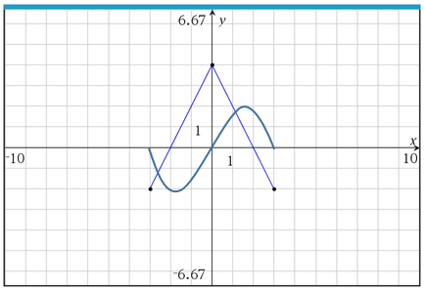  $$g\left(-3\right)=g\left(0\right)=g\left(3\right)=0$$Appropriate increasing/decreasing and concavity behavior. |  | (3 marks)  (2 marks)  (2 marks)  (3 marks)  (A1)  (A1)  (R1)  (A1)  (R1)  (A1)  (A1)

