Topic 5: Calculus | Graphical Relationships of Derivatives (AA Only)
- The following graph shows part of the graph of $y=g(x)$.
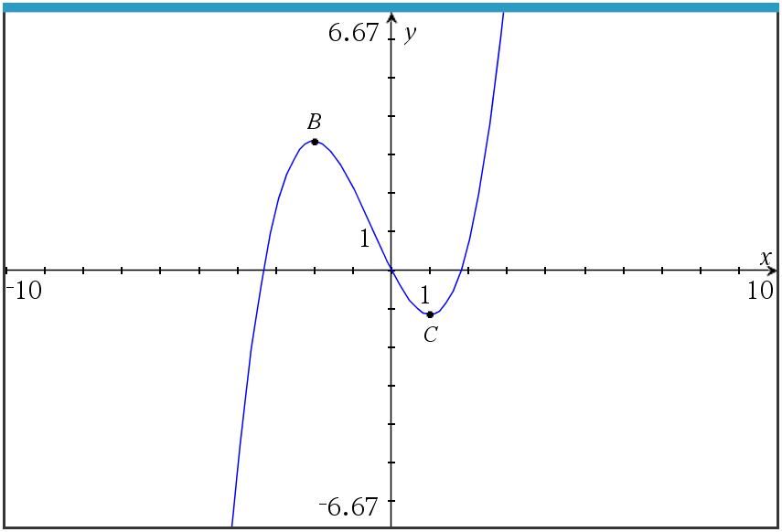
The graph has a local max at $B$ where $x=-2$, and a local min at $C$ where $x=1$.
- On the following axis, sketch the graph of $y=g'(x)$.  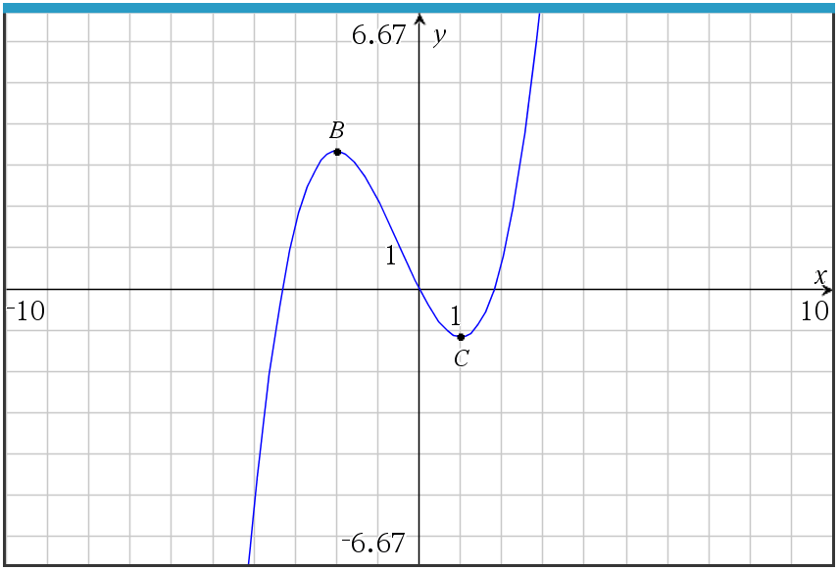  - Write down the following in order from greatest to least:  $g\left(0\right), g^{'}\left(2\right), g''(-2)$  Mark scheme:  - 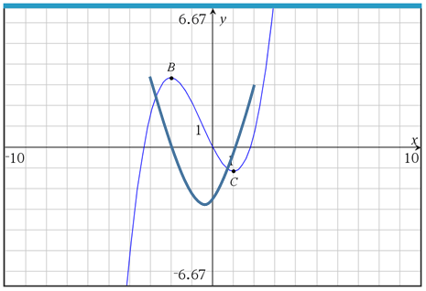  - $g^{'}\left(2\right), g\left(0\right), g''(-2)$ |  | (4 marks)  (2 marks)  (3 marks)  (2 marks)  (A1) (A1) for each correct x-intercept  (A1) for correct shape  (A1) for a negative y-intercept  (A2)

