The first and second derivative of a function can provide a great deal of information about the function itself. In this activity, you will examine the graphs of functions along with their derivatives and look for relationships that exist.

Throughout this activity, make sure your handheld is in Radian mode and round your answers to the nearest hundredth.

Problem 1 –
1. Input the equation $Y_{1}= x^{3}-1.5x^{2}-6x+2$ into the $Y=$ editor. Set the viewing window as shown and graph on your handheld.
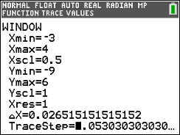

2. Find the x-values at which the relative maximum and relative minimum values of the
function occur. Press 2nd trace to find the exact values.

3. Find the intervals of x over which the function increases.

4. Find the intervals of x over which the function decreases.

5. State the kind of values the derivative should have over an interval where the
function increases. Explain.

6. Graph the derivative of the function. Press Math > 8: nDeriv. You will need to fill in the spaces
provided from this command. It should look like this: $\frac{d}{dx} (Y_{1})|_{x=x}$. You can find $Y_{1}$ by pressing
vars > Y-VARS > 1: Function.
7. Find the x-values of the derivative where a relative maximum or minimum
of the original function occurs.

8. State if the derivative is positive or negative over the intervals where the function
increases.

9. State if the derivative is positive or negative over the intervals where the function
decreases.

10. When the derivative crosses the x-axis from positive to negative, describe what happens
to the graph of the function.

11. When the derivative crosses the x-axis from negative to positive, describe what happens
to the graph of the function.

12. State over what intervals of x the derivative increases.

13. State over what intervals of x the derivative decreases.

14. If the first derivative is increasing, state if the second derivative is positive or negative.

15. If the first derivative is decreasing, state if the second derivative is positive or negative.

16. Graph the second derivative into $Y_{3}$. Use the same commands you used to find the first
derivative, the only difference is instead of using $Y_{1}$ you will be using $Y_{2}.$ Examine it where
the first derivative is increasing and decreasing. State if it matches your predictions. Explain
any differences, and state any additional observations.

17. The graph of a function is concave upward when the graph of the first derivative is
increasing. Sketch a portion of the graph $y=f(x)$ that is concave upward. State what is
true about the graph of $f'(x)$ where the graph of $y=f(x)$ is concave upward.

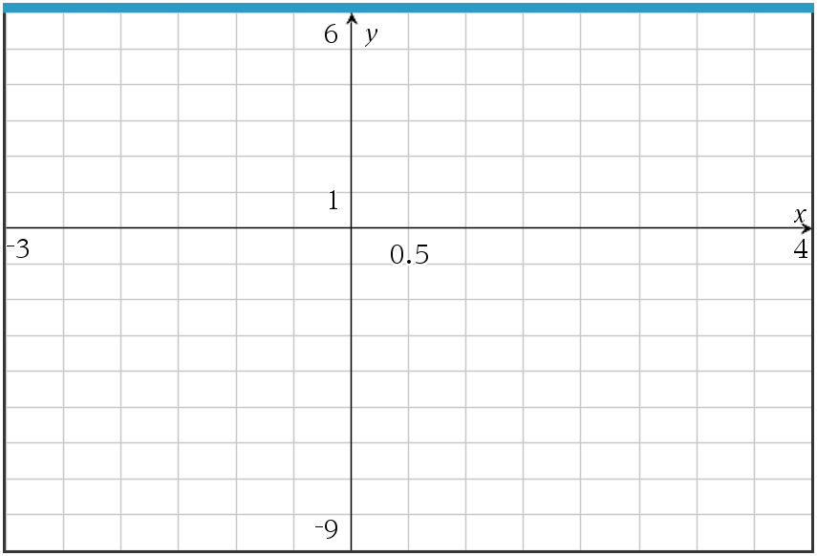

18. The graph of a function is concave downward when the graph of the first derivative is
decreasing. Sketch a portion of the graph $y=f(x)$ that is concave downward. State what is
true about the graph of $f'(x)$ where the graph of $y=f(x)$ is concave downward.

Problem 2 -

19. Graph the equation $Y_{1}=x\cos{(x)}$ over the interval [-5, 5] on your handheld.

a. State the interval(s) of x-values where the function is increasing.

b. State the interval(s) of x-values where the function is decreasing.

c. State the interval(s) of x-values where the function is concave upward.

d. State the interval(s) of x-values where the function is concave downward.

Problem 3 –

20. Suppose that you have only an equation for the derivative of a function. The derivative of f(x) is:

$$f^{'}\left(x\right)= \frac{x^{2}-1}{x^{2}+1}$$

Graph this into the $Y=$ editor and then change the window by pressing Zoom < 4: ZDecimal. Using your handheld as a guide, sketch the graph below.

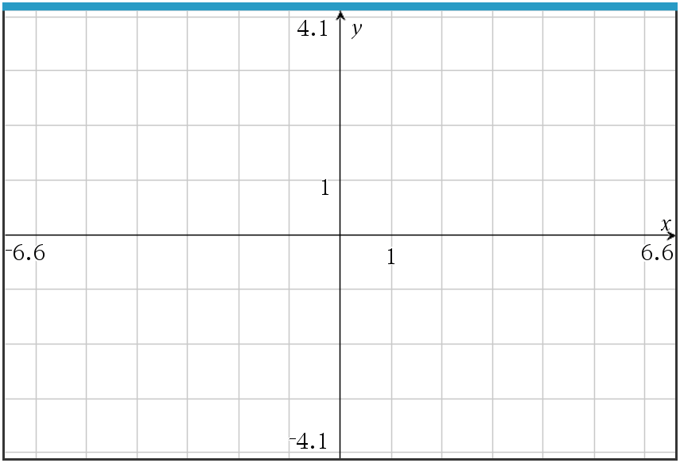

a. State the interval(s) of x-values where the function y = f(x) increases. Explain.

b. State the interval(s) of x-values where the function y = f(x) decreases. Explain.

c. State the interval(s) of x-values where the function y = f(x) is concave upward. Explain.

d. State the interval(s) of x-values where the function y = f(x) is concave downward. Explain.

Ticket Out the Door -

21. Summarize at least three main concepts that you explored in this activity.

