Topic 5: Calculus | Areas between a curve and the x-axis
The following diagram gives some of the graph $g\left(x\right)=\left(4-2x\right)(3+x)$. The shaded region A is bounded by the x-axis, y-axis, and the graph of g.

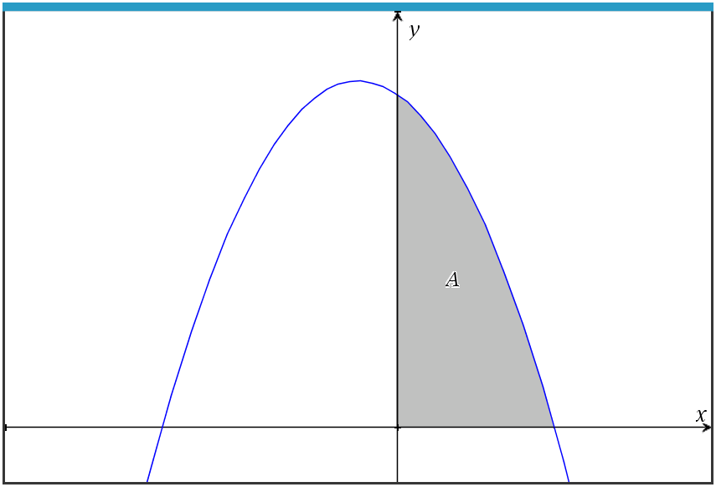

- Write down the integral for the area of region A.  (b) Find the area of region A.  The three points Q(2,0), R(4, 8 ), and S(c, 0) create the triangle below.  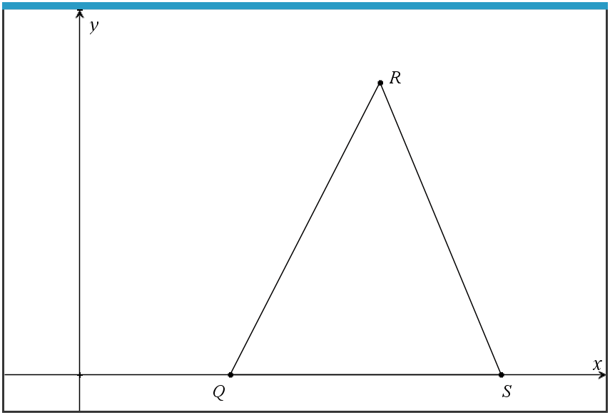  (This question continues on the following page)  (c) Find the value of c, the x-coordinate of S, such that the area of  the triangle is equivalent to the area of region A in part (b). |  | (2 marks)  (1 mark)  (2 marks)
Mark scheme:  - $A= \int_{0}^{2}{\left(4-2x\right)\left(3+x\right)dx}$  Note: Award A1 for having the correct limits x = 0 and x = 2. Award  A1 for an integral of f(x).  - 14.7 (accept $14\frac{2}{3}$, 14.6666…)  (c) $14\frac{2}{3}=\frac{1}{2} ×\left(c-2\right) ×(8)$  $c= \frac{17}{3}$ (accept $5\frac{2}{3}, 5.67, 5.6666…$) |  | (A1)(A1)  (A1)  (M1)  (A1)

