Overview: |  | Goals:
In this project, students build and program an introductory example of a feedback and control loop. This engineering principle is central to many industrial systems and consumer products. There are feedback and control principles in many Texas Instruments TI-Innovator™ Hub projects. During the project, students will engage with fundamental concepts in programming, such as variables, loops, conditional statements and Boolean operators.  The project includes a series of challenges that build the conceptual knowledge and skills needed for the final open-ended challenge. |  | Students will:  - Create and edit a Python program on the calculator.  - Connect the Hub with a sensor to the calculator.  - Write programs that include many commonly used Hub and calculator commands.  - Build a simple feedback and control system.
Note: For programming commands for this project, refer to the “Python Syntax Quick Reference” document

Setup Project: | Supplies:
Students may work in groups of two or three.  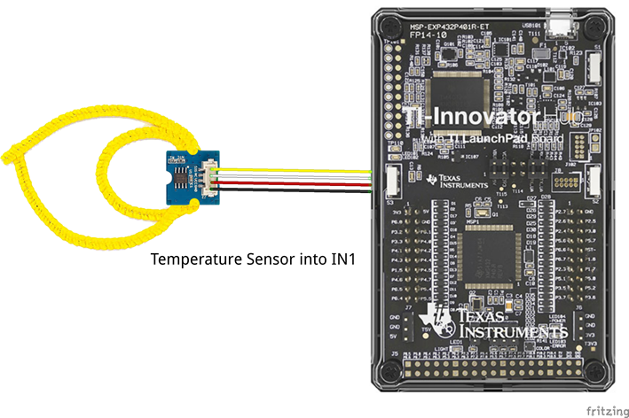 | - Calculator  - Unit to Unit Cable  - Hub  - Temperature sensor  - Grove Cable  - Chenille (“Fuzzy”) Wire  Note: Students will need to push the wire through the holes on the temperature sensor board to create a ring. The sensing element is on the flat side of the sensor board. Expect (and encourage!) trial and error as students attempt to determine the most effective ring design.

Student Activity: | Teacher Notes:
Challenge 6: Choose five mood messages from the list and write a program to display them, each on a different line, of the TI-Nspire CXII display. | - Mood messages to choose from  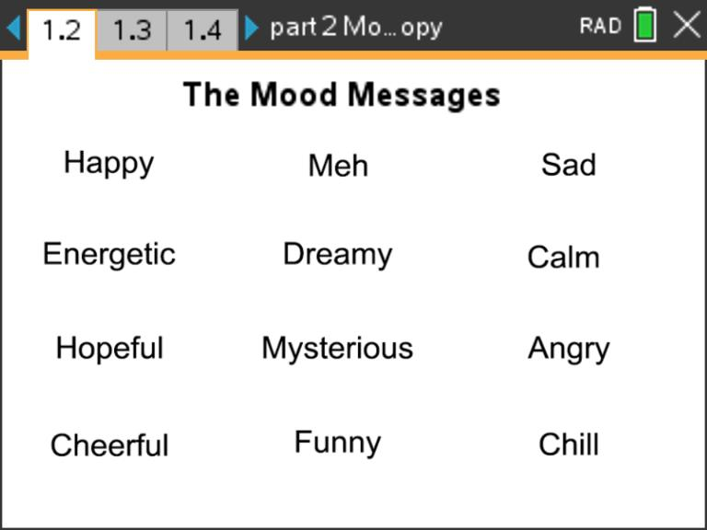  - Example Program:  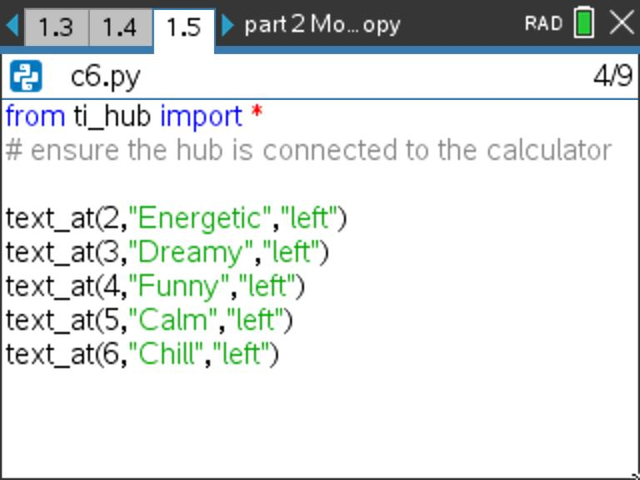
Challenge 7: Combine your favorite mood color with your favorite mood message.  Write a program that displays both. | - Example Program:  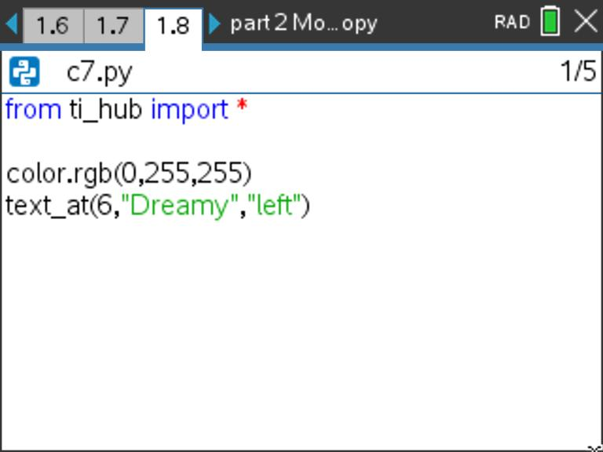  - Question:  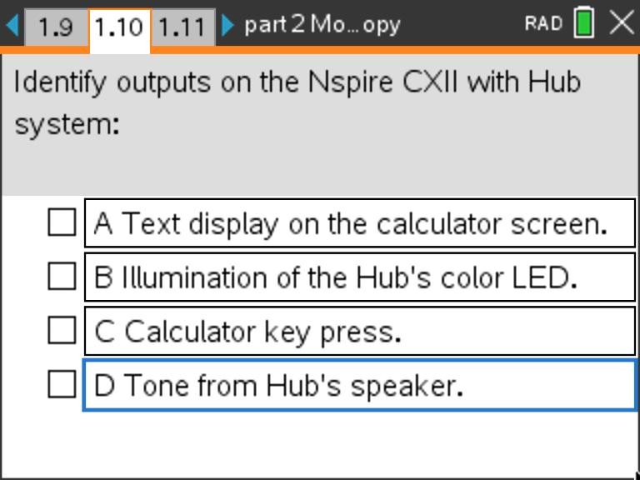
Challenge 8: Connect the temperature sensor to IN1 and write a program that creates a temperature object named my_temp.  Measure the my_temp object and store value in the variable named temp.  Display an appropriate prompt with the measurement value and units. | - Connect temperature sensor to port IN1  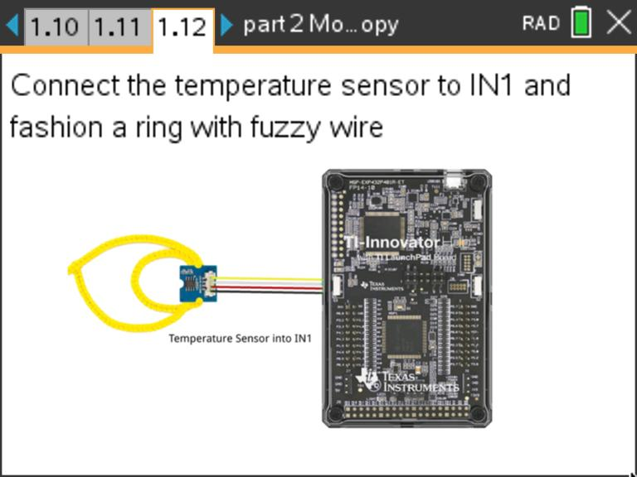  - Example Program:  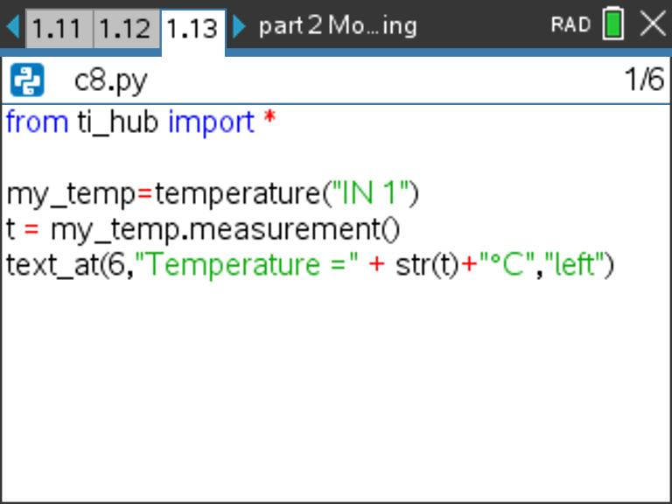
Activity 10: Use the previous program to explore the temperatures around you.  -What is the temperature of the room?  -What is the temperature of your skin?  -How low of a reading can you measure?  -What is the temperature of an ice cube?  * do not submerge sensor in liquid | - Question:  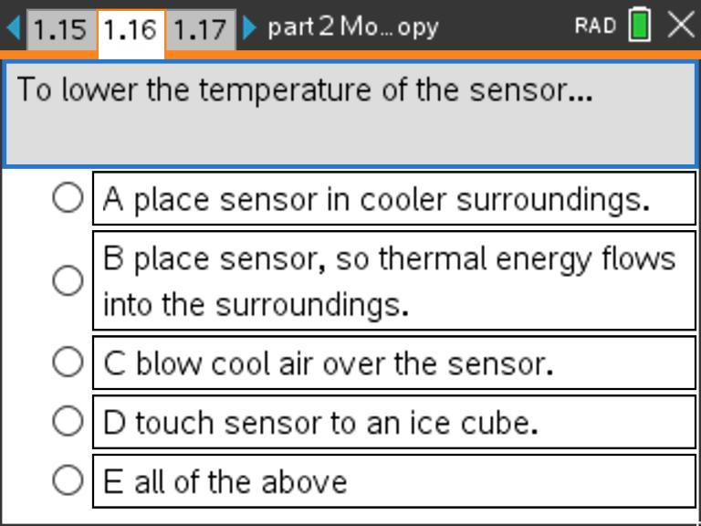
Challenge 9: Write a program using a for loop that will read and display ten temperature measurements.  Use sleep(2) to pause for two seconds in each cycle. | - Example Program:  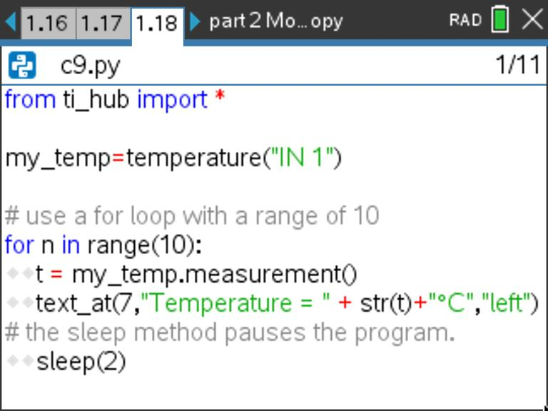  - Question:  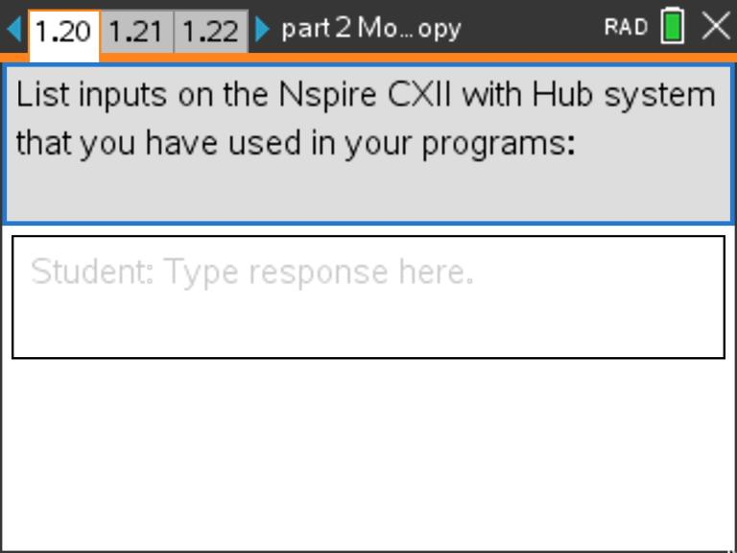
Challenge 10: Use a while loop to continuously monitor temperature.  Include an if conditional statement using appropriate temperatures to display the following text and LED color:  - "cool" - blue  - "just right" - green  - "hot" - red | - Example Program:  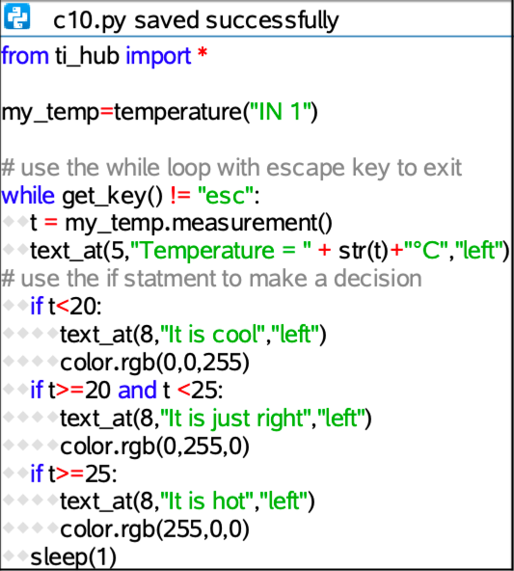
Final Challenge 11: Use the skills from all of the previous challenges to design and code your mood ring. Your program should display mood messages and colors over a range of finger temperatures.  Helpful tips:  -As a starting point, modify a copy of the previous program. Switch to that program editor page, and select [ctrl]+B, then [menu]->Actions->Create Copy.  - Include at least five if case intervals that change the mood color and message based on finger temperatures.  - Temperature intervals of about two degrees will help your ring respond to typical temperature measurements. | - Example Program:  