Overview: |  | Goals:
In this project, students build and program an introductory example of a feedback and control system. This engineering principle is central to many industrial systems and consumer products. During the project, students will engage with fundamental concepts in programming, such as variables, loops, conditional statements and Boolean operators.  The project includes a series of challenges that build the conceptual knowledge and skills needed for the final open-ended challenge. |  | Students will:  - Create and edit a Python program on the calculator.  - Connect the Hub to the calculator and a sensor to the Hub.  - Write Python programs that include many foundational programming concepts.  - Build a simple feedback and control system.
Note: For programming commands for this project, refer to the “Python Syntax Quick Reference” document.

Setup Project: | Supplies:
Each student codes their own calculator. Students may work individually or in groups of two, three or four to share the TI-Innovator Hub, temperature sensor and other equipment.  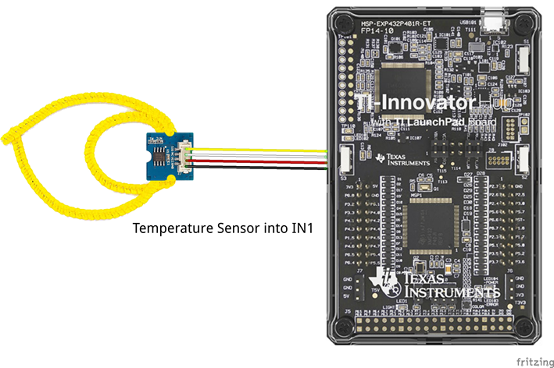 | - Calculator  - Unit to Unit Cable  - TI-Innovator Hub  - Temperature sensor (small blue square)  - Grove Cable (multi-colored cable)  - Chenille (“fuzzy”) Wire  Note: Students will need to push the wire through the holes on the temperature sensor board to create a ring. The sensing element is on the flat side of the sensor board. Expect (and encourage!) trial and error as students attempt to determine the most effective ring design.

Student Activity: | Teacher Notes:
First Step: Learn the basics of creating, editing and running a Python program on the TI-Nspire CXII by following two short videos. The first video provides an overview of the TI-Nspire CXII. The second video provides step-by-step guidance to write a short “Hello, World” Python program. | - Learn the basics of creating, editing and running a Python program on the TI-Nspire CXII by following two short videos. The first video (link) provides and overview of the TI-Nspire CXII. The second video (link) provides step-by-step guidance to write a short “Hello, World” Python program.  - For a more extensive exploration of Python on the TI-Nspire CXII, the 10 Minutes of Code lessons (link) are a step-by step introduction to programming concepts. Unit 1 will help your students become familiar with creating, editing and running Python programs on the TI-Nspire CXII.  - If some students are unfamiliar with Mood Rings or how they work, have students do a quick search on the internet for resources describing how a mood ring works. You may want to begin with this YouTube video, https://www.youtube.com/watch?v=gvGl51xOKTU&feature=youtu.be
Challenge 1: The color LED is controlled with the statement color.rgb(red value,green value,blue value). Each value ranges from 0 to 255, where 0 is off, 255 is full-on, and 128 is moderately dim.  Write a program named "c1" that turns on the Hub's color LED to red. Can you change the code to make a dim red? | - Example program:  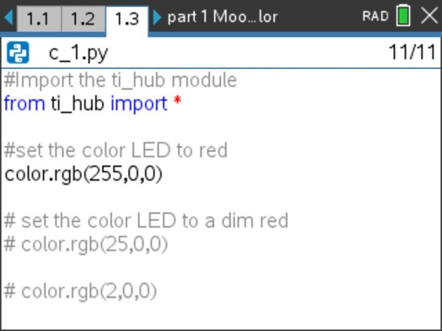  - Python enables extended functions beyond the core Built-in set by importing modules. For the Digital Mood Ring project, from ti.hub import * will bring in all the additions that you will need. The import statement and functions are available on the TI Hub menus.  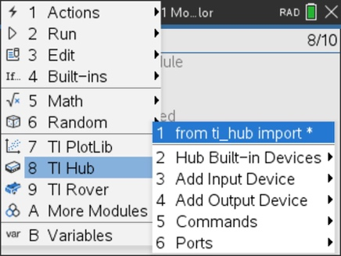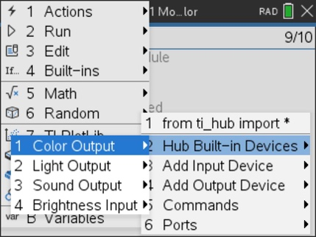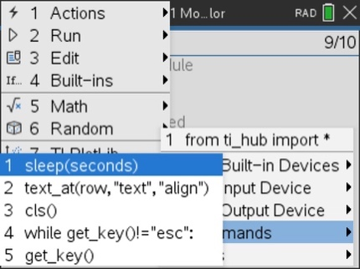  - In addition to annotating a program, comments can be used to turn a statement on and off. For example, in the Challenge 1 program, [ctrl]+T can be used to turn on for execution the color.rgb(25,0,0) or the color.rgb(2,0,0) statements.  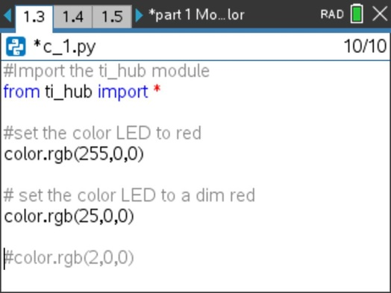
Activity 1: On the next page, hover the cursor over a center point in a box then [ctrl] + [center-click] to grab and drag one primary color box over another. Press [center-click] to release.  What secondary color is created from mixing two primary colors?  What happens when all three overlap?  Make these three secondary colors: Yellow, Cyan, and Magenta  Answer the questions following the activity. | - Color simulation and question:  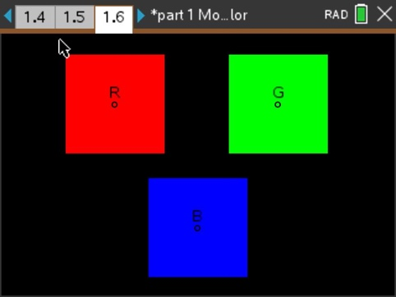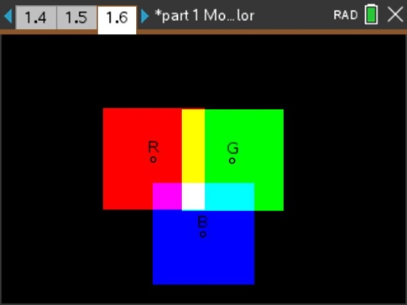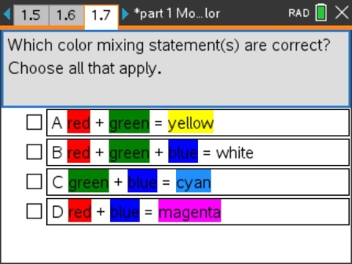
Challenge 2: Use the color mixing simulation as a clue to figure out the R, G, and B values for the secondary colors of cyan, yellow, and magenta.  Write a program that displays all three.  Use sleep(2) for a two-second pause between colors. | - Example Program:  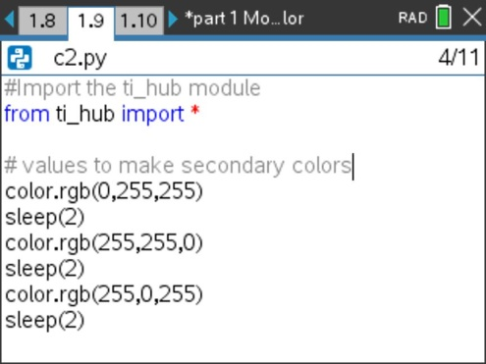
Challenge 3: Use the color mixing simulation as a clue to figure out the R, G, and B values for white.  Write a program that displays white and two darker shades of white (grayer).  Use sleep(2) for a two-second pause between shades. | - Example Program:  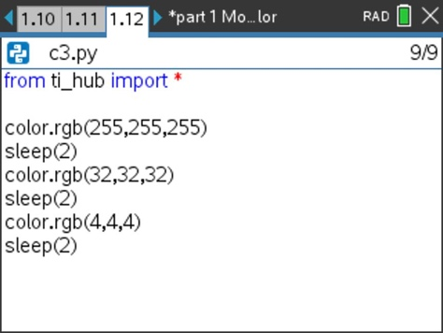  - Question:  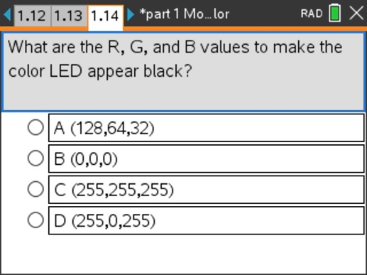
Activity 2: On the next page, check out the range of electromagnetic radiation (EMR) that exists in the universe.  Humans perceive a narrow region called visible light. There are many different wavelengths that humans do not perceive and are seen as black with our eyes.  Technologies exist that detect these invisible wavelengths and convert them to visible, such as infrared night vision goggles.  Direct your TV remote toward your eyes. Press any button.  Do you see the light flashing? Probably not since the remote flashes invisible infrared light signals to change the channel.  Next, point the remote at your cell phone camera or a web camera.  Does the camera detect the light?  It probably does because the camera detects the infrared.  Some cameras have a filter to block this unwanted light, so try different cameras. | - Electromagnetic Spectrum:  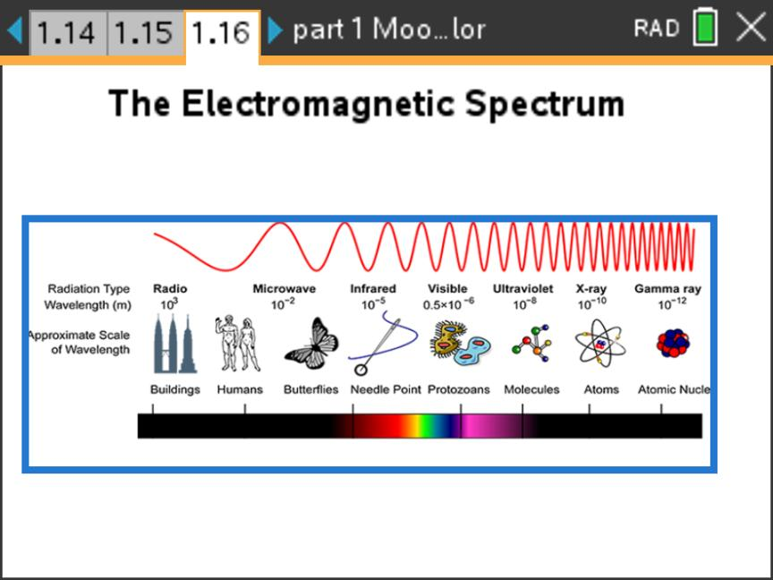  - Photo of Infrared (IR) Remote:  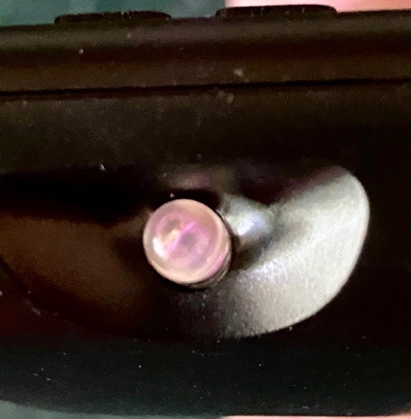  - Question:  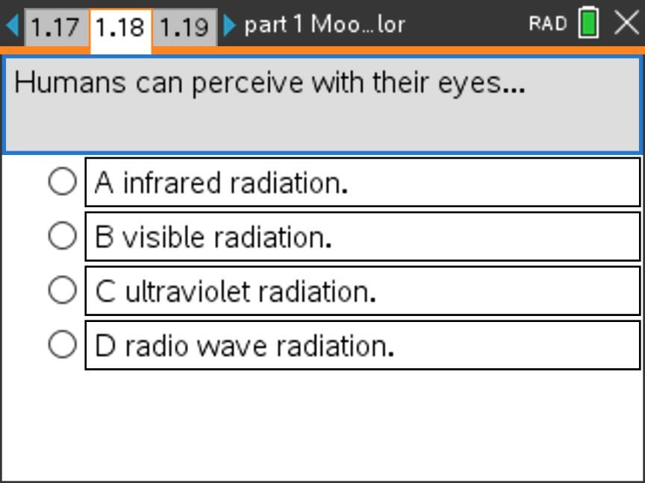
Activity 3: Use the simulation to explore the R, G, and B values and wavelengths of different colors.  Try to find the values of the primary and secondary colors.  The color wavelength has a very small unit nanometer (nm). One billion nanometers equals one meter!  Find the values for a favorite color.  Be creative and give your color an exciting name. | - The simulation is a tool for students to explore the part of the electromagnetic spectrum that is visible to humans.  - The simulation shows the wavelength of each color along the RGB values.  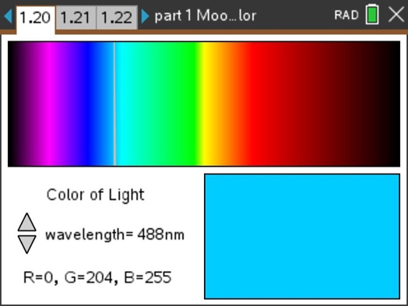  - Students find their favorite color along with RGB values for the color. Students give a creative name for their favorite color.  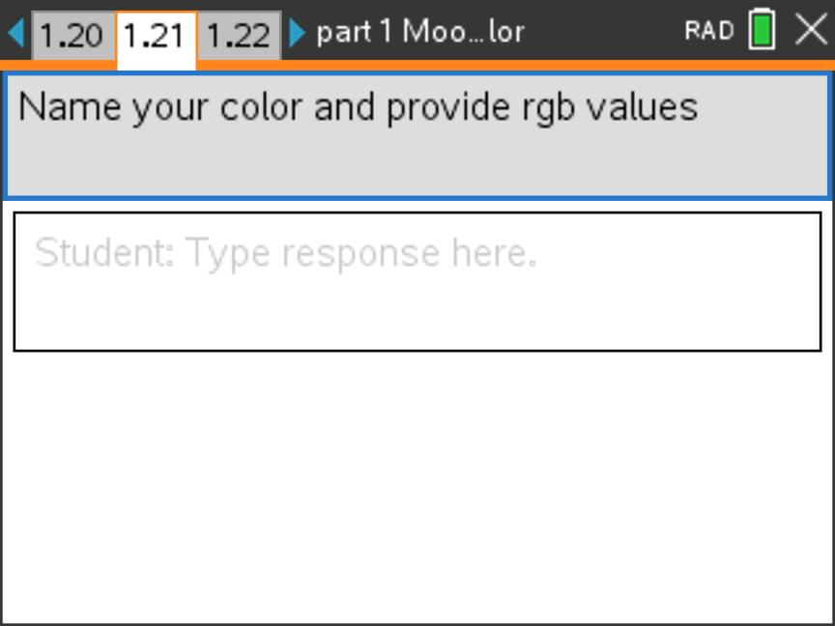
Challenge 4: Use the R, G, and B values for a favorite color in activity 3 to write a program that displays this color. Use the [ctrl] + [T] key combination to insert a comment in the program with the name of your favorite color. | - Example Program:  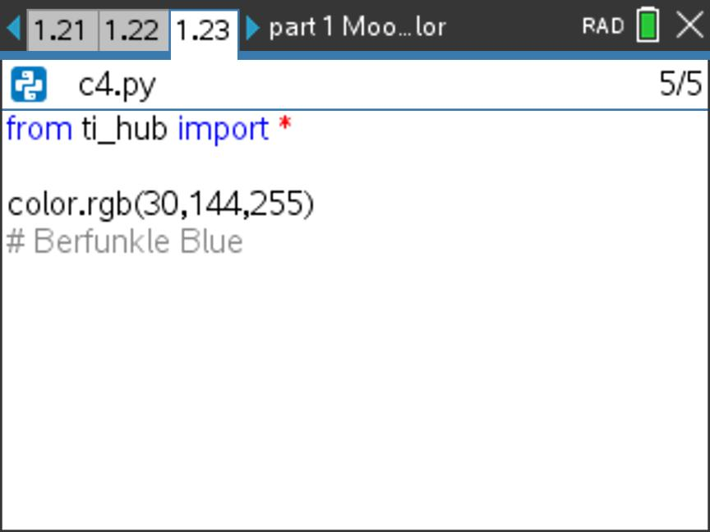
Activity 4: See the page showing a mood ring along with the mood colors the ring's stone could make depending on the "mood" (finger temperature) of the wearer.  Use your knowledge of color along with the previous activities to find the R, G, and B values for all of the colors listed.  Record the values in the spreadsheet provided. Use these as a reference in the next challenge program. | - Mood Ring Colors  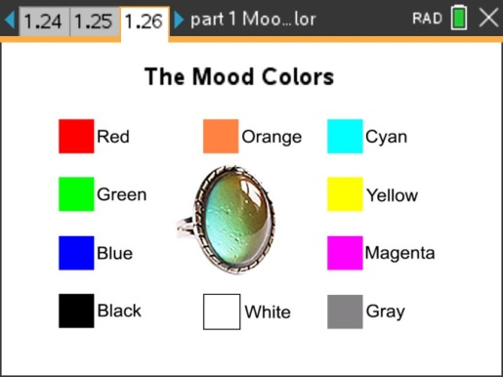  - Spreadsheet with RGB values  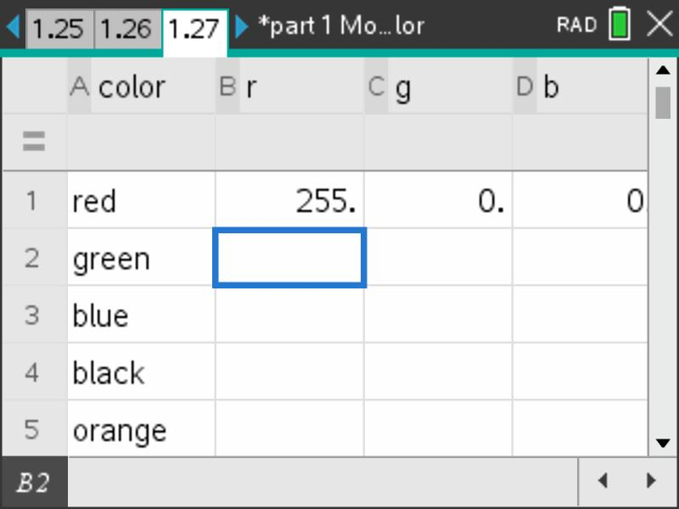
Challenge 5: Use the R, G, and B values you recorded in the activity 4 spreadsheet to write a program to display each mood ring color on the color LED.  Use sleep(2) for a two-second pause between each mood color. | - Example Program:  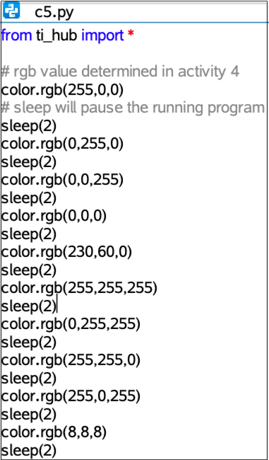
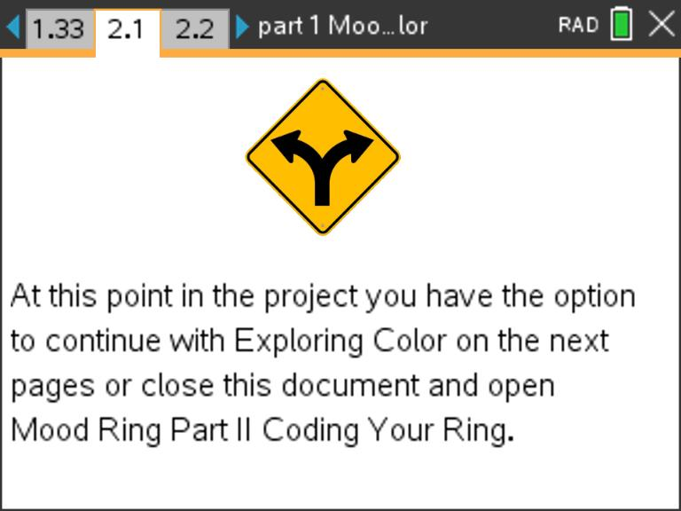 | - Your students have learned the science, engineering and programming concepts of color needed to complete the project. At this point you have the option to move to part 2 of the project to begin creating your mood ring or you can continue the optional section of part 1 to learn more about the science of color.
Activity 5: Use the simulation of the Hub's color light-emitting diode (LED).  There are three elements within the bulb. Each produces a different primary color.  The brightness of each primary color can be changed. Many colors result from mixing brightnesses of the primary colors.  The rgb.color(value, value, value) statement sets the brightness of each element in the color LED.  Explore how a few different colors are produced by the color LED. | - TI-Innovator Hub color light-emitting diode (LED) simulation  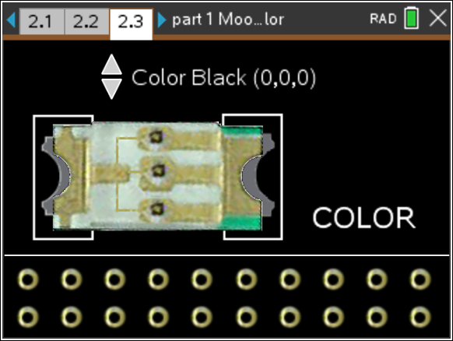  - Question:  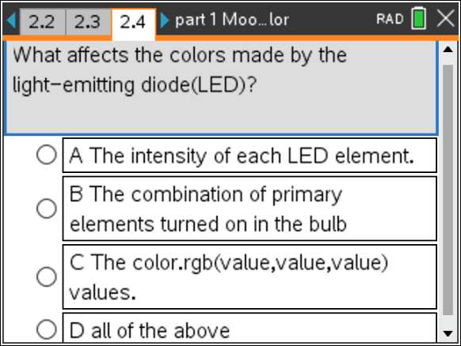
Activity 6: The human eye has a lens that focuses light onto the retina at the back of the eye.  Cone cells are one type of cell in the tissue of the retina. There are three kinds of cone cells, each sensitive to a range of wavelengths containing either red, green, or blue colors.  When colored light enters the eye, each cone cell produces a weak to a strong stimulus that travels along the optic nerve and enters the brain.  Inside the brain, we perceive color based on the stimuli from these three types of cone cells. | - How do we see color?  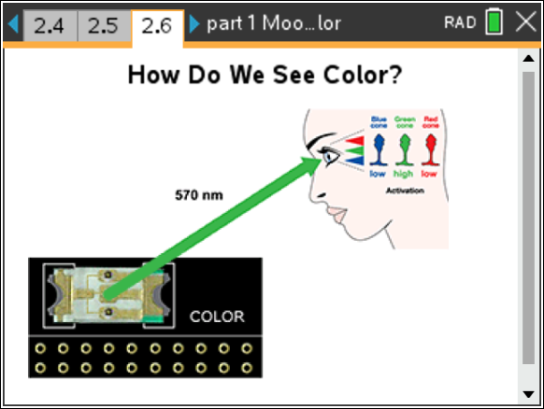  - Question  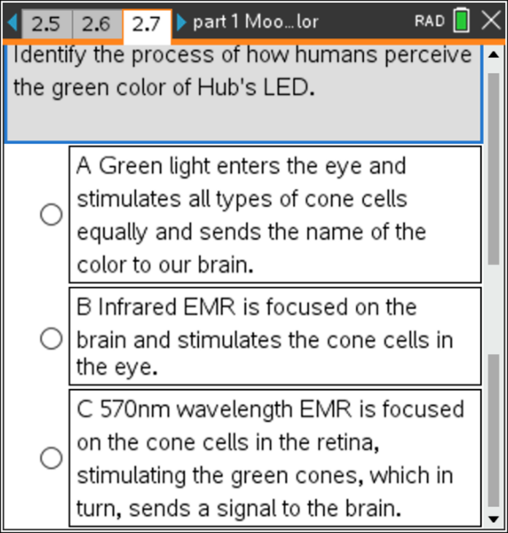
Activity 7: Try some of these fun experiments if you have the supplies available.  - In a dark room, view a green plant with a red lightbulb. How does it appear? Explain why.  - Place a blue plastic filter over an eye and view a green plant with that eye. How does it appear? Explain why.  - View a plant grow lamp. What color does it appear? Explain why it is that color? | - LED plant grow lamp  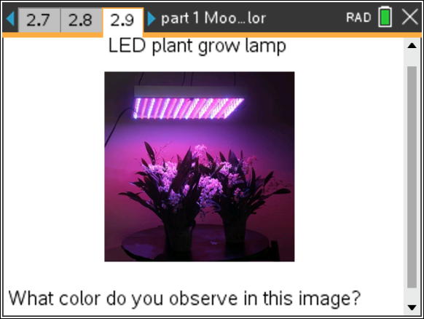  - Questions  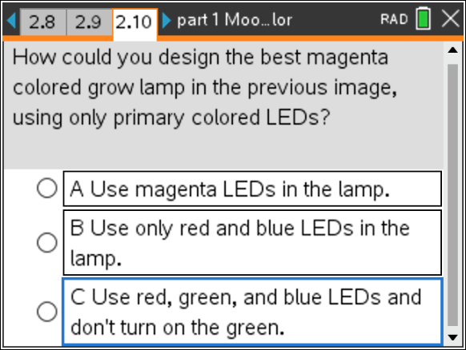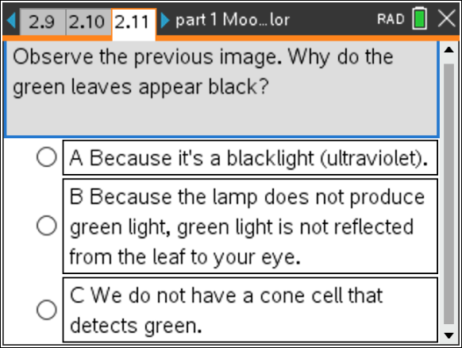
Activity 8: Color vision is a human perception based on the stimuli received by our brain from the three kinds of cone cells in the retina of the eye.  Differences among people's eyes result in slight differences in the perception of a particular color. Some people may perceive that color differently from others, similar to how some people do not have 20/20 vision.  These differences in color perception are called "color blindness". On the next page, check your color vision. | - What number do you see?  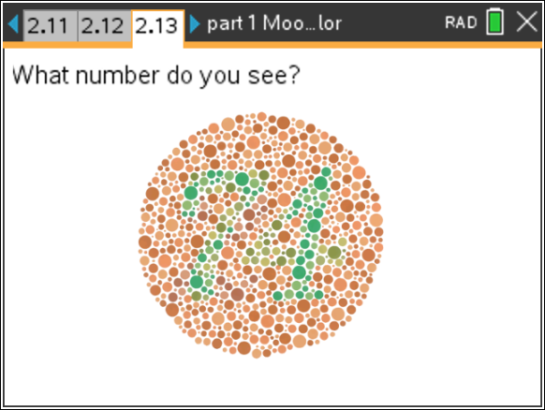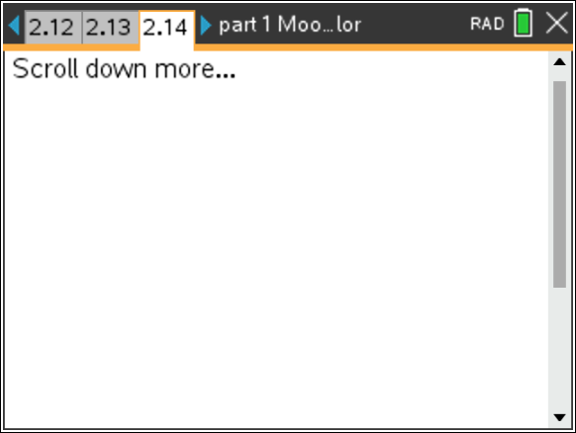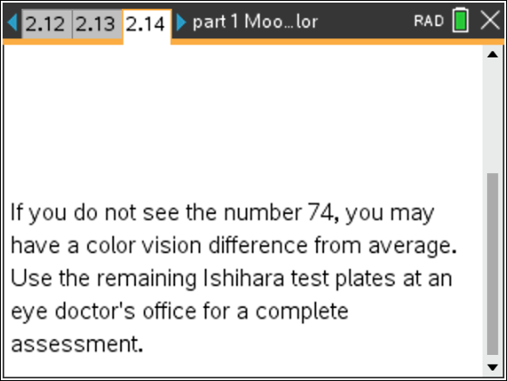
Activity 9: Georges Seurat was a 19th century French painter.  He painted with the pointillism method. This technique applies different colors of paint dots to the canvas so that adjacent colors optically interact to produce new perceived colors and an entire scene.  This technique from art is applied to the technology of television screens. A modern TV or cell phone screen is composed of millions of tiny color LEDs packed tightly behind a glass screen.  A TV or cell phone picture is produced by turning on each LED in a way similar to how Seurat painted with the picture on the next page using pointillism!  Try this fun experiment if you have the supplies available.  - Use a real magnifying glass to view a computer, cell phone, or TV screen up close. What do you see?  - Use a digital camera to take a closeup picture of a computer screen and then zoom in as far as allowed on the image. What do you see? | - A Sunday Afternoon on the Island of La Grande Jatte, on exhibit at the Art Institute of Chicago  