Math Objectives  - Students will discuss scenarios when best to use a t-test.  - Students will practice writing their null and alternative hypotheses.  - Students will decide between one and two tailed tests, finding the t-value and p-value with the handheld, and stating their conclusions.  Vocabulary  - t-test • normally distributed • variance  - hypotheses • pooled data • p-value  About the Lesson  - This lesson is aligning with the curriculum of IB Mathematics Applications and interpretations SL/HL  - This falls under the IB Mathematics Core Content Topic 4 Statistics and Probability:  4.11c  - In examinations t-test calculations will be made using technology.  - At SL, samples will be unpaired, and population variance will always be unknown.  - Students will be asked to interpret the results of a test.  - Students should know that the underlying distribution of the variables must be normal for the t -test to be applied. In examinations, students should assume that variance of the two groups is equal and therefore the pooled two-sample t -test should be used.  As a result, students will:  - Apply this information to real world situations  TI-Nspire™ Navigator™  - Transfer a File.  - Use Class Capture to examine patterns that emerge.  - Use Live Presenter to demonstrate.  - Use Teacher Edition computer software to review student documents.  - Use Quick Poll to assess students’ understanding  Activity Materials  - Compatible TI Technologies: TI-Nspire™ CX Handhelds,  TI-Nspire™ Apps for iPad®, TI-Nspire™ Software | 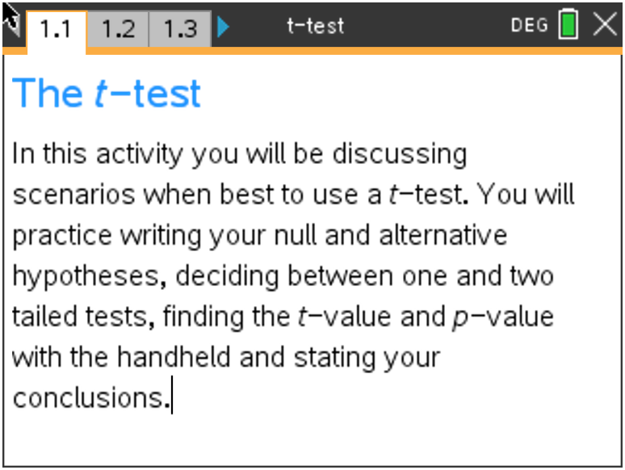  Tech Tips:  - This activity includes screen captures taken from the TI-Nspire CX II handheld. It is also appropriate for use with the TI-Nspire family of products including TI-Nspire software and TI-Nspire App. Slight variations to these directions may be required if using other technologies besides the handheld.  - Watch for additional Tech Tips throughout the activity for the specific technology you are using.  - Access free tutorials at http://education.ti.com/calculators/pd/US/Online-Learning/Tutorials  Lesson Files:  Student Activity  t-test_Student-Nspire.pdf  t-test_Student-Nspire.doc  TI-Nspire document  t-test.tns

Open the TI-Nspire document t-test.tns.

Move to page 1.2.

The t-test was created by William Gosset. He was an employee of the Guinness brewing company tasked with improving the taste and quality of their beer. He published his work under a pen name, "Student", which is why the test is sometimes referred to as Student's t-test.

It is a method of testing hypotheses about the mean of a small sample drawn from a normally distributed population when the population standard deviation is unknown. The t-test is used for comparing two data sets that are measuring the same thing.

Move to page 1.3.

On the following pages, you will be given several examples of data. You will do the following for each
example:

1. Write down the null and alternative hypotheses.
2. State whether the example is a one-tailed or a two-tailed test.
3. Using your handheld, you will find the t-value and p-value for a 2 sample t-test at the 5%
significance level.
4. Write down the conclusion to the test.

Move to page 1.4.

Problem – 1 (Practice)

Your math teacher wants to compare how his 2nd and 4th period classes are doing. He gives both
classes the same test on Wednesday to test their achievement levels, and the results are in the table
below:

Period 2 | 76 | 88 | 91 | 85 | 67 | 73 | 90 | 95 | 82
Period 4 | 94 | 70 | 79 | 83 | 71 | 81 | 89 | 84 | 77

Teacher Note: Please remind students that the two data sets being compared do not have to be of equal size to perform the t-test.

Move to page 1.5 and follow the process of discussing this data.

1. State the Null and Alternative Hypotheses.
H_{o}: $\overline{μ}$₁ = $\overline{μ}$₂
(There is no difference between the achievement levels between periods 2 and 4)
H_{a}: $\overline{μ}$₁ ≠ $\overline{μ}$₂
(There is a difference between the achievement levels between periods 2 and 4)

2. State if this is a one- or two-tailed test.
Two-Tailed Test
(This is a two-tailed test as you want to know whether period 2 is achieving more or less than period
4)

Teacher Note: It is assumed that the teaching and understanding of normally distributed data would have been accomplished before using this activity. This would be a good spot to review what a normal distribution curve looks like and what the one-tailed and two-tailed tests are.

Move to page 1.6 to test and conclude upon this data.

3. Find the t-value and p-value.
t-value = 0.522 and p-value = 0.609
(on page 1.7, the data from the table from above has been entered, go to page 1.8 and press
Menu > 6 Statistics > 7 Stat Tests > 4 2-Sample t Test, fill in the template to find the t-value and p-value and compare, make sure that you are pooling the data)

Teacher Note: This might be a good time to discuss the difference between pooling (equal variances) and unpooling (unequal variances) of the data sets.

4. Write down the conclusion.
Since 0.609 > 0.05, the null hypothesis is not rejected:
There is no real difference in the achievement levels between periods 2 and 4.

Move to page 1.9.

Problem – 2

Two different brands of batteries are being tested for their longevity (in minutes). The number of
minutes are listed in the table.

Battery 1 | 205 | 198 | 234 | 251 | 223 | 237
Battery 2 | 222 | 215 | 241 | 245 | 228 | 232

- Write down the null and alternative hypotheses.

Answer:
H_{o}: $\overline{μ}$₁ = $\overline{μ}$₂
(There is no difference between the battery longevity of the two battery brands)
H_{a}: $\overline{μ}$₁ ≠ $\overline{μ}$₂
(There is a difference between the battery longevity of the two battery brands)

- State whether this is a one-tailed or two-tailed test.

Answer:
Two-Tailed Test
(This is a two-tailed test as you want to know whether battery 1 is lasting longer or less than
battery 2)

- Find the t-value and p-value for a test at a 5% significance level.*

Answer:
t-value = -0.618 and p-value = 0.551

(d) Write down the conclusion to the test.

Answer:
Since 0.551 > 0.05, the null hypothesis is not rejected:
There is no real difference in the longevity between batteries 1 and 2.

*Use pages 1.10 and 1.11 to find the t-value and p-value.

Move to page 1.12.

Problem – 3 (**See Concept Extension for deeper understanding.**)

A company is testing a new fuel that will increase distance travelled per gallon. Using one gallon of gas
for each, six cars were tested with the new fuel and six cars were tested with the current fuel. The
distance travelled, in miles, is listed.

Current Fuel | 40 | 39 | 30 | 31 | 45 | 46
New Fuel | 37 | 47 | 51 | 48 | 38 | 40

- Write down the null and alternative hypotheses.

Answer:
H_{o}: $\overline{μ}$₁ = $\overline{μ}$₂
(There is no difference between the distance travelled with the current and new fuels)
H_{a}: $\overline{μ}$₁ < $\overline{μ}$₂
(There is a difference between the distance travelled with the current and new fuels)

- State whether this is a one-tailed or two-tailed test.

Answer:
One-Tailed Test
(This is a one-tailed test as you want to know whether the current fuel is having you travel less
miles per gallon than the new fuel)

- Find the t-value and p-value for a test at a 5% significance level.*

Answer:
t-value = -1.36 and p-value = 0.101

- Write down the conclusion to the test.

Answer:
Since 0.101 > 0.05, the null hypothesis is not rejected:
The company's claim is correct. There is no difference in the distance travelled with the
new fuel compared to the current fuel.

*Use pages 1.13 and 1.14 to find the t-value and p-value.

Move to page 1.15.

Problem – 4

A company claims to have a new medication to lower total cholesterol. It claims that those on the drug will lower their cholesterol more than those not taking the drug. 16 people are tested, then half will receive the new drug and half will receive a placebo. After one month, their cholesterol is checked again. The changes, in mg/dl, are below.

New Drug | 20 | 35 | 18 | 7 | 15 | 9 | 3 | 16
Placebo | 2 | 7 | 4 | 0 | 8 | 10 | 1 | 4

- Write down the null and alternative hypotheses.

Answer:
H_{o}: $\overline{μ}$₁ = $\overline{μ}$₂
(There is no difference between the cholesterol lowering with or without the new drug)
H_{a}: $\overline{μ}$₁ > $\overline{μ}$₂
(The cholesterol levels drop more with the new drug than without the new drug)

- State whether this is a one-tailed or two-tailed test.

Answer:
One-Tailed Test
(This is a one-tailed test as you want to know whether the drop in cholesterol is higher with the
new drug than without)

- Find the t-value and p-value for a test at a 5% significance level.*

Answer:
t-value = 2.94 and p-value = 0.00537

- Write down the conclusion to the test.

Answer:
Since 0.00537 < 0.05, the null hypothesis is rejected:
There is a difference in the amount of cholesterol that drops with the new drug
compared to without the new drug.

*Use pages 1.16 and 1.17 to find the t-value and p-value.
Extension

- In each of the problems of this activity, an assumption is being made about the given scenario,
state the assumption.

Sample Answers:
The data is normally distributed or the variances of both sets of data are equal.

- With your classmates, list four examples where using a t-test would be applicable in real life.

Sample Answers:
Comparing medications, two groups of students, two sports teams, etc.

TI-Nspire Navigator Opportunity: Quick Poll (Open Response)
Please note that any one of these Sampling questions can be used as Quick Polls

Concept Extension

For the data in problem 3, a .tns file has been created called Difference in means sim. In this file, students will explore the concept of repeated reassignment of cars to fuel types for this experiment. Since the assumption of the null hypothesis is that the mean distance traveled by the cars on each fuel type is equal, it is similar to saying that fuel type had no impact on the distance the cars would have traveled, and we are hypothesizing that the difference observed happened by chance. In other words, each of the twelve cars in the test would have driven their measured distance regardless of which fuel they were assigned to.

To test that claim, we will reassign the cars to the two treatments (new fuel and current fuel) and then compute the means of each group. Each time we do this, we record the difference in means. This creates a simulated sampling distribution of differences, which can be used to estimate the probability of observing the difference that occurred in the actual experiment, assuming that the null hypothesis is true.

This repeated reassignment gives students an opportunity to get a real feel for what the null hypothesis really means, and what their resulting p-value truly means. Counting the number of occurrences of the observed sample difference in means or a difference larger and computing the probability of such an occurrence lends to an understanding of what the computed area under the t-curve actually represents.

Page 1 shows the original experimental data. Page 2 shows that data plotted and Page 3 allows for repeated re-sampling of the data, showing the individual re-assignments, individual sample differences, and computes the p-value. Have your students interpret the p-value in context. It is the probability of observing a difference in mean distance traveled as large or larger than the one observed, assuming there is no difference in the efficiency of each fuel type.

**Note: This activity has been developed independently by Texas Instruments and aligned with the IB Mathematics curriculum, but is not endorsed by IB™. IB is a registered trademark owned by the International Baccalaureate Organization

