In this activity, students will use a tree diagram to find theoretical probabilities and use this information in lists to find the expected value. Students will be asked to differentiate between independent and dependent events and how to navigate the handheld when finding these probabilities. | 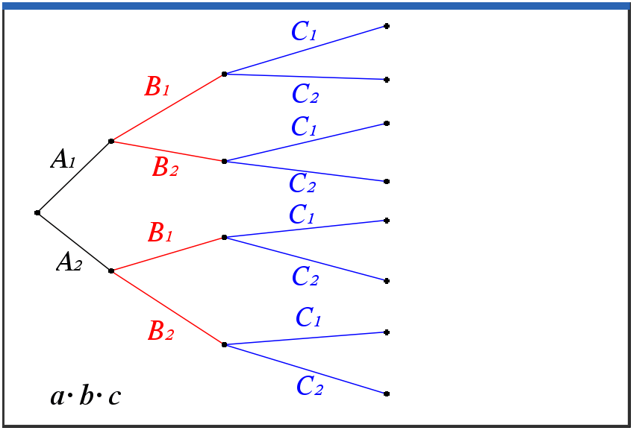
_____________________________________________________________________________________
Problem 1 – Creating a Tree Diagram

Open ItsToBeExpected.tns. Read the problem on page 1.2 and follow each page with each question below.

Three basketball players are in a contest, hoping to win money for a charity. There is a 63% chance that Aisha will make a shot, a 74% chance that Bria will make a shot, and a 56% chance that Carmen will make a shot.
1. List the sample space for the three shots. Use an A, B, or C to represent each girl in the sample space.

2. Find the probability that Aisha will make her shot. Find the probability she will miss her shot.

3. Find the probability that Bria will make her shot. Find the probability she will miss her shot.

4. Find the probability that Carmen will make her shot. Find the probability she will miss her shot.

One way to organize the results of the scenario is to create a diagram where each girl’s shots are represented. Next to the labels of each branch write the appropriate probabilities. (A = Aisha, B = Bria, C = Carmen, 1 = made, 2 = miss.)

C1
C1
C1
C1
C2
C2
C2
C2
A1
A2
B1
B1
B2
B2

Since the events of each girl making her shot are independent, the multiplication rule for probability can be used. Use the diagram to help calculate the eight probabilities.
5. Find the probability that none of the girls make their shots.

6. Find the probability that one girl makes her shot. (Hint: Find which of the eight probabilities that must be added together to find the answer.)

7. Find the probability that two girls make their shots.

8. Find the probability that all the girls make their shots.

Problem 2 – Introducing Expected Value

Read the problem on page 1.7. Then on page 1.8, enter the probabilities from pages 1.5 and 1.6. Enter the payoff in Column C and then calculate probabilities ∙ payoff in Column D.

If only one of the players makes her shot, they earn $5,000. If two make shots, they earn $12,500. If all three are successful, they earn $20,000. All of the money earned goes to charity. You will need to find the expected value of the contest for the charity. Expected Value is defined as the sum of the products of probabilities of the outcomes and their payoffs.

9. Find the expected value of the contest.

10. State if the charity should expect this amount of money. Explain why or why not.

Problem 3 – Putting it All Together

In a lottery game, players may pick six numbers from two separate pools of numbers — five different numbers from 1 to 56 and one number from 1 to 46. You win the jackpot by matching all six winning numbers in a drawing.
MATCH |  | MATCH | PRIZE | CHANCES
5 | + | 1 | Jackpot | 1 in 175,711,536
5 | + | 0 | $250,000 | 1 in 3,904,701
4 | + | 1 | $10,000 | 1 in 689,065
4 | + | 0 | $150 | 1 in 15,313
3 | + | 1 | $150 | 1 in 13,781
3 | + | 0 | $7 | 1 in 306
2 | + | 1 | $10 | 1 in 844
1 | + | 1 | $3 | 1 in 141
0 | + | 1 | $2 | 1 in 75
Overall chances of winning a prize: |  |  |  | 1 in 40

1. Verify the chances to win the jackpot from your knowledge of counting principles.

2. Calculate the expected value for the lottery assuming the jackpot is $42 million.

3. Tickets cost $1.00 per play. Find how much the lottery will make/lose for each ticket sold.

4. Find the expected value that would be needed for the lottery to break even.

5. Find what the jackpot would need to be for the lottery to break even.

Futher IB Application

After the Bills vs the Patriots game on Sunday, a sample of 50 attendees was randomly selected as they were leaving Highmark Stadium. They were asked how many times they visited the concessions stands for food or drink. The information is summarized in the following frequency table.

Number of times visited concession stands | Frequency
0 | 5
1 | 20
2 | 18
3 | 4
4 | 3

It can be assumed that this sample is representative of all attendees to the stadium for next week’s game vs the Dolphins. For next week’s game, estimate

(a) the probability that a randomly selected attendee will visit a concession stand.

(b) the expected number of times an attendee will visit a concession stand.

