Overview

In this activity, you will look at a setting that involves categorical data and determine which is the appropriate chi-square test to use. You will input data into a list or matrix and conduct the chi-squared goodness of fit or chi-squared two-way test.

Materials
• TI-Nspire™ handheld or Computer Software
____________________________________________________________________________________

Three different chi-squared tests will be discussed in this activity:
- χ² Goodness-of-Fit (1): Compares sample counts (sometimes given as proportions) to expected counts based on a given population distribution.
- χ² Two-way tables (2 & 3): There are two chi-squared tests using two-way tables—independence and homogeneity. The two tests differ in their hypotheses and conclusions but are mechanically identical. Determining which to use depends on how the data were collected.
- Test of Independence: Compares two categorical variables in a single population to determine whether there is a significant association between the two variables.
- Test of homogeneity: Compares categorical variables from two or more different populations to determine whether proportions are the same across different populations.

Part 1 – Preparing the document
1. Open a new document by pressing On > New > Add Notes.
2. Type Chi-Square Tests.
3. Press doc > File > Save As … and type the file name Chi-Square_Tests. Tab to save, and press ·.
Note: To obtain capital letters on the handheld, press the g key, then the letter.

Problem 1
A school wants to see if student absences are different on different days of a randomly selected week of school.

Day of  week | Observed  absences | Expected  absences
Monday | 173
Tuesday | 157
Wednesday | 138
Thursday | 149
Friday | 188
Total:

Part 2 – Determine which Chi-Square test to use

The school wants to see if daily student absences are the same on different days of a randomly selected week of school — do the observed student absences fit a uniform distribution? This question uses a Chi-squared Goodness-of-Fit Test. The hypotheses are:
- Ho: the proportions of absences are the same for each day of the week, that is 20% of the total absences would occur each day (p_{monday} = p_{tuesday} = p_{wednesday} = p_{thrusday} = p_{friday} = 0.2).
- Ha: at least one proportion is different.

Part 3 – Enter the data

1. Find the total number of observed student absences for the week. You can use the Scratchpad »
on your handheld to do the addition. Fill in the value under the table above.

The expected counts for each day of the week in this chi-square Goodness of Fit Test are the total number of absences divided by five (5).

2. Enter the total absences, divided by 5, into the first cell of the expected absences column in the table above.

3. Fill in all five rows of the table with the expected counts that you found.
- Another option would be to use the Scratchpad » to find the expected counts. Close the Scratchpad by clicking the red X.

Note: Sometimes students will get an exact rather than an approximate answer when calculating inside a cell. This can be changed in c > Settings >Document Settings > Calculation Mode. Or, individual approximate answers can be forced by using a decimal point in one of the values.

4. Add a new page by pressing / ¿ and selecting Add Lists & Spreadsheet.

5. On the Lists & Spreadsheet page, use the scroll bar on the right to move to the top of the
spreadsheet, and then move the cursor to the top of Column A. Type absences to label Column A, and press ·.

6. Move the cursor to the top of Column B, and type expected to label Column B.

7. Fill in the data for the number of absences for each day of the week.  Be sure to press · after you enter each value, which will move you to the next cell. |  |  | 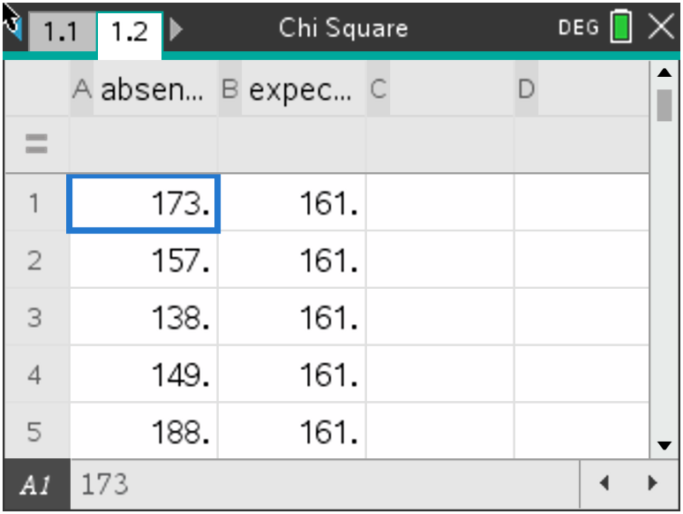
8. Move to the next column to fill in the data for the expected absences.
- If you make a mistake, move the cursor to that cell, press a to activate the cell, input the correct value and press ·.

Note: To save your document, press / ».

Part 4 — Find the test statistic and p-value  1. Move the cursor to top right cell of the data (B1) in your lists.  2. Select MENU > Statistics > Stat Tests > ${}^{2}$ GOF Test to begin the hypothesis test to find your test statistic and p-value. |  |  | 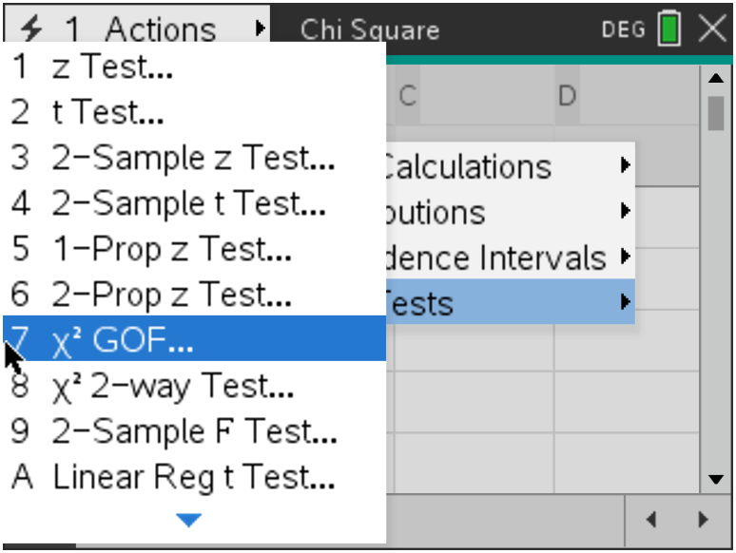
3. Fill in boxes of the dialogue box as follows (tabbing between fields):  - Observed list: absences  - Expected list: expected  - Deg of Freedom : 4 [the number of rows minus one (n-1)].  If you want to draw a picture of the chi-square curve with the p-value shaded, click the check box (this will split the screen and draw the graph on the right side of the screen when the calculation is performed). |  |  | 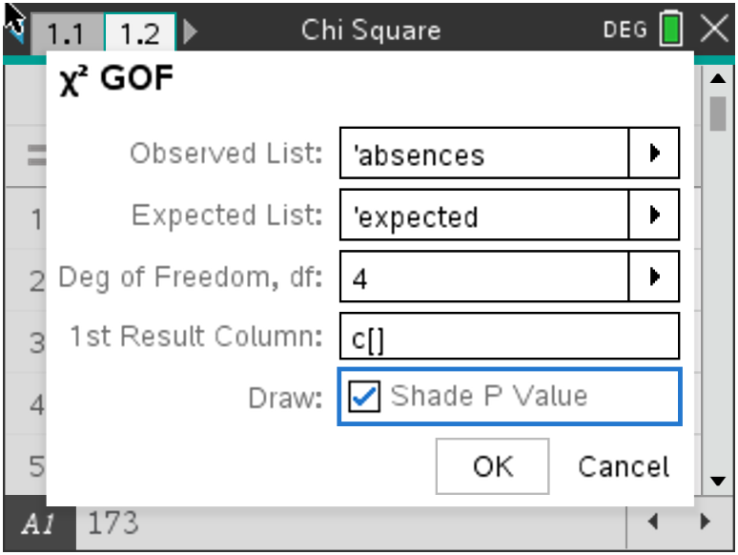
4. Press · to calculate the test statistic (${}^{2}$), the associated p-value (PVal) and draw the curve.  Note: See the Student activity sheet that accompanies this activity to answer questions about the example and the results. |  |  | 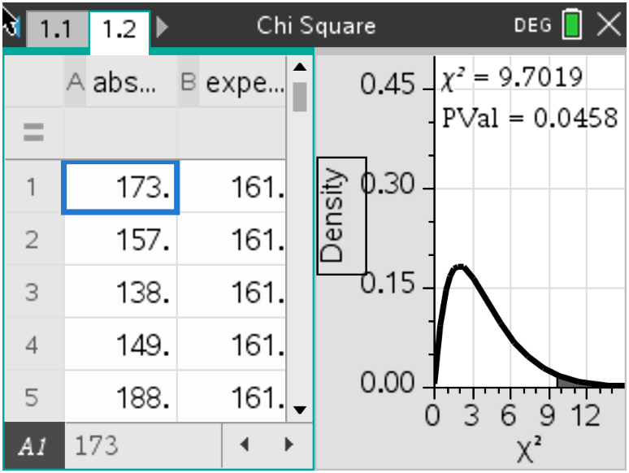
Problem 2
An advertiser for television shows suspected males and females had different television viewing preferences. The company commissioned a survey of 100 males and 120 females asking their preferences between crime, reality, and comedy formats. The table below shows the survey results.

Program Format | Males from survey | Females from  survey | Totals
Crime | 29 | 49
Reality | 31 | 45
Comedy | 40 | 26
Totals | 100 | 120

Part 1—Determine which Chi-square test to use
The company wants to see if viewing preferences differ between men and women. This example compares categorical variables from male/female populations to determine whether proportions of TV format preferences are the same across the two genders, so it uses a Chi-squared Test of Homogeneity with:
- Ho: the three television formats have the same proportions of male and female viewers (p_{males}=p_{females} for each format)
- Ha: the proportions are not the same

Part 2—Enter the data

1. Press ctrl < +page to add a new page, and select Calculator.
2. Press math template and select the 3 x 3 matrix template to open the dialogue
box to create a matrix.

3. Use the dialogue box to enter 3 for the number of rows and 2 for the number of columns. Select OK and press ·.  - An appropriate-sized, empty matrix will show on the calculator page. |  | 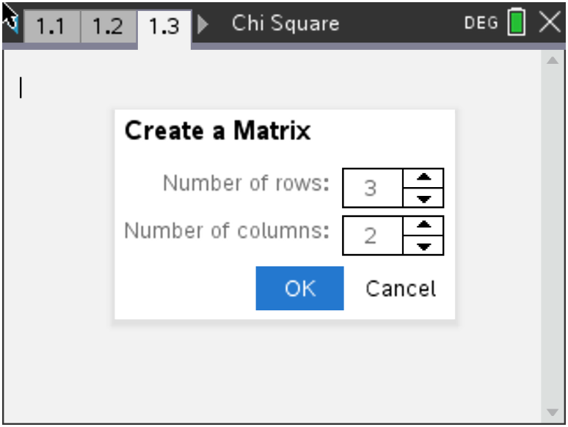
4. Enter the data from the two-way table into the matrix, pressing e to move between  cells. |  | 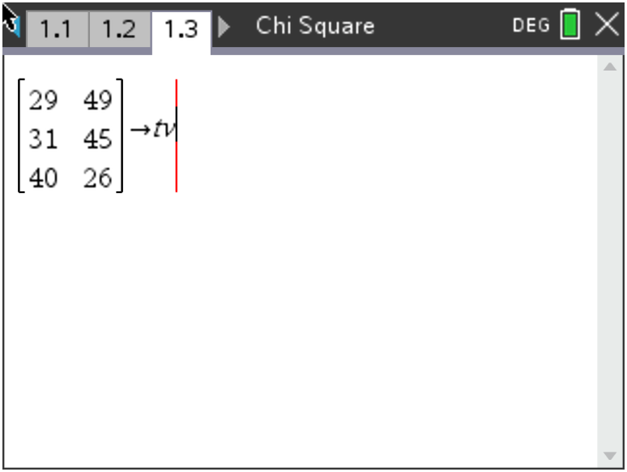
5. After all counts have been entered, press e to move to the right of the data matrix.
6. Press / Ë to name the matrix (name it tv) and · to store it. |  | 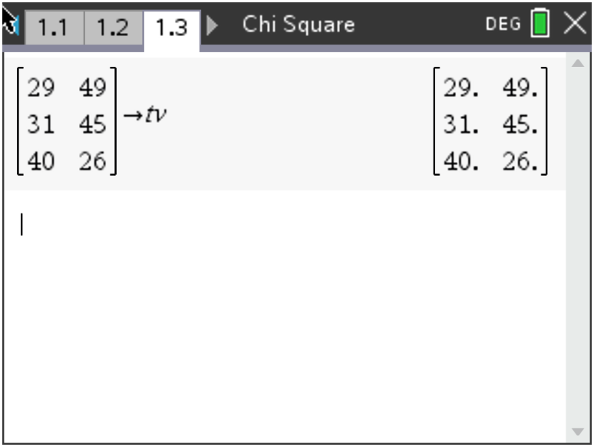
Part 3—Find the test statistic and p-value
1. Select MENU > Statistics > Stat Tests > ${}^{2}$Two-Way Test to run the hypothesis test and find  your test statistic and p-value. | 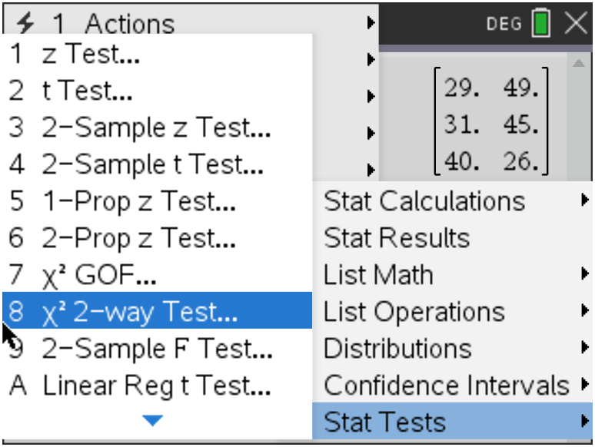
2. Fill in the dialogue box with the name of the observed list  by clicking on the arrow and selecting tv. | 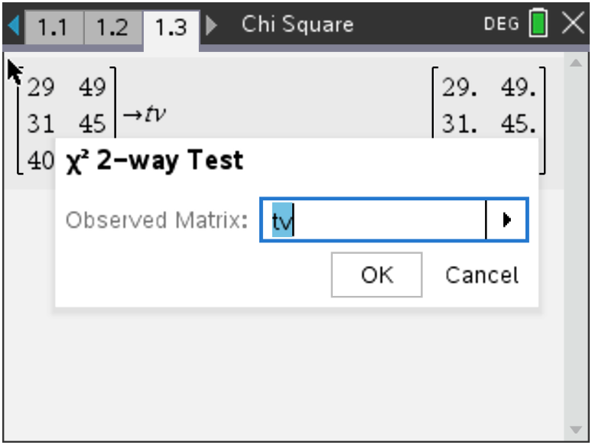
3. Press · to calculate the test statistic (${}^{2}$), the  associated p-value (PVal) and the degrees of freedom  (df). | 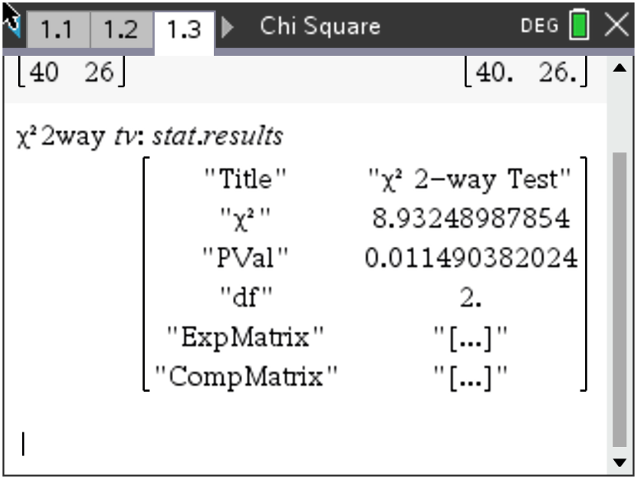
4. To view the expected counts matrix, press h, scroll  down, select stat.expmatrix, and press ·.  Note: See the Student activity sheet that accompanies this activity to answer questions about the example and the results. | 