Follow your teacher's directions either to create a .tns file or to open the pre-made file your teacher sends you (Binomial_Pdf_Eye_Color.tns).  What's the probability of a success? This activity investigates how to answer that question in a binomial situation. | 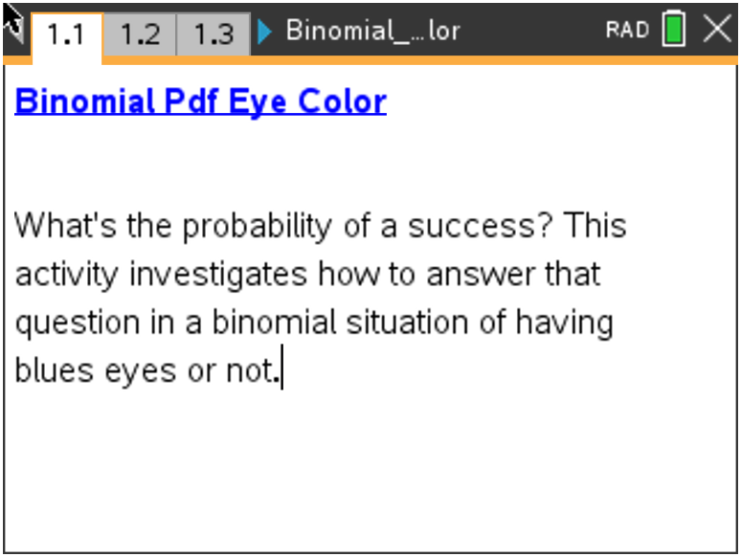

Several sources indicate that the probability of a person in the United States having blue eyes is approximately 30%. Suppose you randomly sampled 50 people in the United States. One basic question to answer is whether an underlying probability model might describe the probability of the possible numbers of blue-eyed people in your sample.
1. This situation involves binomial trials, so the first step is to check whether the requirements for binomial trials are met: two outcomes per trial; a fixed number of trials; a constant probability of success; and independent trials. Verify that these conditions are met in this context.
- Two outcomes
- Fixed # of trials
- Constant probability of success
- Independent trials

2. a. Reflect on how you built the .tns file. State two inputs that determined the binomial distribution.

b. For a random sample of 50 people, state what you would expect to be the most likely number of blue-eyed people. Explain your reasoning.

Move to page 1.2.

3. In terms of the context,
a. state what the zero represents in cell A1.

b. state what the value in cell B5 represents.

Move to page 1.3.

If the conditions for binomial trials are met, a binomial model can be used to represent the probabilities, which is the distribution you created on Page 1.3.
4. a. Describe the distribution in terms of shape, center, and spread.

b. Describe how the context of the eye color for a sample of randomly chosen people relates to the graph.

c. Saundra wonders whether the probability of getting 4 blue-eyed people in the sample of 50 was 0. State what you would tell her.

5. Suppose x represents the number of blue-eyed people. Describe how the graph helps you answer each of the following:
a. The most likely outcomes.

b. The least likely outcomes.

c. If you add the probabilities of every possible outcome, state what the result should be.

6. a. State the approximate probability that exactly 10 people will have blue eyes, P(x=10).

b. State the approximate probability that 10 or 11 people will have blue eyes, P(x=10,11).

c. State the approximate probability that fewer than 10 people will have blue eyes, P(x<10).

d. State the approximate probability that at least 10 people will have blue eyes, P(x≥ 10). Describe how you could use your answer to part b to find the answer to this question.

7. Suppose a researcher was checking the number of candies of a certain color chosen from randomly selected bags where each bag has exactly 50 candies. The manufacturer claimed that the probability of getting a green candy was approximately 0.3.
a. Describe how this context is alike or different from the context involving eye color above.

b. In a sample size of 50 candy pieces, if the researcher found the number of green candies in the sample indicated below, explain if he should be surprised or not.
i. 12

ii. 8

c. If the researcher were surprised, state the conclusions he might draw.

Extension
Follow your teacher's instructions for the following:
Adding the two sliders to the .tns file as described in the Extension instructions of the Binomial Pdf Eye Color Create document allows you to change both the sample size and the probability of a success.

8. The probability of having green or light brown eyes with green specks is about 12%. In a random sample of 100 people, find the probability of the following:
a. Exactly 6 people with that eye color.

b. At least 16 people with that eye color.

c. Anywhere from 7 to 15, including 7 and 15, people with that eye color.

9. a. Before using the arrows to change anything, predict how your answers to question 8 might
change if the sample size were 30 people.

b. Check your prediction by changing the sample size to 30 and using the resulting distribution.

10. a. Predict how your answers to question 8 would change if the sample size remained 100 but the
probability of brown eyes was 0.40 or 40%.

b. Check your prediction by changing n and p accordingly and using the resulting distribution.

11. a. Describe how the distribution changes as the sample size goes from 100 to 50 people for
p=0.4.

b. State how your answer to part a would change if the probability of a success was a different value.

c. Fix the sample size at n=50. Change the values of p, and describe what happens.

Tech Tip: If you use a large n and a large p, you might need to select
Menu > Window/Zoom > Window Settings… and change the x Max
to a larger value.

