Math Objectives  - Students will find the solution to a system of linear equations by hand.  - Students will use the TI-Nspire CX II to graph a linear system in two variables and find the intersection point(s).  - Students will create and graph linear piecewise functions.  - Students will try to make a connection with how to understand these topics in IB Mathematics courses and on their final assessments.  Vocabulary  - linear system • piecewise function  About the Lesson  - This lesson is aligning with the curriculum of IB Mathematics Applications and Interpretations SL/HL and IB Mathematics Approaches and Analysis SL/HL  - This falls under the IB Mathematics Core Content Topic 2 Functions:  2.4b Finding the point of intersection of two curves or lines using technology.  - As a result, students will:  Apply this information to real world situations  TI-Nspire™ Navigator™  - Transfer a File.  - Use Class Capture to examine patterns that emerge.  - Use Live Presenter to demonstrate.  - Use Teacher Edition computer software to review student documents.  - Use Quick Poll to assess students’ understanding  Activity Materials  - Compatible TI Technologies:  TI-Nspire™ CX Handhelds,   TI-Nspire™ Apps for iPad®,  TI-Nspire™ Software |  |  | 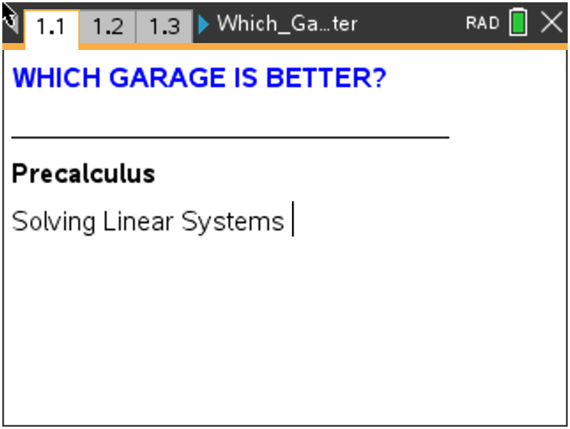  Tech Tips:  - This activity includes screen captures taken from the TI-Nspire CX II handheld. It is also appropriate for use with the TI-Nspire family of products including TI-Nspire software and TI-Nspire App. Slight variations to these directions may be required if using other technologies besides the handheld.  - Watch for additional Tech Tips throughout the activity for the specific technology you are using.  - Access free tutorials at http://education.ti.com/calculators/pd/US/Online-Learning/Tutorials  Lesson Files:  Student Activity  Which_Garage_is_Better_Student-Nspire.pdf  Which_Garage_is_Better_Student_Nspire.doc  Which_Garage_is_Better.tns
Tech Tip: Before beginning the activity, it may be beneficial to discuss with students how to graph a piecewise function on the handheld and where to find it under the math template button.
Teacher Tip: Students may also follow along with this activity on the handheld by downloading the file Which_Garage_is_Better.tns.

1. Complete the table.
Length of time in the garage (hours) | Blue Street Garage total cost (dollars) | Red Street Garage total cost (dollars)
0 | 10 | 0
1 | 10 | 7
2 | 15 | 14
3 | 20 | 21
4 | 25 | 28
5 | 30 | 35
6 | 35 | 35
7 | 40 | 35
8 | 45 | 35
9 | 50 | 35

Answer: Students may find it easier to compete the table for the Red Street Garage
first. Using the slope, students might build the table for the Blue Street Garage by adding 5 to the previous row of the table.
2. Joe parked in the Blue Street Garage and Flo parked in the Red Street Garage for the
same length of time. After they checked out and paid, they asked each other which
garage was cheaper, only to discover they paid the same amount for their stay.
Using the table above, answer the following questions:
(a) Find the length of time each might have parked in the garage. Find all possible
answers.
Answer: Each could have stayed 6 hours and paid $35, but that is not the only
possible answer. Red surpasses Blue between 2 and 3 hours. Using
proportional reasoning, for each half hour the cost of the Blue Street
Garage increases by ½ of 5 or $2.50, and the cost of the Red Street
Garage increases by ½ of 7 or $3.50.

(b) Find what their fee would have been. Find all possible answers.

Answer: Each could have stayed only 2.5 hours and paid $17.50. This will be more
apparent with the graph.
3. Write the equations of piecewise functions that model the cost of staying in each of the garages.
Blue Street Garage: B(x) =
Answer: $B\left(x\right)= \left\{\begin{aligned}10, &x≤1 \\ 5\left(x-1\right)+10, &x>1\end{aligned}\right.$

Red Street Garage: R(x) =
Answer: $R\left(x\right)= \left\{\begin{aligned}7x, &x≤5 \\ 35, &x>5\end{aligned}\right.$

Teacher Tip: If your students are new to writing piecewise functions, a scaffolding idea is to give them the structure and have them fill in the rest of it. For example, give them the first line and let them figure out the second part.

4. Move to page 1.4. To graph a piecewise function on your TI-Nspire CX II, on a graph page, press tab if the $f1\left(x\right)$ entry line is not showing, press the math template button and select the two piece piecewise function template (one to the right of the log template). Enter your equations and inequalities into the four empty boxes. You will repeat this for the Red Street Garage as well. Your graph should look like the one to the right using the viewing window shown.  Answer:  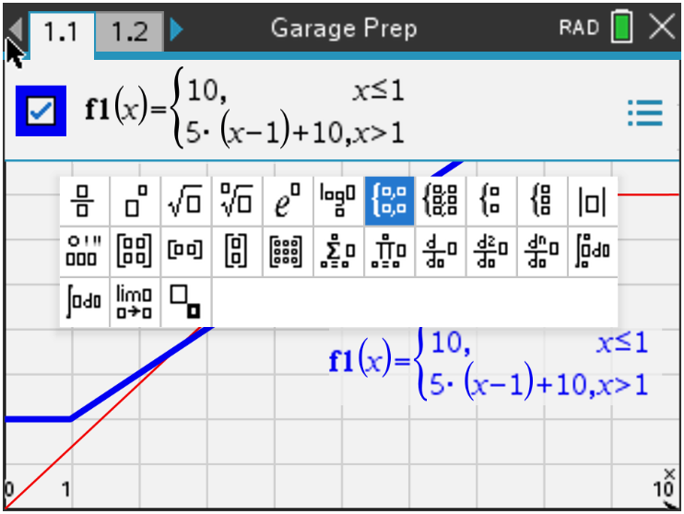 |  | 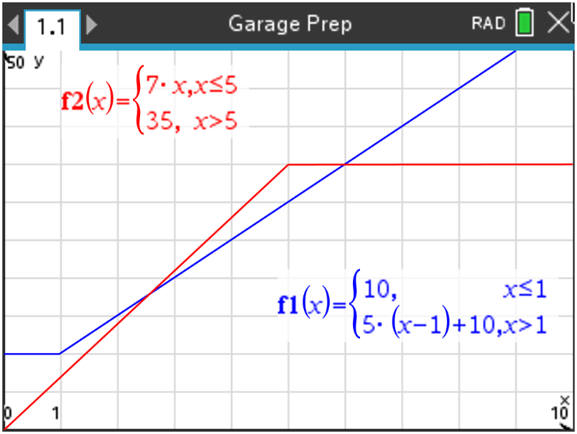  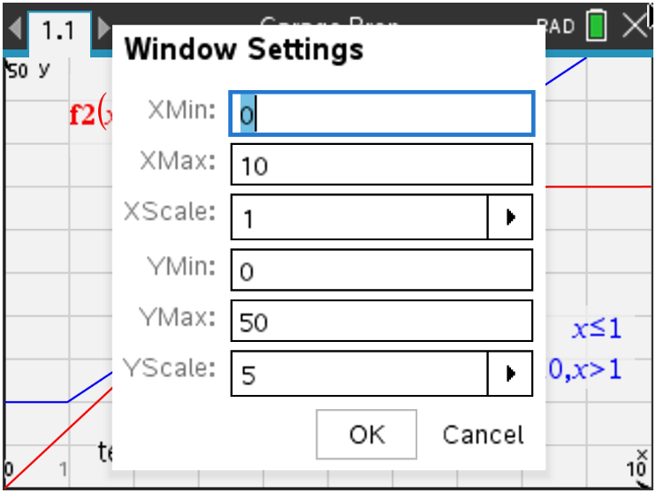
5. Find when the costs for using each garage will be equal to each other. Write down the equations you would set equal to each other to find when the costs are equal. Solve these equations below. Verify your answer by examining the intersection on the handheld. Press menu, 6 Analyze Graph, 4 Intersection.
Equation 1: _______________________________

Answer: $7x=10+5(x-1)$
$7x=10+5x-5$
$2x=5$
$x=2.5$
Equation 2: _______________________________
Answer: $10+5\left(x-1\right)=35$
$5\left(x-1\right)=25$
$x-1=5$
$x=6$

6. Move to page 1.5. Use the table, formula, or graph to answer the following. Press ctrl t for the table.
a. Find which garage costs less for a short stay. For example, you enter the garage, park, realize you forgot your wallet, and end up having to leave only 15 minutes later.
Answer: Students may need to be reminded of units. They can evaluate each function at x = 0.25 hours or just use the graph. The Red Street Garage is cheaper since the blue Street Garage is $10 and the Red Street Garage is $1.75.

b. Move to page 1.6. Suppose after a 2.5-hour movie you decide to go out to a restaurant and stay an additional 2 hours. Find which garage will cost less. State how much less.
Answer: If you stay 4.5 hours, the Blue Street Garage ($25 + $2.50 = $27.50) is cheaper than the Red Street Garage (4.5 x $7 = $31.50) by $4. You can also use the table feature on the handheld.

c. Move to page 1.7. Suppose you needed to park your car for 12 hours in the garage. State which garage will cost less. State how much less.
Answer: If you stay 12 hours, the Red Street Garage ($35) is cheaper than the Blue
Street Garage ($10 + $55 = $65) by $30. You can also use the table feature on the
handheld.

7. Move to page 1.8. Use the graph to solve when $B\left(x\right)<R\left(x\right)d Street Garage is better.er..__________________$. Interpret the solution in real-world practical terms.
Answer: In terms of the context of parking
garages, the Blue Street Garage is cheaper
than the Red Street Garage if you stay more
than 2.5 hours but less than 6 hours.

8. Move to page 1.9. Over the length of a day, find what duration the Blue Street Garage is better. Find what duration the Red Street Garage is better.
Answer: The Blue Street Garage is better for a duration of 3.5 hours (when you stay more than 2.5 hours but less than 6 hours). The Red Street Garage is better for the remaining 20.5 hours of the day (for hours 0 to 2.5 and 6 to 24).

Problem 2 – Music Sales
Move to page 2.1. In recent years, the numbers of CDs sold in the United States has
declined while digital music has become the new method for purchasing music.
The table below, and on page 2.2, shows data of the sales, in millions, of CDs, digital albums (DA), and individual songs (IS) for the first three months of the year.
Year | CD | DA | IS
2006 | 112 | 119 | 24.2
2007 | 89 | 99 | 28.8
2007 – 2006 | -23 | -20 | 4.6

9. Move to page 2.3. Describe what the value of -23 (under CD) represents.
Answer: The difference between the sales data for CDs and, since there is only a difference of one year, it is also equal to the slope of the line.

10. Move to page 2.4. Discuss with a classmate and write down why you think it is negative.
Answer: Because there was a decrease in sales of CDs from 2006 to 2007.

11. Discuss with a classmate how the result in the final column (IS) is different from the
other two (CD and DA) and explain why.
Answer: The result is positive because the individual song sales went up for the same
time period.

12. Move to page 2.5. Use the data in the table above to find the equation for each of the
three lines in either slope-intercept form or point-slope form and write them in the
spaces provided.
- CDs _____________________________
Answer: $y= -23x+46250 or \left(y-112\right)= -23(x-2006)$
- Digital Albums _____________________________
Answer: $y= -20x+40239 or \left(y-119\right)= -20(x-2006)$
- Individual Songs _____________________________
Answer: $y=4.6x-9203.4 or \left(y-24.2\right)=4.6(x-2006)$

Move to page 2.6. Use the lines to find and record the coordinates of the three intersection
points.
CDs and Digital Albums (____________ , ______________)
Answer: $(2003.67, 166)$
CDs and Individual Songs (____________ , ______________)
Answer: $(2009.18, 38.8)$
Digital Albums and Individual Songs (____________ , ______________)
Answer: $(2009.85, 41.9)$

13. Move to page 2.7. Find when the sales of digital albums overtakes the CDs.
Answer: The later part of 2003.

14. Move to page 2.8. Find when the graph projects that the sales of individual songs
overtakes CDs.
Answer: The beginning part of 2009.

15. Move to page 2.9. Find when the graph projects that the sales of individual songs
overtakes digital albums.
Answer: The later part of 2009.

16. Move to page 2.10. As time goes on according to the graph, it indicates the CD sales
becoming zero. Discuss with a classmate if you think this is possible. Explain why or
why not.
Answer: The sales of CDs will continue to go down but probably will not go away, until
the industry decides to stop making CDs.
IB Further Extension

To further instruction, finding where two functions are equal should not be limited to linear functions. In this extension, you will be exploring where two exponential functions are equal.

Luca purchases a new bike for himself at a cost of $355. He also purchases a professional racing bike for his sister Christine for $1815. Luca’s bike will depreciate in value 5% per year, while Christine’s will depreciated at a rate of 12% per year. Luca and Christine’s bikes will have the same value p years after they were purchased.

(a) Estimate the value of Luca’s bike after 6 years.

Answer: Students will first have to write the given information as an exponential equation.
Luca: $L\left(t\right)=355{\left(1-0.05\right)}^{t}$
$L\left(6\right)=355{\left(0.95\right)}^{6}$
$L\left(6\right)=260.958 ≈\$261$

(b) Using your handheld, find p.

Answer: Christine: $C\left(t\right)=1815{\left(1-0.12\right)}^{t}$
$C\left(t\right)=1815{\left(0.88\right)}^{t}$
Set the exponential equations equal to solve for p.
$355{\left(0.95\right)}^{p}=1815{\left(0.88\right)}^{p}$
Finding their point of intersection using the graphs on their handheld,
$\left(21.3185, 118.94\right)$
After approximately $p=21.3$ years, their bikes will have an approximate value of
$118.94.

(c) Explain why or why not the answer to part (b) is valid.

Answer: Depreciation rates are not constant from year to year, especially over long periods
of time.

TI-NspireTM NavigatorTM Opportunities

Quick Poll
Since every question is part of the tns file, you may choose to use Quick Poll to assess student understanding. The worksheet questions can be used as a guide for possible questions to ask.

Class Capture
You may want to use Class Capture from time to time to verify that students are understanding the process, especially the process involving piecewise functions.

**Note: This activity has been developed independently by Texas Instruments and aligned with the IB Mathematics curriculum, but is not endorsed by IB™. IB is a registered trademark owned by the International Baccalaureate Organization.

