In this activity, you will explore the properties of functions of the forms $f(x)= \frac{1}{x-a}$ and
$f(x)= \frac{ax+b}{cx+d}$ , and learn to create sliders that allows you to dynamically examine these rational functions generated by quotients of linear functions.

Using the handheld, students will discover, or re-discover, the connection between a rational function, transformations, and both vertical and horizontal asymptotes. To accomplish this, they will be creating and using a dynamic tool called a slider.

Let’s review the idea behind vertical and horizontal asymptotes. A vertical asymptote is a vertical line that guides the graph of the function but is not part of it. It can never be crossed by the graph because it occurs at the x-value that is not in the domain of the function. A function may have more than one vertical asymptote. A horizontal asymptote is a horizontal line that the graph of a function approaches as the magnitude of the input increases without bound in either a positive or negative direction. A function may cross a horizontal asymptote for finite values of the input.

Problem 1 – Testing the Slider with Vertical Asymptotes
From the home screen on the handheld, press  1 New (Document) and press 2 Add Graphs. In the f1(x) =, type the fraction $\frac{1}{x-a}$. Once you press enter a box will pop up and ask if you would like to create a slider for the variable a, press ok. | 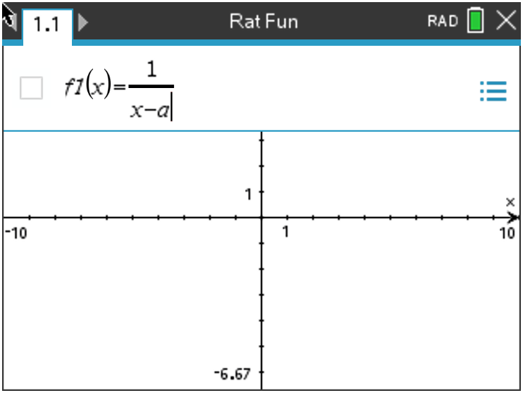
Now that the slider has appeared, you can customize it to your liking. The default slider has a minimum a value of -5 and a maximum of 5. It also contains an arrow that you can manipulate to change the a value. If you would like to change anything about the slider, press ctrl menu to alter the settings, minimize to a button slider, or animate the slider. | 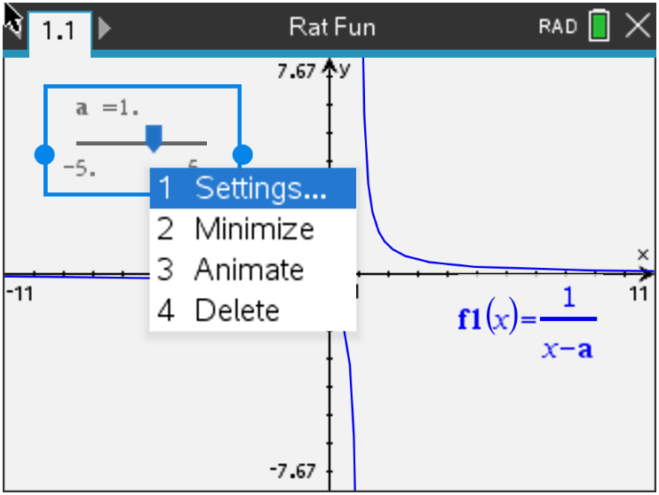

Let’s add one more piece to the slider puzzle to really enhance the connection to asymptotes. While on the Graphs page, press menu, 3 Graph Entry/Edit, 3 Equation Templates, 1 Line, 2 Vertical Line x = c. Type a into the template box and press enter.  Discussion Questions | 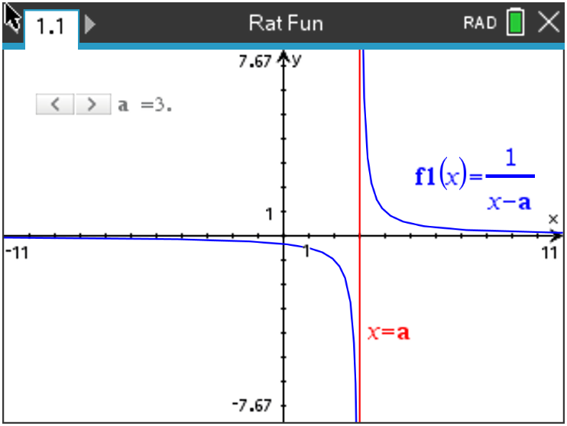
1. With a classmate, press or move the slider and discuss what you see. Write an explanation and share with the class what you notice about the relationships between the rational function and the vertical line.

2. Find the value of x where the function $f1\left(x\right)= \frac{1}{x-2}$ is undefined.

3. Find the value of x where the function $f1\left(x\right)= \frac{1}{x+1}$ is undefined.

4. Find the value of x where the function $f1\left(x\right)= \frac{1}{x-a}$ is undefined.

5. Find the value of x where the function $f1\left(x\right)= \frac{1}{x-a}$ has a vertical asymptote. With a classmate, come up with a rule to find the vertical asymptote.

Extension Question:
6. Discuss with a classmate what you notice about what happens horizontally as you move the slider left and right. Write an explanation and share with the class.

Problem 2 – Using Sliders to Make Connections to Horizontal Asymptotes
Now that the slider has appeared, you can customize it to your liking, by pressing ctrl menu. The picture at the right shows minimized sliders and they have been moved to the first quadrant. | 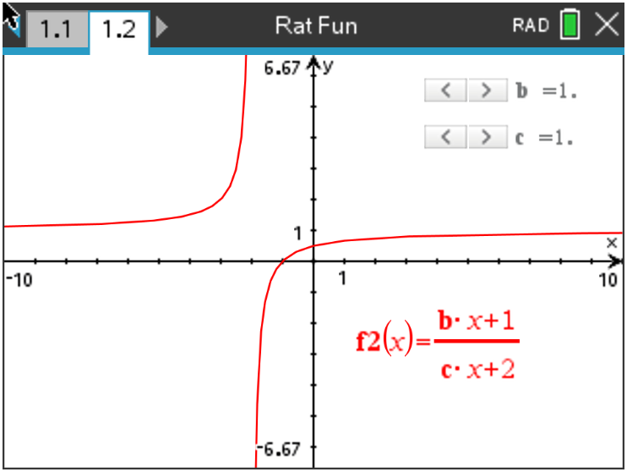
To make the connection once again to asymptotes, we will add a line. Press tab and enter the fraction $\frac{b}{c}$ into f3(x) = and press enter. | 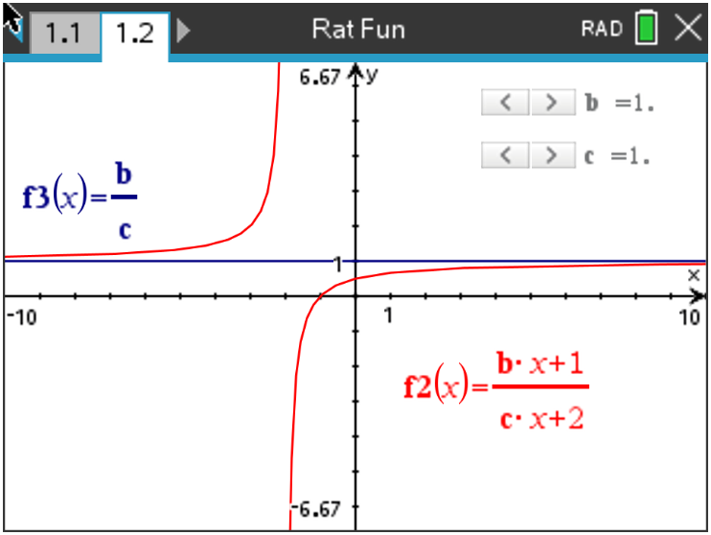

Let’s repeat the procedure from Problem 1, but this time we will add two sliders. Press ctrl, doc and add another Graphs page. Enter the fraction $\frac{b∙x+1}{c∙x+2}$ into f2(x) = and press enter. When the box pops up and asks if you would like to create a slider for the variables b and c, press ok. | 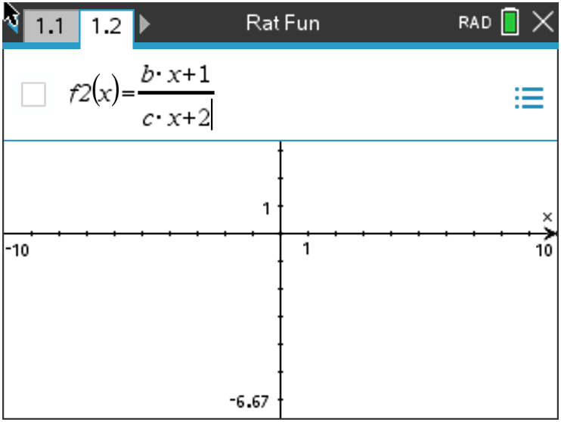
Discussion Questions
1. With a classmate, press or move the sliders and discuss what you see. Write an explanation and share with the class what you notice about the relationships between the rational function and the horizontal line.

2. Find the value of $f2(x)$ that the function seems to approach as the input values approach both positive and negative infinity when $2\left(x\right)= \frac{2x+1}{3x+2}$ .

3. Find the value of $f2(x)$ that the function seems to approach as the input values approach both positive and negative infinity when $2\left(x\right)= \frac{4x+1}{x+2}$ .

4. Find the value of $f2(x)$ that the function seems to approach as the input values approach both positive and negative infinity when $2\left(x\right)= \frac{bx+1}{cx+2}$ .

5. Find the value of $f2(x)$ that the function $f2\left(x\right)= \frac{bx+1}{cx+2}$ has a horizontal asymptote. With a classmate, come up with a rule to find the horizontal asymptote.

Further IB Application

The function $f$ is defined by $f\left(x\right)= \frac{8x-8}{3x-6}$ for $x ∈ R, x ≠2$.

(a) Find the zero of $f\left(x\right).$

(b) For the graph of $y=f(x)$, write down the equation of
(i) the Vertical Asymptote;

(ii) the Horizontal Asymptote.

(c) (i) Find $f^{-1}(x)$, the inverse function of $f(x)$.

(ii) Hence, or otherwise, find the value of $f^{-1}(0)$.

