In this activity, you will use the data in the file KANSTEMP.8xp, which contains the temperatures and hours of sunlight in Kansas City, and the heights of tides in the Bay of Fundy. You will find the equations of Sine curves that model the given data and answer several questions about what you have found.  **Note: Make sure that your handheld is in Radian mode. | 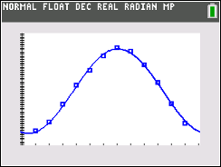

Problem 1 – Temperature

In this problem, you will graph data and find a sinusoidal function.

The temperature in Kansas City fluctuates from cold in the winter to hot in the summer. The average, monthly temperature (°F) will be loaded into L₁ and L₂ when you run the program. After your teacher has transferred the file to your handheld, press prgm to access the Program menu. Choose the KANSTEMP program and press enter. This will load the six lists with the data for all three problems.
Press stat, 1 Edit… to see the data in the lists. The number of the month is in L₁ and the temperature is in L₂. Note: The data that appears in L₃ through L₆ will be used later in the activity.

To graph the data, press 2nd y = and enter to access Plot1. Make sure that the Plot1 settings are the same as shown below. Press zoom and select 9:ZoomStat. You will get a graph similar to the one below.

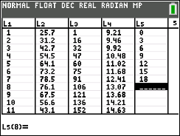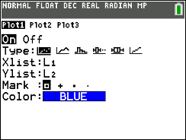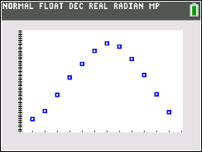
(a) Find the sine equation that models the data. Press stat, arrow over to CALC, and select
C:SinReg. Fill in the information with the following:
XList: L YList: L₂ Store EQ: Y₁ enter to calculate
Rounding to the nearest hundredth, write down the sine equation in the form
$y=a ∙\sin\left[bx+c\right]+d$.

Press graph to see the sine regression with the data.
(b) Discuss with a classmate how well the sine curve of regression models the data. Share your
thoughts with the class.

(c) Find the approximate temperature in Kansas City on March 15. Explain if this is a reliable
temperature you found.

(d) Using your sine curve of regression, estimate when your temperature will reach 85° in Kansas
City and give an explanation of your results.

Problem 2 – Hours of Sunlight

The amount of light a location on the Earth receives from the Sun changes each day depending upon the time of year and latitude of that location. The amount of daily sunshine Kansas City experiences has been recorded in the lists where the calendar day is in L₃, and the hours of sunlight is L₄.
Create the scatter plot and sine equation that models the data as outlined in Problem 1. To create the scatter plot, make sure to change the XList to L₃ and the YList to L₄.
In early cultures, certain days of the year had significant importance because of the planting cycle. These days were the winter and summer solstices, and the spring and fall equinoxes. The equinoxes are the days with equal amounts of light and dark. The summer solstice has the greatest amount of sunlight, while the winter solstice has the fewest amount of sunlight.

(a) Rounding to the nearest hundredth, write down the sine equation.

(b) Discuss with a classmate how well the sine curve of regression models the data. Share your
thoughts with the class.

(c) Find the solstice and equinox dates using your sine curve of regression. Make sure that after
you find your regression curve that you turn off Plot1 so you can see your curve and not the data
points.
Winter Solstice ____________________ Summer Solstice ___________________

Fall Equinox ____________________ Spring Equinox ___________________

Problem 3 – Tides

The Bay of Fundy has the highest tides in the world. If a tape measure were attached at the water line of a peer, and the water level height were recorded over a period of eighteen hours, data like that in L₅ and L₆ would be generated.
Create the scatter plot and sine equation that models the data as outlined in Problems 1 and 2. To create the scatter plot, make sure to change the XList to L₅ and the YList to L₆.

(a) Rounding to the nearest hundredth, write down the sine equation.

(b) Discuss with a classmate how well the sine curve of regression models the data. Share your
thoughts with the class.

(c) Using the sine curve of regression for the data, predict the water level when the time is 49 hours
after the readings were started. Share one or more ways you can attain this answer by using
your TI-84 Plus CE handheld.

Further IB Applications

The height of the tides off the coast of Fripp Island, SC is modelled by the function
$H\left(t\right)=a sin\left(b\left(t-c\right)\right)+d$, where t is the number of hours after midnight, and a, b, c, and d are constants, where a > 0, b > 0, and c > 0. The following graph shows the water for 15 hours, starting at midnight.

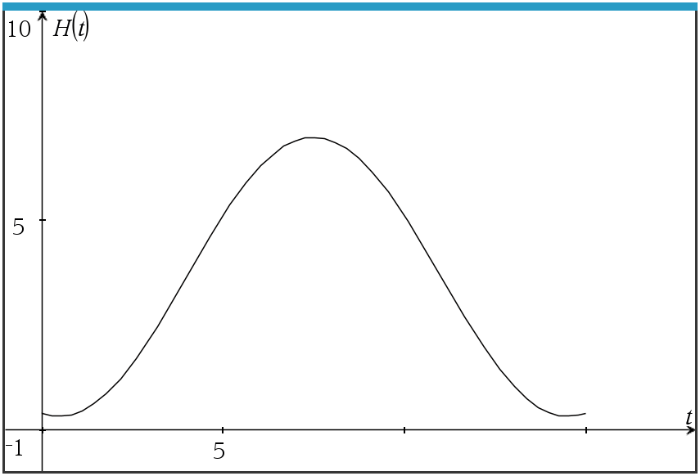

The first high tide occurs at 7:10 am and the next occurs 12 hours later. Throughout the day, the height of the water fluctuates between 6.9 ft. and 0.4 ft. All heights are given correct to one decimal place.

(a) Show that $b= \frac{π}{6}$.

(b) Find the value of a.

(c) Find the value of d.

(d) Find the smallest possible value for c.

(e) Find the height of the tide at 12:00 pm.

(f) Determine the number of hours, over a 24 hour period, that the tide is over 4 ft.

