The goal of this activity is to make a connection to Topic 3.6 of the curriculum in the course

IB Mathematics Applications and Interpretations SL/HL. You will not only create your own Voronoi Diagram on paper, but you will also practice with what math is needed to make the diagram. Ultimately, you will apply it as you would in an IB Math AI class and on the IB Math AI exam.

Before we can apply Voronoi Diagrams to the real world, let us discuss what it is. They were named after the mathematician Georgy Vorinoy (1868 - 1908) and is based on the idea of the minimal distance needed to reach a landmark (hospital, school, transportation station, etc.).

The diagram is a partition of a plane into regions, called Voronoi cells, close to each of a given set of objects. These objects are just finitely many points in the plane sometimes referred to as seeds, sites or generators. For each seed, there is a corresponding region consisting of all points of the plane closer to that seed than to any other.

To get to the point of creating our own Voronoi Diagram, we need to go back to our Geometry days and review the important features of a triangle, namely the *circumcenter*.

**Problem 1 – The Circumcenter**

|  |
| --- |
| 1. What is a circumcenter?  2. Follow the directions below to create a circumcenter in the space provided.  **Step 1:** With a ruler, create a triangle using three segments.  **Step 2:** With a ruler, find the midpoint of each side of the triangle.  **Step 3:** With a ruler, draw a perpendicular line (perpendicular bisector) through each of the midpoints.  **Step 4:** Place a point on the intersection of the three perpendicular bisectors.  3. Discuss with a classmate what you have made and what possible uses there may be outside of the math classroom. |
| **Problem 2 – Equations of Lines**  Another skill we will need to review is finding the equation of a line given two points.  1. On the graph below, select three coordinate pairs, (x, y), and plot them. Connect the points and create a triangle.  Dry Erase Graph Magnet - Numbered XY Axis  2. You have now created a triangle using 3 coordinates. Find the equation of each line that would pass through each side using the coordinates you selected. Write your equations in the form  *ax + by + d = 0* where *a, b, d* ∈ ℤ. |

**Problem 3 – Sample Voronoi Diagram**

1. Let us now practice by creating your own Voronoi

Diagram on the following coordinate plane. Follow the directions below.

**Step 1:** Space out five (5) random points on the coordinate plane.

**Step 2:** Connect each of the five points creating triangles. Do not cross any of the lines.

**Step 3:** With a ruler, find the midpoint of each side of each triangle.

**Step 4:** With a ruler, draw a perpendicular bisector through each of the midpoints.

**Step 5:** Draw a point at each of the circumcenters.

**Step 6:** Connect the circumcenters with segments. There should be three line segments coming from each circumcenter. The third line may not connect to another circumcenter but may be drawn along one of the perpendicular bisectors.

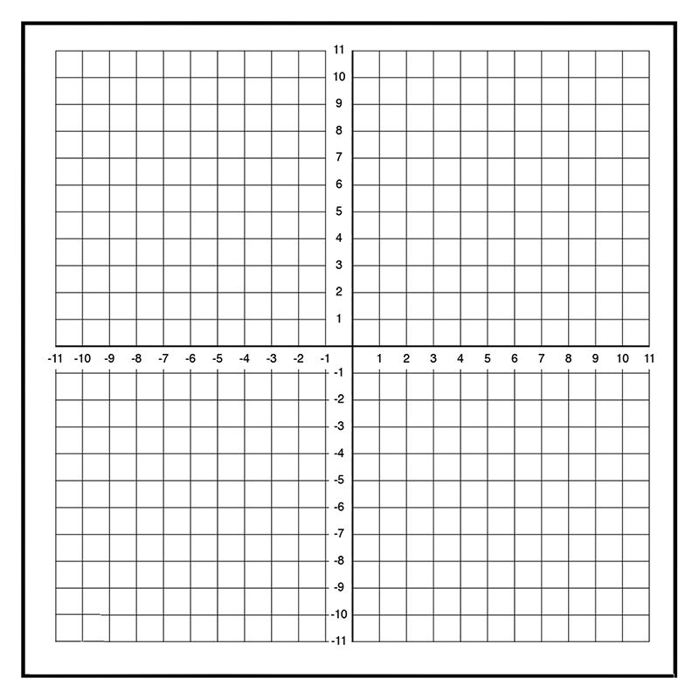

2. Discuss with a classmate what you have created. Give several examples of what you think the

singular point located in each region you created represents.

**Application**

1. There are five hospitals, A, B, C, D, and E in the city. The coordinates of the hospitals are A(2, 3),

B(1, -1), C(5, 4), D(3, 1), and E(4, -2). In order for each hospital to accommodate an equal amount of the population, how should the city be divided into regions so that there is one hospital in each region and this hospital is centrally located for each region? Use the graph paper below to answer this problem.



2. Explain why or why not the location (1, 6) would be a good choice for the city to add another hospital.