In this activity, students define right and oblique three dimensional figures and calculate the volume for prisms, pyramids, cylinders, and cones. The will use multiple representations to explore properties of area and volume. This investigation offers opportunities for review and consolidation of key concepts related to area and volume. | 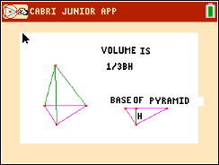

Problem 1 – Rectangular Prisms
Using the prism to the right, answer the following.
1. Describe when the prism is a right prism.
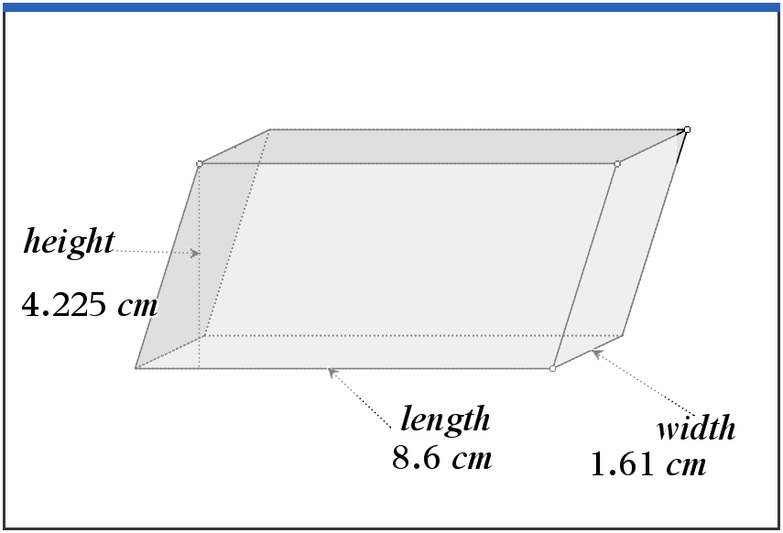
2. Describe when the prism is an oblique prism.

3. Find the volume of the pictured rectangular prism. Record the dimensions of the prism below.
Base length = _________ (l) Base width = _________ (w)
Area of the Base = _________ (B)
Prism height = _________ (h) Prism Volume = _________ (V)

Problem 2 – Triangular Prisms and Pyramids
4. Using the prism below, describe why it is called a triangular prism.
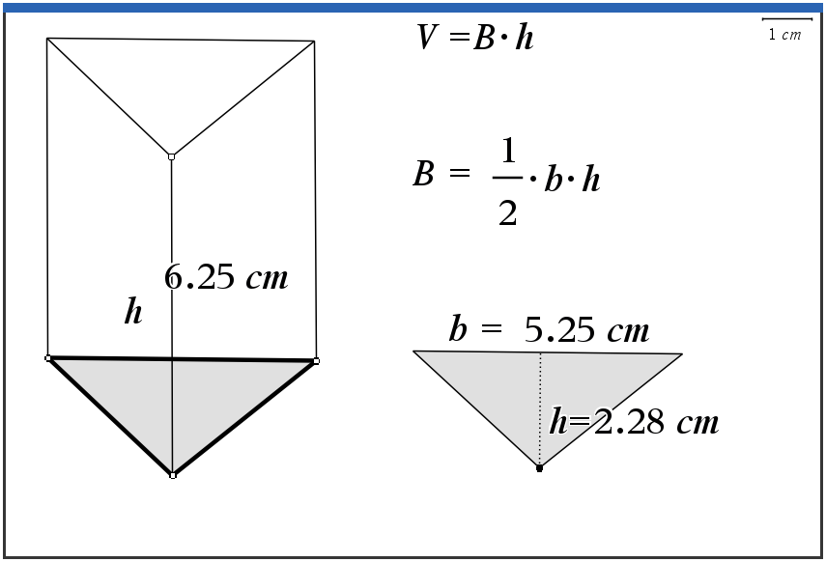
5. Find the volume of the pictured triangular prism and record the dimensions below.
Triangle base = _________ (b) Triangle height = _________ (h)
Area of Triangle = _________ (B)
Prism height = _________ (h) Prism Volume = _________ (V)

6. Describe what the difference is between a prism and a pyramid. Find the portion of the volume of a prism that is the volume of a pyramid with the same base and height.

7. Find the volume of the pyramid pictured below. Record the dimensions of the pyramid.
Triangle base = _________ (b) Triangle height = _________ (h)
Area of Triangle = _________ (B)
Pyramid height = _________ (h) Pyramid Volume = _________ (V)
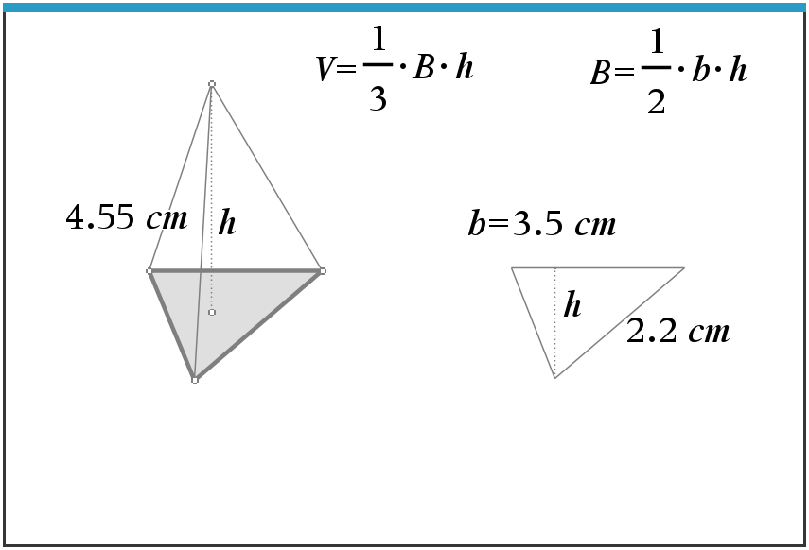
8. Describe how the triangular prism and triangular pyramid are alike. Describe how they are different.

9. Describe how their volume formulas are alike and different.

Problem 3 – Cylinders and Cones
10. Using the pictured cylinder below, record the steps you would perform to find its volume:
(1)_________________________________________________________________

(2)_________________________________________________________________
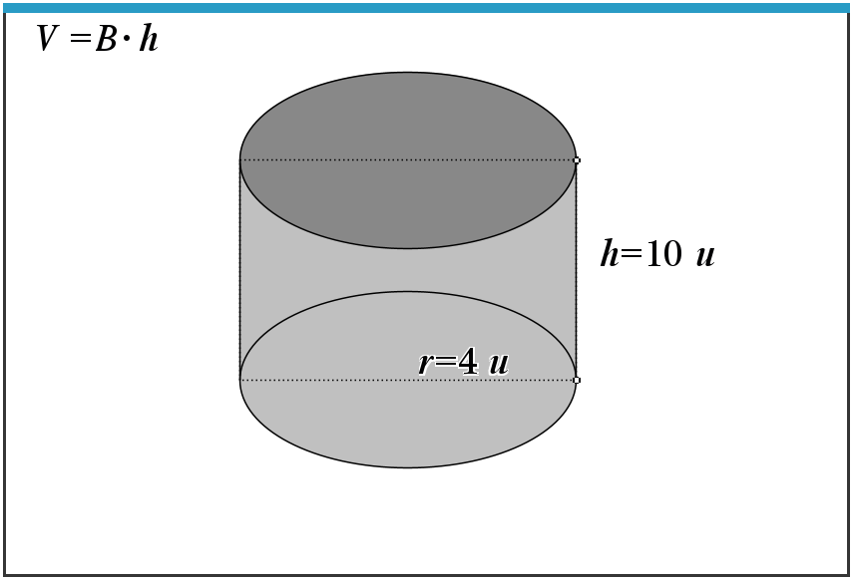
11. Record the dimensions below and find the volume of the pictured cylinder.
Circle radius = _________ (r) Area of Circle = _________ (B)
Cylinder height = _________ (h) Cylinder Volume = _________ (V)

12. Find the volume of the cone pictured below. Record the dimensions of the cone below.
Circle radius = _________ (r) Area of Circle = _________ (B)
Cone height = _________ (h) Cone Volume = _________ (V)
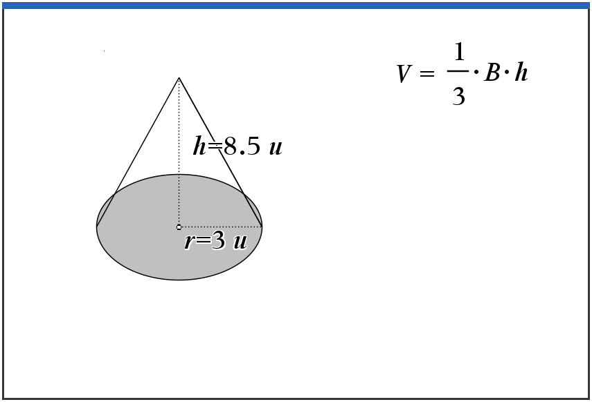

13. If a cone and a cylinder have the same radius and the same height, describe how the volume of the cone is related to the volume of the cylinder.

Describe how this relates to the prism and pyramid formulas when the prism and the pyramid have the same base and the same height.

Further IB Application

Abigail is building a flower box out of a rectangular block of wood for her windowsill. She will take this block and carve out a cylindrical trough. See diagram below. The length of the flower box is 2.5 ft, the width is 0.5 ft, and the height is 0.6 ft. The cylindrical trough will have a diameter of 0.3 ft.
Find the volume of the flower box, after the trough has been carved out, in cubic inches.

Diagram not to scale.

0.3 ft
2.5 ft
0.6 ft
0.5 ft

