In this activity, students define right and oblique three dimensional figures and calculate the volume for prisms, pyramids, cylinders, and cones. The will use multiple representations to explore properties of area and volume. This investigation offers opportunities for review and consolidation of key concepts related to area and volume. | 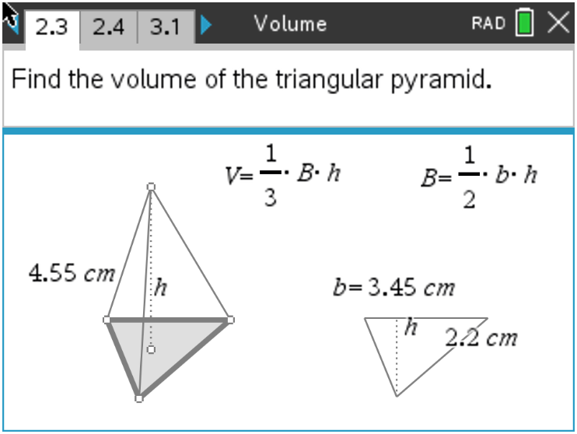
Open the file Volume.tns to help guide you through this activity and provide useful visuals.

Move to page 1.4.
Problem 1 – Rectangular Prisms
Explore the rectangular prism on page 1.4 by grabbing and dragging the open vertices.
1. Describe when the prism is a right prism.

2. Describe when the prism is an oblique prism.

3. Use the Calculate tool on page 1.8 to find the volume of the right rectangular prism. Record the dimensions of your prism below.
Base length = _________ (l) Base width = _________ (w)
Area of the Base = _________ (B)
Prism height = _________ (h) Prism Volume = _________ (V)

Move to page 2.2.
Problem 2 – Triangular Prisms and Pyramids
4. Grab and drag the vertices of base on page 2.2. Describe why it is called a triangular prism.

Move to page 2.3.
5. Find the volume of the triangular prism and record the dimensions below.
Triangle base = _________ (b) Triangle height = _________ (h)
Area of Triangle = _________ (B)
Prism height = _________ (h) Prism Volume = _________ (V)
6. Describe what the difference is between a prism and a pyramid. Find the portion of the volume of a prism that is the volume of a pyramid with the same base and height.

7. Find the volume of the pyramid on page 2.4. Record the dimensions of your pyramid.
Triangle base = _________ (b) Triangle height = _________ (h)
Area of Triangle = _________ (B)
Pyramid height = _________ (h) Pyramid Volume = _________ (V)

8. Describe how the triangular prism and triangular pyramid are alike. Describe how they are different.

9. Describe how their volume formulas are alike and different.

Problem 3 – Cylinders and Cones
10. Use the Text and Calculate tools on page 3.1 to find the volume of the cylinder. Record the steps you performed to find the volume:

(1)_________________________________________________________________

(2)_________________________________________________________________

11. Record the dimensions of your cylinder below.
Circle radius = _________ (r) Area of Circle = _________ (B)
Cylinder height = _________ (h) Cylinder Volume = _________ (V)

12. Find the volume of the cone on page 3.4. Record the dimensions of your cone below.
Circle radius = _________ (r) Area of Circle = _________ (B)
Cone height = _________ (h) Cone Volume = _________ (V)
13. If a cone and a cylinder have the same radius and the same height, describe how the volume of the cone is related to the volume of the cylinder.

Describe how this relates to the prism and pyramid formulas when the prism and the pyramid have the same base and the same height.

Further IB Application

Abigail is building a flower box out of a rectangular block of wood for her windowsill. She will take this block and carve out a cylindrical trough. See diagram below. The length of the flower box is 2.5 ft, the width is 0.5 ft, and the height is 0.6 ft. The cylindrical trough will have a diameter of 0.3 ft.
Find the volume of the flower box, after the trough has been carved out, in cubic inches.

Diagram not to scale.

0.3 ft
2.5 ft
0.6 ft
0.5 ft

