Math Objectives  - Students will define right and oblique three dimensional figures.  - Students will calculate the volume for prisms, pyramids, cylinders, and cones.  - Students will try to make a connection with how to understand these topics in IB Mathematics courses and on their final assessments.  Vocabulary  - Prism • Oblique • Right Prism  - Pyramid  About the Lesson  - This lesson is aligning with the curriculum of IB Mathematics Applications and Interpretations SL/HL and IB Mathematics Approaches and Analysis SL/HL  - This falls under the IB Mathematics Core Content Topic 3 Geometry and Trigonometry:  3.1: (b) Volume and surface area of three-dimensional solids  including right pyramid, right cone, sphere, hemisphere  and combinations of these solids.  As a result, students will:  - Apply this information to real world situations.  TI-Nspire™ Navigator™  - Transfer a File.  - Use Class Capture to examine patterns that emerge.  - Use Live Presenter to demonstrate.  - Use Teacher Edition computer software to review student documents.  - Use Quick Poll to assess students’ understanding  Activity Materials  Compatible TI Technologies: TI-Nspire™ CX Handhelds,  TI-Nspire™ Apps for iPad®, TI-Nspire™ Software | 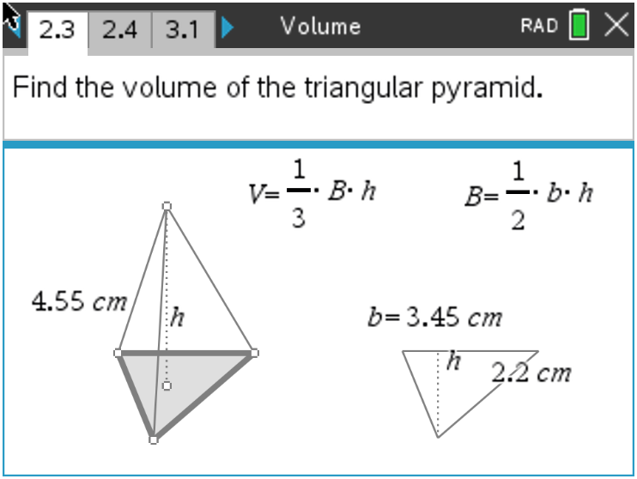  Tech Tips:  - This activity includes screen captures taken from the TI-Nspire CX II handheld. It is also appropriate for use with the TI-Nspire family of products including TI-Nspire software and TI-Nspire App. Slight variations to these directions may be required if using other technologies besides the handheld.  - Watch for additional Tech Tips throughout the activity for the specific technology you are using.  - Access free tutorials at http://education.ti.com/calculators/pd/US/Online-Learning/Tutorials  Lesson Files:  Student Activity  Volume-Student-Nspire.pdf  Volume-Student-Nspire.doc  Volume.tns
In this activity, students define right and oblique three dimensional figures and calculate the volume for prisms, pyramids, cylinders, and cones. The will use multiple representations to explore properties of area and volume. This investigation offers opportunities for review and consolidation of key concepts related to area and volume.

Open the file Volume.tns to help guide you through this activity and provide useful visuals.
Teacher Tip: Although there is a file to download to the handheld, this activity can be done without it. The file provides helpful visuals that might make the review of volume easier to grasp.

Move to page 1.4.
Problem 1 – Rectangular Prisms

Explore the rectangular prism on page 1.4 by grabbing and dragging the open vertices.
1. Describe when the prism is a right prism.
Solution: A prism is right when the joining edges and faces are perpendicular to the base
faces. This applies if and only if all the joining faces are rectangular.

2. Describe when the prism is an oblique prism.
Solution: A prism is oblique when the joining edges and faces are not perpendicular to the
base faces.

3. Use the Calculate tool on page 1.8 to find the volume of the right rectangular prism. Record the dimensions of your prism below.
Base length = _________ (l) Base width = _________ (w)
Area of the Base = _________ (B)
Prism height = _________ (h) Prism Volume = _________ (V)
Solution: Answers will vary depending on the dimensions used by the students, but all
students should be using the formula V = Bh, where B represents the area of the base.

Teacher Tip: This is an excellent moment to select one or more students to demonstrate the use of the Calculate tool as the presenter. Using multiple students will also give varying answers.

Move to page 2.2.
Problem 2 – Triangular Prisms and Pyramids
4. Grab and drag the vertices of base on page 2.2. Describe why it is called a triangular prism.
Solution: A triangular prism is made up of two triangular bases and three rectangular sides.

Move to page 2.3.
5. Find the volume of the triangular prism and record the dimensions below.
Triangle base = _________ (b) Triangle height = _________ (h)
Area of Triangle = _________ (B)
Prism height = _________ (h) Prism Volume = _________ (V)
Solution: Answers will vary depending on the dimensions used by the students, but all
students should be using the formula V = Bh, where B represents the area of the base.

6. Describe what the difference is between a prism and a pyramid. Find the portion of the volume of a prism that is the volume of a pyramid with the same base and height.
Solution: Both a prism and a pyramid are three dimensional solids that have flat faces and
base, but a prism has two identical bases whereas a pyramid has only one base and a
connecting point.

7. Find the volume of the pyramid on page 2.4. Record the dimensions of your pyramid.
Triangle base = _________ (b) Triangle height = _________ (h)
Area of Triangle = _________ (B)
Pyramid height = _________ (h) Pyramid Volume = _________ (V)
Solution: Answers will vary depending on the dimensions used by the students, but all
students should be using the formula $V= \frac{1}{3}Bh$, where B represents the area of the base.

8. Describe how the triangular prism and triangular pyramid are alike. Describe how they are different.
Solution: Both are three dimensional solids that have flat faces and base, but a prism has two
identical bases whereas a pyramid has only one base and a connecting point.

9. Describe how their volume formulas are alike and different.
Solution: Both formulas contain the area of the base (B) times the height, but the volume of a
pyramid multiplies this product by one third.

Teacher Tip: Problem 2 is a great place to have some student lead discussion and listen to their thoughts and explanations about prisms, pyramids, and their volumes.

Problem 3 – Cylinders and Cones
10. Use the Text and Calculate tools on page 3.1 to find the volume of the cylinder. Record the steps you performed to find the volume:

(1)_________________________________________________________________
Solution: Find the area of the circular base of the cylinder $\left(A= πr^{2}\right).$

(2)_________________________________________________________________
Solution: Multiply the area of the base by the height.

11. Record the dimensions of your cylinder below.
Circle radius = _________ (r) Area of Circle = _________ (B)
Cylinder height = _________ (h) Cylinder Volume = _________ (V)

Solution: Answers will vary depending on the dimensions used by the students, but all
students should be using the formula V = Bh, where B represents the area of the base.

12. Find the volume of the cone on page 3.4. Record the dimensions of your cone below.
Circle radius = _________ (r) Area of Circle = _________ (B)
Cone height = _________ (h) Cone Volume = _________ (V)

Solution: Answers will vary depending on the dimensions used by the students, but all
students should be using the formula $V= \frac{1}{3}Bh$, where B represents the area of the base.

13. If a cone and a cylinder have the same radius and the same height, describe how the volume of the cone is related to the volume of the cylinder.
Solution: If a cone and a cylinder have the same radius and the same height, then the volume
of the cone is one-third the volume of a cylinder.

Describe how this relates to the prism and pyramid formulas when the prism and the pyramid have the same base and the same height.

Solution: If a prism and a pyramid have the same base and the same height, then the
volume of the pyramid is one-third the volume of a prism.

Further IB Application

Abigail is building a flower box out of a rectangular block of wood for her windowsill. She will take this block and carve out a cylindrical trough. See diagram below. The length of the flower box is 2.5 ft, the width is 0.5 ft, and the height is 0.6 ft. The cylindrical trough will have a diameter of 0.3 ft.
Find the volume of the flower box, after the trough has been carved out, in cubic inches.

Diagram not to scale.

0.3 ft
2.5 ft
0.6 ft
0.5 ft
Solution: Volume of rectangular prism – volume of the half cylinder trough
$V=\left(2.5\right)\left(0.5\right)\left(0.6\right)- \frac{1}{2}\left(π{\left(\frac{1}{2}∙0.3\right)}^{2}\left(2.5\right)\right)$
$V=0.75-0.08835…$
$V=0.662 {ft}^{3}$
$V=\left(0.662\right)\left(1728\right)=1143.936 or 1140 {in.}^{3}$

TI-Nspire Navigator Opportunity: Quick Poll (Open Response)
Any part to any Problem in the activity would be a great way to quickly assess your student’s understanding of finding the volume of solids.

Teacher Tip: Please know that in this activity there is a lot of time dedicated to students talking with one another and sharing their thoughts with the class. The goal here is to not only review and apply volume, but also to generate discussion.

**Note: This activity has been developed independently by Texas Instruments and aligned with the IB Mathematics curriculum, but is not endorsed by IB™. IB is a registered trademark owned by the International Baccalaureate Organization.

