Math Objectives  - Students will analyze and discuss 3D objects and the 2D shapes that make up those objects.  - Students will unfold 3D objects to aid in finding both the Surface Area and Volume of the objects.  - Students will apply this knowledge to finding the Surface Area and Volume of real-world objects.  - Students will try to make a connection with how to understand these topics in IB Mathematics courses and on their final assessments.  Vocabulary  - Circle • Circumference • Sector  - Cylinder • Surface Area • Volume  About the Lesson  - This lesson is aligning with the curriculum of IB Mathematics Applications and Interpretations SL/HL and IB Mathematics Approaches and Analysis SL/HL  - This falls under the IB Mathematics Core Content Topic 3 Geometry and Trigonometry:  3.1b Volume and surface area of three-dimensional solids including right pyramid, right cone, cylinder, sphere, hemisphere, and combinations of these solids.  - As a result, students will:  - Apply this information to real world situations.  TI-Nspire™ Navigator™  - Transfer a File.  - Use Class Capture to examine patterns that emerge.  - Use Live Presenter to demonstrate.  - Use Teacher Edition computer software to review student documents.  - Use Quick Poll to assess students’ understanding  .  Activity Materials  - Compatible TI Technologies: TI-Nspire™ CX Handhelds,  TI-Nspire™ Apps for iPad®, TI-Nspire™ Software | 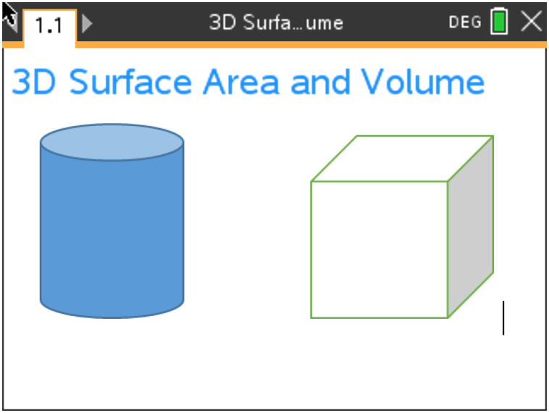  Tech Tips:  - This activity includes screen captures taken from the TI-Nspire CX II handheld. It is also appropriate for use with the TI-Nspire family of products including TI-Nspire software and TI-Nspire App. Slight variations to these directions may be required if using other technologies besides the handheld.  - Watch for additional Tech Tips throughout the activity for the specific technology you are using.  - Access free tutorials at http://education.ti.com/calculators/pd/US/Online-Learning/Tutorials  Lesson Files:  Student Activity  3D_Surface_Area_and_Volume_Student-Nspire.pdf  3D_Surface_Area_and_Volume_Student-Nspire.doc
Review

In this activity, you will be finding both the Surface Area and Volume of several 3D objects. The following formulas will be useful:

Right Cylinder Rectangular Prism Right Cone Sphere
Surface Area:
$A=2πrh+2πr^{2}$ $A=2\left(wl+wh+lh\right)$ $A=πr\left(r+ \sqrt{h^{2}+ r^{2}}\right)$ $A=4πr^{2}$

Volume:
$V= πr^{2}h$ $V=lwh$ $V= \frac{1}{3}πr^{2}h$ $V= \frac{4}{3}πr^{3}$

Problem 1

Before we start finding the Surface Area and Volume, let us practice unfolding 3D objects. First, the right cylinder. Discuss with a classmate what three 2D shapes you can unfold this cylinder into. Also, mention how the dimensions of the 2D shapes are found.

Possible discussion points:
The cylinder can be unfolded into two circles (the top and bottom) and a rectangle.

The length of the rectangle is the circumference of the
circular top or bottom and the width of the rectangle is
the height of the cylinder.

Second, the rectangular prism. Discuss with a classmate what six possible 2D shapes you can unfold
this rectangular prism into. Also, mention how the dimensions of the 2D shapes are found.

Possible discussion points:
The rectangular prism can be unfolded into 6 total rectangles.

The length of the prism is the length of one rectangle,
the height of the prism is the width of one rectangle,
and the width of the prism is the length of one of the
end rectangles.

And finally, a right cone. Discuss with a classmate what two 2D shapes you can unfold this right cone
into. Also, mention how the dimensions of the 2D shapes are found.

Possible discussion points:
The right cone can be unfolded into a sector (of a circle) and a circle.

The radius of the sector is the slant height of the cone found
by creating a right triangle with the height as a leg, the radius
as the other leg and the hypotenuse is the slant height.

Problem 2

Find the Surface Area and Volume of each of the following 3D objects:
(a) A right cylinder with a height of 8 in. and with a base that has a diameter of 4 in.
_{4 in.}

_{8 in.}

Solution:
$SA=2πrh+2πr^{2}$ $V= πr^{2}h$
$SA=2π\left(2\right)\left(8\right)+2π{\left(2\right)}^{2}$ $V= π{\left(2\right)}^{2}(8)$
$SA=32π+8π$ $V=32π {in.}^{3}≈100.531 {in.}^{3}$
$SA=40π {in.}^{2}≈125.664 {in.}^{2}$

(b) A rectangular prism with a length of 3 ft., a width of 2 ft., and a height of 30 in.

30 in.

2 ft.
3 ft.

Solution:
**First convert the height from 30 in. to 2.5 ft
$SA=2\left(wl+wh+lh\right)$ $V= lwh$
$SA=2\left(\left(2\right)\left(3\right)+\left(2\right)\left(2.5\right)+(3)(2.5)\right)$ $V=(3)(2)(2.5)$
$SA=37 {ft}^{2}$ $V=15 {ft}^{3}$

(c) A right cone with a height of 18 cm and its base has a radius of 5 cm.

_{18 cm}

_{5 cm}

Solution:
$SA=πr\left(r+ \sqrt{h^{2}+ r^{2}}\right)$ $V= \frac{1}{3}πr^{2}h$
$SA=π\left(5\right)\left(5+ \sqrt{{18}^{2}+ 5^{2}}\right)$ $V= \frac{1}{3}π{\left(5\right)}^{2}(8)$
$SA ≈371.989 {cm}^{2}$ $V≈209.440 {cm}^{3}$

Problem 3

Given the ice cream cone below is made up of a hemisphere scoop of vanilla ice cream and a right sugar cone, find the total surface area and volume of the entire cone and ice cream.

r = 1.5 in.

h = 4.625 in.

Solution:
$SA=πr\left(r+ \sqrt{h^{2}+ r^{2}}\right)+4πr^{2}$ $V= \frac{1}{3}πr^{2}h+ \frac{4}{3}πr^{3}$
$SA=π\left(1.5\right)\left(1.5+ \sqrt{{4.625}^{2}+ {1.5}^{2}}\right)+4π{\left(1.5\right)}^{2}$ $V= \frac{1}{3}π{\left(1.5\right)}^{2}\left(4.625\right)+ \frac{4}{3}π{\left(1.5\right)}^{3}$
$SA ≈58.255 {in.}^{2}$ $V≈17.606 {in.}^{3}$

Problem 4

The water below has a half of a sphere dome as the top. Find the total surface area of the entire water bottle, and if only the bottom cylindrical portion of the bottle can hold liquid, find how much it can hold.
^{r = 1 cm}
^{1.3 cm}

h = 17 cm

r = 4.5 cm

Solution:
There are actually two cylinders in the water bottle where you only find the surface area of one of its bases.
$SA=2πrh+\frac{1}{2}\left(2πr^{2}\right)+ 2πrh+\frac{1}{2}\left(2πr^{2}\right) + \frac{1}{2}\left(4πr^{2}\right)$ $V= πr^{2}h$
$SA=2π\left(4.5\right)\left(17\right)+π{\left(4.5\right)}^{2}+ 2π\left(1\right)\left(1.3\right)+π{\left(1\right)}^{2}+2π{\left(4.5\right)}^{2}$ $V= π{\left(4.5\right)}^{2}(17)$
$SA ≈682.825 {cm}^{2}$ $V≈1081.493 {cm}^{3}$

TI-Nspire Navigator Opportunity: Quick Poll (Open Response)
How do you convert inches squared into feet squared?

Teacher Tip: After doing each of the real-world Surface Area and Volume problems, it would be a good place to have a discussion about accuracy due to the 3D objects, when combined, are not a perfect fit or that there might be some irregularities in the making of the objects. If time permits, you can do a class experiment and bring in ice cream cones and ice cream and have the students collect their own measurements and check for accuracy.

Extension

Problem 5

The entire rectangular toy chest below with a half cylindrical top needs to be stained. If the stain costs $25.95 to cover 2 square feet of surface, find the surface area of the entire chest and the cost of the stain you will need to cover it.
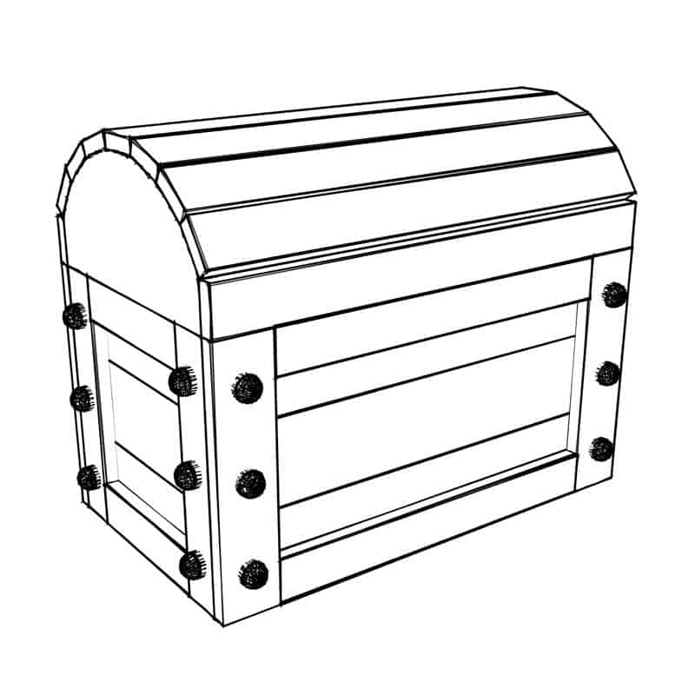

10 in.

8 in. 20 in.
Solution:
You will use the Surface Area formula for a rectangular prism, but that needs to be adjusted due to the top being half a cylinder.
$SA=wl+2wh+2lh+ \frac{1}{2}\left(2πrh+2πr^{2}\right)$
Method 1:
Since the stain cost is in ${ft}^{2}$, you can convert each measurement from inches to feet and plug into the formula:
$SA= \left(\frac{8}{12}\right)\left(\frac{20}{12}\right)+2\left(\frac{10}{12}\right)\left(\frac{8}{12}\right)+2\left(\frac{10}{12}\right)\left(\frac{20}{12}\right)+ \frac{1}{2}\left(\left(2\right)π\left(\frac{4}{12}\right)\left(\frac{20}{12}\right)+2π{\left(\frac{4}{12}\right)}^{2}\right)$
$SA ≈7.094 {ft}^{2}$

Method 2:
You also have the option to leave your dimensions in inches, but then at the end, since there are 12 inches in a foot, and you are looking for ${ft}^{2}$, you would divide your answer by ${12}^{2} or 144$.

$SA= \left(8\right)\left(20\right)+2\left(10\right)\left(8\right)+2\left(10\right)\left(20\right)+ \frac{1}{2}\left(2π\left(4\right)\left(20\right)+2π{\left(4\right)}^{2}\right)$
$SA ≈1021.593 {in.}^{2}$
$SA ≈ \frac{1021.593}{144} ≈7.094 {ft}^{2}$

Total cost of the stain:
$7.094 ÷2 ×25.95 ≈\$92.04$

Teacher Tip: Please know that in the beginning of this activity there is a lot of time dedicated to students talking with one another and sharing their thoughts with the class. The goal here is to not only review Surface Area and Volume of 3D objects, but also to generate discussion.

**Note: This activity has been developed independently by Texas Instruments and aligned with the IB Mathematics curriculum, but is not endorsed by IB™. IB is a registered trademark owned by the International Baccalaureate Organization.

