In this activity, students will differentiate between 2D and 3D polygons and shapes and how simple formulas, like midpoint and distance, alter depending on which you are dealing with. Students will then apply this knowledge to real life applications to enhance their ability to understand this math in both the two-dimensional and three-dimensional planes. | 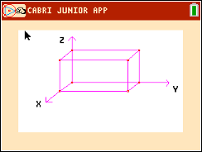
Throughout this activity, students will have to use the following formulas:

$$2D Midpoint= \left(\frac{x_{1}+ x_{2}}{2}, \frac{y_{1}+ y_{2}}{2}\right)$$
$$2D Distance= \sqrt{{\left(y_{2}- y_{1}\right)}^{2}+ {\left(x_{2}- x_{1}\right)}^{2}}$$
Other formulas to be used, but are not limited to, are the laws of sines and cosines, and simple right triangle trigonometry.
Problem 1 – Converting from 2D to 3D
1. Given the coordinates of points A and B: A(-2, 4) and B(6, 8)
Find the midpoint of AB.

2. Given the coordinates of points C and D: C(3, -1, 5) and D(-7, 3, -9)
Discuss with a classmate what would need to change about the midpoint formula above so that you
could find the midpoint of CD, then find the midpoint of CD.

3. Given the coordinates of points E and F: E(4, -5) and F(7, -9)
Find the distance from E to F.

4. Given the coordinates of points G and H: G(2, 1, -4) and H(5, -3, 8)
Discuss with a classmate what would need to change about the distance formula above so that you
could find the distance from G to H, then find the distance from G to H.

Problem 2 – Combining Trig with Coordinate Geometry

Now that you have worked through altering those basic formulas for the 3D plane, let’s try and use some trigonometry as well.

5. Given rectangle ABCD below, find angle ABD.
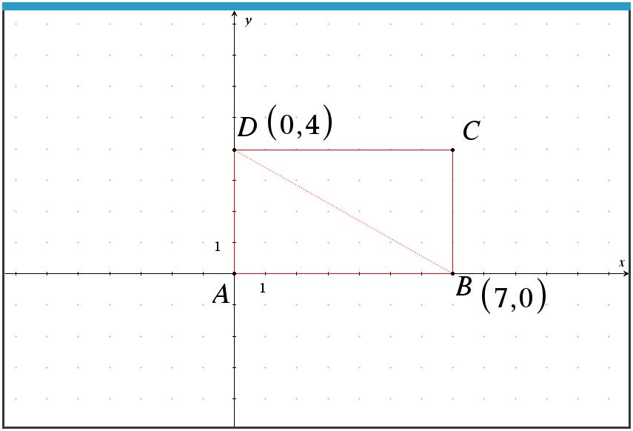
6. Given rectangle EFGH below, where M is the midpoint of GH, find angle EMF.

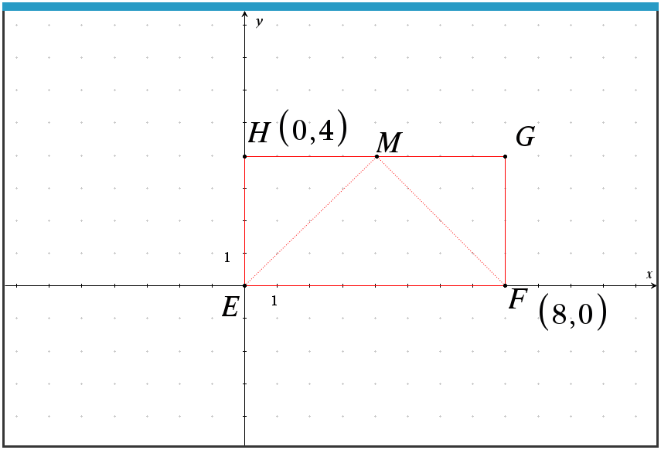

Problem 3 – Shapes on the 3D plane
Now let’s combine what you have practiced in problems 1 and 2 by placing three-dimensional shapes on a coordinate plane.
7. A marble paper weight was modelled after a right pyramid, with vertex T and a square base PQRS. The center of the base is U. The coordinates of vertex T and point P are (2, 3, 0) and (-3, 2, 4) respectively. See the diagram below.
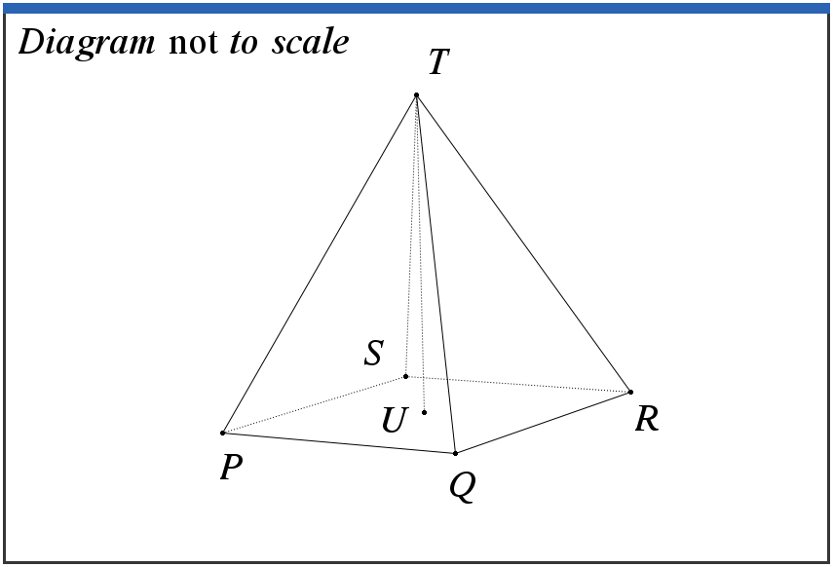
The volume of the pyramid is $41.3 {cm}^{3}$.
a. Find PT.

b. Given that angle QTR = 35°, find QR.

c. Find the height of the pyramid, UT.

Further IB Application

Alan was injured during his climb up the mountain below. He reached a first aid outpost located at point A. Unfortunately, the outpost did not have the supplies he needed. With the help of his hiking partner, Kathy, they must get down to the main first aid outpost located at point B at ground level. Answer the questions below given that the coordinates of A and B are (5, 30, 300) and (160, 20, 0), respectively, in meters.

Diagram not to scale.
z
x 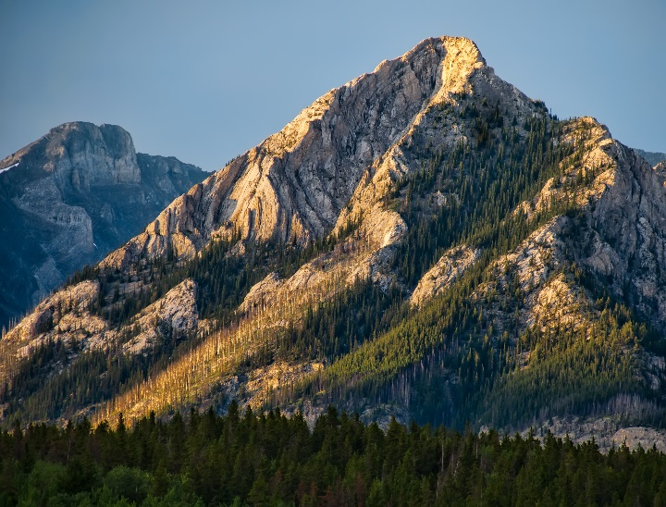 y
A

B

Thankfully, there is a straight trail from outpost A to outpost B and each set of coordinates can be described in reference to the x, y, and z-axes, where the x and y-axes are in the horizontal plane and the z-axis is in the vertical plane.

(a) Find the distance from outpost A to outpost B.

(b) With the sun going down and the temperatures dropping, Alan and Kathy will have to make camp halfway between outpost A and B. Find the coordinates for the midpoint between outposts A and B. Call this point M.

(c) Write down the height of point M, in meters, above the ground.

