Math Objectives  - Students will be introduced to related rates.  - Students will use differentiation, including implicitly, to apply related rates to real world situations.  - Students will try to make a connection with how to understand these topics in IB Mathematics courses and on their final assessments.  Vocabulary  - Related Rates • Differentiation • Implicit  - Rate of Change  About the Lesson  - This lesson is aligning with the curriculum of IB Mathematics Applications and Interpretations HL and IB Mathematics Approaches and Analysis HL  - This falls under the IB Mathematics Content Topic 5 Calculus:  AI HL 5.9: (a) Related rates of change  5.14: (a) Setting up a model/differentiation equation from  a context  AA HL 5.14: (a) Implicit differentiation  (b) Related rates of change  As a result, students will:  - Apply this information to real world situations.  TI-Nspire™ Navigator™  - Transfer a File.  - Use Class Capture to examine patterns that emerge.  - Use Live Presenter to demonstrate.  - Use Teacher Edition computer software to review student documents.  - Use Quick Poll to assess students’ understanding  Activity Materials  Compatible TI Technologies: TI-Nspire™ CX Handhelds,  TI-Nspire™ Apps for iPad®, TI-Nspire™ Software | 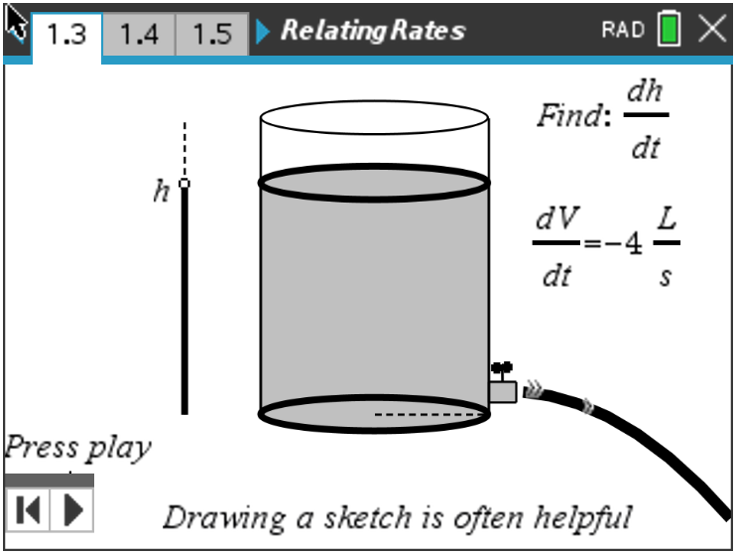  Tech Tips:  - This activity includes screen captures taken from the TI-Nspire CX II handheld. It is also appropriate for use with the TI-Nspire family of products including TI-Nspire software and TI-Nspire App. Slight variations to these directions may be required if using other technologies besides the handheld.  - Watch for additional Tech Tips throughout the activity for the specific technology you are using.  - Access free tutorials at http://education.ti.com/calculators/pd/US/Online-Learning/Tutorials  Lesson Files:  Student Activity  RelatingRates-Student-Nspire.pdf  RelatingRates-Student-Nspire.doc  RelatingRates.tns
In this activity, students are able to apply their knowledge of finding a derivative and using implicit differentiation as they are introduced to the topic of related rates. In several problems, students will have two variables, which are both changing with time. With each problem, one variable’s rate of change at a given instant will be known and the student will need to find the second variable’s rate of change at that same instant.

Let’s do a couple practice problems to better understand the process when dealing with related rates.
Open the file RelatingRates.tns to help guide you through this activity and provide useful visuals.
Teacher Tip: Although there is a file to download to the handheld, this activity can be done without it. The file provides helpful visuals that might make the understanding of the topic of related rates easier to grasp.

Move to page 1.2.
Problem 1 – Example & Explanation

Water is draining from a cylindrical tank at 4 liters/seconds. If the radius of the tank is 2 centimeters, find how fast the surface is dropping. Move to page 1.3 to see a helpful visual of the tank draining.
Step 1: Assign variables, list given information, and determine the unknown(s).
  - Variables:
Solution: height h, radius r, volume V, time t
  - Given information:
Solution: $\frac{dV}{dt}= -4 Ls^{-1}, r=2$
  - Unknown(s):
Solution: $\frac{dh}{dt}$

Move to page 1.4.
Step 2: Write a formula relating given(s) and unknown(s) for a cylindrical tank.
Solution: $V= πr^{2}h$

Move to page 1.5.
Step 3: Differentiate both sides of the equation from Step 2 with respect to t to find the related rates.
- Explain if this problem can or cannot be solved using the Product Rule.
Solution: No, r is constant

Move to page 1.6.
- Use implicit differentiation to differentiate the equation. Show your work.
Solution: $\frac{dV}{dt}= πr^{2}∙\frac{dh}{dt}$

Move to page 1.7.
Step 4: Evaluate—substitute and answer the question being asked!
- Find how fast the surface is dropping when the radius is 2 cm.
Solution: $\frac{-1000}{π} cm{∙s}^{-1}$

Teacher Tip: Students may have some difficulty realizing that if the volume is decreasing, the rate is negative. They also have difficulty remembering an appropriate formula that relates what they know and what they want to find.

Move to page 2.1.
Problem 2 – Additional Example & Explanation

Two cars leave at the same time, one traveling east at 15 units/hour and the other traveling north at 8 units/hour. Find at what rate the distance between them is increasing when the car going east is 30 units from the starting point. Move to page 2.2 to see a helpful visual of this situation.
Step 1: Assign variables, list given information, and determine the goal.
Solution:
Variables: x is the distance east, y is the distance north, z is the distance between the cars,
and t is the number of hours passed;
Given information: $\frac{dy}{dt}=8, \frac{dx}{dt}=15$
Goal: $\frac{dz}{dt}$ when x = 30

Move to page 2.3.
Step 2: Find the equation that relates what is known and what you want to find.
Solution: $x^{2}+ y^{2}= z^{2}$

Move to page 2.4.
Step 3: Implicitly differentiate both sides of the equation from Step 2 with respect to t to find the related rates.
Solution: $2x∙x^{'}+2y∙y^{'}=2z∙z'$

Step 4: Substitute to evaluate.
- Show these key steps.
Solution: $2 ∙30 ∙15+2∙16∙8=2∙34 ∙\frac{dz}{dt}$

Move to page 2.5.
- Find at what rate the distance between them is increasing when the car going east is 30 units from the starting point.
Solution: 17 units

Teacher Tip: To add more depth to this question, ask the students if they would get the same answer if the care going to the east actually started from 60 units away and traveled west at 15 units/hour. Ask them to explain their reason.

Move to page 3.2.
Problem 3 – Practice/Extension
Move to page 3.2.
1. A spherical bubble is being blown up. The volume is increasing at the rate of 9 mm³ per second. Find at what rate the radius is increasing when the radius is 3 mm. Move to page 3.3 for a helpful visual.
Solution: $\frac{1}{4π} mm/sec$

Move to page 3.4.
2. A point moves along the curve y = –0.5x² + 8 in such a way that the y value is decreasing at the rate of 2 units per second. Find at what rate x is changing when x = 4.
Solution: decreasing 0.5 units/sec

Move to page 3.5.
3. A particle moves on the curve such that = 6. Find the instantaneous rate of change of x with respect to t when x = 2. Move to page 3.6 for a helpful visual.
Solution: -36

Move to page 3.7.
4. Two trains leave the station at the same time with one train traveling south at 20 mph and the other traveling west at 33 mph. Find how fast the distance between the trains is changing after 3 hours.
Solution: approximately 28.83 mph

Move to page 3.8.
5. A cylindrical tumbler with a radius of 3 cm has its height increasing at a rate of 2.5 cm/sec. Find the
rate of change of the volume of the cylinder when the height is 12.56 cm. Move to page 3.9 for a
helpful visual.
Solution: 70.686 mL/s

Further IB Application

Move to page 3.10.

A balloon is submerged in liquid nitrogen. The balloon’s diameter contracts when it is cooled. The diameter of the sphere is decreasing at a rate of 4 cm/s.

(a) Find an equation for the change in surface area in terms of the radius (r).
Solution: $SA=4πr^{2}$
$\frac{dSA}{dt}=8πr\frac{dr}{dt}$

(b) Find how fast the surface area is changing when the radius is 10 centimeters.
Solution: $\frac{dd}{dt}= -4 cm∙s^{-1}$
$\frac{dr}{dt}= \frac{1}{2}\left(\frac{dd}{dt}\right)= \frac{1}{2}\left(-4\right)= -2 cm∙s^{-1}$
$\frac{dSA}{dt}=8πr\frac{dr}{dt}=8π(10)(-2)$
$=-160π {cm}^{2}∙s^{-1}$

TI-Nspire Navigator Opportunity: Quick Poll (Open Response)
Any part to any Problem in the activity would be a great way to quickly assess your student’s understanding of related rates.

Teacher Tip: Please know that in this activity there is a lot of time dedicated to students talking with one another and sharing their thoughts with the class. The goal here is to not only introduce and review related rates, but also to generate discussion.

**Note: This activity has been developed independently by Texas Instruments and aligned with the IB Mathematics curriculum, but is not endorsed by IB™. IB is a registered trademark owned by the International Baccalaureate Organization.

