The goal of this activity is to help you understand how the use of derivatives, optimization, and integration affect cost, revenue, and profit equations used in industry from around the world. | 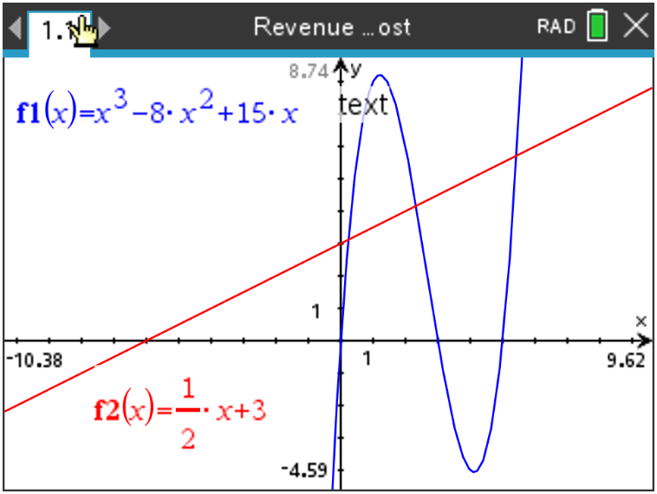

To help with this activity, it should be known that Profit is equal to the Revenue of a manufactured item minus the item’s Cost. In other words:
$$p\left(x\right)=r\left(x\right)-c(x)$$
Where $p(x)$ is the profit function, $r(x)$ is the revenue function, and $c(x)$ is the cost function.
Students should already know the relationship between a function and its first and second derivatives.

Review

(a) Discuss with a classmate how companies can use the first and second derivatives of the profit function to aid in the manufacturing and sales of their merchandise. Share your results with the class.

(b) Discuss with a classmate the different techniques on the TI-Nspire CX II in which you can find and use the first and second derivatives (and their graphs) to aid in these profit function problems. Share your results with the class.

Problem 1

Armor Guard manufactures and sells silver polish. The cost of manufacturing the silver polish can be modelled by the function $c\left(x\right)=\frac{1}{2}x+3$, where x is the number of cases, with each case containing 100 bottles, manufactured. Revenue is modelled by
$r\left(x\right)= x^{3}-8x^{2}+15x$. The company has enough work force to produce a max of a 130 cases per day.

(a) State the domain of both the cost and revenue functions.

(b) Without graphing, find the number of cases that the company should manufacture in order to maximize profits.

After years of developing, the company has found a way to now produce 250 cases per day.

(c) Find the number of cases that would cause the company to minimize profits (or maximize losses).

(d) Using a graphing utility, graph the cost and revenue functions, find the number of cases which should be manufactured if the company is going to just break even (i.e. the production level when $c\left(x\right)=r(x) going to just break even (i.e. the production level when nctions, find the number of cases which should be manufactured if t$).

(e) It would not maximize the company’s profits to produce as many cases as workers are capable of producing. Use your graph to explain why.

Problem 2

In its annual shareholders meeting Best Buds stated that the cost of producing earbuds is modelled by
the function $c\left(x\right)=3x+ 1$ and the revenue for producing these earbuds is modelled by the function
$r\left(x\right)=40x+12x^{2}-x^{3}$ , where x represents the number of batches of earbuds and each batch
contains 100. Find the number of earbuds which maximizes profit and determine the maximum
profit.

Extension

What if you were given the rate of change of a company’s profit on the production of a certain item of merchandise, could you find the company’s profit function? In this final problem of the activity, we will explore this situation.

Problem 3

Snow Shifters produces and sells shovels. The company’s profit, $P(x)$ in thousands of dollars, changes based on the number of shovels produced per month.

The rate of change of their profit from producing shovels is modelled by $\frac{DP}{dx}= -4x+15$, where $x$ is the number of shovels produces (in hundreds).

The company makes a profit of 18 (thousand dollars) when they produce 4 (hundred) shovels.

(a) Find an expression for $P$ in terms of $x$.

(b) At certain times of year, the company has the ability to increase production. Describe how their profit changes if they increase production to over 5 (hundred) shovels and up to 6 (hundred) shovels.

Further Discussion

As preparation for the end of course assessments, a portion of the exam is done with the calculator and a portion is done without. Using this activity as a guide, discuss with a classmate, and make a list of each method used throughout the activity and explain how to do them with and without a calculator. Remember, there are multiple ways to do each method with and without technology. Take time to discuss how to verify each process. Share your results with the class.

