Topic 5: Calculus | Optimization
- Erica works for a company that produces metal tins. The tins are created from a metal sheet
6 in. by 6 in. Erica’s job is to operate a machine that removes a square, with side length
$x$ in., from each corner. See picture below, not drawn to scale.
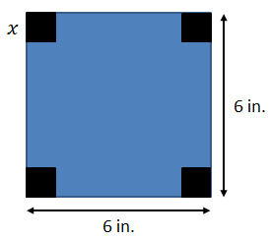

The remaining metal sheet is sent to a machine that folds up the sides to form a tray. See picture below, not drawn to scale.

- Find the length and width of the tray, in terms of $x$  - Show that the volume, $V$ in³, of the tray is  $$V=4x^{3}-24x^{2}+36x$$  - Find $\frac{dv}{dx}$  - Using your answer from part (c), find the value of $x$ that maximizes the volume of the tin.  - Find the maximum volume of the tin |  |  | (2 marks)  (2 marks)  (3 marks)  (3 marks)  (2 marks)
Mark scheme:  - Length: $6-2x$Width: $6-2x$  - $V=l*w*h$  $$V=(6-2x)(6-2x)(x)$$  $$V=4x^{3}-24x^{2}+36x$$  - $\frac{dv}{dx}=12x^{2}-48x+36$  - $0=\text{12}x^{2}-48x+36$  $$0=x^{2}-4x+3 \\ 0=\left(x-3\right)\left(x-1\right) \\ x=3, 1 \\ x=1$$  - $V=4{(1)}^{3}-24{\left(1\right)}^{2}+36(1)$  $V=16$ in³ |  | (A1)  (A1)  (M1) ft Correct substitution of their length and width into the volume of a rectangular prism formula  (A1) ft Correct multiplication of the three polynomials  (A1)(A1)(A1)  (1) Setting their part (c) = 0  (1) Solving for x  (A1) Knowing that 3 cannot work and that 1 is the solution  (1) ft Correct substitution of their solution from part (d)  (1) ft

