Topic 5: Calculus | Kinematics
A particle moves in a straight line. The velocity, $v ms^{-1}$, of the particle at time $t$ seconds is given by $v\left(t\right)=t\cos{t}-2, for 0 ≤t ≤8$.  The following diagram shows the graph of $v$.  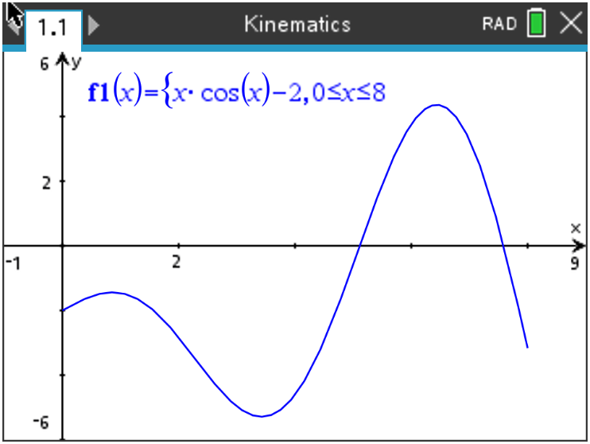  (a) Find the smallest value of $t$ for which the particle is at rest.  (b) Find the total distance travelled by the particle.  (c) Find the acceleration of the particle when $t=6$. |  | [2 marks]  [2 marks]  [2 marks]
Mark scheme:  (a) Setting $v\left(t\right)=0$  $t=5.114…$  $t=5.11 sec$  Note: Do not award A1 if multiple times are given.  (b) $\int_{0}^{8}{\left|v\left(t\right)\right| dt}$  $or -\int_{0}^{5.1141…}{v\left(t\right) dt} + \int_{5.1141…}^{7.5872…}{v\left(t\right) dt}- \int_{7.5872…}^{8}{v\left(t\right) dt }$  $=23.135066…$  $=23.1 m$  (c) Finding $a\left(6\right)=v'(6)$  Acceleration = 2.63666…  = $2.64 ms^{-2}$ |  | (M1)  A1  [2 marks]  A1  A1  [2 marks]  (M1)  A1  [2 marks]

