The goal of this activity is to help you understand how the use of derivatives and integration, combined with Kinematics, demonstrate how particle movement can apply to real world situations. | 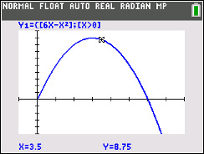

To get this activity started, a quick review on Kinematics will be beneficial. Simply stated, Kinematics is the features or properties of the motion of an object. Three words associated with Kinematics are displacement, velocity, and acceleration. s is the displacement of the object (or particle) from a fixed origin at time t. v is the velocity of the particle at time t. a is the acceleration of the particle at time t.

Students should already know the relationship between a particle’s displacement, velocity and acceleration, but we will review those skills through this activity.

Review

(a) Discuss with a classmate how using a particle’s displacement equation can help you find a particle’s velocity equation. Also, discuss how you using a particle’s velocity equation can help you find the particle’s acceleration equation. Share your results with the class.

(b) Discuss with a classmate how using a particle’s acceleration equation and a boundary condition can help find the velocity equation. Also, discuss how you using a particle’s velocity equation and a boundary condition can help find the displacement equation. Share your results with the class.

After your results have been shared, fill in the following blanks:
$s\left(t\right)$ $s\left(t\right)= ______________________$
$v\left(t\right)= __________$ $v\left(t\right)= ______________________$
$a\left(t\right)= __________= __________$ $a(t)$

What is the difference between displacement and distance traveled? Let us explore that now!
Problem 1

Particle A travels in a straight line such that its displacement, s meters, from a fixed origin after t seconds is given by $s\left(t\right)=6t-t^{2}$, for $0 ≤t ≤8$.
Particle A starts at the origin and passes through the origin again when t = q. Particle A changes direction when t = r. The total distance travelled by particle A is given by d.

(a) (i) Find the position, velocity and acceleration of particle A after 1 second. With a classmate, discuss
what each of these answers mean with respect to particle A. Share your results with the class.

(ii) Determine if particle A is speeding up or slowing down at t = 1. Explain your reasoning.

(b) Find the value of q. With a classmate, discuss the significance of what this value of q means about particle A and the math used to find the value of q. Share your results with the class.

(c) Find the intervals on which particle A is speeding up and the intervals on which it is slowing down. With a classmate, discuss the math used to come to your conclusion. Share your results with the class.

(d) (i) Find the value of r. With a classmate, discuss the significance of what this value of r means about the particle and the math used to find the value of r. Share your results with the class.

(ii) Find the displacement of particle A from the origin when t = r.

(e) Find the distance of particle A from the origin when t = 8.

(f) Find the value of d. Discuss with a classmate what the difference is between particle displacement
and a particle’s total distance. Share your results with the class.

(g) A second particle B, travels along the same straight line such that the velocity is given by
$v\left(t\right)=8-2t$, for $t ≥0$. When t = p, the distance traveled by B is equal to d. Find the value of p.
Discuss with a classmate how you would use velocity to help find the distance traveled. Share your
results with the class.

Reflection

Discuss with a classmate how your TI-84 Plus CE could have helped or did help you through the
process of answering Problem 1. Share your results with the class.

Problem 2

The velocity, $v {ms}^{-1}$, of a particle moving along a line, for $0 ≤ t≤ 8$, is shown in the following
diagram:

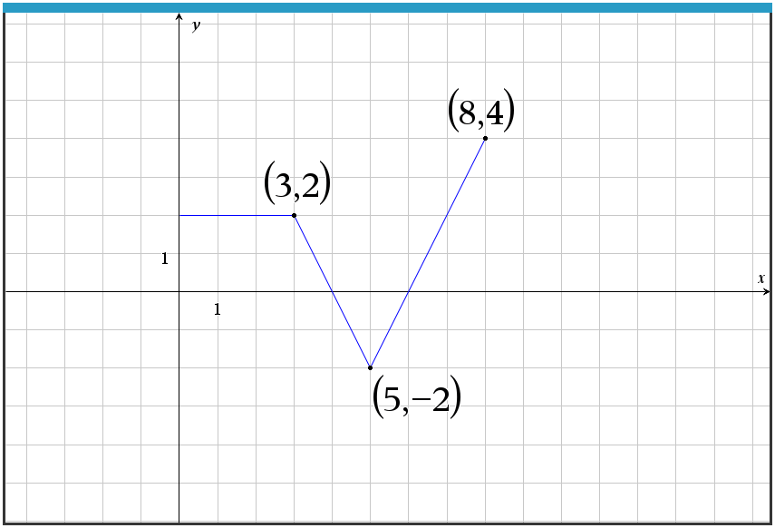

(a) Find the acceleration of the particle when t = 4. Discuss with a classmate how you would find this
given the velocity graph. Share your results with the class.
(b) Write down the interval(s) on which the particle is travelling to the right. Discuss with
a classmate how you can tell by the velocity graph. Share your results with the class.

(c) Write down a definite integral that represents the displacement of the particle after 8 seconds. Find
this displacement.

(d) Write down a definite integral that represents the total distance travelled for $0≤t≤8$. Find this total distance.

(e) Discuss with a classmate the difference between distance travelled and displacement. Share your results with the class.

Problem 3

The velocity, $v {ms}^{-1}$, of a particle moving in a straight line is given by $v\left(t\right)= t^{2}-25$, where $t ≥0$ seconds.

(a) Find the acceleration of the particle at t = 3.

(b) The initial displacement of the particle is 8 m. Find an expression, s, for the displacement of the particle at time t.

(c) Find the distance travelled between times 3 seconds and 6 seconds.

Further Applications Beyond Particles

1.) A child’s sling shot launches water balloons in the air. The height, h m, of a water balloon which is launched into the air with an initial velocity $v_{o}$ and an initial height of $h_{o}$ can be modelled by the function $h\left(t\right)= h_{o}+ v_{o}\left(t\right)-4.9t^{2}$ where $t$ is time in seconds that have passed since the balloon was launched. A water balloon is launched from the ground with $v_{o}=50 ms^{-1}$. Find the maximum height the balloon reaches and the time that passes before it hits the ground again.

2.) During the diving championships, a team member jumps from a diving board above a swimming pool. At a time, $t$ seconds after leaving the board, the team member’s height above the surface of the pool, $s$ meters, can be modelled by the function $s\left(t\right)=12+4t- t^{2}$. Find:

(a) The height of the diving board above the surface of the pool.

(b) The time between the person leaving the board and hitting the water.

(c) The velocity and acceleration of the diver upon impact with the water. Interpret these in the context of the problem.

