Math Objectives  - Students will practice and discuss applications of finding the area bounded by a curve and the x-axis.  - Students will apply this information to finding the area bounded by two curves.  - Students will try to make a connection with how to understand these topics in both IB Mathematics and AP Calculus and on their final assessments.  Vocabulary  - Riemann Sums • Underestimate • Overestimate  - Definite Integrals • Bounded Areas • Concavity  About the Lesson  - This lesson involves comparing the Riemann Sum area estimates with the exact bounded area of a curve and the x-axis.  - This lesson is aligning with the curriculum of IB Mathematics Applications and Interpretations SL/HL and IB Mathematics Approaches and Analysis SL/HL  - This falls under the IB Mathematics Core Content Topic 5 Calculus:  5.5a Introduction to integration as anti-differentiation of functions and its link between definite integrals and area  5.5c Definite integrals using technology and the area of a region  enclosed by y = f(x) and the x-axis.  5.8 Approximating areas using the trapezoid rule (IB AI only)  5.11a/b Definite integrals and area between curves (IB AA only)  - As a result, students will:  - Apply this information to real world situations  Teacher Preparation and Notes  - This activity is done mainly by hand, but uses the TI-84 family as an aid to the problems.  - Students will need to know how to find the definite integral using the TI-84 calculator menu and using the area under the curve capabilities on a graph.  Activity Materials  - Compatible TI Technologies:  TI-84 Plus*, TI-84 Plus Silver Edition*, TI-84 Plus C Silver Edition, TI-84 Plus CE  * with the latest operating system (2.55MP) featuring MathPrintTM _{functionality.} | 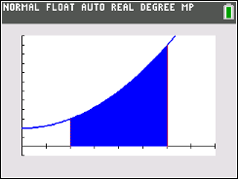  Tech Tips:  - This activity includes screen captures taken from the TI-84 Plus CE. It is also appropriate for use with the rest of the TI-84 Plus family. Slight variations to these directions may be required if using other calculator models.  - Watch for additional Tech Tips throughout the activity for the specific technology you are using.  - Access free tutorials at http://education.ti.com/calculators/pd/US/Online-Learning/Tutorials  Lesson Files:  Student Activity  Bounded_Areas_Student-84.pdf  Bounded_Areas_Student-84.doc
Teacher Tip: Students should have worked with Riemann Sums and Definite Integrals prior to this activity.

The function $f\left(x\right)= x^{2}+2$ is shown. You will answer the following questions to refresh your skills on left-hand rectangle, right-hand rectangle, midpoint rectangle, and trapezoidal Riemann Sums given the bounded area between $f(x)$, the x-axis, and the vertical lines x = 1 and x = 3. For the remainder of this activity, we will call this bounded area $A(x)$.  This is a visual of the bounded area, $A(x)$. |  | 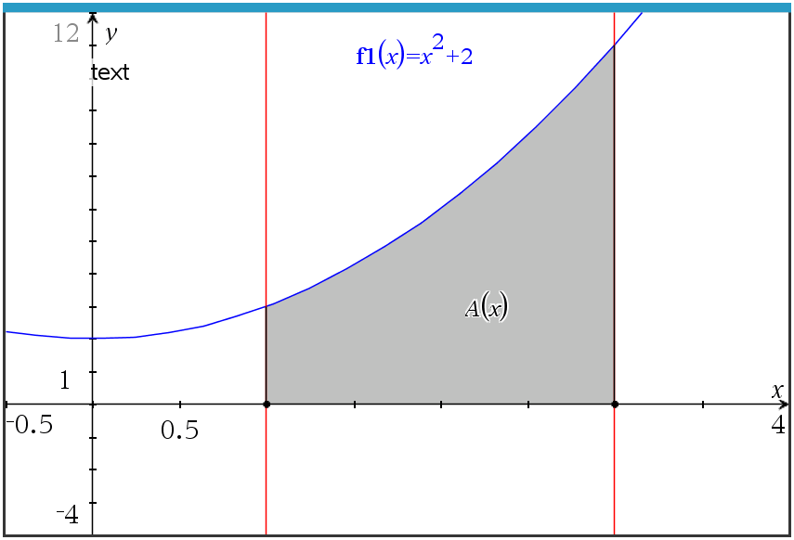
1. Using the four left-endpoint rectangles provided below, find their sum total area between the curve and the x-axis. State if this is an underestimate or overestimate of the bounded area A(x).  Explain your reasoning. |  | 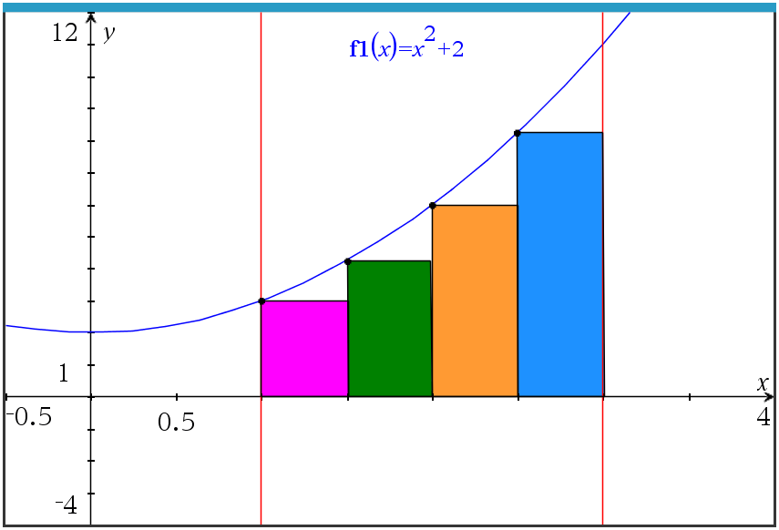
Sample Answer: Sum Total Area- 10.75, this is an underestimate due to the graph increasing, making the left sum an underestimate of the actual bounded area between the x-axis, f(x), x = 1, and x = 3.

Teacher Tip: When finding the area of each rectangle, remember that the base is the x width of each rectangle (0.5) and the height is f(left endpoint x-value).

2. Using the four right-endpoint rectangles provided below, find their sum total area between the curve and the x-axis. State if this is an underestimate or overestimate of the bounded area $A(x)$. Explain your reasoning. |  | 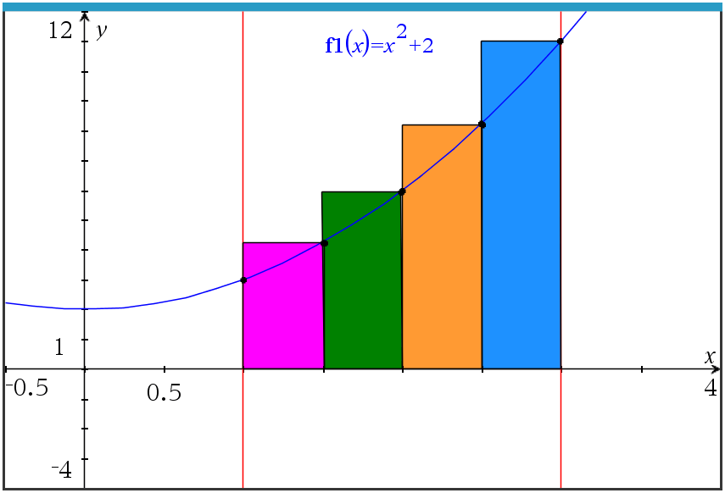
Sample Answer: Sum Total Area- 14.75, this is an overestimate due to the graph increasing, making the right sum an overestimate of the actual bounded area between the x-axis, f(x), x = 1, and x = 3.

3. Using the four midpoint rectangles provided below, find their  sum total area between the curve and the x-axis. State if this an  underestimate or overestimate of the bounded area $A(x)$.  Explain your reasoning. |  | 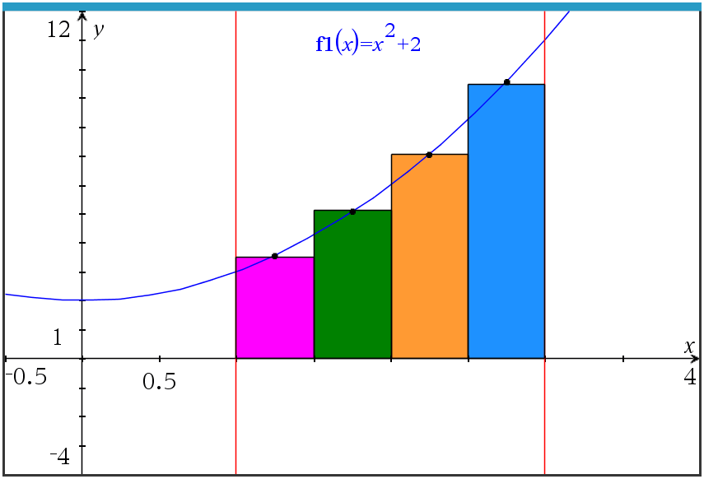
Sample Answer: Sum Total Area- 12.625, this is an underestimate due to the graph being concave up, making the midpoint sum an underestimate of the actual bounded area between the x-axis, f(x), x = 1, and x = 3.
4. Using the four trapezoids provided below, find their sum total area between the curve and the x-axis. State if this is an underestimate or overestimate of the bounded area $A(x)$. Explain your reasoning.  Sample Answer: Sum Total Area- 12.75, this is an overestimate due to the graph being concave up, making the trapezoidal sum an overestimate of the actual bounded area between the x-axis, f(x), x = 1, and x = 3. |  | 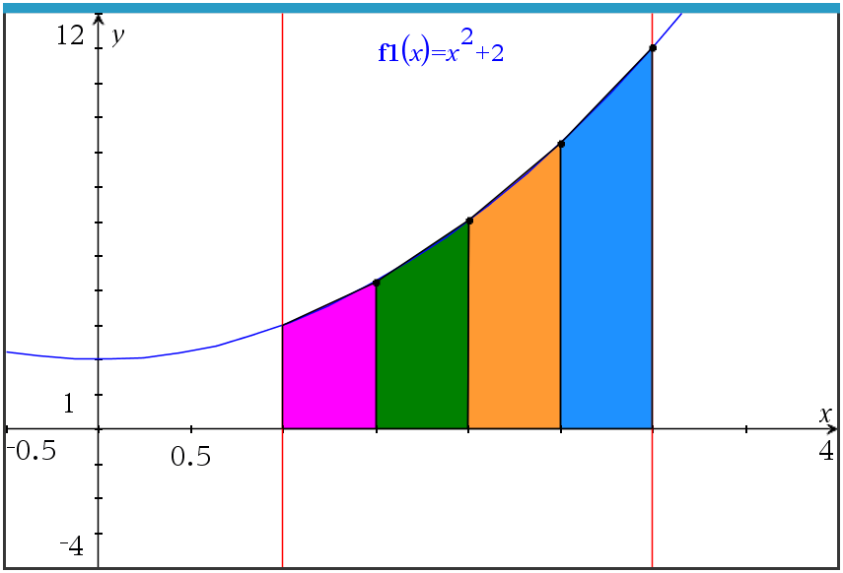
Teacher Tip: Using the Area of a trapezoid formula,
A = 0.5(b₁+ b₂)h, the height in this case is the x width of each trapezoid (0.5) and the bases are f(left endpoint x-value) and f(right endpoint x-value).

5. Looking back on the last four questions 1 – 4, state which you think is the most accurate for the area, $A(x)$. Explain your reasoning.

Sample Answer: Since students have not yet found the exact area, answers may vary. The differences are:
Left Sum: 12.67 – 10.75 = 1.92 under
Right Sum: 12.67 – 14.75 = -2.08 over
Midpoint Sum: 12.67 – 12.63 = 0.04 under
Trapezoidal Sum: 12.67 – 12.75 = -0.08 over

It seems that the Midpoint Sum in this case is the closest.

6. With your classmates, explain how we can use integration to find the exact bounded area.

Sample Answer: You can find the definite integral of f(x) using the boundaries x = 1 and x = 3. This will find the exact area between the curve and the x-axis between 1 and 3.

7. Use your handheld to find the exact area by graphing f(x) and by calculating the integral. Explain why the answers are or are not the same.  Graph: Graph > 2nd Trace > 7 Integral f(x) dx, then move your cursor to x = 1 and press enter. Move your cursor to x = 3 and press enter. The shaded region is the area.  Calculator: Math > 9 fnInt(, then fill in the boundaries with 1 and 3, the expression with f(x), with respect to x.  Area of the bounded region (definite integral) = 12.67 |  | 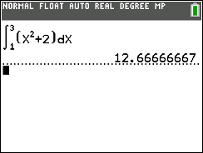
Extension

Discuss with one another what would happen if:

8. The function was $f\left(x\right)= {-x}^{2}+2$ instead;

Sample Answer: Students should discuss that if the boundaries are kept the same (x = 1 and x = 3) that some of the area will be above the x-axis and some below. They should also discuss that the function is now deceasing which may affect which sums are overestimates and underestimates.

9. The number of rectangles/trapezoids was doubled;

Sample Answer: Students should discuss that if the number of rectangles or trapezoids went from 4 to 8, the sum total areas will be more precise and closer to the actual area of the bounded region.

10. The function was $f\left(x\right)= {-x}^{2}-2$;

Sample Answer: Students should discuss that this function is a reflection over the x-axis and will give the identical areas as the original function, just the opposite of each answer.

11. The x-axis and vertical lines were no longer the boundaries, but a second function,
$g\left(x\right)= {-x}^{2}+4$, was. Describe how you would you find this area.

Sample Answer: This would be a great opportunity to have the students discuss that the definite integration that they have been using was actually finding the area between two curves. The first was the given function, the second was the line y = 0 (the x-axis). They could then discuss the subtraction of the two functions as part of the integral expression set up and the points of intersection as the boundaries.

Application  A couple building a house want to make a statement with their front door. They are considering multiple shapes for the entrance. They find the standard rectangular doorway to be boring. One shape that piqued their interest was an arch. The door is the shaded region modeled by the function  $f\left(x\right)=\frac{1}{3}(8-x)(x-2)$, bounded by the x-axis and $f\left(x\right)$. It is shown here.  (a) Write down an integral for the shaded region.  Answer: $\int_{2}^{8}{\frac{1}{3}(8-x)(x-2)} dx$  (b) Find the area of this shaded region.  Answer: Area = 12 | 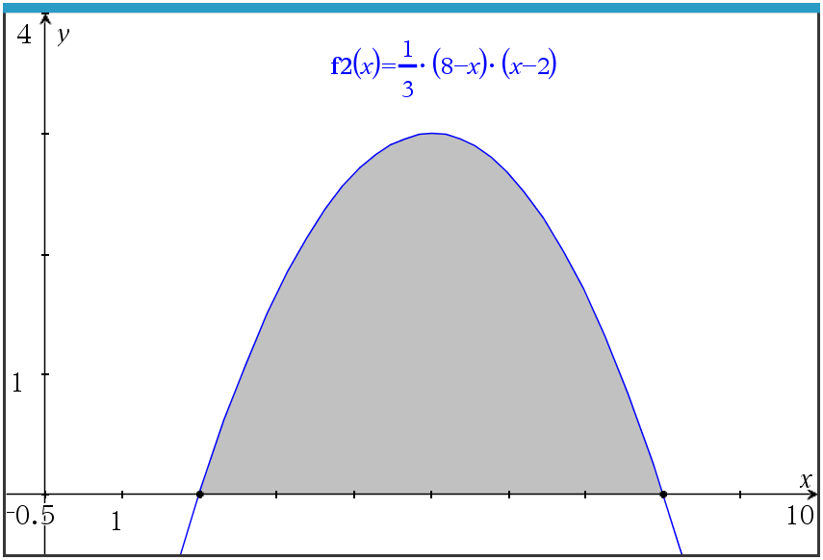
The couple have always been fascinated by triangles. Here is the rendering of how a triangular entrance would look. The three vertices are given as P(0, 2.5), Q(5, 4), and R(c, 0).  c) Find the value of c, the x-coordinate of R, such that the area of the triangle is equal to the area of the region found in part (b).  Answer: 12 = 0.5 (c – 2.5)(4)  c = 8.5 | 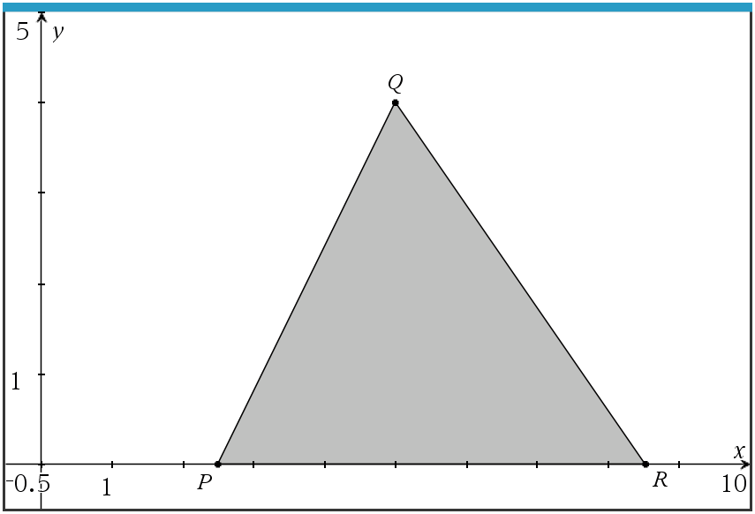
Wrap Up

Upon completion of the discussion, the teacher should ensure that students are able to understand:
- How to compare Riemann Sums and explain overestimates and underestimates.
- How to find and compare definite integrals to Riemann Sum estimates.
- How to apply bounded areas to the real world.

Further Discussion for Next Class:
Briefly explain how limits can be used to approximate a more exact answer when using Riemann Sums.

**Note: This activity has been developed independently by Texas Instruments and aligned with the IB Mathematics curriculum, but is not endorsed by IB™. IB is a registered trademark owned by the International Baccalaureate Organization

