Math Objectives
- Students will be able to state and apply the properties of logarithms:
- $\log_{a}\left(mn\right)= \log_{a}\left(m\right)+ \log_{a}\left(n\right)$
- $\log_{a}\left(\frac{m}{n}\right)= \log_{a}\left(m\right)- \log_{a}\left(n\right)$
- $\log_{a}\left(m^{n}\right)= n\log_{a}\left(m\right)$
- Students will be using Lists and Spreadsheets/Data and Statistics pages on the TI-Nspire CX II to make comparisons between the properties of exponents and the properties of logarithms.
- Students will try to make a connection with how to understand these topics in IB Mathematics courses and on their final assessments.

Vocabulary
- logarithmic expressions ● equivalent expressions
- exponential properties

About the Lesson
- This lesson is aligning with the curriculum of IB Mathematics Applications and Interpretations SL/HL and IB Mathematics Approaches and Analysis SL/HL
- This falls under the IB Mathematics Content Topic 1 Algebra:
AI HL 1.9 Laws of Logarithms (see above)
AA 1.7b Laws of Logarithms (see above)
- As a result, students will:
Apply this information to real world situations

TI-Nspire™ Navigator™ System
- Use Quick Poll to assess students’ understanding throughout the activity.
- Use Live Presenter for student demonstrations.
- Use Screen Capture to examine patterns that emerge.

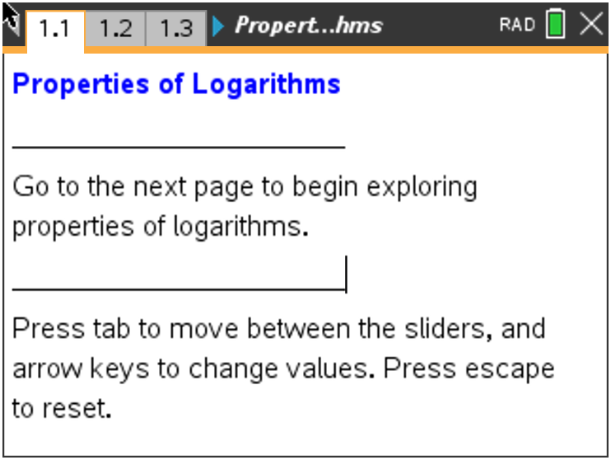

Tech Tips:
- This activity includes screen captures taken from the TINspire CX handheld. It is also appropriate for use with the TI-Nspire family of products including TI-Nspire software and TI-Nspire App. Slight variations to these directions may be required if using other technologies besides the handheld.
- Watch for additional Tech Tips throughout the activity for the specific technology you are using.
- Access free tutorials at http://education.ti.com/calcul ators/pd/US/OnlineLearning/Tutorials

Lesson Files:
Student Activity
Properties_of_Logarithms_ Student.pdf
Properties_of_Logarithms_
Student.doc
TI-Nspire document
Properties_of_Logarithms.tns

Activity Materials
- Compatible TI Technologies: TI-Nspire™ CX Handhelds,
TI-Nspire™ Apps for iPad®, TI-Nspire™ Software

Discussion Points and Possible Answers

TI-Nspire Navigator Opportunity: Live Presenter See Note 1 at the end of this lesson.

Tech Tip: All the pages after the title screen are designed to easily allow students to drag the slider values. Instruct the students to move the cursor to the point m or n until they get the open hand (÷) and select the Touchpad or select ·. The point should slowly blink. Then the point can be moved by pressing the directional arrows of the Touchpad.

Tech Tip: All the pages after the title screen are designed to easily allow students to drag the slider values. To move the point on each slider, tap on the point and begin sliding it.

Teacher Tip: At some point during the investigation, you may want to discuss some of the historical implications of the properties of logarithms. The usefulness of logarithms in calculations is based on these properties. The first two properties are the basis for the slide rule, a mechanical computation device that preceded the electronic calculator.

Move to page 1.2.
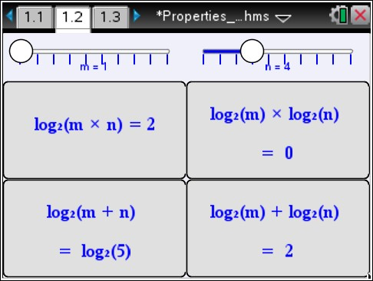
For this activity, the expression used is $\log_{2}{(x})$.
The investigations also work for any base > 0 and any base ≠ 1.
- As you drag the sliders for m and n, note what happens as these values are substituted into the four expressions.
a. Find which expressions, if any, appear to be equivalent
independent of the values of m and n.

Answer: $\log_{2}\left(mn\right)$ and $\log_{2}\left(m\right)+ \log_{2}\left(n\right)$

  - Set m = 8 and n = 4. Substitute these values into the logarithmic expressions you found to be equivalent in part 1a, and simplify these expressions to show they are indeed equivalent.

Answer: $\log_{2}\left(8∙4\right)= \log_{2}{(32)}=5$ and $\log_{2}\left(8\right)+ \log_{2}\left(4\right)=3+2=5$

  - Use the expressions you found in parts 1a and 1b to write a general logarithmic property forlog_{a} mn where a is a real number, $a>0$ and $a ≠1$.

Answer: $\log_{2}\left(mn\right)$ = $\log_{2}\left(m\right)+ \log_{2}\left(n\right)$

  - Explain how the operations in the logarithmic property in part 1c relate to the operations in the exponential property $a^{m}a^{n}= a^{m+n}$.

Answer: For the exponential rule, if the bases are the same and the expressions are being multiplied, the exponents are added. Because a logarithm is also an exponent, the rule applies similarly.

Teacher Tip: If desired, you may want students to prove question 1d instead. Here is a sample answer:
Using the definition of logarithms that states $\log_{a}{x=y ⇔ a^{y}=x}$and the stated exponential property, you can verify the logarithm property from question 1c.

$\log_{a}\left(m\right)= y_{1} ⇔ a^{y_{1}}=m$
$\log_{a}\left(n\right)= y_{2} ⇔ a^{y_{2}}=n$
$\log_{a}\left(m\right)+ \log_{a}\left(n\right)= y_{1}+ y_{2}$
$mn= a^{y_{1}}a^{y_{2}}= a^{y_{1}+ y_{2}} ⇔ \log_{a}{(mn)}= y_{1}+ y_{2}$ Thus, $\log_{a}{(m)}+ \log_{a}{(n)}= \log_{a}{(mn)}$

Tech Tip: To reset, students can select >Controls> Reset.

TI-Nspire Navigator Opportunity: Screen Capture and Quick Poll See Note 2 at the end of this lesson.

Move to page 1.5

Now let’s look at this same idea but graphically. Suppose you wanted to simplify the logarithm of a product, like $\log{6a}$. Think about how you might go about doing this. Let’s start by defining a new variable $b=6a$.
Step a: At the top of column 1, name this list $a$. Enter at least 10 values for $a$, that are in the domain of
the logarithmic function.
Step b: At the top of column 2, name this list $b$. Move down to the second row and enter a formula that
will calculate $b=6a$, from the values in column 1.
Step c: Move to page 1.6 and click on the bottom to add variable $a$ and click on the left to add variable
$b$.

2. Describe the shape of the graph. Discuss with a classmate if it is what you expected. Share your
results with the class.

Answer: The shape of the graph is linear.

Step d: Move back to page 1.3. Now we will define two new variables, x and y. Let $x=\log{a}$ and
$y=\log{b}$. At the top of the third column, name it $x$. Move down to the second row and enter a
formula that calculates $x$ from the values in column 1. At the top of the fourth column, name it $y$.
Move down to the second row and enter a formula that calculates $y$ from the values in column 2.

Step e: Move to page 1.7 and click on the bottom to add variable $x$ and click on the left to add variable
$y$.

The data appear linear. Find the equation of a line through these points by pressing menu, 4 Analyze, 6 Regression, 1 Linear (mx + b).

3. Write down the equation of the line through these points.

Answer: $y=x+0.778151$

4. Find the y-intercept of the line.

Answer: y-intercept = 0.778151

You should have found that the equation of the line was $y=x+0.778151$. Think about where this
$y-intercept$ comes from. (Here’s a hint: Try raising 10 to the 0.778151 power.)

5. Using logs, find what 0.778151 is.

Answer: $\log_{10}{6} ≈0.778151$

6. Since ${10}^{0.778151} ≈$___________, $\log{(6)} ≈$ ____________.

Answer: ${10}^{0.778151} ≈6$ and $\log_{10}{(6)} ≈0.778151$

You have found that $y= \log{6}+x$. Think about what this means. Substitute to rewrite this as an equation in terms of $a$. The explanation for each step is given to the right.
$$y= \log{6}+x$$ | Equation of the line
 | $x= \log{a}$ and $y= \log{b}$
 | $$b=6a$$

Product Property of Logarithms Examples $\log{xy}$ is written in expanded form
For $a>0$ and $b>0$, $\log{ab}= \log{a}+ \log{b}$. as $\log{x}+ \log{y}$
$\log{7}+\log{z}$is written as a single
logarithm as $\log{7z}$

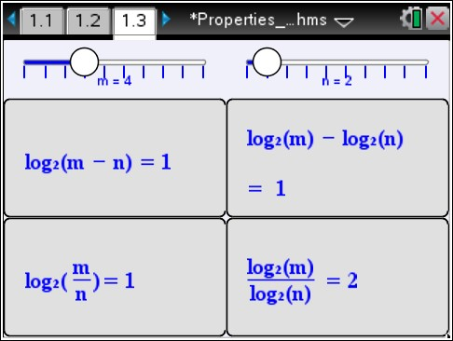
Move to page 1.3

7. As you drag the sliders for m and n, note what happens as these
values are substituted into the four expressions.
  - Find which expressions, if any, appear to be equivalent independent of the values of m and n.
Answer: $\log_{2}\left(\frac{m}{n}\right)$ and $\log_{2}\left(m\right)- \log_{2}{(n)}$

  - Set m = 8 and n = 4. Substitute these values into the logarithmic expressions you found to be equivalent in question 7a, and simplify these expressions to show they are indeed equivalent.
Answer: $\log_{2}\left(\frac{8}{4}\right)= \log_{2}{(2)}=1$ and
$\log_{2}\left(8\right)- \log_{2}\left(4\right)=3-2=1$
  - Use the expressions you found in parts 7a and 7b to write a general logarithmic property
for $\log_{a}\left(\frac{m}{n}\right)$ where a is a real number and $a>$0 and $a ≠1$.

Answer: $\log_{a}\left(\frac{m}{n}\right)=$ $\log_{a}\left(m\right)- \log_{a}{(n)}$

  - Explain how the operations in the logarithmic property in part 7c relate to the operations in the exponential property $\frac{a^{m}}{a^{n}}= a^{m-n}$.

Answer: The log of a quotient is the difference of the logs. Since logarithms are exponents, the exponent of a quotient is the difference of the exponents.

Teacher Tip: If desired, you may want students to prove question 2d instead. Here is a sample answer:

Using the definition of logarithms that states $\log_{a}{x}=y ⇔ a^{y}=x$ and the stated exponential property, you can verify the logarithm property from question 2c.

$\log_{a}\left(m\right)= y_{1} ⇔ a^{y_{1}}=m$
$\log_{a}\left(n\right)= y_{2} ⇔ a^{y_{2}}=n$
$\log_{a}\left(m\right)- \log_{a}\left(n\right)= y_{1}- y_{2}$
$\frac{m}{n}= \frac{a^{y_{1}}}{a^{y_{2}}}= a^{y_{1}- y_{2}} ⇔ \log_{a}\left(\frac{m}{n}\right)= y_{1}- y_{2}$
Thus, $\log_{a}{(m)}- \log_{a}{(n)}= \log_{a}\left(\frac{m}{n}\right)$

TI-Nspire Navigator Opportunity: Screen Capture and Quick Poll See Note 3 at the end of this lesson.

Move to page 2.1

Again, let’s look at this same idea but graphically. Suppose you wanted to simplify the logarithm of a quotient, like $\log{\frac{8}{a}}$. Think about how you might go about doing this. Let’s start by defining a new variable $b=\frac{8}{a}$.
Step a: At the top of column 1, name this list $a$. Enter at least 10 values for $a$, that are in the domain of
the logarithmic function.
Step b: At the top of column 2, name this list $b$. Move down to the second row and enter a formula that
will calculate $b=\frac{8}{a}$, from the values in column 1.
Step c: Move to page 2.2 and click on the bottom to add variable $a$ and click on the left to add variable
$b$.

8. Describe the shape of the graph. Discuss with a classmate if it is what you expected. Share your
results with the class.

Answer: The shape of the graph is linear.

Step d: Move back to page 2.1. Now we will define two new variables, x and y. Let $x=\log{a}$ and
$y=\log{b}$. At the top of the third column, name it $x$. Move down to the second row and enter a
formula that calculates $x$ from the values in column 1. At the top of the fourth column, name it $y$.
Move down to the second row and enter a formula that calculates $y$ from the values in column 2.

Step e: Move to page 2.3 and click on the bottom to add variable $x$ and click on the left to add variable
$y$.

The data appear linear. Find the equation of a line through these points by pressing menu, 4 Analyze, 6 Regression, 1 Linear (mx + b).

9. Write down the equation of the line through these points.

Answer: $y=0.90309-x$

10. Find the y-intercept of the line.

Answer: y-intercept = 0.90309

You should have found that the equation of the line was $y=0.90309-x$. Think about where this
$y-intercept$ comes from.

11. Using logs, find what 0.90309 is.

Answer: $\log_{10}{8} ≈0.90309$

12. Since ${10}^{0.90309} ≈$___________, $\log{(8)} ≈$ ____________.

Answer: ${10}^{0.90309} ≈8$ and $\log_{10}{(8}) ≈0.90309$

You have found that $y= \log{8}-x$. Think about what this means. Substitute to rewrite this as an equation in terms of $a$. The explanation for each step is given to the right.
$$y= \log{8}- x$$ | Equation of the line
 | $x= \log{a}$ and $y= \log{b}$
 | $$b=\frac{8}{a}$$
Quotient Property of Logarithms Examples $\log{\frac{x}{y}}$ is written in expanded form
For $a>0$ and $b>0$, $\log{ab}= \log{a}+ \log{b}$. as $\log{x}- \log{y}$
$\log{7}- \log{z}$is written as a single
logarithm as $\log{\frac{7}{z}}$

Teacher Note: On page 1.4, the slider example is meant to read and be calculated as ${\left(\log_{2}{m}\right)}^{n}$.

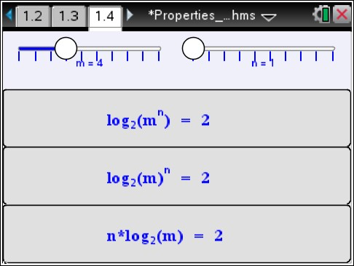
Move to page 1.4.

13. As you drag the sliders for m and n, note what happens as these
values are substituted into the three expressions.
a. Find which expressions, if any, appear to be equivalent
independent of the values of m and n.

Answer: $\log_{2}\left(m^{n}\right)$ and $n \log_{2}\left(m\right)$

b. Set m = 4 and n = 3. Substitute these values into the logarithmic expressions you found in part
3a, and simplify these expressions to show they are equivalent.

Answer: $\log_{2}\left(4^{3}\right)= \log_{2}{(64)}=6$ and
${3log}_{2}\left(4\right)=3∙2=6$

c. Use the expressions you found in parts 13a and 13b to write a general logarithmic property for
$\log_{a}{{\left(m\right)}^{n}}$ where a is a real number, $a>0$ and $a ≠1$.

Answer: $\log_{a}{{\left(m\right)}^{n}}=n\log_{a}\left(m\right)$

d. Explain how do the operations in the logarithmic property in part 13c relate to the operations in
the exponential property ${\left(a^{m}\right)}^{n}= a^{mn}$?

Answer: When an expression with an exponent is raised to an exponent, the exponents are multiplied. Roughly speaking, this is a restatement in logarithm form of the law of exponents.

Teacher Tip: If desired, you may want students to prove question 3d instead. Here is a sample answer:

$\log_{a}\left(m^{n}\right)= y ⇔ a^{y}=m^{n}$
${\left(a^{y}\right)}^{1/n}= {\left(m^{n}\right)}^{1/n}$
${\left(a\right)}^{y/n}=m ⇔ \log_{a}{m}= \frac{y}{n}$
$n \log_{a}{m}=y$
Or $\log_{a}\left(m^{n}\right)= \underset{n times}{\underbrace{\log_{a}\left(m∙m∙m∙… ∙m\right) }}= \underset{n times}{\underbrace{\log_{a}{m}+ \log_{a}{m+…+ \log_{a}{m}}}}=n\log_{a}{(m)}$

e. Use the logarithmic property you proved in part 13c to show that $\log_{a}{a}=1$ for all values of a
where $a>0$ and $a ≠1$.

Answer: Since $a= a^{1}$ then $\log_{a}{a^{1}=1}$.

f. Use the logarithmic property you proved in part 13c to show that $\log_{a}{1}=0$ for all values of a
where $a>0$and $a ≠1$.

Answer: Since $1= a^{0}$then $\log_{a}{a^{0}=0}$.

Teacher Tip: The last page does not allow for the n value to be negative, so this is a perfect opportunity to discuss with students how this can be
applied as well. In other words, discuss why $\log_{2}\left(\frac{1}{x}\right)= -\log_{2}{x}$ . This
discussion can provide review of other laws of exponents as well.

TI-Nspire Navigator Opportunity: Screen Capture and Quick Poll See Note 4 at the end of this lesson.
Move to page 3.1

One final time, let’s look at this same idea but graphically. Suppose you wanted to simplify the logarithm of a power, like $\log{a^{2}}$. Think about how you might go about doing this. Let’s start by defining a new variable $b=a^{2}$.
Step a: At the top of column 1, name this list $a$. Enter at least 10 values for $a$, that are in the domain of
the logarithmic function.
Step b: At the top of column 2, name this list $b$. Move down to the second row and enter a formula that
will calculate $b=a^{2}$, from the values in column 1.
Step c: Move to page 3.2 and click on the bottom to add variable $a$ and click on the left to add variable
$b$.

14. Describe the shape of the graph. Discuss with a classmate if it is what you expected. Share your
results with the class.

Answer: The shape of the graph is linear.

Step d: Move back to page 3.1. Now we will define two new variables, x and y. Let $x=\log{a}$ and
$y=\log{b}$. At the top of the third column, name it $x$. Move down to the second row and enter a
formula that calculates $x$ from the values in column 1. At the top of the fourth column, name it $y$.
Move down to the second row and enter a formula that calculates $y$ from the values in column 2.

Step e: Move to page 3.3 and click on the bottom to add variable $x$ and click on the left to add variable
$y$.

The data appear linear. Find the equation of a line through these points by pressing menu, 4 Analyze, 6 Regression, 1 Linear (mx + b).

15. Write down the equation of the line through these points.

Answer: $y=2x$

16. Find the y-intercept of the line.

Answer: y-intercept = 0

You should have found that the equation of the line was $y=2x$. Think about what this means.

You have found that $y= \log{6}+x$. Think about what this means. Substitute to rewrite this as an equation in terms of $a$. The explanation for each step is given to the right.
$$y= 2x$$ | Equation of the line
$$\log{b}=2\log{a}$$ | $x= \log{a}$ and $y= \log{b}$
$$\log{a^{2}=2\log{a}}$$ | $$b=a^{2}$$

Power Property of Logarithms Examples $\log{x^{3}}$ can be written as $3\log{x}$
For $a>0$, $\log{a^{b}}= b\log{a}.$ $8\log{x}$can be written as $\log{x^{8}}$

Further IB Math Extension

Using the properties discussed in this activity, find the solution of:

$$\log_{3}{x}-2\log_{3}{2}=3- \log_{3}{2}$$

Answer: Using the power property, simplify $2\log_{3}{2}$
$\log_{3}{x}- \log_{3}{2^{2}=3- \log_{3}{2}}$
Using the quotient property, combine the logs on the left
$\log_{3}{\frac{x}{4}}=3- \log_{3}{2}$
Add the $\log_{3}{2}$ to both sides.
$\log_{3}{\frac{x}{4}}+ \log_{3}{2}=3$
Using the product property, combine the logs on the left
$\log_{3}\left(\frac{x}{4}∙2\right)=3$
$\log_{3}\left(\frac{x}{2}\right)=3$
Rewrite the log in exponential form and solve for x
$3^{3}= \frac{x}{2}$
$27= \frac{x}{2}$
$x=54$

Wrap Up
Upon completion of the discussion, the teacher should ensure that students know and can apply the following logarithm properties:

- $\log_{a}\left(mn\right)= \log_{a}\left(m\right)+ \log_{a}\left(n\right)$
- $\log_{a}\left(\frac{m}{n}\right)= \log_{a}\left(m\right)- \log_{a}\left(n\right)$
- $\log_{a}\left(m^{n}\right)= n\log_{a}\left(m\right)$

TI-Nspire Navigator

Note 1
Question 1, Live Presenter: You may want to demonstrate how to drag the point on the slider using Live Presenter.

Note 2
Question 1c, Screen Capture: Take a Screen Capture of page 1.2 where students are on different m-values and n-values. As a class, discuss the various cases that occur and the
fact that the two same expressions are always equivalent.

Question 1.c, Quick Poll (Open Response): Send an Open Response Quick Poll asking students to submit their answers to question 1c. If students struggle to write the general logarithmic property, revisit the Screen Capture and use equivalent expressions to write the
general property.

Note 3
Question 7c, Screen Capture: Take a Screen Capture of page 1.3 when students are on different m-values and n-values. As a class, discuss the various cases that occur and the
fact that the two same expressions are always equivalent.

Question 7c, Quick Poll (Open Response): Send an Open Response Quick Poll asking students to submit their answer to question 7c. If students struggle to write the general logarithmic property, revisit the Screen Capture and use equivalent expressions to write the general property.

Note 4
Question 13c, Screen Capture: Take a Screen Capture of page 1.4 when students are on different m-values and n-values. As a class, discuss the various cases that occur and the
fact that the two same expressions are always equivalent.

Question 13c, 13e, and 13f, Quick Polls (Open Response): Send Open Response Quick Polls asking students to submit their answers to questions 13c, 13e, and 13f. If students struggle to write the general logarithmic property, revisit the Screen Capture and use equivalent expressions to write the general property.

**Note: This activity has been developed independently by Texas Instruments and aligned with the IB Mathematics curriculum, but is not endorsed by IB™. IB is a registered trademark owned by the International Baccalaureate Organization.

