The goal of this activity is to help students analyze temperature-loss data graphically, use Newton’s Law of Cooling to predict temperature loss, solve the Newton’s Law of Cooling formula for the exponential constant of cooling (k), and determine the time required for tank temperature to equalize with room temperature. | 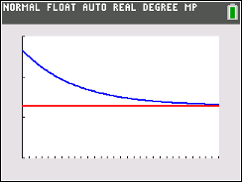

Newton’s Cool in the Pool
Background
This problem is part of a series that applies mathematical principles in NASA’s human spaceflight.
Human spaceflight is an important part of NASA’s mission. From lunar exploration to the completion of the International Space Station (ISS), NASA has been preparing humans to explore the unknown. The research and innovation required to explore space has led to technological advancements on Earth. Space exploration has brought benefits to medicine, medical care, transportation, public safety, computer technology, and many other areas that enrich our everyday lives.

Exploring space is a complex endeavor, and missions that involve humans require extensive research, precise planning, and preparation. This includes spacewalks, which are critical for current and future missions.

To prepare for spacewalks, astronauts train at NASA’s Neutral Buoyancy Laboratory (NBL) – the largest indoor pool in the world, located at the Sonny Carter Training Facility in Houston, Texas. Besides astronaut training and the refinement of spacewalk procedures, NASA also uses the NBL to develop flight procedures and verify hardware compatibility – all of which are necessary to achieve mission success.

The NBL is 202 ft (61 m) long, 102 ft (31 m) wide, and 40 ft (12 m) deep. It is sized to perform two suited test activities simultaneously, and it holds 6.2 million gallons (23.5 million liters) of water. Even at this size, the complete International Space Station, with dimensions of 350 ft (106 m) by 240 ft (73 m), will not fit inside the NBL (see Figure 1).

The water within the NBL is recycled every 19.6 hours. It is automatically monitored and controlled to a temperature of 82°-88° Fahrenheit to minimize the potential effects of hypothermia on support divers. It is also chemically treated to control contaminant growth while minimizing the long-term corrosion effect on training mockups and equipment.

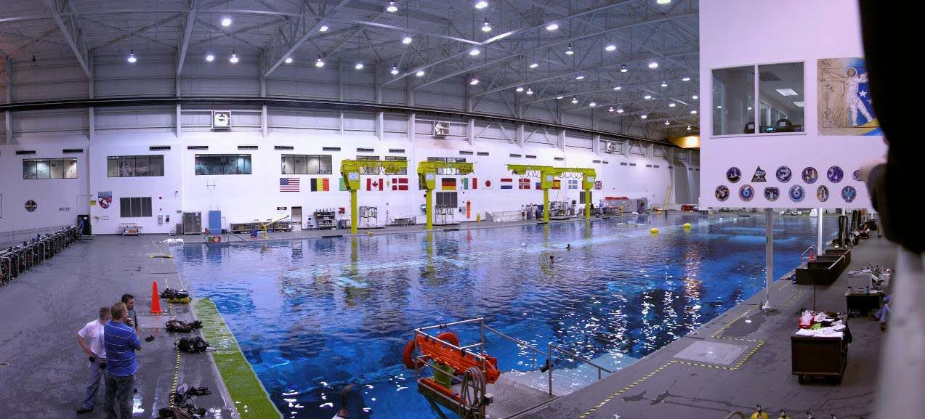
Figure 1: View of the entire pool at the Neutral Buoyancy Lab (NBL)

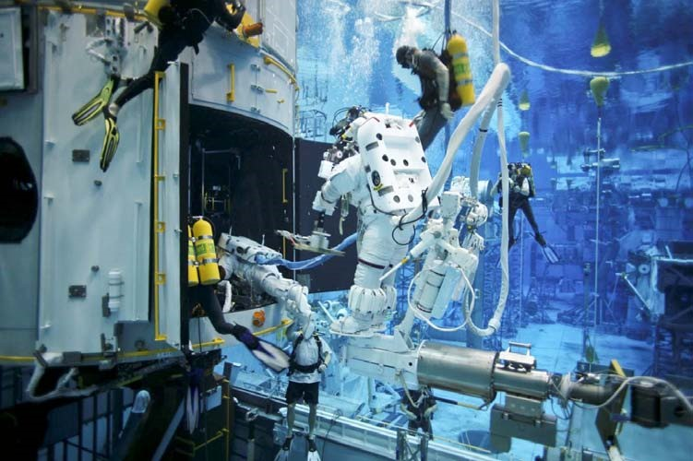
Figure 2: Astronauts practicing for a spacewalk to repair the Hubble Telescope in the NBL
The NBL allows crewmembers to properly train by experiencing the simulation of a weightless environment in space. With the assistance of divers, suited astronauts are weighted in the pool in order to perform simulated extra-vehicular activities (EVAs) on full mockups of parts of the International Space Station (ISS), the space shuttle cargo bay, and on various payloads.

You may wonder, what is neutral buoyancy and how does it resemble weightlessness? Neutral buoyancy is the equal tendency of an object to sink or float. If an item is made neutrally buoyant through a combination of weights and flotation devices, it will seem to hover under water. In such a state, even a heavy object can be easily manipulated, as is the case in microgravity of space. However, there are two important differences between neutral buoyancy (as achieved in the NBL) and weightlessness. The first is that suited astronauts training in the NBL are not truly weightless. While the suit/astronaut combination is neutrally buoyant, the astronauts can still feel their weight while underwater in their suits. The second is that water drag hinders motion, making some tasks easier to perform in the NBL than in microgravity. While these differences must be recognized by spacewalk trainers, neutral buoyancy is still the best method currently available to train astronauts for spacewalks.

Activity
Using your TI-84 CE to aid in the process, answer the problem set and use the following temperature data to create a scatter plot on the handheld.
Time (days) | Temperature (Fahrenheit)
0 | 86.6°
1 | 85.3°
2 | 83.7°
3 | 82.2°
4 | 80.7°

Problem 1

On the handheld, press STAT $→$ EDIT, and enter the Time in $L_{1}$ and the Temperature in $L_{2}$.
Press 2nd, y =, enter, enter to turn your Plot 1 on. Make sure that your XList matches with $L_{1}$ and your YList matches with $L_{2}$. Press Zoom, 9 Stat, to see your data graphed. Do not change this graph as it will be used later in the activity.

Problem 2

Newton's Law of Cooling states that the rate of change of the temperature of an object is proportional to the difference between its own temperature and the ambient temperature (i.e. the temperature of its surroundings). The formula for Newton's Law is:

$T\left(t\right)= T_{a}+ \left(T_{o}- T_{a}\right)e^{-kt}$

$T\left(t\right)=$ pool temperature, ºF, at a given time
$T_{a}=$ ambient temperature, ºF
$T_{o}=$initial temperature of the pool, ºF
$t=$ time,days

Solve for k in the formula for Newton’s Law of Cooling for each daily temperature difference.
Use 73º F as the ambient temperature. Round to the nearest thousandth.

Day 1: $k=$________________

Day 2: $k=$________________

Day 3: $k=$________________

Day 4: $k=$________________

Problem 3

Notice that the k-values are different for each day. Explain why the k-value is not constant in this
situation.

Problem 4

Use the average of the calculated k-values to determine the pool temperature on Day 4. Round the
temperature you found to the nearest tenth. How close is the calculated temperature to the actual pool
temperature on Day 4 (from the data table)?

Problem 5

Find the function that represents the data, from the table, by substituting your average k- value into the
Newton’s Law equation. Write the function below, and then graph the function together with the scatter
plot from Problem 1. (To graph the function, press y =, enter the function into $Y_{1}$, graph.)

$T\left(t\right)=$___________________________________

Problem 6

Determine the number of days it will take the pool to reach a temperature of 74° F. Round to the nearest
day. Support your answer graphically on your graph from Problem 5.

Problem 7
On your graph from Problem 5, show when the pool approaches ambient temperature. Adjust the
window of the graph.

Problem 8
What temperature would the pool reach in 10 days? Round to the nearest tenth.

Use the function you graphed in Problem 5 to answer the next three problems.

Problem 9

Is the function increasing or decreasing? How can this be determined from the function rule?

Problem 10

Is the function asymptotic? Explain.

Problem 11
What is the range of the function?

Problem 12
What is the range of the data?

