Problem 1 – Reflecting the Exponential Function
Enter the equation y = e^{x} on the o screen. Then press p  and change the following parameters: Xmax=5 and Ymax=5. Leave all others the same. Press s to observe its graph.  1. What would the inverse of this graph look like? | 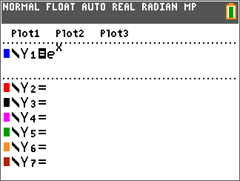
Recall that an inverse of a function if found when the input (x) is switched with the output (y).  Press y [table] to access a table of values for your function.  2. Record the y-values under the original y-value column in the table below.  Next record the inverses of each point by switching the x- and y-values and recording the results in the inverse columns in the table below. | 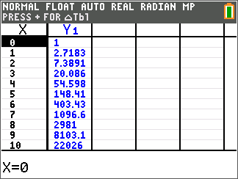
Original x-value | Original y-value | Inverse x-value | Inverse y-value
–2
–1
0
1
2
3

Now, plot out these inverse points by pressing … Í and entering the inverse values in L1 and L2.  To set up the scatter plot of the two lists, press  y [stat plot] and match the screen to the right.  Now press s to observe the plotted values. | 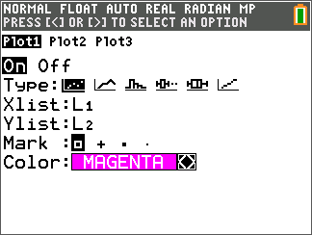
3. What do you notice about the plotted values?

Graph the equation y = x to test your observation.

4. Find the inverse of y = e^{x}. This is done by switching x and y (exchanging the input with the output) in the equation and solve for y.

Check your result by graphing this result to see if it passes through all the plotted points.

Extension – Reflecting y = 10^{x}
Repeat the process of the activity, but use y = 10^{x}.
5. Find the inverse of y = 10^{x}.

